ENGR 3323: Signals and Systems
HW 9_Ch6

Q1) For the periodic signals x(t) and y(t) shown below:
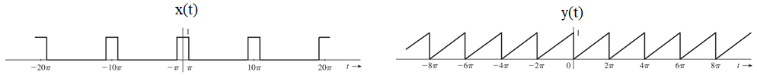
- Find the exponential Fourier series for x(t) and y(t).
- Sketch the amplitude and phase spectra for signal x(t).
- Use Parseval’s theorem to approximate the power of the periodic signal x(t) by calculating the power of the first N^{th} harmonics, such that the strength of the N^{th} harmonic is 10% or more of the power of the DC component.
Q2) The exponential Fourier series of a certain function is given as

x(t) = (2 + j2)e^{-j3t} + j2e^{-jt} + 3 - j2e^{jt} + (2 - j2)e^{j3t}

- Sketch the exponential Fourier spectra.
- By inspection of the spectra in part (a), sketch the trigonometric Fourier spectra for x(t). Find the compact
trigonometric Fourier series from these spectra.
- Show that the trigonometric series found in part (b) is equivalent to the exponential series for x(t).
- Find the signal bandwidth.

Q3) Figure below shows the exponential Fourier spectra of a periodic signal x(t).
- By inspection of the Figure find the exponential Fourier series representing x(t).
- By inspection of the Figure, sketch the trigonometric Fourier spectra for x(t).
- By inspection of the trigonometric Fourier spectra found in part (b), find the trigonometric Fourier series for x(t).
- Show that the series found in parts (a) and (c) are equivalent.

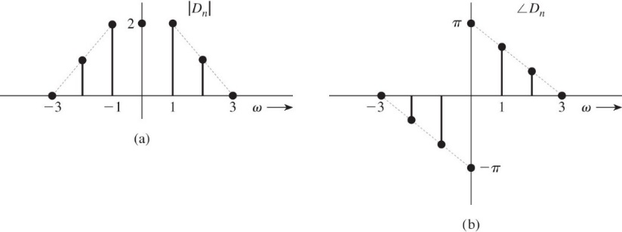

Q4)Find the response of an LTIC system with transfer function $H\left(s\right)=\frac{s}{s^{2}+2s+3}$ to the periodic input
x(t) = (2 + j2)e^{-j3t} + j2e^{-jt} + 3 - j2e^{jt} + (2 - j2)e^{j3t}

Q5) Find the exponential Fourier series for a periodic signal x(t) shown in Figure below

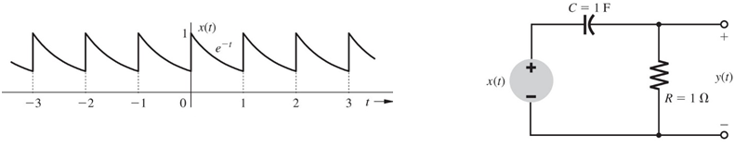

The signal x(t) is applied at the input of an LTIC system shown above. Find the expression for the
output y(t).

