Chapter 1
$$E_{x}=\int_{-∞}^{∞}{{\left|x(t)\right|}^{2}dt}$$

$$P_{x}=\lim_{T→∞}{\frac{1}{T}\int_{-T/2}^{T/2}{{\left|x(t)\right|}^{2}dt}}$$

x(t-T) time shift to the right left by T
x(t+T) time shift to the left by T
x(at) signal compression by a factor of a if a>1
x(t/a) signal expansion by a factor of a if a<1
x(-t) time reversal around the y-axis
Signal is periodic with T period if x(t) = x(t+T)
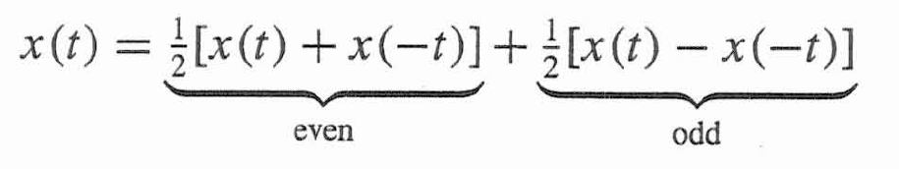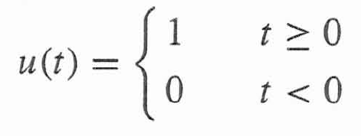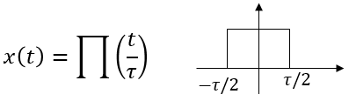
$$\frac{du(t)}{dt}=δ(t)$$
$$δ\left(t\right)=0 t≠0$$
$$\int_{-∞}^{∞}{δ\left(t\right)dt=1}$$

$$ϕ\left(t\right)δ\left(t-T\right)=ϕ\left(T\right)δ\left(t-T\right)$$
$$\int_{-∞}^{∞}{ϕ(t)δ\left(t-T\right)dt=ϕ(T)}$$

$$e^{st}=e^{\left(σ+jω\right)t}=e^{σt}e^{jωt}=e^{σt}\left(\cos{ωt}+j sin ωt\right)$$
System is linear
if x₁ ---> y₁ and x₂ ----> y₂ then k₁ x₁ + k₂x₂ ---> k₁ y₁ + k₂ y₂
System is time invariant if 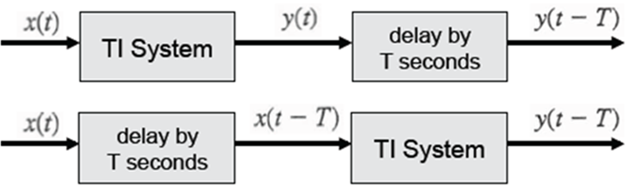
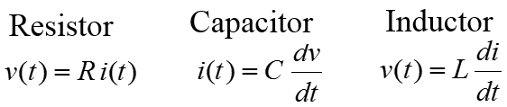
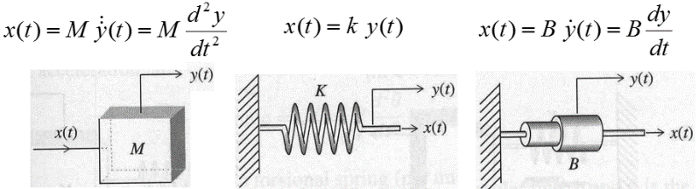
Chapter 2
Zero-input response
$$\left(D^{N}+a_{1}D^{N-1}+a_{2}D^{N-2}+…+a_{N}\right)y(t)=0$$
$$λ^{N}+a_{1}λ^{N-1}+a_{2}λ^{N-2}+…+a_{N}=0$$
$$\left(λ-λ_{1}\right)\left(λ-λ_{2}\right)…\left(λ-λ_{N}\right)=0$$
Characteristic roots: λ₁ , λ₂ , …., λ_{n}
$${y\left(t\right)=c}_{1}e^{λ_{1}t}+c_{2}e^{λ_{2}t}+…+c_{N}e^{λ_{N}t}$$
Impulse response h(t)
$$Q\left(D\right)y\left(t\right)=P\left(D\right)x(t)$$
$${y_{n}\left(t\right)=c}_{1}e^{λ_{1}t}+c_{2}e^{λ_{2}t}+…+c_{N}e^{λ_{N}t}$$
To solve for the constants C set all initial conditions to zero except
$$y_{n}^{N-1}\left(0\right)=1$$
$$h\left(t\right)=\left[P\left(D\right)y_{n}\left(t\right)\right]u(t)$$
If M = N then h(t) = b₀ δ(t)+ [P(D) y_{n}(t)] u(t)
Zero-state response
y(t) = x(t) * h(t)
$$y\left(t\right)=\int_{-∞}^{∞}{x\left(τ\right)h\left(t-τ\right)dτ}$$

Convolution Property
x₁ * x₂ = x₂ * x₁
x₁ * [x₂ * x₃] = [x₁ * x₂ ] * x₃
x₁ * [x₂ ₊ x₃] = [x₁ * x₂ ] + [x₁ * x₃ ]
x(t) * δ(t) = $\int{x\left(τ\right)δ\left(t-τ\right)dτ}=$ x(t)
if x₁(t) * x₂(t) = c(t)
then x₁(t -T) * x₂(t) = x₁(t) * x₂(t -T) = c(t -T)
also x₁(t –T₁) * x₂(t –T₂) = c(t –T₁ –T₂)
Chapter 4
$$\text{Laplace Transform: } X\left(s\right)=\int_{-∞}^{∞}{x(t)e^{-st}dt}$$

Use partial fraction expansion and the table to find the inverse Laplace transform.
$$y\left(t\right)=x\left(t\right)*h\left(t\right) ---→ Y\left(s\right)=X\left(s\right)H\left(s\right)$$
$$\text{Transfer Function: }H\left(s\right)=\frac{Y(s)}{X(s)}$$

Y(jω) = X(jω)H(jω)
You can find H(jω) from H(s) by replacing s with jω
If x(t) = Acos (ω_{o}t) then y(t) = |H(jω_{o})|A cos (ω_{o}t + ∠H(jω_{o}))
A delay system: y(t) = x(t-T) H(s) = e^{-sT} H(jω) = e^{-jωT}
Group delay = d/dω [∠H(jω)]
A differentiator: y(t) = dx(t)/dt H(s) = s H(jω) = jω
An integrator: $y\left(t\right)=\int{x\left(t\right)dt}$ H(s) = 1/s H(jω) = 1/jω
System is internally stable if all the poles are in the LHP
System is unstable if at least one pole is in the RHP or there are repeated poles in the imaginary axis
System is marginally stable if there is no poles in the RHP and there are some unrepeated poles on the imaginary axis.
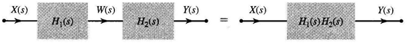
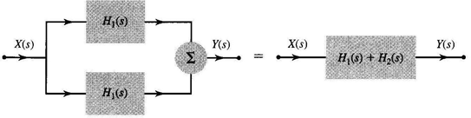
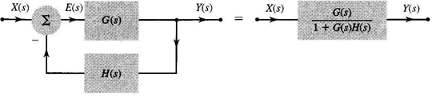
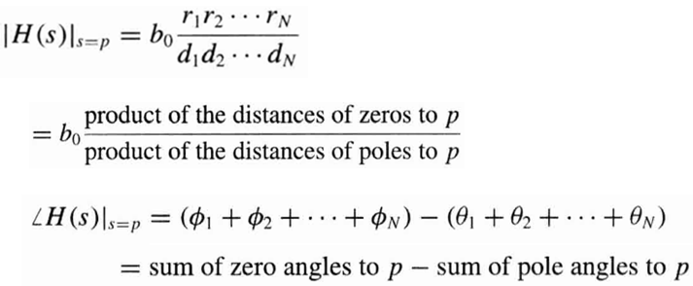
Form I Realization
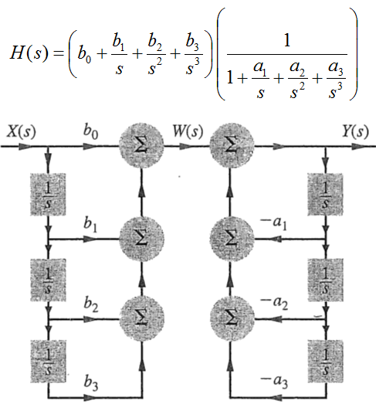
Form II realization
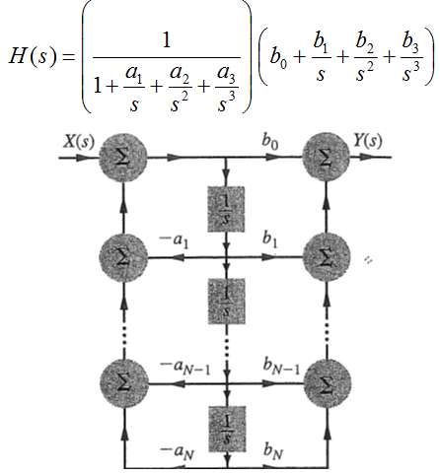
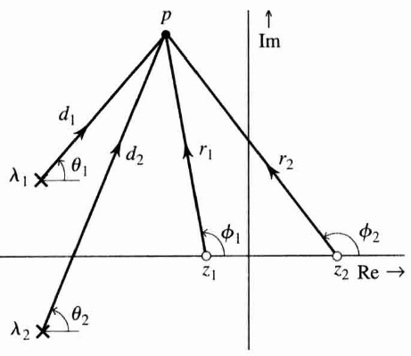
Frequencies near poles are enhanced and frequencies near zeros are suppressed.
Chapter 6
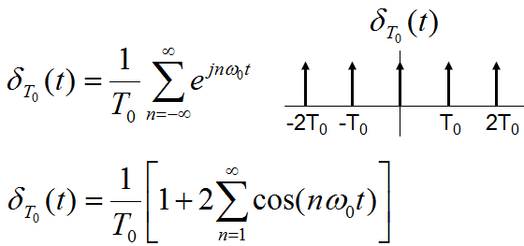
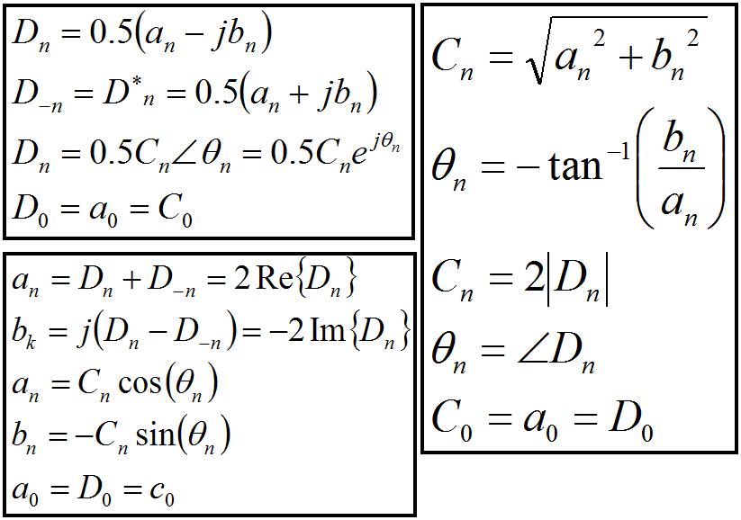
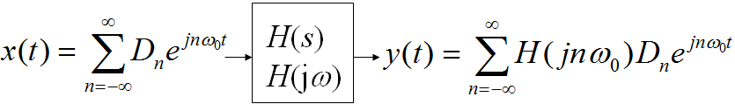
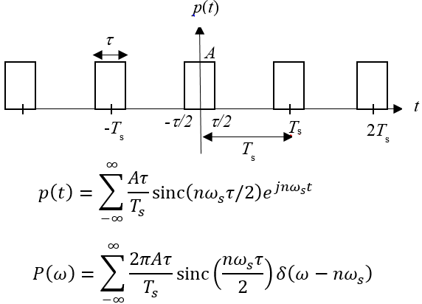
Chapter 7
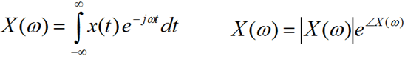
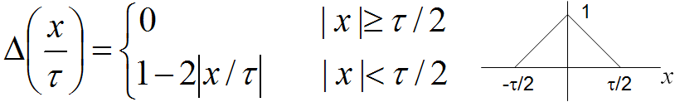
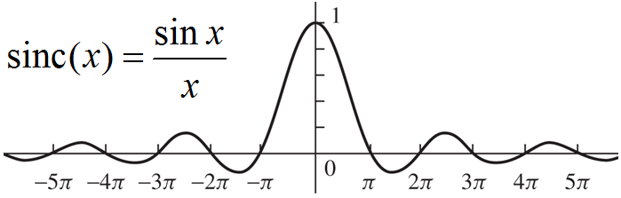
Chapter 8
Sampling Theorem: The minimum sampling rate (Nyquist rate) to avoid aliasing is twice or larger than the bandwidth of the signal (highest frequency in the signal).
Apparent frequency due to undersampling f_{a} =| f – mf_{s} | f_{a} < f_{s}/2
The quantization level L = 2^{n} where n is the number of bits per sample.
Quantization error = Δx/2 where Δx = (x_{max} – x_{min})/L
