ENGR 2303: Electrical Science
HW 1_Ch1
1) How many coulombs are represented by these amounts of electrons:
(a) (b)
(c) (d)
2) Determine the total charge transferred over the time interval of 0 ≤ t ≤ 10s when A.
3) A rechargeable flashlight battery can deliver 85 mA for about 12 h. How much charge can it release at that rate? If its terminals voltage is 1.2 V, how much energy can the battery deliver?
4) The current entering the positive terminal of a device is and the voltage across the device is .
- Find the charge delivered to the device between t = 0 and t = 2 s.
- Calculate the power absorbed.
- Determine the energy absorbed in 3 s.

5) Find I in the network below
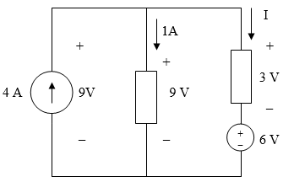
6) A 1.8-kW electric heater takes 15 min to boil a quantity of water. If this is done once a day and power costs 10 cents per kWh, what is the cost of its operation for 30 days?
7) A 600-W TV receiver is turned on for 4 hours with nobody watching it. If electricity costs 10 cents/kWh, how much money is wasted?

