ENGR 2303: Electrical Science
HW 10_Ch10
- Determine i(t) in the circuit below.
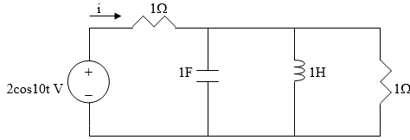

- Use nodal analysis to find V in the circuit below.
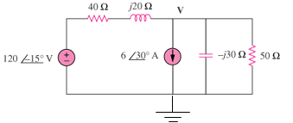
- Solve for i_{o} in the circuit below using mesh analysis.

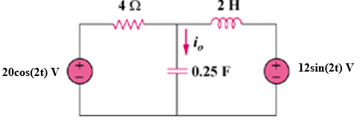
- In the circuit below, determine the mesh currents i₁ and i₂. Let v_{i} = 10 cos4t V and v₂ = 20 cos(4t – 30°) V.

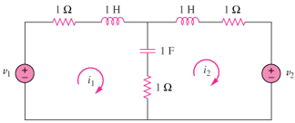
- Find i_{o} in the circuit below using superposition.

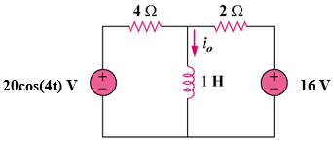
- Use superposition to find i(t) in the circuit below.
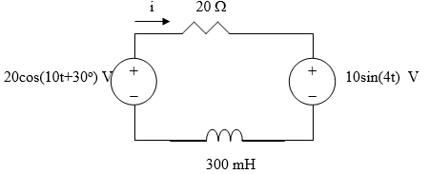
- Using source transformation, find i in the circuit below.
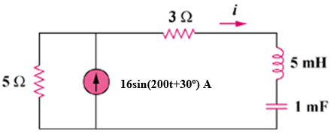
- Find the Thevenin and Norton equivalent circuits at terminals a-b for each of the circuits below.
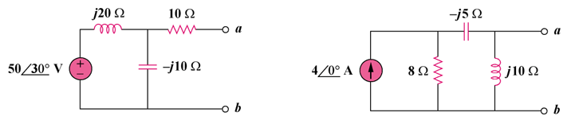
- Compute i_{o}(t) in the op amp circuit below if v_{s} = 10 cos(10⁴t +30˚) V.
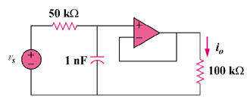
- For the op amp circuit below, obtain v_{o}(t).

