ENGR 2303: Electrical Science
HW 11_Ch11 and Ch14

Problems from Ch 11

- If v(t) = 160 cos 50t V and i(t) = - 20 sin (50t - 30°) A, calculate the instantaneous power and the average power.

- Assuming that v_{s} = 16 cos(2t - 40°) V in the circuit shown below, find the average power delivered to each of the passive elements.

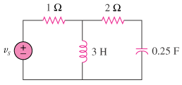
- In the circuit below, find the value of Z_{L} that will absorb the maximum power and the value of the maximum power.
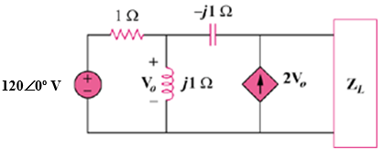
- Calculate the rms value of the current waveform below.

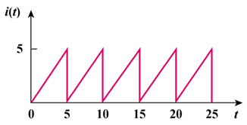
- A coupling capacitor is used to block dc current from an amplifier as shown in first figure below. The amplifier and the capacitor act as the source, while the speaker is the load as shown in second figure below.

- At what frequency is maximum power transferred to the speaker?

- If V_{s} = 4.6 V rms, how much power is delivered to the speaker at that frequency?
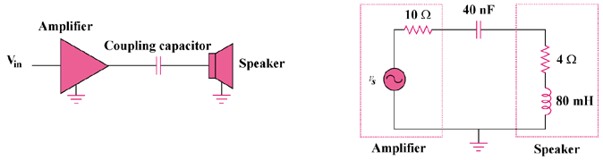

Problems from Ch 14

- Show that a series LR circuit is a lowpass filter if the output is taken across the resistor. Calculate the corner frequency f_{c} if L = 2 mH and R = 10 kΩ.

- Determine what type of filter is shown below. Calculate the corner frequency f_{c}.

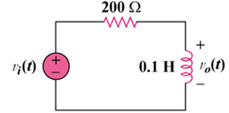

- Determine the center frequency and bandwidth of the bandpass filters below.

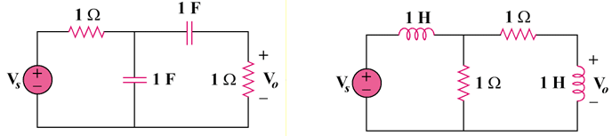
- Find the bandwidth and center frequency of the bandstop filter below.

