ENGR 2303: Electrical Science
HW 2_Ch2
- Find the number of branches and nodes in each of the circuits below
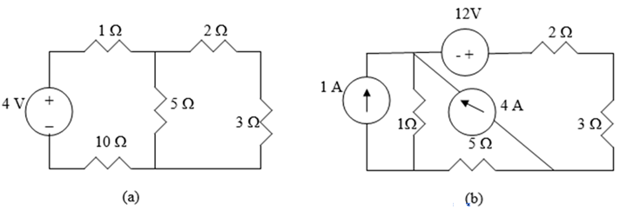
- Find i₁, i₂, and i₃
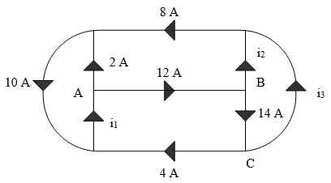

- In the circuit below, calculate V₁ and V₂.
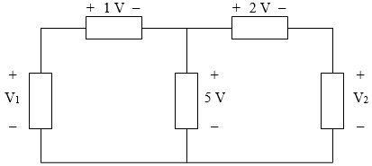

- Obtain v₁ , v₂ , and v₃ in the circuit below
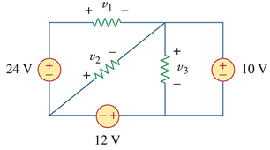
- Find V_{x} in the circuit below
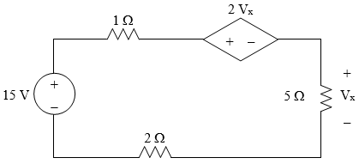

- Calculate V_{o} and I_{o} in the circuit below
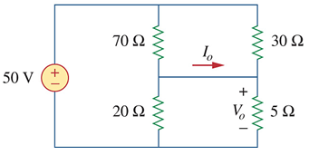
- Evaluate R_{eq} for each of the circuits shown below
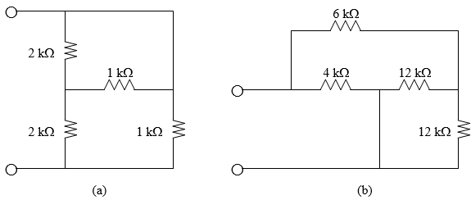
- As a design engineer, you are asked to design a lighting system consisting of a 70-W power supply and two lightbulbs as shown in figure below. You must select the two bulbs from the following three available bulbs.
R₁ = 80Ω, cost = $0.60 (standard size)
R₂ = 90Ω, cost = $0.90 (standard size)
R₃ = 100 Ω, cost = $0.75 (nonstandard size)
The system should be designed for minimum cost such that I = 1.2 A ± 5 percent.
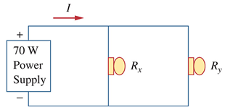
- Two delicate devices are rated as shown in figure below. Find the values of the resistors R₁ and R₂ needed to power the devices using a 24-V battery.
