ENGR 2303: Electrical Science
HW 3_Ch3
- For the circuit below obtain v₁ and v₂.
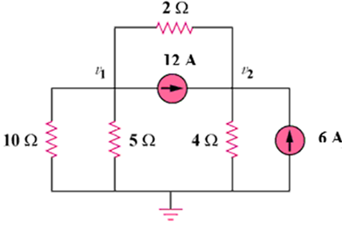
- Obtain v₀ in the circuit below
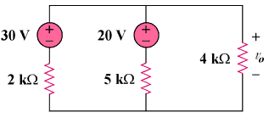
- Using nodal analysis, find current i_{o} in the circuit below.
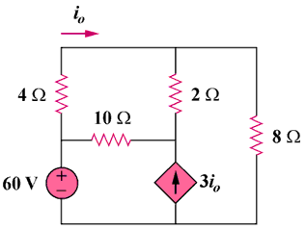
- Use nodal analysis to find v₁, v₂, and v₃ in the circuit below.
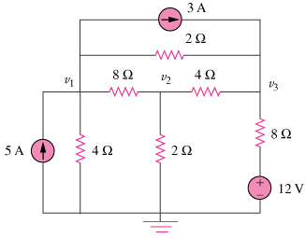
- An audio amplifier with resistance 9Ω supplies power to a speaker. In order that maximum power is delivered, what should be the resistance of the speaker?

- Determine the mesh currents i₁ and i₂ in the circuit below.
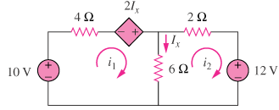
- Use mesh analysis to obtain i_{o} in the circuit below.
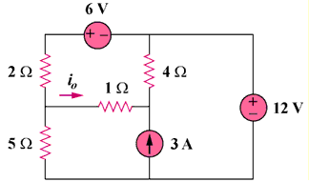

- Calculate the current gain i_{o}/i_{s} in the circuit below.
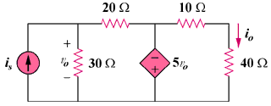
- Write the mesh-current equations for the circuit below.
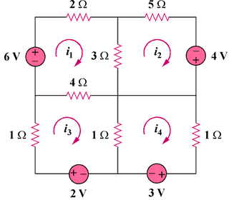
- For the circuit below, find the gain v_{o}/v_{s}.
