ENGR 2303: Electrical Science
HW 4_Ch4
- For the circuit below, assume v_{o} = 1 V, and use linearity to find the actual value of v_{o}.
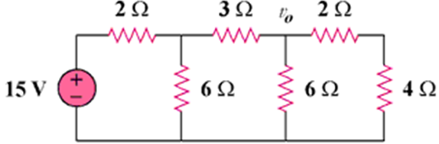
- For the circuit below, use superposition to find i. Calculate the power delivered to the 3-Ω resistor.
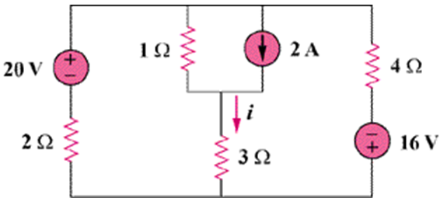
- Use superposition to solve for v_{x} in the circuit below.
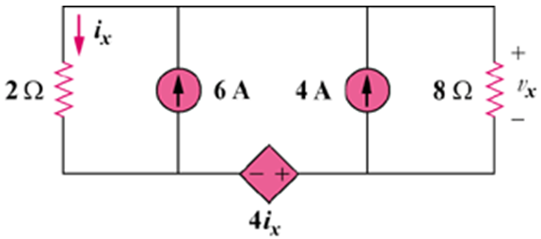
- For the circuit below, use source transformation to determine the current and power in the 8-Ω resistor.
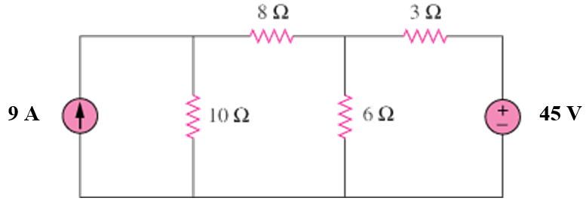
- Use source transformation to find v_{o} in the circuit below.
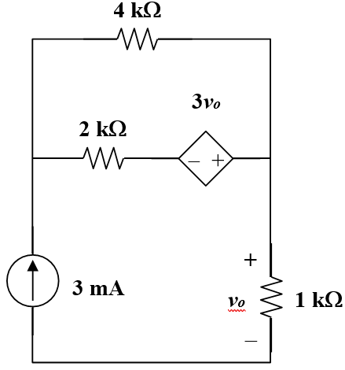

- Use Thevenin’s theorem and superposition principle to find v_{o} in the circuit below
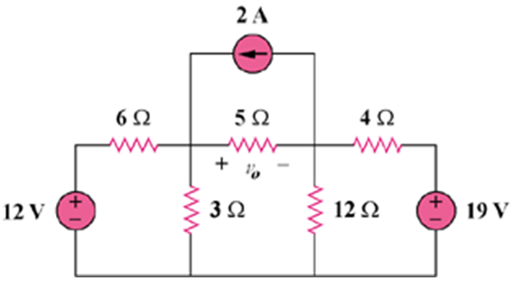
- Obtain the Thevenin equivalent at terminals a-b of the circuit below.
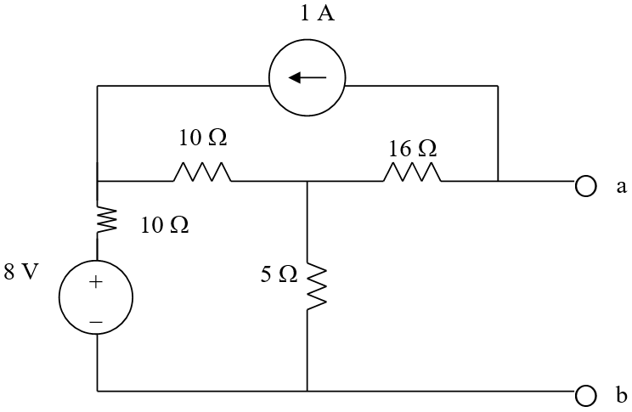
- Find the Norton equivalent at terminals a-b of the circuit below.
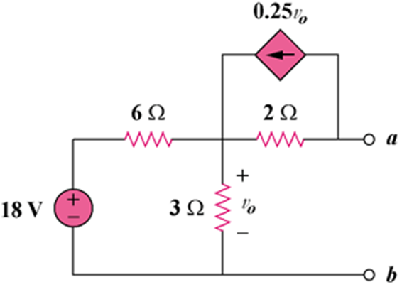
- The variable resistor R in the circuit below is adjusted until it absorbs the maximum power from the circuit. (a) Calculate the value of R for maximum power. (b) Determine the maximum power absorbed by R.
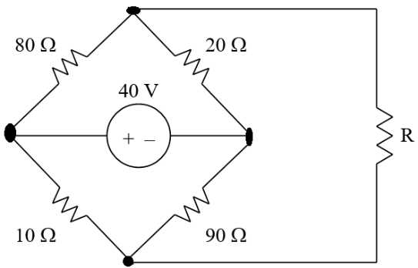
- A transducer is modeled with a current source I_{s} and a parallel resistance R_{s}. The current at the terminals of the source is measured to be 9.97506 mA when an ammeter with an internal resistance of 20 Ω is used.
- If adding a 2-kΩ resistor across the source terminals causes the ammeter reading to fall to 9.87654 mA, calculate I_{s} and R_{s}.
- What will the ammeter reading be if the resistance between the source terminals is changed to 4 kΩ?

