ENGR 2303: Electrical Science
HW 5_Ch5
- Determine v_{o} for each of the op amp circuits below.
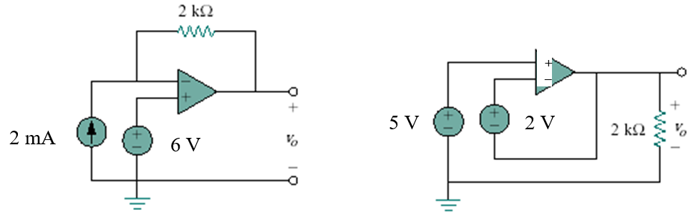
- Find v_{o} and i_{o} in the circuit below.
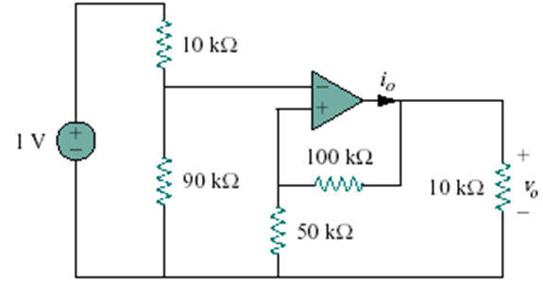
- Determine i_{o} in the circuit below.
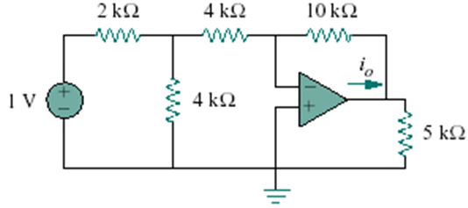
- Find v_{o} in the op amp circuit below.
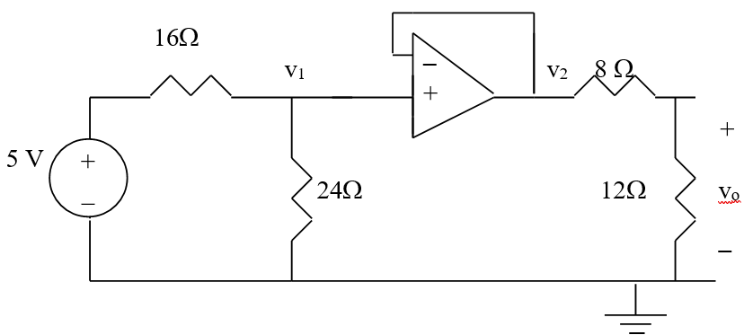

- Refer to the op amp circuit below. Calculate i_{x} and the power dissipated by the 3-kΩ resistor.
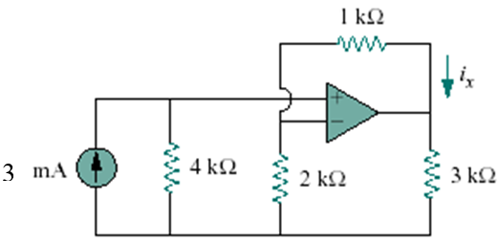
- An averaging amplifier is a summer that provides an output equal to the average of the inputs. By using proper input and feedback resistor values, one can get
Using a feedback resistor of 10 kΩ, design an averaging amplifier with four inputs.
- The circuit below is for a difference amplifier. Find v_{o} given that v₁ =1V and v₂ = 2V.
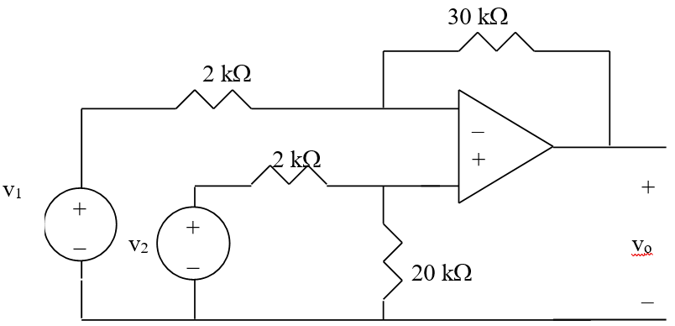

- Design an op amp circuit such that v_{o} = - 2v₁ + 4v₂ - 5v₃ - v₄
Let all the resistors be in the range of 5 to 100 kΩ.

- Calculate i_{o} in the op amp circuit below.
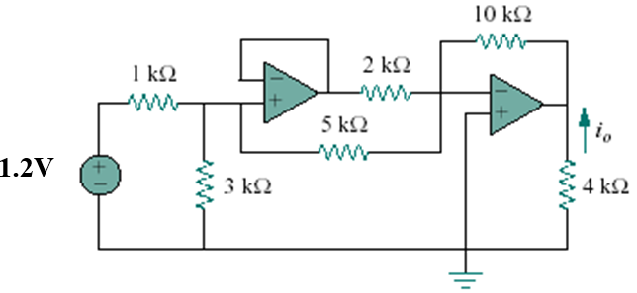
- A noninverting current amplifier is below. Calculate the gain i_{o}/i_{s}. Take R₁ = 8 kΩ and R₂ = 1 kΩ.
