ENGR 2303: Electrical Science
HW 6_Ch6
- The current through a 0.5-F capacitor is 6(1-e^{-t}) A. Determine the voltage and power at t=2 s. Assume v(0) = 0.

- Find the voltage across the capacitors in the circuit below under dc conditions.
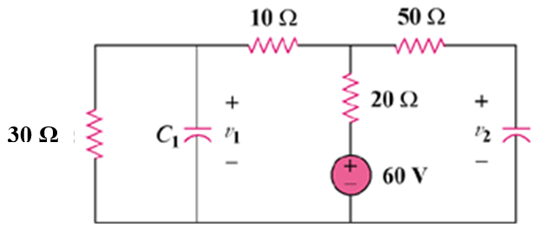

- In the circuit below, let i_{s} = 30e^{-2t} mA and v₁(0) = 50 V, v₂(0) = 20 V. Determine: (a) v₁(t) and v₂(t), (b) the energy in each capacitor at t = 0.5 s.

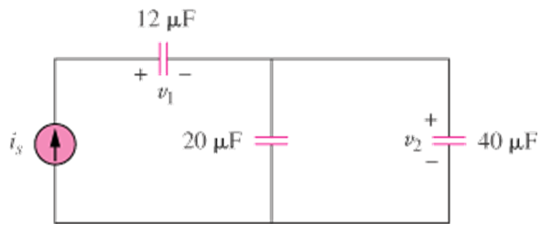
- Consider the circuit below. Find: (a) L_{eq}, i₁(t) and i₂(t) if mA, (b) v_{o}(t),
(c) energy stored in the 20-mH inductor at t=1s.

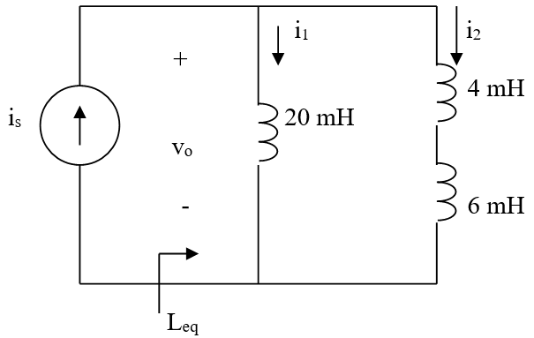

- The inductors in the circuit below are initially charged and are connected to the black box at t = 0. If i₁(0) = 4 A, i₂(0) = -2 A, and v(t) = 50e^{-200t} mV, t ≥ 0 find:

- the energy initially stored in each inductor,
- the total energy delivered to the black box from t = 0 to t = ∞,
- i₁(t) and i₂(t), t ≥ 0,
- i(t), t ≥ 0.

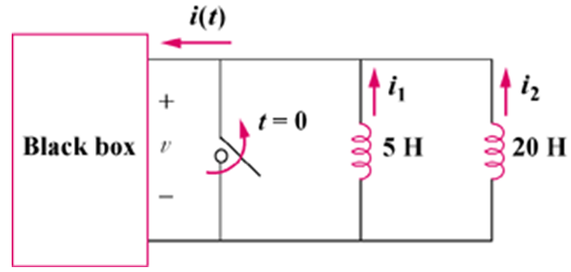
- An op amp differentiator has R= 250 kΩ and C = 10 μF.
The input voltage is a ramp r(t) = 12 t mV. Find the output voltage.

- Design an analog computer circuit to solve the following ordinary differential equation.
where y(0) = 1 V.

