ENGR 2303: Electrical Science
HW 7_Ch7
- In the circuit shown below v(t)=56e^{-200t} V, t>0 i(t)=8e^{-200t} mA, t >0
a) Find the values of R and C. b) Calculate the time constant τ
c) Determine the time required for the voltage to decay half its initial at t=0.
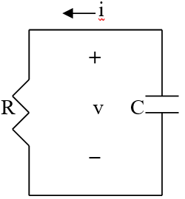
- The switch in the circuit below moves instantaneously from A to B at t=0. Find v for t>0.
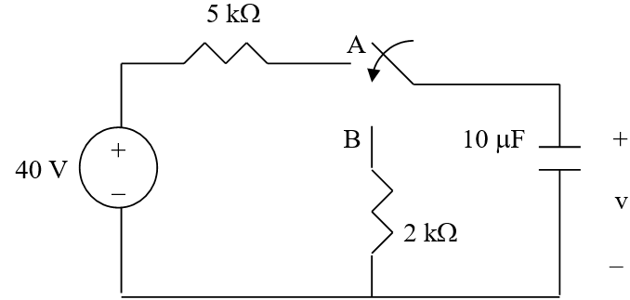
- The switch in the circuit below opens at t=0. Find v_{o} for t > 0.
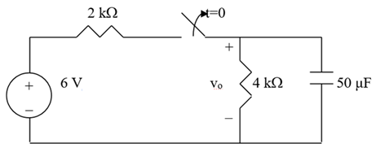
- For the circuit below, find i_{o} for t >0.
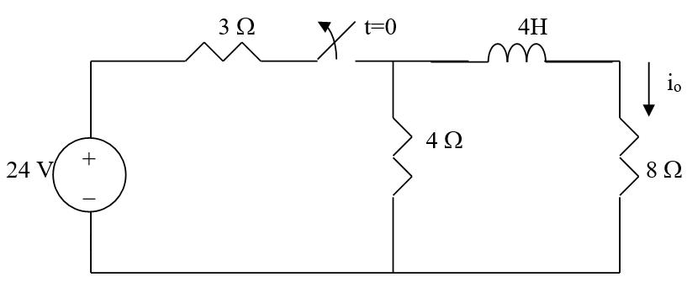
- In the circuit below, find i(t) for t > 0 if i(0) = 2 A.
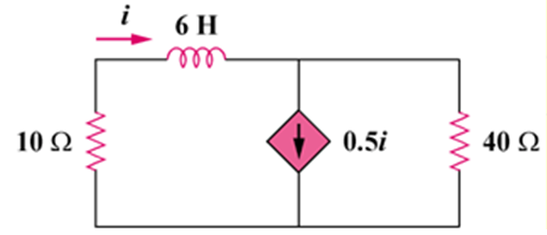
- Calculate the capacitor voltage for t < 0 and t > 0 for each of the circuits below.
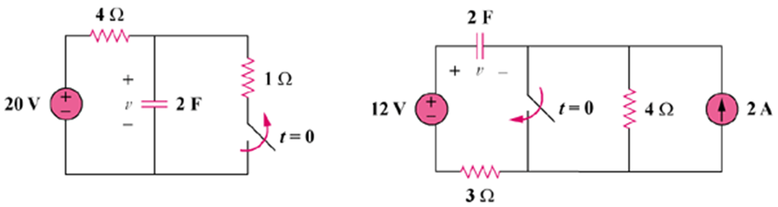
- Consider the circuit below. Find i(t) for t < 0 and t > 0.
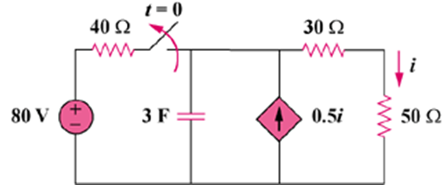
- Find v(t) for t < 0 and t > 0 in the circuit below.
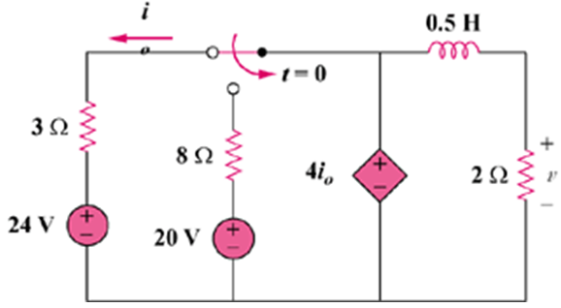
- For the following circuit, solve for i_{o}(t).
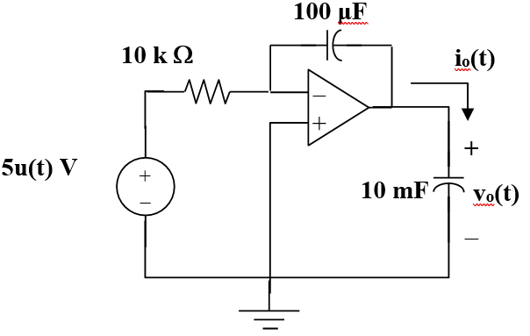
- A RC circuit consists of a series connection of a 120-V source, a switch, a 34-MΩ resistor and a 15-μF capacitor. The circuit is used in estimating the speed of a horse running a 4 km racetrack. The switch closes when the horse begins and opens when the horse crosses the finish line. If the capacitor charges to 85.6 V, calculate the speed of the horse.

