ENGR 2303: Electrical Science
HW 9_Ch9
1) Given the sinusoidal voltage v(t) = 50 cos(30t+10º) V, find:
(a) the amplitude V_{m}, (b) the period T, (c) the frequency f, and (d) v(t) at t=10 ms.

2) Given v₁ = 20 sin (ωt + 60°) and v₂ = 60 cos (ωt - 10°), determine the phase angle between the two sinusoids and which one lags the other.

3) Evaluate the following complex numbers and leave your results in polar form.
(a)
(b)
4) Find the phasors corresponding to the following signals.
(a) v(t) = 21 cos(4t-15º) V (b) i(t) =-8 sin (10t+70º) mA
(c) v(t) = 120 sin (10t –50º ) V (d) i(t) = -60cos (30t +10º) mA

5) Evaluate the following complex numbers:

- A series RLC circuit has R = 80 Ω, L = 240 mH, and C = 5mF. If the input voltage is v(t)= 10cos20t, find the current flowing through the circuit.

6) Calculate v_{o}(t) in the circuit below.

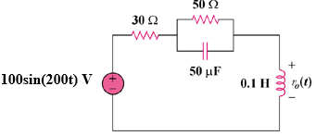

7) Find v_{s}(t) in the circuit below if the current i_{x} through the 1-Ω resistor is 0.5 sin 200t A.

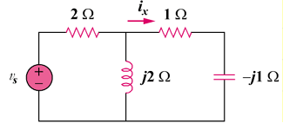

8) Determine I and Z_{T} in the circuit below.

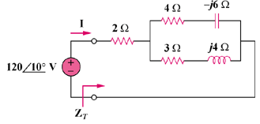
9) The ac bridge circuit below is called a Wien bridge. It is used for measuring the frequency of a source. Show that when the bridge is balanced,

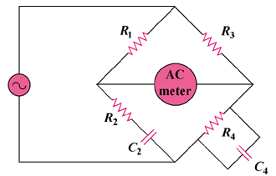

10) Figure below shows a parallel combination of an inductance and a resistance. If it is desired to connect a capacitor in series with the parallel combination such that the net impedance is resistive at 10 MHz, what is the required value of C?
