ENGR 2303 Electrical Science
Review Material for Test 1 and Sample Test

Given Electric circuit diagram, you should be able to find the current, voltage, and power at any element in the circuit using any of the following techniques:
  - Ohm’s law with KVL and KCL
  - Finding the equivalent of resistors connected in series and parallel.
  - Nodal analysis,
  - Loop (Mesh) analysis,
  - Superposition.

Question 1
Find the power delivered to the 2- and 6-ohms resistors in Fig. 1.

Question 2
Find R_{eq} for the circuit shown in Fig. 2.
12 KΩ
6 KΩ
18 KΩ
6 KΩ
R₂
R₄
R₃
R₁
9 KΩ
R_{eq}
R₅
6 Ω
4 A
2 Ω
Fig. 1
Fig. 2
For questions 3 and 4 you need to solve them by two different methods (loop and nodal techniques).

Question 3
Find I_{o} in the circuit in Fig. 3 below using super.

Question 4
Find V_{o} in the network in Fig. 4 below.

Question 5: Find I_{o} in the network in question 3 using the super position.

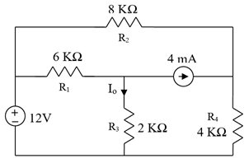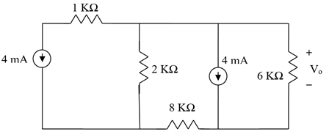
Fig. 3
Fig. 4

