ENGR 2303 Electrical Science
Review Material for Test 3 (7/14/26)

The test will cover circuit analysis of first order RC circuit and RL circuit.
You should be able to do the following
- Find the voltage across the capacitor if current is given.
- Find the current through the inductors if voltage is given.
- Add capacitors or inductors in parallel and in series
- Use voltage and current divider rules for capacitors and inductors.
- Find the energy stored in capacitors and inductors when there is DC voltage or current in the circuit.
- Find the voltage of the capacitor in source-free circuit
- Find the current through the inductor in source-free circuit.
- Find the voltage of the capacitor when there is a DC voltage or current source.
- Find the current in the inductor when there is a DC voltage or current source.

Sample Questions
Question 1
The switch was closed for a long time and at t=0 the switch was open. Find i_{L}(t) for t ≥ 0. What is the current value when t = 2τ? τ is the time constant.
12 V
t = 0
R₂
6 Ω
6 Ω
2 H
i _{L} (t)
R₃
Question 2
Find v_{C}, i_{L}, and the energy stored in the capacitor and inductor in the circuit under dc, steady-state, conditions.
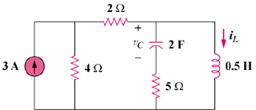
6 A

Question 3
Calculate the capacitor voltage for t < 0 and t > 0 for circuit below.

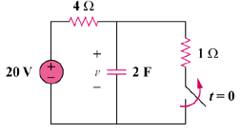
Question 4
Use the differential equation approach to find i(t) for t > 0. The circuit is in steady state prior to time t = 0, when the switch is closed.
2 KΩ
36 V
100 μF
12 V
t = 0
6 KΩ
4 KΩ
i(t)
R₁
R₂
R₃
Question 5
Find the voltage across each of the capacitors in the circuit shown below:

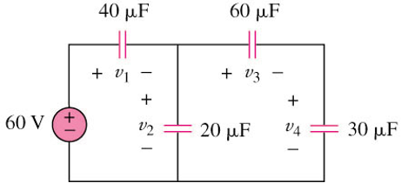

Question 6
The circuit below is used by a biomedical engineering student to study the "frog kick." She noticed that the frog kicked a little when the switch was closed but kicked violently for 5 second when the switch was opened. Model the frog as a resistor and calculate its resistance. Assume that it takes 10 mA for the frog to kick violently.
