ENGR 2303 Electrical Science
Review Material for Test 4 (7/28/26 from 9-10:50 am)

The test will cover sinusoidal steady-state analysis
- Phasor relationships for circuit elements
- Impedance and admittance
- Kirchhoff’s laws in the frequency domain
- Impedance combinations
- Nodal Analysis
- Mesh Analysis
- Superposition Theorem
- Source Transformation
- Thevenin and Norton Equivalent Circuits
- Op-Amp

Sample Questions

Q1) Refer to Figure below, determine v(t) and i(t).

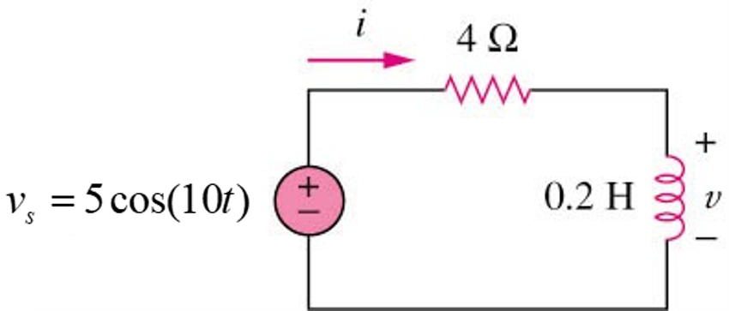

Q2) Determine the input impedance of the circuit in figure below at ω =10 rad/s.

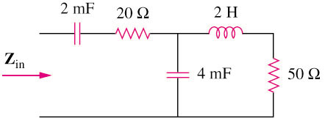

Q3) Using nodal analysis, find v₁ and v₂ in the circuit of figure below.

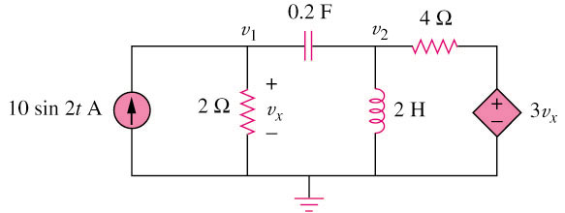

Q4) Find I_{o} in the following figure using mesh analysis.

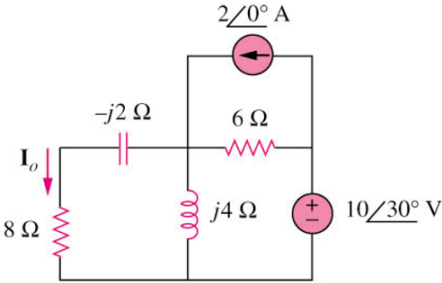

Q5) Calculate v_{o} in the circuit of figure shown below using the superposition theorem.

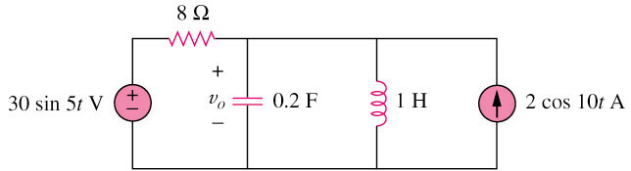

Q6) Find Io in the circuit of figure below using the concept of source transformation.

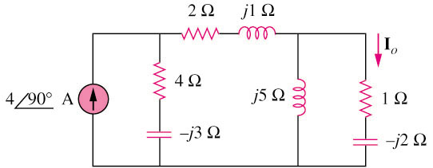

Q7) Find the Thevenin equivalent at terminals a–b of the circuit below.

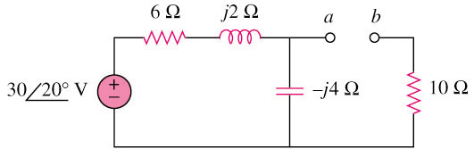

Q8) Evaluate the voltage gain A_{v} = V_{o}/\V_{s} in the op amp circuit. Find A_{v} at ω = 0, ω → ∞, ω = 1/R₁C₁, and ω = 1/R₂C₂.

