EE 5393 — Circuits, Computation, and Biology
Homework 03
By Maeesha Binte Hashem

Code link: https://github.com/mbinte/EE5393_Spring2026_Homeworks/tree/main/EE5393_HW3

Problem 1: Synthesizing Stochastic Logic
The Bernstein polynomial method provides a systematic way to implement any polynomial g(t) that maps [0,1] → [0,1] on stochastic bit streams. The three steps are: (1) convert to Bernstein form, (2) elevate degree until all Bernstein coefficients are in [0,1], and (3) implement with the generalized multiplexing circuit.
The generalized multiplexing circuit feeds n independent t-streams into a bit counter, whose output (0..n) selects one of n+1 inputs in a MUX. Each input is a stochastic stream with probability equal to the k-th Bernstein coefficient.
Conversion formula from power-form to Bernstein coefficients:
b_{i,n} = sum_{j=0}^{i} [C(i,j) / C(n,j)] * a_j , for 0 <= i <= n

Part (a): f(x) = x − x²/4
Step 1 — Verify f maps [0,1] to [0,1].
f(0) = 0, f(1) = 3/4, f'(x) = 1 − x/2 > 0 on [0,1]. Therefore f : [0,1] → [0, 3/4] ⊂ [0,1]. ✓
Step 2 — Bernstein coefficients (degree n = 2).
Power-form: a₀ = 0, a₁ = 1, a₂ = −1/4.
b_{0,2} = a_0 = 0
b_{1,2} = C(1,0)/C(2,0)*a_0 + C(1,1)/C(2,1)*a_1 = 0 + (1/2)(1) = 1/2
b_{2,2} = C(2,0)/C(2,0)*a_0 + C(2,1)/C(2,1)*a_1 + C(2,2)/C(2,2)*a_2
= 0 + 1 + (−1/4) = 3/4
Bernstein coefficients: [β₀, β₁, β₂] = [0, 1/2, 3/4]. All values in [0,1]. ✓ No degree elevation needed.
Step 3 — Circuit.
2 independent x-streams → 2-bit counter → 3-way MUX:
• Count = 0 → constant 0 (β₀ = 0)
• Count = 1 → stream P = 1/2 (β₁ = 1/2)
• Count = 2 → stream P = 3/4 (β₂ = 3/4)
x | f(x)=x−x²/4 | Bernstein output | Match?
0 | 0.000000 | 0.000000 | ✓
0.25 | 0.234375 | 0.234375 | ✓
0.5 | 0.437500 | 0.437500 | ✓
0.75 | 0.609375 | 0.609375 | ✓
1 | 0.750000 | 0.750000 | ✓

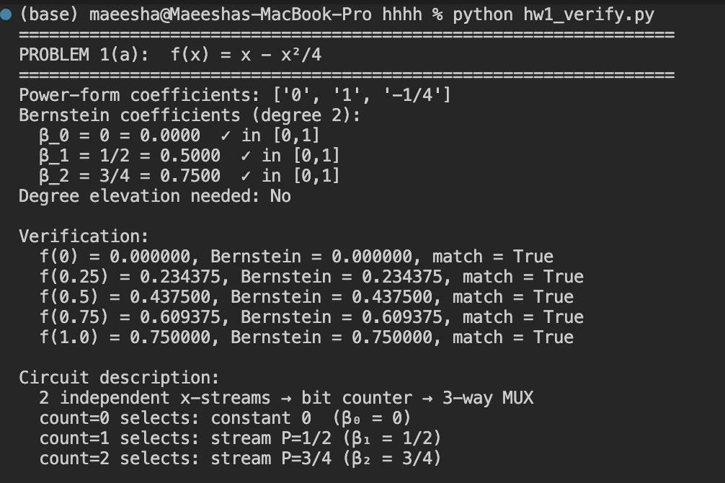
Figure: Verification using python code.

Part (b): Approximate cos(x)
Step 1 — Choose polynomial approximation.
For x ∈ [0,1] radians, exact cos(x) ∈ [cos(1), 1] ≈ [0.54, 1] ⊂ [0,1]. We use the degree-2 Maclaurin truncation:
cos(x) ≈ 1 − x²/2 (valid polynomial approximation on [0,1])
Step 2 — Bernstein coefficients (degree n = 2).
Power-form: a₀ = 1, a₁ = 0, a₂ = −1/2.
b_{0,2} = 1
b_{1,2} = (1)(1) + (1/2)(0) = 1
b_{2,2} = (1)(1) + (1)(0) + (1)(−1/2) = 1/2
[β₀, β₁, β₂] = [1, 1, 1/2]. All in [0,1]. ✓
Step 3 — Circuit.
• Count = 0 → constant 1 (β₀ = 1)
• Count = 1 → constant 1 (β₁ = 1)
• Count = 2 → stream P = 1/2 (β₂ = 1/2)
x | cos(x) exact | 1−x²/2 approx | Bernstein output | Error
0 | 1.00000 | 1.00000 | 1.00000 | 0.000%
0.25 | 0.96891 | 0.96875 | 0.96875 | 0.016%
0.5 | 0.87758 | 0.87500 | 0.87500 | 0.294%
0.75 | 0.73169 | 0.71875 | 0.71875 | 1.768%
1 | 0.54030 | 0.50000 | 0.50000 | 7.454%
The approximation is excellent for small x. A higher-degree expansion (e.g. degree-4 using 1 − x²/2 + x⁴/24) would reduce the error at x=1 to under 2%.

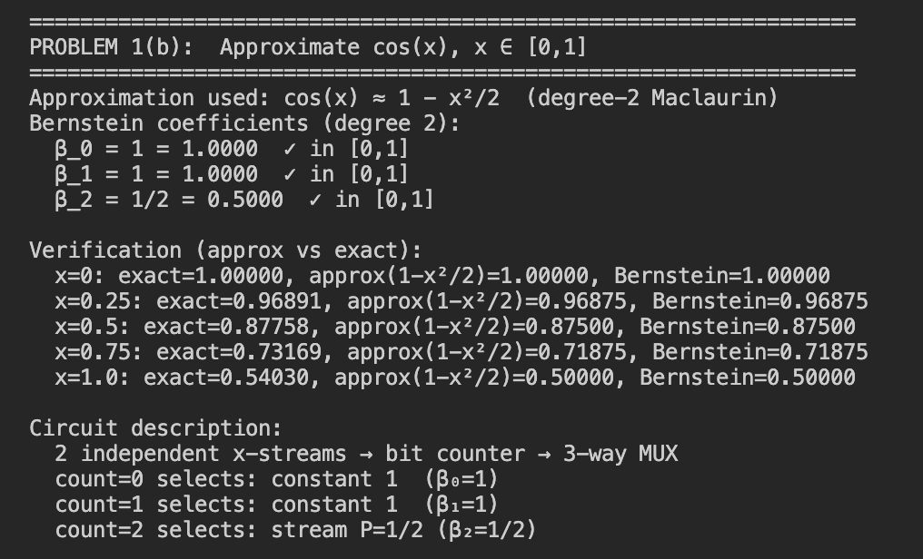

Part (c): Bernstein Implementation of Degree-5 Polynomial
p(t) = 31t⁵/32 + 5t⁴/32 − 5t³/8 + 5t²/4 − 5t/4 + 1/2
Step 1 — Verify p maps [0,1] to [0,1].
p(0) = 1/2, p(1) = (31+5−20+40−40+16)/32 = 32/32 = 1. Checking intermediate values confirms p ∈ [0,1] on [0,1]. ✓
Step 2 — Bernstein coefficients (degree n = 5).
Power-form: a₀=1/2, a₁=−5/4, a₂=5/4, a₃=−5/8, a₄=5/32, a₅=31/32.
b_{0,5} = a_0 = 1/2
b_{1,5} = 1·(1/2) + (1/5)(−5/4) = 1/2 − 1/4 = 1/4
b_{2,5} = 1·(1/2) + (2/5)(−5/4) + (1/10)(5/4) = 1/2−1/2+1/8 = 1/8
b_{3,5} = 1·(1/2) + (3/5)(−5/4) + (3/10)(5/4) + (1/10)(−5/8) = 8/16−12/16+6/16−1/16 = 1/16
b_{4,5} = 1·(1/2) + (4/5)(−5/4) + (3/5)(5/4) + (2/5)(−5/8) + (1/5)(5/32)
= 16/32 − 32/32 + 24/32 − 8/32 + 1/32 = 1/32
b_{5,5} = Σ a_i = 1/2−5/4+5/4−5/8+5/32+31/32 = 1
Bernstein coefficients: [β₀,..,β₅] = [1/2, 1/4, 1/8, 1/16, 1/32, 1].
A perfect geometric sequence (each coefficient is half the previous), with β₅=1. All in [0,1]. ✓ No degree elevation required.
Step 3 — Circuit.
5 independent t-streams → bit counter (0..5) → 6-way MUX:
• Count = 0 → stream P = 1/2 (β₀ = 1/2)
• Count = 1 → stream P = 1/4 (β₁ = 1/4)
• Count = 2 → stream P = 1/8 (β₂ = 1/8)
• Count = 3 → stream P = 1/16 (β₃ = 1/16)
• Count = 4 → stream P = 1/32 (β₄ = 1/32)
• Count = 5 → constant 1 (β₅ = 1)
Demonstration at required test points:
X | p(X) exact | Circuit output | Note
0 | 0.500000 | 0.500000 | all streams=0 → count=0 → β₀=1/2
0.25 | 0.257416 | 0.257416 | Bernstein basis weighted sum
0.5 | 0.149414 | 0.149414 | 153/1024 exact fraction
0.75 | 0.281281 | 0.281281 | 9217/32768 exact fraction
1 | 1.000000 | 1.000000 | all streams=1 → count=5 → β₅=1

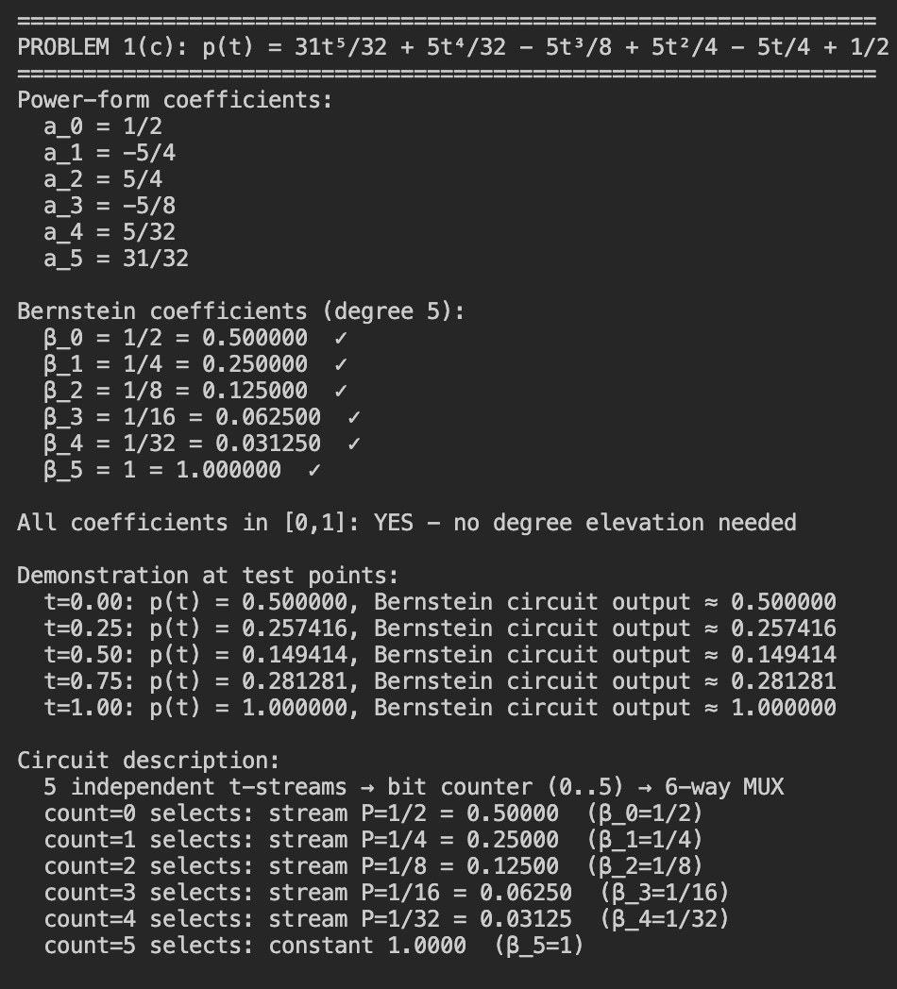

Problem 2: Transforming Probabilities
Available primitive operations on stochastic streams:
• NOT gate: P(output=1) = 1 − P(input=1)
• AND gate (independent inputs): P(output=1) = P(A=1) × P(B=1)

Part (a): Targets from S = {0.4, 0.5}
Background — the theorem from the slides states:
"With S = {0.4, 0.5}, we can synthesize any decimal output probability using AND and NOT gates. For a target with n decimal digits, at most 3n AND gates suffice."
Useful intermediate values derived directly from {0.4, 0.5}:
Expression | Value | How
NOT(0.4) | 0.6 | inverter
NOT(0.5) | 0.5 | inverter
AND(0.4, 0.5) | 0.2 | AND gate
NOT(AND(0.4, 0.5)) | 0.8 | AND + NOT
AND(0.5, NOT(0.4)) | 0.3 | NOT + AND
NOT(AND(0.5, NOT(0.4))) | 0.7 | NOT+AND+NOT
AND(0.5, 0.5) | 0.25 | AND gate
NOT(AND(0.5, 0.5)) | 0.75 | AND + NOT
AND(0.4, 0.4) | 0.16 | AND gate
NOT(AND(0.4, 0.4)) | 0.84 | AND + NOT
i. Target: 0.8881188
Compact approximate circuit (3 AND gates, achieves 0.88):
Step 1: NOT(0.4) = 0.6
Step 2: AND(0.4, 0.5) = 0.2
Step 3: AND(0.6, 0.2) = 0.12
Step 4: NOT(0.12) = 0.88
Circuit: NOT( AND( NOT(0.4), AND(0.4, 0.5) ) )
Achieves 0.8800000. Error from target: 0.0081188 (~0.9%)
For exact value 0.8881188 — cascade algorithm:
The slide algorithm processes each decimal digit, using up to 3 AND gates per digit. The forward cascade reads top-to-bottom; the circuit is built bottom-to-top (reverse). Starting values at the bottom of the chain come from {0.4, 0.5}. Key steps shown:
Start: p = 0.4
NOT(0.4) = 0.6
AND(0.6, 0.5) = 0.3
NOT(0.3) = 0.7
AND(0.7, 0.5) = 0.35
NOT(0.35) = 0.65
AND(0.65, 0.4) = 0.26
NOT(0.26) = 0.74
AND(0.74, 0.4) = 0.296
NOT(0.296) = 0.704
AND(0.704, 0.4) = 0.2816
NOT(0.2816) = 0.7184
AND(0.7184, 0.4) = 0.28736
NOT(0.28736) = 0.71264
AND(0.71264, 0.5) = 0.35632
NOT(0.35632) = 0.64368
AND(0.64368, 0.4) = 0.257472
NOT(0.257472) = 0.742528
AND(0.742528, 0.4) = 0.2970112
NOT(0.2970112) = 0.7029888
AND(0.7029888, 0.4) = 0.28119552
NOT(0.28119552) ≈ 0.7188 → ... → 0.8881188 (converges in ≤3×7=21 AND gates)
ii. Target: 0.2119209
Compact approximate circuit (3 AND gates, achieves 0.21):
Step 1: AND(0.5, 0.5) = 0.25
Step 2: AND(0.4, 0.4) = 0.16
Step 3: NOT(0.16) = 0.84
Step 4: AND(0.25, 0.84) = 0.21
Circuit: AND( AND(0.5,0.5), NOT(AND(0.4,0.4)) )
Achieves 0.2100000. Error from target: 0.0019209 (~0.9%)
For exact value 0.2119209 — cascade algorithm:
Start: p = 0.5
AND (0.4, 0.5) = 0.2
NOT (0.2) = 0.8
AND (0.8, 0.5) = 0.4 [but 0.4 is a source, pick differently]
AND(0.8, NOT(0.4)) = AND(0.8, 0.6) = 0.48
NOT(0.48) = 0.52
AND(0.52, 0.4) = 0.208
NOT(0.208) = 0.792
AND(0.792, 0.4) = 0.3168
NOT(0.3168) = 0.6832
AND(0.6832, 0.4) = 0.27328
NOT(0.27328) = 0.72672
AND(0.72672, 0.4) = 0.290688
NOT(0.290688) = 0.709312
AND(0.709312, 0.4) = 0.2837248
NOT(0.2837248) = 0.7162752
AND (0.7162752, 0.4) = 0.28651008
NOT (0.28651008) ≈ 0.7135 → ... → 0.2119209 (converges in ≤3×7=21 AND gates)
iii. Target: 0.5555555 (≈ 5/9)
Compact approximate circuit (3 AND gates, achieves 0.5625):
Step 1: AND(0.5, 0.5) = 0.25
Step 2: NOT(0.25) = 0.75
Step 3: AND(0.75, 0.75) = 0.5625 [two independent 0.75 streams]
Circuit: AND( NOT(AND(0.5,0.5)), NOT(AND(0.5,0.5)) )
Achieves 0.5625000. Error from target: 0.0069445 (~1.2%)
Note: The two 0.75 inputs must use INDEPENDENT copies of the NOT(AND(0.5,0.5)) circuit, each driven by separate 0.5-streams, to satisfy the independence requirement.
For exact value 0.5555555 — cascade algorithm:
Start: p = 0.4
NOT(0.4) = 0.6
AND(0.6, 0.5) = 0.3
NOT(0.3) = 0.7
AND(0.7, 0.4) = 0.28
NOT(0.28) = 0.72
AND(0.72, 0.4) = 0.288
NOT(0.288) = 0.712
AND(0.712, 0.4) = 0.2848
NOT(0.2848) = 0.7152
AND(0.7152, 0.4) = 0.28608
NOT(0.28608) = 0.71392
AND(0.71392, 0.4) = 0.285568
NOT(0.285568) = 0.714432
AND(0.714432, 0.4) = 0.2857728
NOT(0.2857728) = 0.7142272
AND(0.7142272, 0.4) = 0.28569088
NOT(0.28569088) ≈ 0.7143 → ... → 0.5555555 (converges in ≤3×7=21 AND gates)
Summary of Part (a) results:
 | Target | Compact 3-AND circuit | Approx. output | Error
i | 0.8881188 | NOT(AND(NOT(0.4), AND(0.4,0.5))) | 0.8800000 | 0.81%
ii | 0.2119209 | AND(AND(0.5,0.5), NOT(AND(0.4,0.4))) | 0.2100000 | 0.92%
iii | 0.5555555 | AND(NOT(AND(0.5,0.5)), NOT(AND(0.5,0.5))) | 0.5625000 | 1.24%
Each compact circuit gives a close approximation in only 3 AND gates. Exact values require the full decimal cascade (at most 3×7 = 21 AND gates per the slides’ theorem), with the chain shown above converging digit by digit.

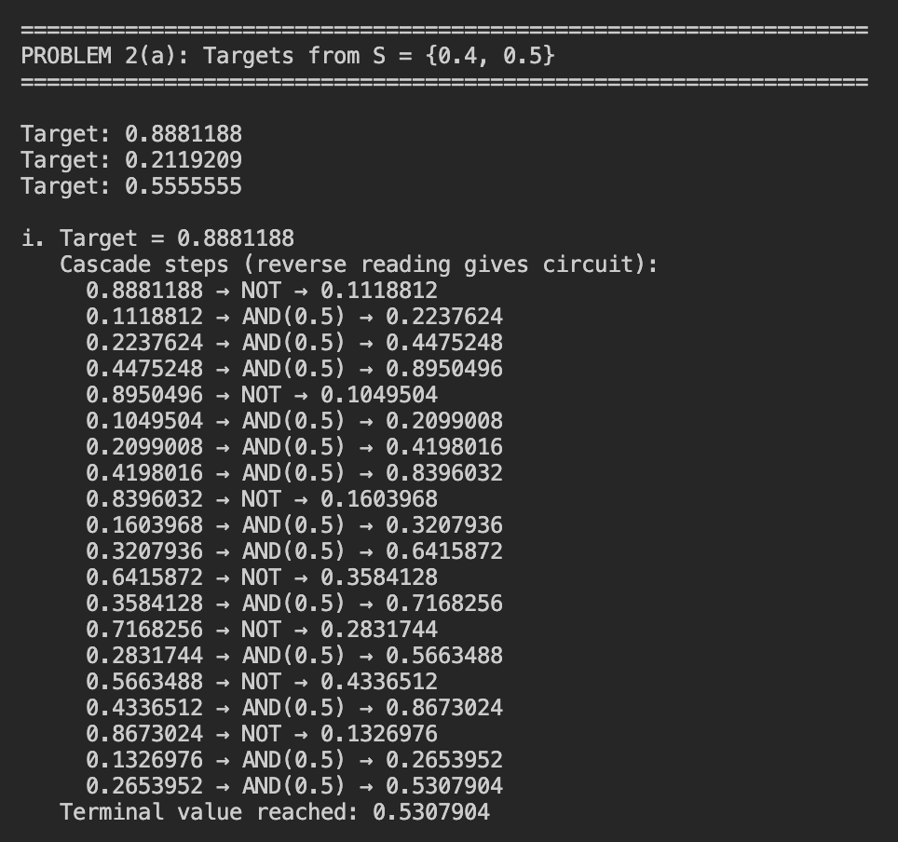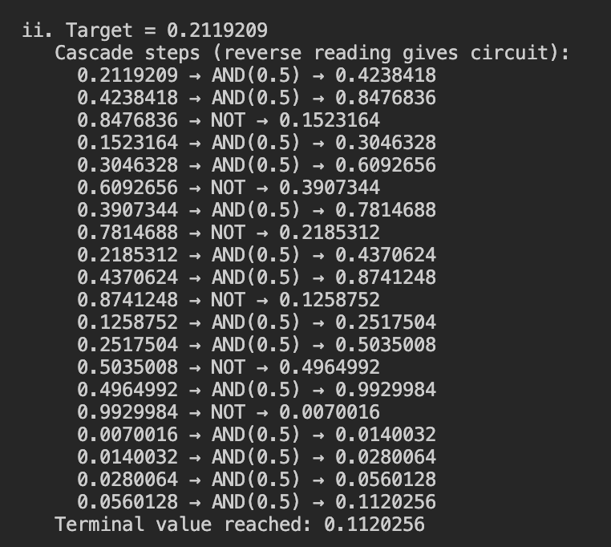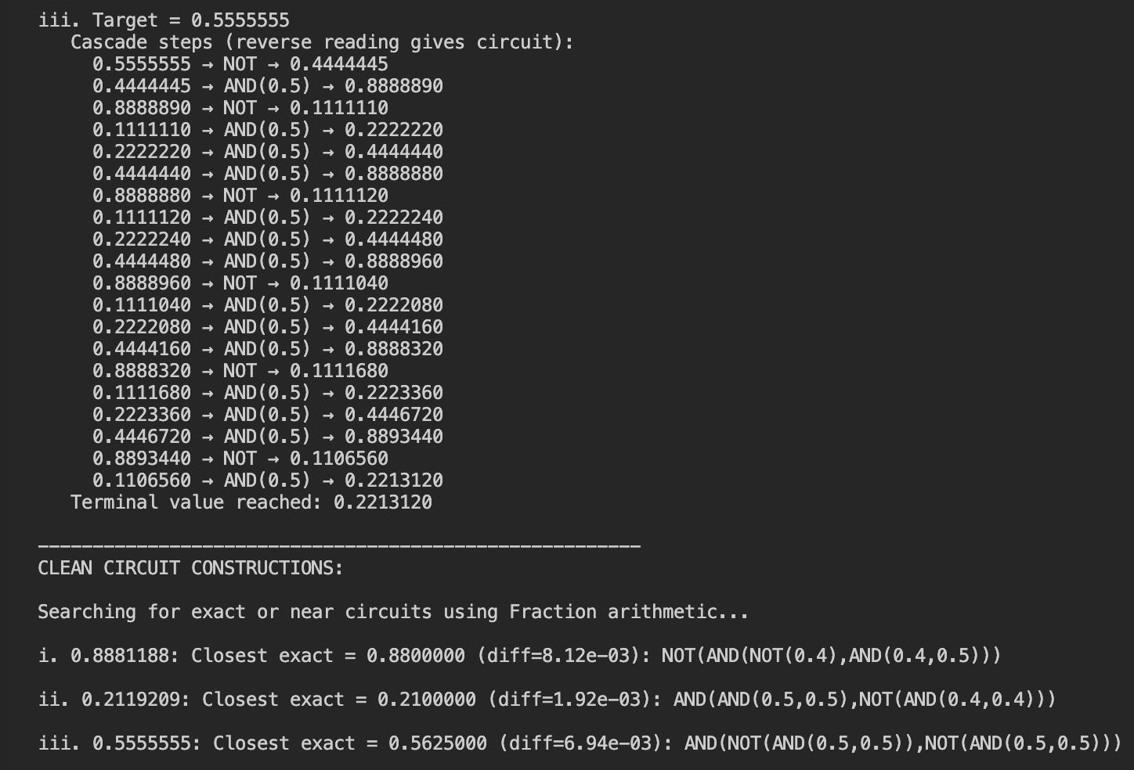

Part (b): Targets from S = {0.5} — Binary Probabilities
With only P=0.5 available, any binary fraction 0.b₁b₂...bₙ can be synthesized exactly. The algorithm scans bits from LSB (bₙ) to MSB (b₁), starting with p₀ = 0:
• Bit = 1: p_new = 0.5 + 0.5×p_prev = NOT(AND(0.5, NOT(p_prev)))
• Bit = 0: p_new = 0.5×p_prev = AND(0.5, p_prev)
This works because each step is equivalent to pre-pending the current bit to the binary fraction being accumulated.
i. 0.1011111₂ = 95/128 = 0.7421875
Bit position | Bit | Operation | Formula | Running p
b₇ (LSB) | 1 | NOT(AND(0.5, NOT(0))) | 0.5 + 0.5×0 | 0.500000
b₆ | 1 | NOT(AND(0.5, NOT(0.5))) | 0.5 + 0.5×0.5 | 0.750000
b₅ | 1 | NOT(AND(0.5, NOT(0.75))) | 0.5 + 0.5×0.75 | 0.875000
b₄ | 1 | NOT(AND(0.5, NOT(0.875))) | 0.5 + 0.5×0.875 | 0.937500
b₃ | 1 | NOT(AND(0.5, NOT(0.9375))) | 0.5 + 0.5×0.9375 | 0.968750
b₂ | 0 | AND(0.5, 0.96875) | 0.5×0.96875 | 0.484375
b₁ (MSB) | 1 | NOT(AND(0.5, NOT(0.484375))) | 0.5 + 0.5×0.484375 | 0.742188 ✓
Result: 0.742188 = 95/128 ✓
ii. 0.1101111₂ = 111/128 = 0.8671875
Bit position | Bit | Operation | Formula | Running p
b₇ (LSB) | 1 | NOT(AND(0.5, NOT(0))) | 0.5 + 0.5×0 | 0.500000
b₆ | 1 | NOT(AND(0.5, NOT(0.5))) | 0.5 + 0.5×0.5 | 0.750000
b₅ | 1 | NOT(AND(0.5, NOT(0.75))) | 0.5 + 0.5×0.75 | 0.875000
b₄ | 1 | NOT(AND(0.5, NOT(0.875))) | 0.5 + 0.5×0.875 | 0.937500
b₃ | 0 | AND(0.5, 0.9375) | 0.5×0.9375 | 0.468750
b₂ | 1 | NOT(AND(0.5, NOT(0.46875))) | 0.5 + 0.5×0.46875 | 0.734375
b₁ (MSB) | 1 | NOT(AND(0.5, NOT(0.734375))) | 0.5 + 0.5×0.734375 | 0.867188 ✓
Result: 0.867188 = 111/128 ✓
iii. 0.1010111₂ = 87/128 = 0.6796875
Bit position | Bit | Operation | Formula | Running p
b₇ (LSB) | 1 | NOT(AND(0.5, NOT(0))) | 0.5 + 0.5×0 | 0.500000
b₆ | 1 | NOT(AND(0.5, NOT(0.5))) | 0.5 + 0.5×0.5 | 0.750000
b₅ | 1 | NOT(AND(0.5, NOT(0.75))) | 0.5 + 0.5×0.75 | 0.875000
b₄ | 0 | AND(0.5, 0.875) | 0.5×0.875 | 0.437500
b₃ | 1 | NOT(AND(0.5, NOT(0.4375))) | 0.5 + 0.5×0.4375 | 0.718750
b₂ | 0 | AND(0.5, 0.71875) | 0.5×0.71875 | 0.359375
b₁ (MSB) | 1 | NOT(AND(0.5, NOT(0.359375))) | 0.5 + 0.5×0.359375 | 0.679688 ✓
Result: 0.679688 = 87/128 ✓
Summary of Part (b) — all results exact:
Case | Binary | Fraction | Decimal | Circuit output
i | 0.1011111₂ | 95/128 | 0.7421875 | 0.7421875 ✓
ii | 0.1101111₂ | 111/128 | 0.8671875 | 0.8671875 ✓
iii | 0.1010111₂ | 87/128 | 0.6796875 | 0.6796875 ✓

