Kyle McChesney
CS576 | Dewey
Fall 2015

Homework #1 Written

2. The sequence we assemble aligns to the Ebola gene: Mononegavirales RNA dependent RNA polymerase

3. For the following strings, (i) give the k = 3 spectrum for the string, (ii) draw the SBH
graph for the spectrum, (iii) give one Eulerian path and its corresponding string for
the SBH graph, and (iv) show whether or not there exists an Eulerian path in the
graph that corresponds to the original string.

(a) TACCGGACTTAGG
i. {ACC, ACT, AGG, CCG, CGG, CTT, GAC, GGA, TAC, TAG, TTA}
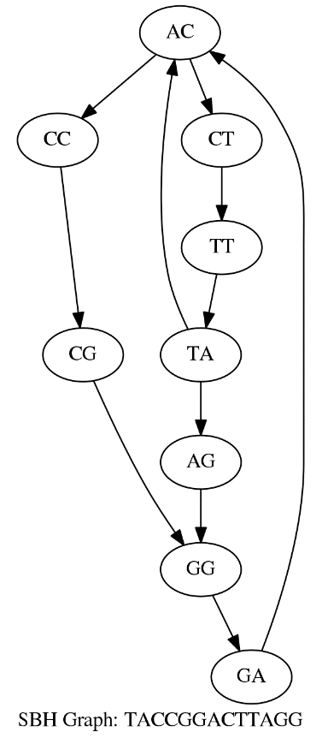
iii. The following is a Eulerian path:
TA → AC → CT → TT → TA → AG → GG → GA → AC → CC → CG → GG
TACTTAGGACCGG

iv. There exists such a path:

TA → AC → CC → CG → GG → GA → AC → CT → TT → TA → AG --> GG
TACCGGACTTAGG

(b) TATCGGATCGTTA
i. {ATC, CGG, CGT, GAT, GGA, GTT, TAT, TCG, TTA}
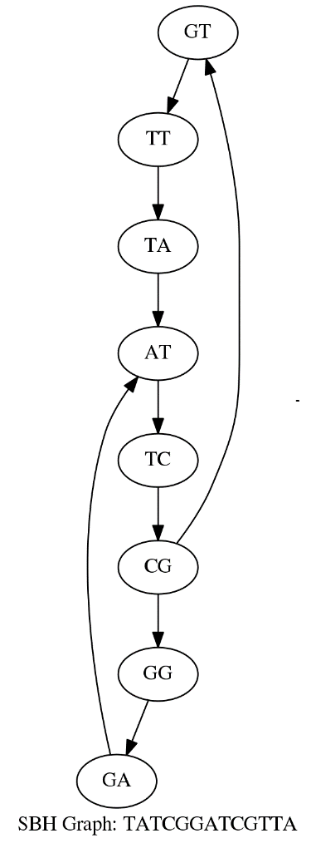
iii. One E. path is:
CG → GT → TT → TA → AT → TC → CG → GG → GA → AT
CGTTATCGGAT
iv.
Such a path would have to start at TT or TA since the string starts with TA
For there the path must look like:
(TT) → TA → AT → TC → CG → GG → GA → AT
When we arrive back at AT we cannot move to TC (an on to GT → TT → TA) since AT → TC has already been traversed. We also see that starting at TT is the wrong idea, not that it matters. Since AT has 2 in edges and only one out edge, it must be the end of the path since we have to go there twice but can only leave once. This also shows that we can’t have the path since the string must end in TA not AT.

4. If there are no repetitive elements, you are guaranteed to have an Eulerian path in the graph for the linear genome. For the circular genome, every node is guaranteed to be the start of an Eulerian cycle, since the graph will always double back on itself.

