**Effects of different seawater concentrations on the stress level of two intertidal marine species, *Lottia* *digitalis* and *Lottia* *scabra* measured through the rate oxygen of consumption.**

Thagulisi Funanani**1**, Bonga Govuza**1**, Dhiren Vanmari**1**, Sasya Lagaa**1**

**1**Department of Biodiversity and conservation biology, University of the Western Cape, Robert Sobukwe Rd, Bellville, Cape Town, 7535.

**Abstract**

Limpets of the genus *Lottia* are known to occupy a broad vertical distribution on wave-exposed rocky shores in which most of it encompasses a severity of both desiccation and thermal stress brought on by aerial emersion. With the use of different seawater concentrations, we examined the level of stress measured through the rate of oxygen consumption between *L.* *digitalis* and *L. scabra*. Experimental individuals were cleaned and placed in shallow trays filtered with aerated seawater of salinity 29.7 and pH of 7.5. Levene’s test for equal variances between oxygen consumption and the concentration of seawaters was not significant (P = 0.827). There is a significant difference in the level of stress depending on the concentration of seawater (P = 0.009), with limpets being more stressed at 50% than the 100 %. However, the two species do not differ significantly in their oxygen consumption (P =0.199). Welch two sample t-test for the difference in the consumption of oxygen between the two species was not significant (P = 0.2528). The difference in the concentration of seawaters has an effect on the level of stress between the two limpet species, with *L*. *Scabra* being more stressed than the *L*. *digitalis*. Our results suggest that both *L*. *scabra* and *L*. *digitalis* are more stressed when there are exposed to low amounts of seawater concentrations.

**Key words:** Intertidal zone, *L. scabra*, *L.* *digitalis*, Oxygen consumption, Seawater concentration, Intertidal limpets

**Introduction**

Factors of thermal and desiccation stress experienced in intertidal habitats can affect the ability of intertidal organisms to reproduce and survive (Denny, 2006). The differences in tolerance to these stresses (mainly associated with the terrestrial environment) among intertidal organisms, affect the distribution of animals and algae across rocky shores (see Wolcott, 1973; Newell, 1979; Denny, 2006). The effects of these factors differ amongst these organisms due to the difference in preferential microhabitats along rocky shores, and often results in what is known as vertical zonation. In addition, the differences in terrestrial conditions within rocky shores, underlies the variation in zonation patterns at a variety of temporal or spatial scales (Lawson 1957; Harley, 2003;Miller et al., 2015)**.** Studies into interactions amongst the physiology, physical environment, and intertidal ecology have often focused on the influences of thermal stress of these organisms (Somero, 2002; Helmuth et al., 2005).

A study conducted by Shumway & Marsden (1982) on *Amphibola* *Crenata*, indicated that organisms occupying high intertidal zones are most likely to experience greater environmental stress than those living at the low intertidal zones. However, Wolcott et al., (2018) indicated that it is very often that the distribution of these intertidal species from one habitat to another is correlated with the species ability to maintain its metabolic requirements. Thus, the movement of these species from the marine environment to the terrestrial environment correlates with equal spatial partitioning of the habitat.

The range limit of most intertidal communities is dependent on physical factors of the terrestrial environment (Wolcott et al., 2018)**.** Despite such fact, it is still difficult to predict how changes in the physical environment could affect the respiration rate of other intertidal species when they ascend and descend from the lower intertidal to the upper intertidal zone (Miller et al., 2015).

There are many environmental factors that are responsible for the change in the respiration rate of these animals including salinity, temperature, and ambient oxygen consumption being the most common (Shumway & Marsden, 1982). However, the effects of each factor on oxygen consumption has been well documented (see Newell & Branch 1980, for a review in salinity and temperature effects on oxygen consumption and McMahon 1973, Machanon & Hunter 1978, and Mangum & Van Winckle 1980, for discussion in the decline of ambient oxygen tension). Generally, organisms that live at high intertidal zones are most likely to experience simultaneous fluctuations of the above mentioned factors (Shumway & Marsden, 1982). However, these factors vary, particularly for organisms living in high intertidal and low intertidal habitats (Shumway & Marsden, 1982). Few studies have dealt with the combined effects of salinity, temperature and oxygen tension on oxygen consumption. Notably, studies by Newel (1977) and Hawkins & Ultsch (1979) only illustrating the effects of temperature and declining oxygen tension in intertidal gastropods and Bayne (1971) and Shumway (1981), who discussed the effects of both salinity and oxygen tension on oxygen consumption by intertidal gastropods.

Limpets of the genus *lottia* are known to occupy a broad vertical distribution on wave-exposed rocky shores in which most of it encompasses a severity of both desiccation and thermal stress brought on by aerial emersion (Morris et al., 1980; Shanks, Walser, & Shanks, 2014). Up to date, there are no studies, which have been conducted to measure the stress (through the rate of oxygen consumption) of these intertidal marine species with the use of different seawater concentrations.

The prime investigation of this study is to test whether the stress of the two intertidal marine species (*L.* *digitalis* and *L. scabra*) measured through the rate of oxygen consumption differs depending on both the difference in seawater concentration or within the limpet species themselves. Within this study, we hypothesize that differences in seawater concentration does not have an effect on the oxygen consumption/level of stress between the two intertidal limpet species. Therefore, we assume that the level of oxygen intake between *L. digitalis* and *L. scabra* does not vary upon the use of different seawater concentrations. The faster these organisms use oxygen, the more stressed they become. This investigation may also aid in understanding how climate change, air quality and coastal water quality may influence the distribution intertidal communities in the near future.

**Aims**

1. To measure the stress of two intertidal marine limpets’ species (*L.* *scabra* and *L.* *digitalis*) exposed to two different seawater concentrations.
2. To test whether the stress of these species differs depending on both the difference in the concentration of seawaters and the species of limpet.

**Material and Methods**

**Collection, study sites and maintenance**

Collection and sampling of the two limpet species, *L.* *digitalis*, and *L.* *scabra* was conducted at the Cape whale museum approximately 127 km away from Cape Town as shown in figure 1. Thirty-two specimens between the two limpet species were collected, with 16 individuals from each species. However, these species were sampled at different intertidal zones; with *L*. *digitalis* collected at a low intertidal zone, and *L*. *scabra* collected at a high-intertidal zone. Therefore, species were separated individually before being stored in the laboratory. Individual separation of these species was done in order to isolate any species that could have been possibly resting on their shells (Newell, Johnson, & Kofoed, 1978).

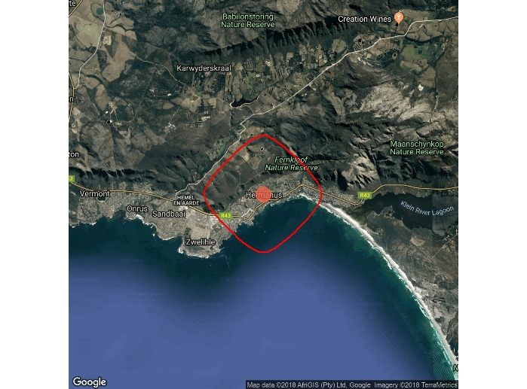

Figure 1. Study site of *L*. *digitalis* and *L*. *scabra*.

Experimental individuals were therefore, cleaned and placed in shallow trays of aerated filtered seawater of salinity 29.7ppt and pH of 7.5. These groups of species were then, placed in a 12hr dark-light regime at a constant temperature of 25 °C on the following day. It was made certain that at least 8 individuals from each species was placed in one of the seawater concentration. All individuals’ species were kept for approximately 7 days under an acclimation regime before measurements of oxygen consumption were made.

The rate of oxygen consumption amongst individual limpets at different seawater concentrations (100% and 50%) was measured continuously in a series of five respiration chambers with one control vessel by means of 6 radiometer pO2 electrodes and a measuring system (model TOX40) connected to a Philips PM 9833 multichannel recorder (Newell, Johnson, & Kofoed, 1978). Individual species were placed in a sealed vessel of 320ml and were therefore fed on a daily basis; see Newell & Kofoed (1977b) for the feeding scheme of marine intertidal animals. However, most individuals within this experiment withdrew into their shells and did not emerge for approximately 2 hours; therefore, before taking account the readings of these individual species they were left for 3 h in the experimental media.

At times where the pO2 in the vessels reached zero, individual species were taken-out from vessels and therefore, returned to their respective seawater concentration at an acclimated temperature. Oxygen consumption of the limpets was recorded in µLO2/mg dry weight body weight/minute.

**Statistical analysis**

Levene’s test for equality of error variances and a two-factor anova were conducted in order to test the difference in oxygen consumption between the two groups of limpet species using the concentration of seawaters as a factor. However, in order to determine the difference in the mean oxygen consumption between the *L*. *digitalis* and *L*. *scabra*, a t-test statistical analysis was conducted.

**Results and discussion**

The levene’s test for equal variances between the variables was not significant, F = 0.2977, P = 0.8270 (see table 1). However, there is a significant difference in oxygen consumption (stress) depending on the oxygen concentration of seawater; F = 8.011 and P=0.00851 (see table 2) with limpets being more stressed at the 50% (mean =12.2) than 100 % (mean=9.0) seawater concentrations (see figure 2 & 3).

Although Figure 4 indicates that *L*. *scabra* (mean = 11.375) has a higher oxygen consumption than *L*. *digitalis* (mean = 9.869), the two species do not differ significantly in their oxygen consumption; F = 1.727, P= 0.19940 (see table 2). Thus, there is no significant interaction between the two variables, F =2.057, P=0.16256 (see table 2). However, *L*. *scabra* was the most stressed species between the two, consuming 18.8 µlO2 and 16.1 µlO2 of oxygen at 50% and 100% seawater concentration respectively, whereas L. digitalis consumed 17.7 µlO2 and 11. 6µlO2 (see figure 5). The welch t-test also confirms that there is a significant difference in the mean oxygen consumption between the two species of limpets, F = 29.013, p = 0.2528 (see table 3).

Table 1: Difference in oxygen consumption between *L*. *scabra* and *L*. *digitals* using seawater concentration as a factor.

|  |  |  |  |
| --- | --- | --- | --- |
| F | df1 | df2 | Sig. |
| 0,298 | 3 | 28 | 0,827 |

*Leven’s Test of Equality of Error Variances\**

Table 2: The effects of seawater concentration on both the limpets’ species on oxygen consumption by two limpet species.

|  |  |  |  |  |  |  |
| --- | --- | --- | --- | --- | --- | --- |
| Source | Type sum of Squares | df. | Mean Square | F | Sig. | Pr. (>F) |
| Species | 18,15 | 1 | 18,15 | 1,727 | 0,199 | 0,1994 |
| Seawater Concentration | 84,175 | 1 | 84,175 | 8,011 | 0,009 | 0,00851 |
| Species* | 21,615 | 1 | 21,615 | 2,057 | 0,163 | 0,16256 |
| Error | 294,194 | 28 |  |  |  |  |

Two -factor Anova

Table 3. difference in the mean oxygen consumption between *L*. *digitalis* and *L.* *scabra.*

|  |  |  |  |  |
| --- | --- | --- | --- | --- |
|  | Welch Two sample t-test | | | |
|  | | f | Sig. | t |
| Total mean oxygen consumption between *L*. *digitalis* and *L.* *scabra* | | 29.013 | 0.2528 | -1.1668 |
| Welch two sample t-test | |

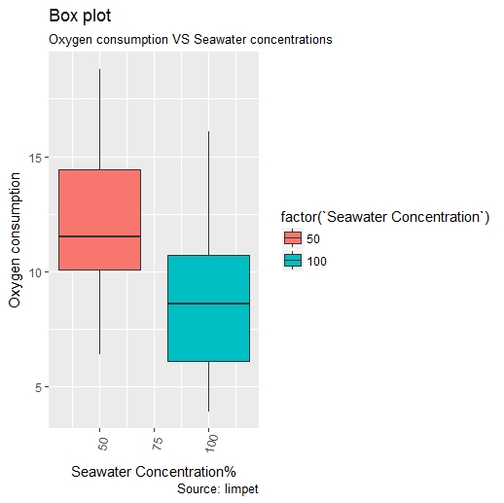

Figure 2. Boxplot denoting the difference in mean oxygen consumption around/between the two seawater concentrations.

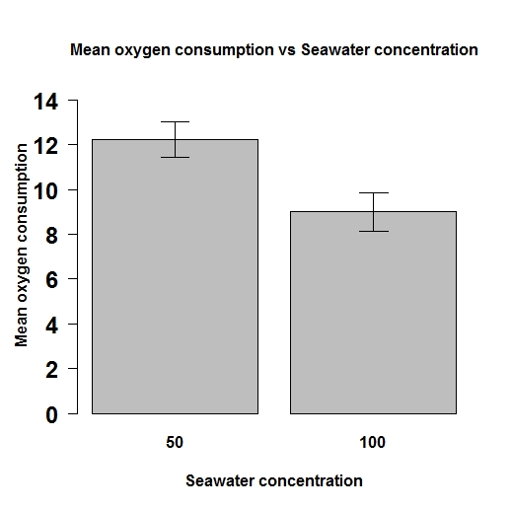

Figure 3. Bar plot denoting the difference in mean (and standard deviation) oxygen consumption of species exposed to 50% seawater concentration and 100% concentrations.

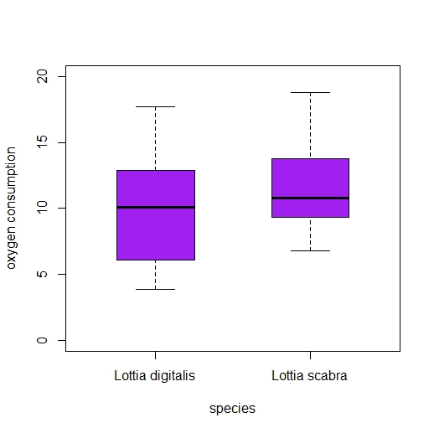

Figure 4. Boxplot denoting the mean oxygen consumption between *L*. *scabra* and *L*. *digitalis.*

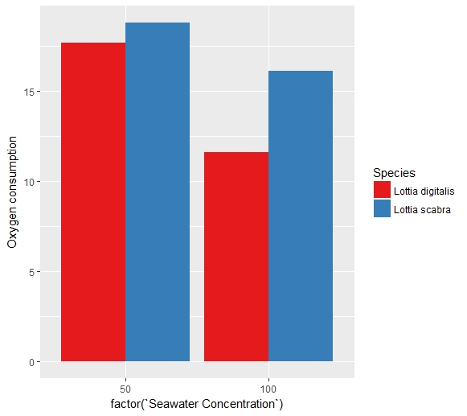

Figure 5. Bar plot denoting the difference in oxygen consumption between *L*. *scabra* and *L*. *digitalis* at different seawater concentrations.

The results above indicate that the two intertidal species, *L*. *scabra* and *L*. *digitalis* are more stressed/ consume more oxygen when they are exposed to low seawater concentrations. Thus, the lower the seawater concentration these species get exposed to, the more stressed they become, therefore consuming more oxygen (see figure 3). The difference in oxygen consumption between *L*. *digitalis* and *L*. *scabra,* even though both species are found in high mid-intertidal zones could have been due to their differences in habitat preference. Thus, the difference in the stress level between these species exposed to different seawater concentrations can be explained by the species microhabitat preferences.

Haven, (1971) described that *L*. *digitalis* prefer areas that are wave-exposed and often occupy sites of vertical rock walls, whereas *L*. *scabra* occupies rock pools with low wave exposure, and low amounts oxygen concentration. Thus, *L*. *scabra* prefer sites that contain low seawater concentration than *L*. *digitalis*. However, another factor that could have led to the slight difference in the level of stress (oxygen consumption) between these two intertidal species is their response towards the variation in tides, *L*. *digitalis* tends to settle in a different location during high tide events, whereas *L*. *scabra* remains in one spot during such events. Thus, the differences in the stress levels between these species can be also explained by their response towards changes in the tides.

In the future, anthropogenic effects such as climate change may alter the oxygen content of seawaters as seawater temperatures rise, causing species to move into different microhabitats, as a result of lower oxygen concentrations therefore affecting their distribution. Anthropogenic wastes may also cause a depletion in oxygen concentration of coastal waters as a result of excessive algae growth.

This study provides the first data which supports that seawater concentration has an effect in the oxygen consumption of intertidal marine species and gives insight into the rate of oxygen consumption (stress level) between *L*. *scabra* and *L*. *digitalis* at different oxygen concentrations of seawater. This finding permits new insights into the effects of different seawater concentrations of oxygen in the stress levels experienced by intertidal limpets.

**References**

**Bayne, B. L.** (1971) ‘Oxygen consumption by three species of lamellibranch mollusc in declining ambient oxygen tension’, *Comparative Biochemistry and Physiology -- Part A: Physiology*, 40(4), pp. 955–970. doi: 10.1016/0300-9629(71)90284-2.

**Denny, M. W.** (2006) ‘Thermal stress on intertidal limpets: long-term hindcasts and lethal limits’, *Journal of Experimental Biology*, 209(13), pp. 2420–2431. doi: 10.1242/jeb.02258.

**Dong, Y.** *et al.* (2018) ‘Interspecific Variation in Constitutive and Inducible Synthesis Correlates with in situ Exposure to Heat Stress Linked references are available on JSTOR for this article : Heat-Shock Protein 70 ( Hsp70 ) Expression in Four Limpets of the Genus Lottia : In’, 215(2), pp. 173–181.

**Harley, C. D. G. and Helmuth, B. S. T.** (2003). Local- and regionalscale effects of wave exposure, thermal stress, and absolute vs. effective shore level on patterns of intertidal zonation. *Limnol. Oceanogr.* 48, 1498-1508.

**Harley, C. D. G. and Lopez, J. P.** (2003). The natural history, thermal physiology, and ecological impacts of the intertidal mesopredators, ***Oedoparena* spp. (Diptera: Dryomyzidae). *Invertebr. Biol.* 122, 61-73.**

**Haven, S. B.** 1971. Niche differences in the intertidal limpets *Acmaea scabra* and *Acmaea digitalis* (Gastropoda) in Central California. Veliger 13: 231-248.

**Hawkins, M. J. and Ultsch, G. R.** (1979) ‘Oxygen consumption in two species of freshwater snails (Goniobasis): Effects of temperature and ambient oxygen tension’, *Comparative Biochemistry and Physiology -- Part A: Physiology*, 63(3), pp. 369–372. doi: 10.1016/0300-9629(79)90604-2.

**Helmuth, B., Kingsolver, J. G. and Carrington, E.** (2005). Biophysics, physiological ecology, and climate change: does mechanism matter? *Annu.Rev. Physiol.* 67, 177-201.

**Kinne. O.,** 1971. *Marine ecoiogy, Vol. I.*Wiley-Interscience, New York, 1774 pp.

**Lawson, G. W.** (1957). Seasonal variation of intertidal zonation on the coast

of Ghana in relation to tidal factors. *J. Ecol.* 45, 831-860.

**Miller, L. P.** *et al.*(2015) ‘Warm microhabitats drive both increased respiration and growth rates of intertidal consumers’, *Marine Ecology Progress Series*, 522(January), pp. 127–143. doi: 10.3354/meps11117.

**Mangum, C. P. & W. Van winkle,** 1973. Responses of aquatic invertebrates to declining oxygen conditions. *Am. ZooL****,*** Vol. 13, pp. *529-541****.***

**Morris RH, Abbott DP, Haderlie EC** (1980) Intertidal invertebrates of California. Stanford University Press, Stanford.

**Mcmahon, R, F.,** 1973. Respiratory variation and acclimation in the freshwater limpet Laevupexfircus.*Biol. Butl. (Woods Hole, Mass.),*Vol. 145, pp. 492-508.

**Mcmahon, R. F. & W.D. Ruseell-Hunter,** 1978. Respiratory responses to low oxygen stress in marine littoral and sublittoral snails. *Ph~~s~o~Z.o ol.,*Vol. *5 1****,*** pp. 408-424.

**Newell, R. C., Johnson, L. G. and Kofoed, L. H**. (1978) ‘Effects of environmental temperature and hypoxia on the oxygen consumption of the suspension-feeding gastropod Crepidula fornicata L.’, *Comparative Biochemistry and Physiology -- Part A: Physiology*, 59(2), pp. 175–182. doi: 10.1016/0300-9629(78)90202-5.

**Newell, R. C.** (1979). *Biology of Intertidal Animals*. Faversham, Kent: Marine

Ecology Surveys.

**Newell, R.C. & G.M. Branch,** 1980. The influence of temperature on the maintenance of metabolic energy balance in marine invertebmes. *Adv. Mar. Biol.****,*** Vol. 17, pp. 329-396.

**Thomas G . Wolcott.** 2018. Physiological Ecology and Intertidal Zonation in Limpets ( Acmaea ): A Critical Look at " Limiting Factors " Author ( s ): Source : Biological Bulletin , Vol . 145 , No . 2 ( Oct ., 1973 ), pp . 389-422 Published by : The University of ’, 145(2), pp. 389–422.

**Shanks, A. L., Walser, A. and Shanks, L.** (2014) ‘Population structure, northern range limit, and recruitment variation in the intertidal limpet Lottia scabra’, *Marine Biology*, 161(5), pp. 1073–1086. doi: 10.1007/s00227-014-2400-3.

**Shumway, S. E.,** 1981. Factors affecting oxygen consumption in the marine pulmonate *Amphibolu crenata*(Gmelin, 1791). *Biol. Bull. (Woods Hole, Muss.)****,*** Vol. 160, pp. 332-347.

**Shumway, S. E. and Marsden, I. d.** (1982) ‘The combined effects of temperature, salinity, and declining oxygen tension on oxygen consumption in the marine pulmonate Amphibola crenata (Gmelin, 1791)’, *Journal of Experimental Marine Biology and Ecology*, 61(2), pp. 133–146. doi: 10.1016/0022-0981(82)90003-X.

**Shumway,S. E** ‘Marine Biological Laboratory’ (2014), 172(2), pp. 202–211.

**Somero, G. N.** (2002). Thermal physiology and vertical zonation of intertidal

animals: optima, limits, and costs of living. *Integr. Comp. Biol.* 42, 780-789.

**Wolcott, T. G.** (1973). Physiological ecology and intertidal zonation in limpets (*Acmaea*): a critical look at ‘limiting factors’. *Biol. Bull.* 145, 389-422.