UML Howto

Table of Contents

Table of Contents

Table of Contents 1
What do I need to install? 1
How do I edit the UML files? 1

What do I need to install?
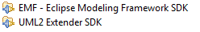
We will need to install two tools inside Eclipse 3.6 32 bit (our IDE). These tools are:
- EMF – Eclipse Modelling Framework SDK
- UML2 Extender SDK

How do I edit the UML files?

Complete details are available here:
http://www.eclipse.org/modeling/mdt/uml2/docs/articles/Getting_Started_with_UML2/article.html

Steps:
- Open the file Project.uml
- Add a new class or attribute:
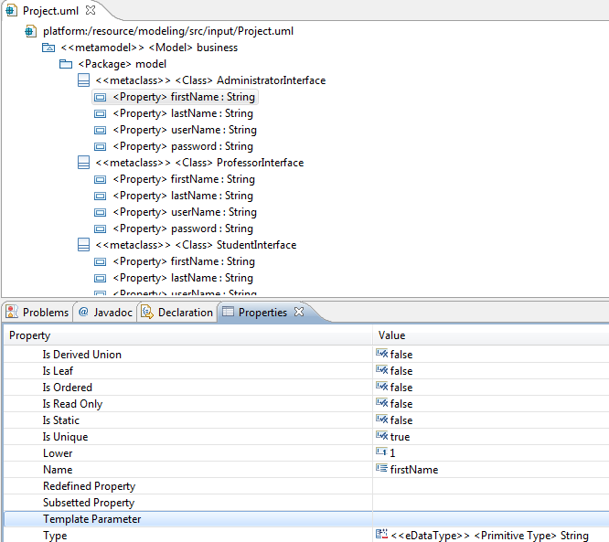
- Open Project.genmodel, right click the top level node, select Reload...
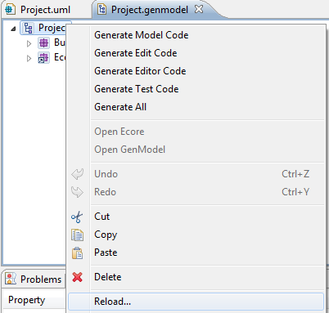
- Press Next, Next, Finish.
- Right click again on the top node of Project.genmodel, select Generate Model Code
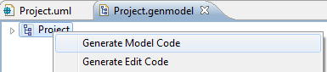
TODO: we need to find a way to generate classes instead of interfaces.

