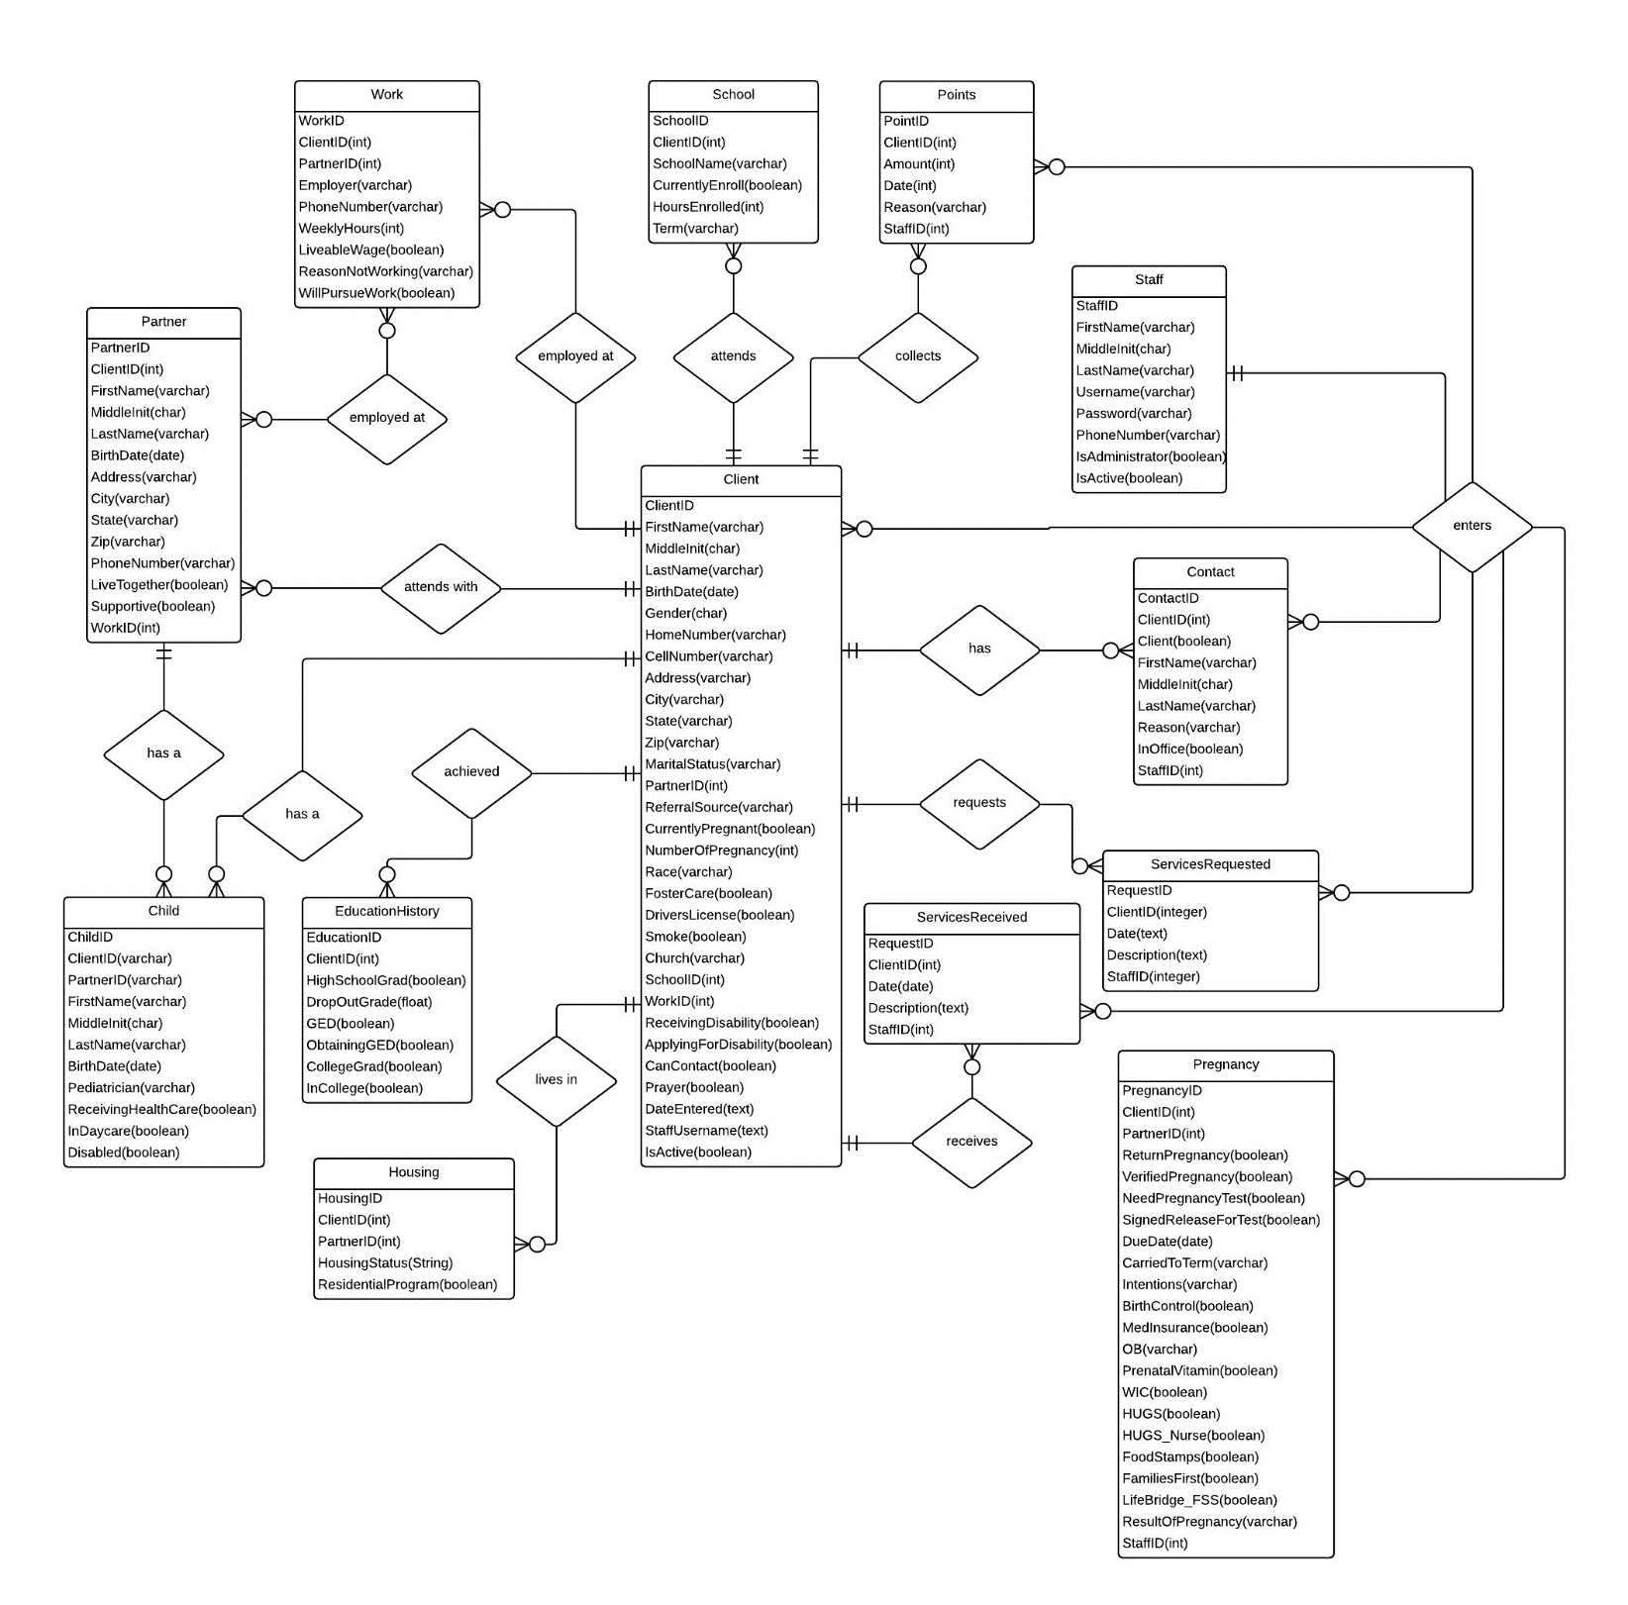

Assumptions:

1. The client will be entered into the system before any other tables are updated.
2. If a client comes in for a pregnancy test, it will be entered into the Contact table instead of as an attribute of the client.
3. Instead of age being a field for the client, the birthdate will be stored and the age can be calculated from that field.
4. Client will have a new entry for each school attended after high school.
5. Client will have a new entry for each service requested and received.
6. Contact table holds information about all phone calls coming into HopeHouse.