Hope House

Client Management System

User Manual

Fall 2015

**Table of Contents**

1. Introduction
2. Functionality
   1. Login
   2. Back up client data
      1. Reminders
      2. Automatic back up
      3. How to choose a back up
   3. Client information
      1. Create client
      2. Update client
      3. Delete client
   4. Viewing client data
   5. Administrator privileges
      1. Create staff account
      2. Delete staff account
      3. View/delete action logs

**Introduction**

Thank you for choosing Team Unicorn’s Hope House Client Management System. Our team focused on providing an aesthetically pleasing but easy-to-use program that will manage the basic client information for your crisis pregnancy center. Since this program was developed with your specific needs in mind, we hope that it will fulfill your requirements and save you time.

In this manual, you will find instructions on how to complete the tasks you need to manage your clients’ information, look up client information for your yearly outcomes, and manage your staff member accounts as well.

**Functionality**

Logging in:

1. 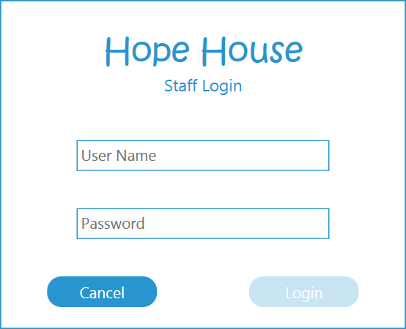When the program is first opened, the login window will pop up:
2. Enter in your credentials and click “Login” to continue.

Back-Ups of Client Data:

1. 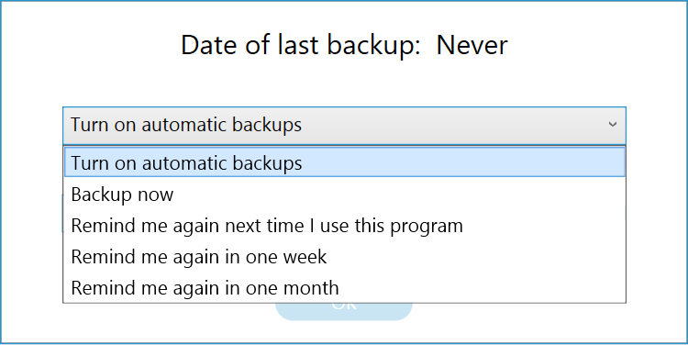After you have successfully logged in, a prompt will appear informing you of the last time a backup was created and asking when you’d like to create a new backup:
2. If you choose “Backup now,” you will need to choose the destination folder for the backup file.
3. Once the reminder is chosen, or the backup location is specified, click “Ok” to continue to the home screen of the program.

Changing backup settings:

1. If you need to change the frequency of backup reminds, turn on automatic backups, or the location the backups are saved to, click “Database” on the toolbar
2. Click “Change Backup Settings”
3. You will get the dialog box that appears when the program first opens.
4. When your changes have been made, click “Ok” to save the settings.

Choosing a backup to read from:

1. If you need to use a backup, click to import client data from a file.
2. In the pop-up, choose the file from which you’d like to import the clients.
3. Click “Open” and the clients will be available for viewing.

Create a client profile:

1. Click the “Add Client” button
2. Enter the applicable fields for the client (view sample form below)
3. 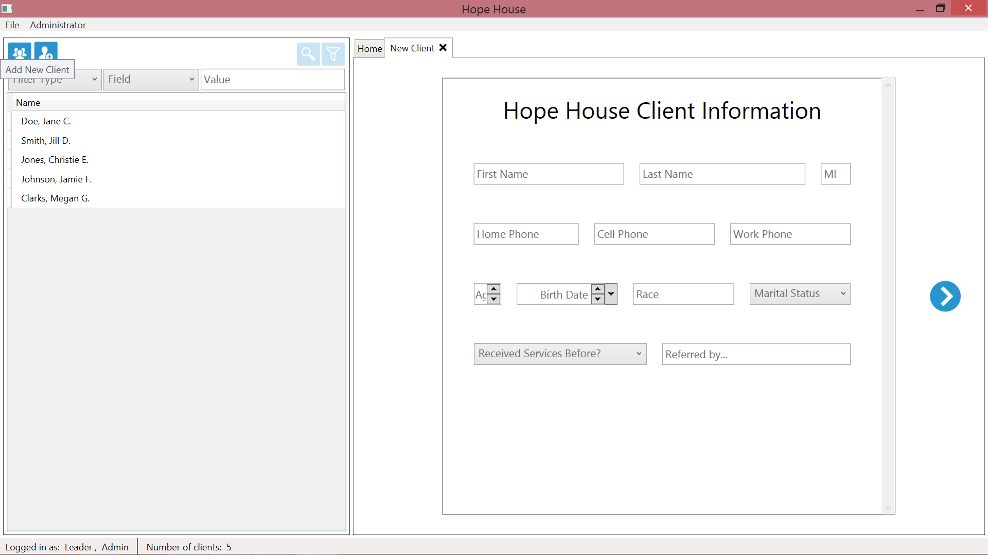Once each page is completed, click to continue
4. Once all of the fields are completed, click “Save Client” to add the client.
5. A pop up notification will inform you if your client has been added correctly.