**SLOT MACHINE APP USER’S MANUAL**

(core version)

Are you familiar with slot machines? if not, here’s a simple explanation of how this game works! Get ready.

**THE INTERFACE.**

When program starts, it shows an initial window as showed in next image.

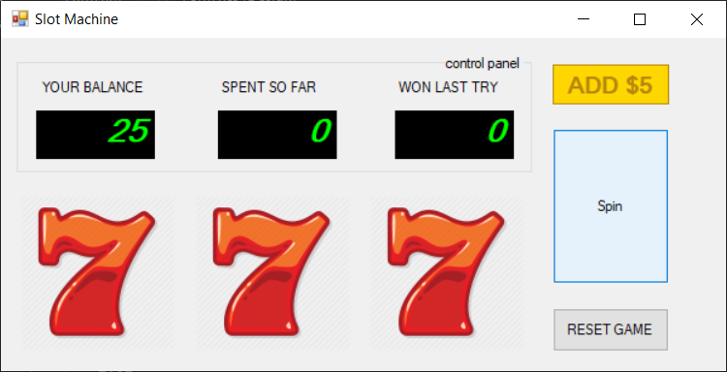

fig. 01

**CONTROL PANEL SECTION:**

Shows information regarding balance, money spent, and money earned after last spin. Numbers are updated after every spin.

**REELS.**

Under control panel, 3 “reels” show a symbol (red sevens on the initial screen). Each reel has 4 symbols (seven, grape, lime and pineapple). Symbols displayed change when reels spin.

**Spin button**. Launches a spin.

**ADD $5 Yellow Button**. Allows user to add $5 to current balance.

**Reset button.** Reinitializes app interface.

**HOW IT WORKS.**

You start with a $25 balance.

Each spin will discount $2 from your balance. Control panel will update balance and money spent since the game started.

Winnings are calculated as follows at the end of each spin

3 sevens pays $25.

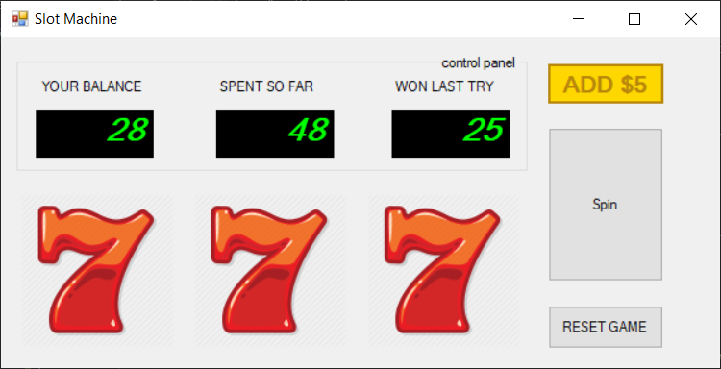

3 identical fruit pays $10

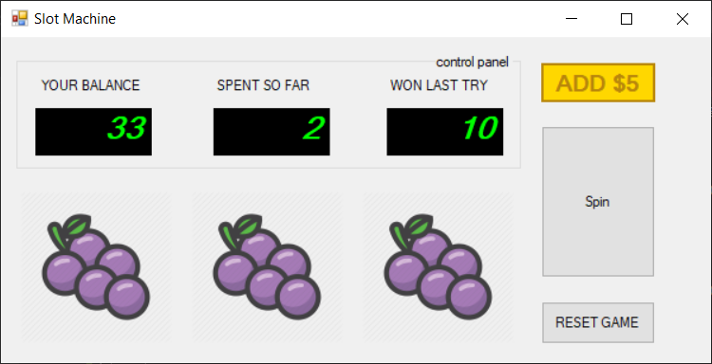

Any three fruit pays $1

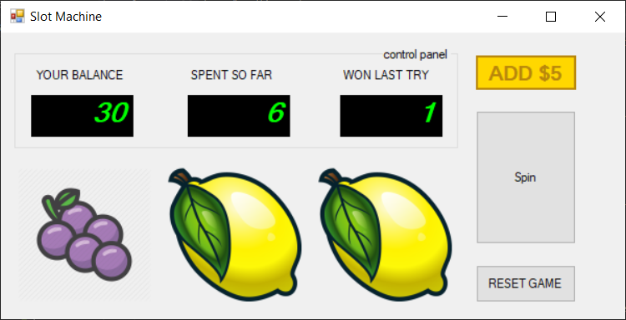

Anything else pays $0

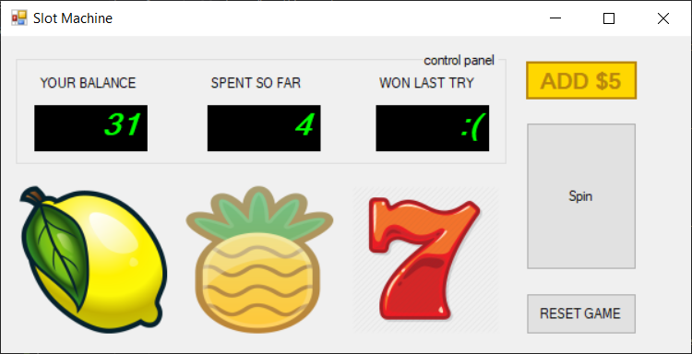

After each spin, you’ll see the money you won (if any) and will update your balance too.

If you try to spin with less than $2, warning will popup. It’s time to get in debt 😊

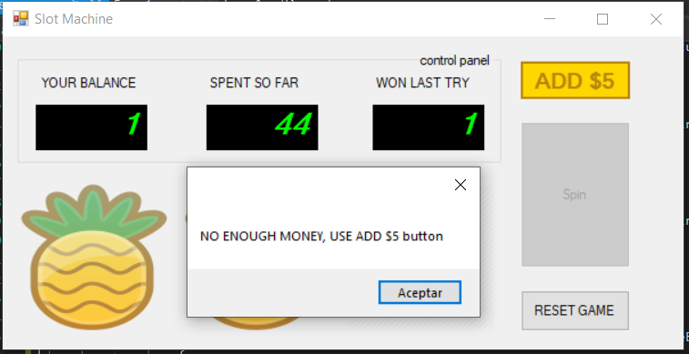

Of course, you can click the ‘Add $5’ button to get more money.

Now, you’re ready to play!