1. INTRODUCTION
1.1 Purpose of the project:
“Handset Theft Monitoring” will provide the security to our handset from being theft. This application is a static application and should have internet connection in order to get the location of the person who theft your mobile. Otherwise only the thief number and sim serial number will be get through sms and mail . This is the first version app for android mobile users.
This application is being built on Android 2.3.3. This is built by the assistance of Eclipse IDE with ADT plug-in configured with android SDK for windows.

Existing System:
Most of the people are using these kind of applications but doesn’t work in real time. And in most of the cases those kind of applications will fail.

Proposed System:
Whenever our handset is theft, the thief should must and should change the sim and will insert the new sim. To do this he must switch off the mobile. Our application will run in the booting process and checks the number and compares to the previous one that is used by the user. If it is different it will send an Sms and e-mail to the user defined numbers that were entered in the application.
1.4 Scope of the Project
The scope of the project is limited to the particular sim that is having either Internet connection or atleast one rupee balance in the new sim that is inserted by the user.

2.ANALYSIS

  - PROJECT ANALYSIS:
“Handset Theft Monitoring” will provide the security to our handset from being theft. This application is a static application and should have internet connection in order to get the location of the person who theft your mobile. Otherwise only the thief number and sim serial number will be get through sms and mail . This is the first version app for android mobile users.
This application is being built on Android 2.3.3. This is built by the assistance of Eclipse IDE with ADT plug-in configured with android SDK for windows.
There is a chance to get the information about our mobile ,if some one had stolen our handset. we install this application we can get the direct information of the location where the mobile is right now.

2.2 STUDY OF THE SYSTEM
To provide flexibility to the users, the interfaces have been developed that are accessible through the mobile. The GUI’S at the top level have been categorized as

- The operational or generic user interface

The ‘administrative user interface’ concentrates on the consistent information that is practically, part of the organizational activities and which needs proper authentication for the data collection. These interfaces help the administrators with all the transactional states like Data insertion, along with the extensive data search capabilities.
The ‘operational or generic user interface’ helps the end users of the system in transactions through the existing data and required services. The operational user interface also helps the ordinary users in managing their own information in a customized manner as per the included flexibilities
2.3 INPUT & OUTPOUT REPRESENTETION
Input design is a part of overall system design. The main objective during the input design is as given below:
- To produce a cost-effective method of input.
- To achieve the highest possible level of accuracy.
- To ensure that the input is acceptable and understood by the user.

2.4 PROCESS MODEL USED WITH JUSTIFICATION

SDLC (Spiral Model):

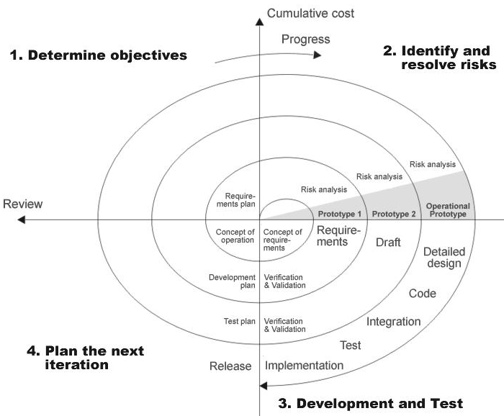

SDLC is nothing but Software Development Life Cycle. It is a standard which is used by software industry to develop good software.

Stages in SDLC:
- Requirement Gathering
- Analysis
- Designing
- Coding
- Testing
- Maintenance
Requirements Gathering stage:
The requirements gathering process takes as its input the goals identified in the high-level requirements section of the project plan. Each goal will be refined into a set of one or more requirements. These requirements define the major functions of the intended application, define operational data areas and reference data areas, and define the initial data entities. Major functions include critical processes to be managed, as well as mission critical inputs, outputs and reports. A user class hierarchy is developed and associated with these major functions, data areas, and data entities. Each of these definitions is termed a Requirement. Requirements are identified by unique requirement identifiers and, at minimum, contain a requirement title and textual description.
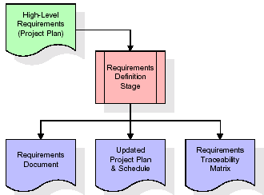

These requirements are fully described in the primary deliverables for this stage: the Requirements Document and the Requirements Traceability Matrix (RTM). The requirements document contains complete descriptions of each requirement, including diagrams and references to external documents as necessary. Note that detailed listings of database tables and fields are not included in the requirements document.
The title of each requirement is also placed into the first version of the RTM, along with the title of each goal from the project plan. The purpose of the RTM is to show that the product components developed during each stage of the software development lifecycle are formally connected to the components developed in prior stages.
In the requirements stage, the RTM consists of a list of high-level requirements, or goals, by title, with a listing of associated requirements for each goal, listed by requirement title. In this hierarchical listing, the RTM shows that each requirement developed during this stage is formally linked to a specific product goal. In this format, each requirement can be traced to a specific product goal, hence the term requirements traceability.
The outputs of the requirements definition stage include the requirements document, the RTM, and an updated project plan.
- Feasibility study is all about identification of problems in a project.
- No. of staff required to handle a project is represented as Team Formation, in this case only modules are individual tasks will be assigned to employees who are working for that project.
- Project Specifications are all about representing of various possible inputs submitting to the server and corresponding outputs along with reports maintained by administrator
Analysis Stage:
The planning stage establishes a bird's eye view of the intended software product, and uses this to establish the basic project structure, evaluate feasibility and risks associated with the project, and describe appropriate management and technical approaches.
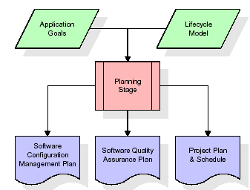
The most critical section of the project plan is a listing of high-level product requirements, also referred to as goals. All of the software product requirements to be developed during the requirements definition stage flow from one or more of these goals. The minimum information for each goal consists of a title and textual description, although additional information and references to external documents may be included. The outputs of the project planning stage are the configuration management plan, the quality assurance plan, and the project plan and schedule, with a detailed listing of scheduled activities for the upcoming Requirements stage, and high level estimates of effort for the out stages.
Designing Stage:
The design stage takes as its initial input the requirements identified in the approved requirements document. For each requirement, a set of one or more design elements will be produced as a result of interviews, workshops, and/or prototype efforts. Design elements describe the desired software features in detail, and generally include functional hierarchy diagrams, screen layout diagrams, tables of business rules, business process diagrams, pseudo code, and a complete entity-relationship diagram with a full data dictionary. These design elements are intended to describe the software in sufficient detail that skilled programmers may develop the software with minimal additional input.
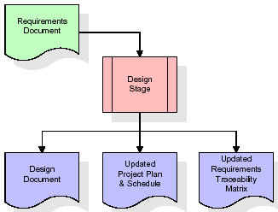
When the design document is finalized and accepted, the RTM is updated to show that each design element is formally associated with a specific requirement. The outputs of the design stage are the design document, an updated RTM, and an updated project plan.
Development (Coding) Stage:
The development stage takes as its primary input the design elements described in the approved design document. For each design element, a set of one or more software artifacts will be produced. Software artifacts include but are not limited to menus, dialogs, data management forms, data reporting formats, and specialized procedures and functions. Appropriate test cases will be developed for each set of functionally related software artifacts, and an online help system will be developed to guide users in their interactions with the software.
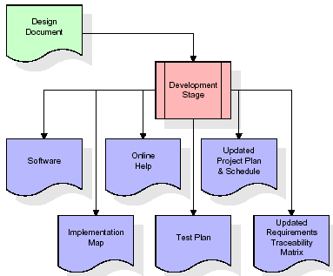
The RTM will be updated to show that each developed artifact is linked to a specific design element, and that each developed artifact has one or more corresponding test case items. At this point, the RTM is in its final configuration. The outputs of the development stage include a fully functional set of software that satisfies the requirements and design elements previously documented, an online help system that describes the operation of the software, an implementation map that identifies the primary code entry points for all major system functions, a test plan that describes the test cases to be used to validate the correctness and completeness of the software, an updated RTM, and an updated project plan.
Integration & Test Stage:
During the integration and test stage, the software artifacts, online help, and test data are migrated from the development environment to a separate test environment. At this point, all test cases are run to verify the correctness and completeness of the software. Successful execution of the test suite confirms a robust and complete migration capability. During this stage, reference data is finalized for production use and production users are identified and linked to their appropriate roles. The final reference data (or links to reference data source files) and production user list are compiled into the Production Initiation Plan.
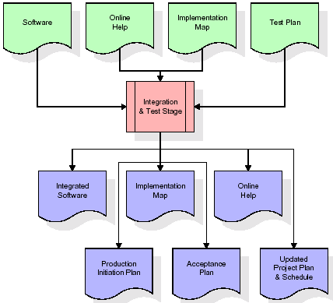

The outputs of the integration and test stage include an integrated set of software, an online help system, an implementation map, a production initiation plan that describes reference data and production users, an acceptance plan which contains the final suite of test cases, and an updated project plan.

- Installation & Acceptance Test:

During the installation and acceptance stage, the software artifacts, online help, and initial production data are loaded onto the production server. At this point, all test cases are run to verify the correctness and completeness of the software. Successful execution of the test suite is a prerequisite to acceptance of the software by the customer.
After customer personnel have verified that the initial production data load is correct and the test suite has been executed with satisfactory results, the customer formally accepts the delivery of the software.
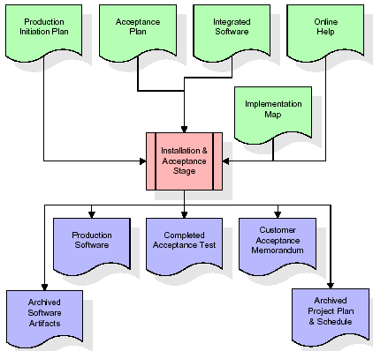
The primary outputs of the installation and acceptance stage include a production application, a completed acceptance test suite, and a memorandum of customer acceptance of the software. Finally, the PDR enters the last of the actual labor data into the project schedule and locks the project as a permanent project record. At this point the PDR "locks" the project by archiving all software items, the implementation map, the source code, and the documentation for future reference.
Maintenance:
Outer rectangle represents maintenance of a project, Maintenance team will start with requirement study, understanding of documentation later employees will be assigned work and they will under go training on that particular assigned category.
For this life cycle there is no end, it will be continued so on like an umbrella (no ending point to umbrella sticks).
2.5 SYSTEM ARCHITECTURE
Architecture flow:

Below architecture diagram represents mainly flow of requests from users to database through servers. In this scenario overall system is designed in three tires separately using three layers called presentation layer, business logic layer and data link layer. This project was developed using 3-tire architecture.
Business Logic Layer
Presentation Layer
Request
Response
Data Link
Layer
Data Base

3. FEASIBILITY STUDY

3 Feasibility Study:
All projects are feasible if they have unlimited resources and infinite time. But the development of software is plagued by the scarcity of resources and difficult delivery rates. It is necessary and prudent to evaluate the feasibility of a project at the earliest possible times.

3.1 Economic Feasibility:
This procedure is to determine the benefits and savings that are expected from the candidate system and compare with cost. If benefits outweigh cost then the decision is to make design and implement the system. Otherwise further justification or alterations in the proposed system that have to make if it is having a change of the system life cycle. For my project I am not expecting any feasibility costs spent on this project because here I am using open source environments.

3.2 Technical Feasibility:
Technical feasibility centres on the existing mobile system and to what extent it support the proposed addition if the budget is serious constraint, then the project is judged not feasible. The technical feasibility is important role in my project because I am using Android operating system.

3.3 Operational Feasibility:
People are inherently resistant to change and mobiles have been known to facilitate change. In my project a technical person requires to configure the software and technical background is necessary to work on the sensors.

3.4 Intended Developers:
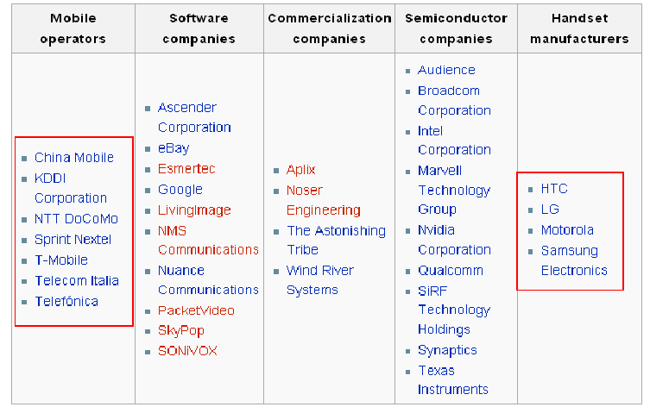
3.5 Product perspective:
This research is on latest open source mobile development platform called Android and to implement a game based technologies for different requirements.

PRODUCT FEATURES:
- Android is “openness”. The promise is that developers can produce applications without any interference.
- “The fact is that Android is an advanced, open source operating system which is important to the development community, but customers don’t buy operating systems.
- The interface is flexible.
- The android platform provides a rich security model that allows developers to request the capabilities, or access, needed by their applications and to define new capabilities that other applications can request.
- Developers have full access to the same framework APIs used by the core applications.
3.6 ASSUMPTIONS AND DEPENDENCIES
- Having only hardware is not sufficient, to access an application Software is must.
- Assumption is made in such a way that the mobile is charged with enough battery.
- The battery should be in working mode.
- The one who is using the mobile must have a minimum knowledge how to create an account in the buddy locator and send request to another buddy and add buddy in the account.

4. SOFTWARE REQUIREMENT SPECIFICATION
4.1 Functional Requirements Specification:
The system is required to perform the following functions:
- Display all the information about the application that is being developed and some set of instructions the user might want to remember before he sets up the system for configuring global time.
- Sign in your application with jar signer before running your application.
- Install your apk file with android bridge (i.e.; adb).
- After executing your application Tower of Hanoi
- Ability to drag the disks and drop them.
- Able to display score.
- Ability to pause and resume & stop the application.

4.2 Non-Functional Requirements:
- Application framework enabling reuse and replacement of components.
- Dalvik virtual machine optimized for mobile devices.
- Integrated browser based on the open source Web Kit engine.
- Optimized graphics powered by a custom 2D graphics library; 3D graphics based on the OpenGL ES 1.0 specification (hardware acceleration optional).
- SQLite for structured data storage.
- GPS
- Rich development environment including a device emulator, tools for debugging, memory and performance profiling, and a plug-in for the Eclipse IDE.
- The system is expected to run on low memory devices also.
- The system should not consume lot of bandwidth so that the other applications will block for the internet.
- The system should provide secured access to the web server.

Requirement Specifications:

4.3 Software Requirements:

- Operating System : Android, Linux, Windows XP
- Software : J2SE, ADT plugin
- Development Tools : Android SDK, Android Emulator, Eclipse Helios

4.4 Hardware Requirements:

- Pentium IV with 2 GHZ
- 1GB RAM
- 40 GB Hard Drive
- Android Phone (optional)

4.5 INTRODUCTION TO ANDROID
4.5.1 INTRODUCTION TO ANDROID

Android is a software stack for mobile devices that includes an operating system, middleware and key application. Android is a software platform and operating system for mobile devices based on the Linux operating system and developed by Google and the Open Handset Alliance. It allows to write managed code in a java-like language that utilize Google-developed Java Libraries, but does not support program developed in native code.
The unveiling of the Android platform on 5 November 2007was announced
With the founding of the Open Handset Alliance, a consortium of 34 hardware, software and telecom companies devoted open standard for mobile devices. When released in 2008, most of the Android platform will be made available under the Apache free-software and Open-source-license.

    - THE BIRTH OF THE ANDROID

Google Acquire Android Inc.
In July 2005, Google acquire Android Inc, a small company based in PolaAlto, CA. Android co-founder who went to work with Google included Andy Rubin(co-founder of Danger), Rich Miner(co-founder of Wildlife communication, Inc), Nick Seares(once VP @ T-Mobile), and Chris White(one of the first engineer at WebTV). At the time, little was about the function of Android Inc. other than they made software for mobile-phones.

    - OPEN HANDSET ALLIANCE FOUNDED
On 5 November 2007, the open Handset Alliance, a consortium of several companies which included Google, HTC, Intel, Qualcomm, T-Mobile, Sprint Nextel and NVIDIA, was unveiled with the goal to develop open standards for mobile devices. Along with the OHA also unveiled their first product, Android, an open source mobile devices platform based on the Linux operating system.

    - HARDWARE
Google has unveiled at least three prototypes for Android, at the Mobile world Congress on February 12, 2008. One prototype at the ARM both displayed several basic Google Application. A “d-pad” control zooming of items in the clock with a relatively quick response.
A prototype at the Google IO conference on May 28 had a 528 MHz Qualcomm processor and a Synaptic capacitive touch screen, and used the UMTS cellular standards. It had 128 MB of RAM of flash, showing that Android Memory require are reasonable. The demo was carried out using a 3.6 Mbit/s HSDPA connection

    - FEATURES

      - Application Framework
It is used to write applications for Android. Unlike other embedded mobile environments, Android applications are all equal, for instance, an applications which come with the phone are no different than any developer writes. The framework is supported by numerous open source libraries such as openssl, SQLite and libc. It is also supported by the Android core libraries. From the point of security, the framework is based on UNIX file system permissions that assure applications have only those abilities that mobile phone owner gave them at install time.
      - Dalvik Virtual Machine
It is extremely low-memory based virtual machine, which was designed especially for Android to run on embedded system and work well in low power situation. It is also tuned to the CPU attribute . The Dalvik VM creates a special file format (.dex) that is created through the build time post processing, Conversion between Java classess and .dex format is done by included “dx” tool.
      - INTEGREATED BROWSER:-
Google made a right choice WebKit as open source web browser. They added a two layout and frame flattering. Two pass layout loads a page without waiting for blocking elements, such as external CSS or external JavaScript & after a while renders again with al resources downloaded. To the devices. Frame flattering frames single one and loads into browser. These features increases speed and usability browsing the internet via mobile phone.

      - OPTIMISED GRAPHICS
As Android has 2D graphics library and 3D graphics based on OpenGL ES 1.0, possibly we will see great application like Google Earth and spectacular games like Second Life, which come on Linux version. At this movement, the shooting legendry 3d gane Doom was presented using Android on the mobile phone.
      - SQLite
Extremely small (~500kb) relational database management system, which is integrated in Android. It is on function call and single file, where all definitions, tables and data are stored. This simple design is more than suitable for a platform as Android.

      - HANDSET LAYOUTS
The platform is a adaptable to both larger, VGA, 2D graphics library based on OpenGL ES 1.0 specification, traditional smart phone layouts. An underlying 2D graphics engine is also included. Surface Manager manages access to the display subsystem & seamlessly composite 2D & 3d graphics layers from multiple applications.

4.5.5.7 DATA STORAGE
SQLite is used for structured data storage. SQLite is a powerful and lightweight relational database engine available to all applications.

4.5.5.8 CONNECTIVITY
Android supports a wide variety of connectivity is a powerful on technology including GSM, CDMA, Bluetooth, EDGE, EVDO, 3G and Wi-Fi.

      - MESEGING
SMS, MMS, & XMPP are available forms of messaging including threaded text messaging.

4.5.5.10 WEB-BROWSER
The web browser available in Android is based in the open source WebKit application framework. It includes LibWebCore which is a modern web browser engine powers both the Android and an embeddable web view.

4.5.5.11 JAVA VIRTUAL MACHINE
Software written in Java can be complied into Dalvik Virtual Machine byte code and executed in the Dalvik Virtual Machine, which is a specialized VM implementation designed for mobile devices use, although not technically a standards Java Virtual Machine.

4.5.5.12 MEDIA SUPPORTS
Android will supports advanced audio/video/still media formats such as MPEF-4, H-264, and AAC, AMR, JPEG, PNG,GIF.

4.5.5.13 ADDITIONAL HARDWARE SUPPORTS
Android is fully capable of utilizing video/still cameras, touch screens, GPS, compasses, accelerometers, and accelerated 3d graphics.

4.5.5.14 ADROID DEVELPOMENT ENVIRONMENT

Includes a devices emulator, tools for debugging, memory and performance profiling, a plug-in for the Eclipse IDE. There are a number of the Hardware dependent features, for instance, a huge media and connection supports, GPS, improved supports for Camera and simply GSM telephony. A great work was done for the developers to start work with Android using device emulator, tools for debugging for Eclipse IDE.

    - DETAILED DESCRIPTION ABOUT THE TOPIC
4.5.6.1 OPERATION
ANDROID RUNTIME
Android includes a set of core libraries that provided most of the functionality available in the core libraries of the Java Programming Language. Every Android application runs in it own process, with its own instance of the Dalvik Virtual Machine. Dalvik has been written so that a device can run multiple VMs efficiently.
The Dalvik VM execute files in the Dalvik Executable (.dex) format which is optimized for minimal memory footprint. The VM is register-based, and runs classes complied by a Java Languages Compiler that have been transformed into the .dex format by the included “dx” tool. The Dalvik VM relies on the Linux kernel for underlying functionality such as threading and low-level memory management.

LINUX KERNAL
Android relies on the Linux version 2.6 for core system such as security, memory management, process management, network stack, and driver model. The Kernel also acts as an abstraction layer network the hardware and the rest of the software stack.
It helps to manages security, memory management, process management, network stack, and other important issues. Therefore, the user should bring the Linux in his mobile devices as the mobile devices as the main operating system and install all the drivers required in order to run it.
Developers have full access to the same framework APIs used by the core applications. The application architecture is designed to simplify the reuse of components; any application can publish its capabilities and any other application may then make use of the capabilities(subject to security constraints enforced by the frame work). This same mechanism allows components to be replaced by the user.

Underlying all application is a set services and systems.

ARCHITECTURE

The following diagram shows the major components of the android operating system. Each section is described in more details below

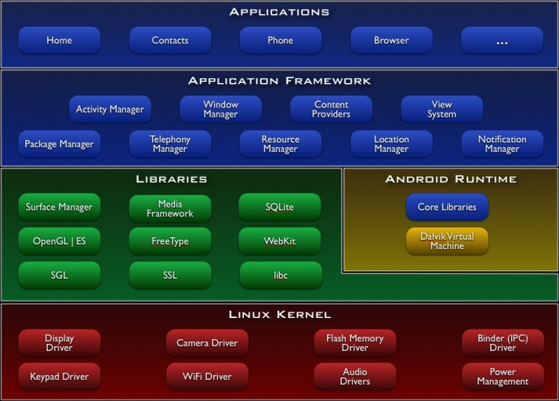

Figure Architecture of Android

Linux Kernel
Android Architecture is based on Linux 2.6 kernel. It helps to manage security, process management, network stack and other important issues. Therefore, the user should bring Linux in his mobile devices as the main operating system and install all the drivers required in order to run it. Android provides system and install the drivers required in order to run it. Android provides the supports for the Qualcomm MSM7K chipset, but in the second half of the 20085 we should see mobile devices with stable versions Qualcomm MSM 7200, which includes major features.

- WCDMA/HUSPA and EGPRS network supports.
- Bluetooth 1.2 and Wi-Fi supports.
- Digital audio supports for mp3 and other formats.
- Supports for Linux and other third party operating systems.
- Java Hardware acceleration and supports for Java applications.
- Qcamera up to 6.0 mpx.
- GPS-One-solution for GPS.
- and lots of other.

LIBRARIES
In the next level there are set native libraries written in c/ c++, which are responsible for stable performance of various components. For example, surface managers are responsible for composing different drawing surface on the mobile screen. It manages the access for different process to compose 2D & 3D graphics layers. OpenGl ES and S GL make a core of graphics libraries and are used accordingly for 2D & 3D hardware acceleration. Moreover, it is possible to use 2D and 3D graphics in the same Android application. The media framework was provided by PacketVideo, one of the members of OHA. It gives libraries for a playback and recording support for all the major media and static image files. FreeType libraries are used to render all the bitmap and Vector Fonts. For data storage, Android uses SQLite. As mentioned before, it is extra light relational management system, which locates a single file for all operation related to database. WebKit, the same browser by Apple’s Safari, was modified by Android in order to fit better in small size screen.

Android Runtime
At the same level there is Android Runtime, where the main component Dalvik Virtual Machine is located. It was designed specifically for Android running in limited environment, where the limited battery, CPU, memory and data storage are the main issues. Android gives an integrated tool “dx”, which converts generated byte code from .jar to .dex file, after this byte code becomes much more efficient to run on the small processors.
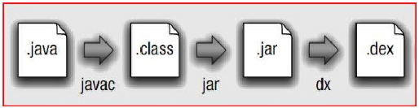
Figure 2.2: Conversion from .java to .dex file

As the result, it is possible to have multiple instances of Dalvik Virtual Machine running on the single device at the same time. The Core libraries are written in Java language and contains of the collection classes, the utilities, IO and other tools.

Application Framework

After that, there is Application Framework, written in Java language. It is a toolkit that all applications use, ones which come with mobile device like Contacts or SMS box, or applications written by Google and any Android developer. It has several components.
The Activity Manager manages the life cycle of the applications and provides a common navigation back stack for applications, which are running in different processes. The Package Manager keeps track of the applications, which are installed in the device. The Window Manager is Java programming language abstraction on the top of lower level services that are provided by the Surface Manager.
The Telephony Manager contains of a set of API necessary for calling applications.
Content Providers was built for Android to share a data with other applications, for instance, the contacts of people in the address book can be used in other applications too. The Resource Manager is used to store localized strings, bitmaps, layout file descriptions and other external parts of the applications. The View System generates a set of buttons and lists used in UI. Other components like Notification manager is used to customize display alerts and other functions.

Application Layer
At the top of Android Architecture we have all the applications, which are used by the final user. By installing different applications, the user can turn his mobile phone into the unique, optimized and smart mobile phone. All applications are written using the Java programming language.

4.5.6.2 Developing Applications

Application Building Blocks

We can think of an Android application as a collection of components; of various kinds. These components are for the most part quite loosely coupled, to the degree where you can accurately describe them as a federation of components rather than a single cohesive application.
Generally, these components all run in the same system process. It’s possible (and quite common) to create multiple threads within that process, and it’s also possible to create completely separate child processes if you need to. Such cases are uncommon, because Android tries very hard to make processes transparent to your code.
Google provides three versions of SDK for Windows, Mac OSX and one for Linux. The developer can use Android plugin for Eclipse IDE or other IDEs such as intelliJ. First step for Android developer is to decompose the application into the components, supported by the platform. The major building blocks are these:
- Activity
- Intent Receiver
- Service
- Content Provider

Activity
User interface component, which corresponds to one screen at time. It means that for the simple application like Address Book, the developer should have one activity for displaying contacts, another activity component for displaying more detailed information of chosen name and etc.
Intent Receiver
Wakes up a predefined action through the external event. For example, for the application like Email Inbox, the developer should have intent receiver and register his code through XML to wake up an alaram notification, when the user receives email.
Service
A task, which is done in the background. It means that the user can start an application from the activity window and keep the service work, while browsing other applications. For instance, he can browse Google Maps application while holding a call or listening while browsing other application.

Content Provider
A component, while allows a sharing of the data with other process and applications. It is the way to communicate the between each other. Android will ship with a set of core application including an email client. SMS program, calendar maps, browser, contacts and others. All applications are using the Java Programming language.

AndroidManifest.xml
A AndroidManifest.xml file is the that tells the system what to do with all the top-level components(specifically activities, services, intent receivers and content providers’ described below)you’ve created. For instance, this is the “glue” that actually specifies which Intents your Activities receives.
A developer should predefine and list all components, which he want to use in the specifies AndroidManifest.xml file. It is a requires file for all the application and is located in the root folder. It is possible to specify all global values for the package, all the components and its classess used, intent filters, which describes where and when the certain activity should be start, permissions and instruction like security control and testing.

Here is an example of AndroidManifest.xml file
<?xml version=”1.0” encoding=”utf-8”?>
<manifest xmlns:android=http://scheme.android.com/apk/res/android package=”dk.mdev.android.hello”>
<application android:icon=”@drawable/icon”>
<activity class=”.HelloAndroid” android:label=”@string/app_name”>
<intent-filter>
<action android:values=”android.intent.action.MAIN”/>
<category amdroid:value=”android.intent.category.LAUNCHER”>
</intent-filter>
</activity>
</application>
</manifest>

The line 2 is a namespace declaration, which makes a standard Android attribute available for that application. I the there <application> elements, where the developer specifies all application level components and its properties used by the package. Activity class in the line represents the initial screen the user see and it any have one or more <intent-filter> elements to describe the action that activity supports.

APPLICATION LIFECYCLE
In Android, every application runs in its own process, which gives better performance in security, protected and other benefits. Therefore, Android is responsible to run and shut down correctly these process when it is needed.
It is important that application developers understand how different application components (in the particular Activity, services and BroadCastReciver) impact the lifetime of the application’s process. Not using these components correctly can result in the system killing the application’s process while it is doing important work.
To determine which process should be killed when low on memory. Android places each process into an “importance hierarchy” based on the components running in them and state of these components. These process types are (in order of importance).
- A foreground process is one that is required for what the user is currently doing. Various application components can cause its containing process to be considered foreground in different ways. A process is considered to be in the foreground if any of the following condition hold.
- It is running an Activity at the top of the screen that the user is interacting with (its onResume() method has been called).

- It has a BroadCastReciver that is currently running (its BroadCastReciver.onRecive() method is executing).
- It has a service that is currently executing code of one of its call callbacks (Services.onCreate(), Service.onStart(), or Service.onDestroy()).

There will only ever be a few such process in the system, and these will only be killed as a last resort if memory is so low that not even these process can continue to run. Generally, at this point, the devices has reached a memory paging state, so this action is required in order to keep the user interface responsive.

- A visible process is one holding an Activity that is visible to the user on-screen but not in the foreground (its onPause() method has been called).This may occur, for example, if the foreground Activity is displayed as dialog that allows the previous Activity to be seen behind it. Such a process is considered extremely important and will not be killed unless doing so is required to keep al foreground processes running.
- A service process is one holding a Services that has a process started with the startService() method. Through these process are not directly visible to the user, they are generally doing things that user cares about(such as background mp3 playback network data upload or download). So the system will always keep such process running there is not enough memory to retain foreground and visible process.
- A background process is one holding is one holding an Activity that is not currently visible to the user(its onStop() has been called). These process have no direct impact on the user experience. Provided they implements their Activity life-cycle correctly(see Activity for more details), the system can kill such process at any time to reclaim memory for one of the three previous processes types. Usually there are many of these processes are running, so they are kept in an LRU list to ensure the process that was most recently seen by the user is last to be killed when running low on memory.
- An Empty process is one that doesn’t hold any active application components. The only reason to keep such a process around is a cache to improve startup time the next time a components of its application needs to run. As such, the system will often kill process in order to balance overall system resources between these empty cached and the underlying kernel caches.
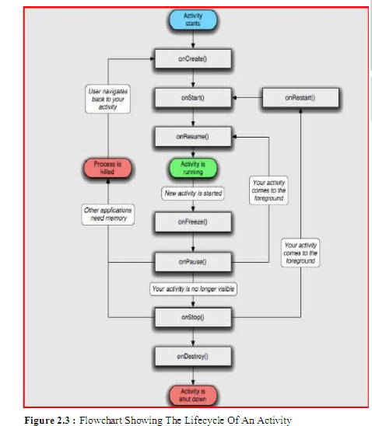

In the following example we will displays a process flow from the Android System point of view to get a clear how the application behave. Let assume the

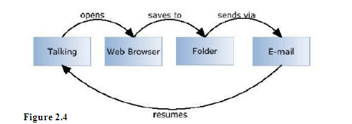

Possible scenario: A user talks to his friend via mobile phone and he is asked to browse the internet (a talk is hold for a memory), find a picture of him in his Picasa Album, Send Email back to his friend and resume a talk.
In this situation, there are 4 different and 4 different process running, but from the user point of view none of them important, as Android manages CPU work and memory usage by itself. It means the user can travel through the applications forward and back without thinking about how much memory is left or which processes are run at the time. Firstly, as the user is talking to his friend, a specific Talk application is opened, which contains the Activity Manager. In the following stack we can se two processes running, the main system process and Talk application process. Moreover, before going to Web Browser application, the system saves a Talk state T in order to remember that process.

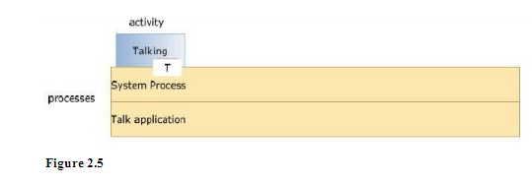

At this point, as a user holds a talk and opens a web browser. The system creates a new process and new web browser is launched in it. Again, the state of the last Activity is saved(W).

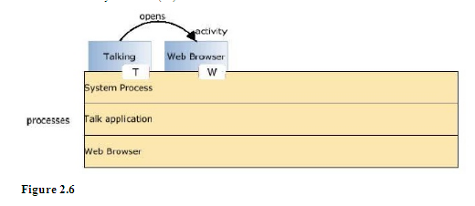

After that, the user browses the internet, finds his picture in Picasa album and saves it to particular folder. He does a web browser, instead he opens a folder to find saved picture. The folder activity is launched in particular process.

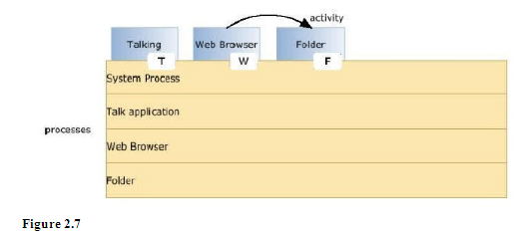

At this point, the user finds his saved picture in the folder and he creates a request to open an Email application. The last state F is saved. Now assume that the Mobile phone is of the memory and is room to creates a new process for Email application. Therefore, Android looks to kill a process. It cannot destroy Folder process, as it was used previously and could be reused again, so it kills Web Browser as it is not useful anymore locates a new Email process instead.

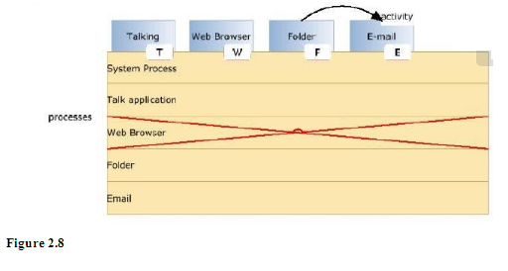
The user opens Email application And sends a picture to his friend via email application. Now he wants to go back to the Talk application and a talk to his friend. Because of the previously saved states, this work is done fast and easily. In this example, Email application is popped and the user see a previous Folder application.
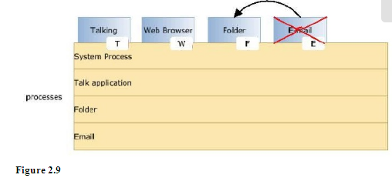
Next the user goes back to web Browser application. Unfortunately, web browser process was killed previously so the system has to kill another process(in our case it I s Email application process, which is not used anymore) in order to locate Web Browser and manages the Stack memory.

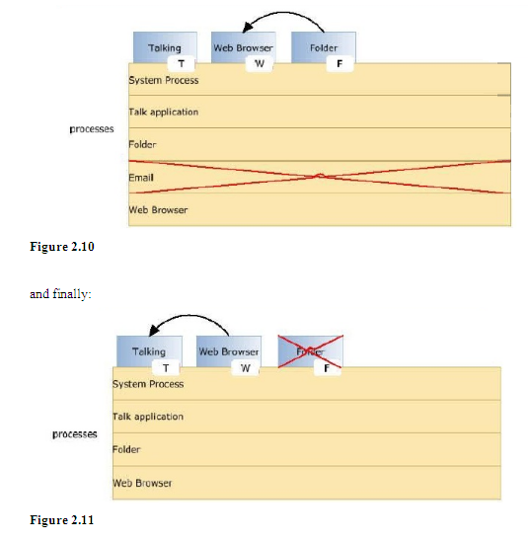

Now the user comes back to the Talk application and resumes his talk with his friend. Because of the saved states, going back is fast and useful, because it remembers previous activities and its views.
This example shows, that it does not matter ho many application and processes are active or how much available memory is left, Android it manages fast and without a user interaction.

Application Framework:
Developers have full access to the same framework APIs used by the core applications. The application architecture is designed to simplify the reuse of components; any application canpublish its capabilities and any other application may then make use of those capabilities (subject to security constraints enforced by the frame work). This same mechanism allows components to be replaced by the user.

Under laying all applications is a set of service and systems, including:
- A rich and extensible set of views that can be used to build an application, including lists,grids,text boxes,buttons,and even an embeddable web browser.
- Content providers that enable applications to access data from other applications (such as Contacts),or to share their own data.
- A Resource Manager , providing access to non-code resources such as localized strings,graphics,and layout files.
- A Notification Manager that enables all applications to display custom alerts in the status bar.
- An activity Manager that manages the life cycle of application and provides a common navigation backstack.

Library
- Android includes a set of C/C++ libraries used by various components of the android system. These capabilities are exposed to developers through the android application frame work. Some of the core libraries are listed below:
- System C library- a BSD-derived implementation of a the standard C system library(libc),turned for embedded Linux-base devices
- Media Libraries- based on PacketVideos OpenCore; the libraries support playback and recording of many popular audio and video formats,as well as a static image files, including MPEG4,H.264,MP3,AAC,AMR,JPG, and PNG.
- Surface Manager-manages access to the display subsystem and seamlessly composite 2Dand 3D graphic layers from multiple applications.
- LibWebCore- a modern web browser engine which powers both the Android browser and an embeddable web view
- #D libraries- an implementation based on OpenGL ES 1.0 APIs;the libraries use either hardware 3D acceleration(where available)or the included,highly optimized 3D software resterizer
- Free type- bitmap and vector font rendering.
- SQLite- a powerfull and lightweight relational data base engine available to all applications.

4.5.6.3 SOFTWARE DEVELOPMENT
The feedback on developing applications for the Android platform has been mixed issues cited includes bugs, lack of documentation, inadequate QA. The first publicly available application was the Snake game.
Software Development Kit:
It includes development and debugging tools, a device eulator, documentation, sample projects, tutorials, and FAQs.Requirements also include Java Development Kit, Apache Ant,and Python 2.2 or later.The only officially supported integrated development environment(IDE) is Ecllipse 3.2 or later,through the Android Development Tools Plugin, but programmers can use command line tools to create, build and debug Android applications.
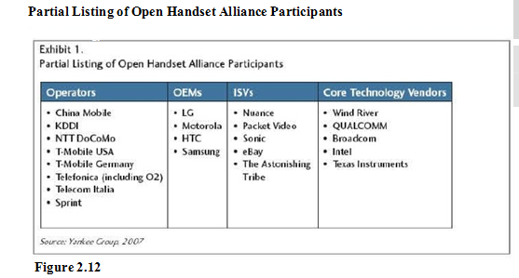

4.5.6.4 SECUIRITY ISSUES:
Android mobile phone platform is going to be more secure then Apples iPhone or any other devices in the long run. There are several solutions nowadays to protect Google phone from various attacks. One of them is security vendor McAfee,a member of Linux Mobile(LiMo) foundation. This foundation joins particular companies to develop an open mobile device software platform. Many of the companies listed in the LiMo Foundation have also become members of the Open Handset alliances(OHA).
As a result, Linux secure coding practice should successfully be built into the android development process . However , open platform has its own disadvantages, such as source code vulnerability for black-hat hackers. In parallel with great opportunities for mobile applications developers, there is an expectation for exploitation and harm. Stealthy Trojans hidden in animated images, particular viruses passed from friend to friend, used for spying and identity theft, all these threats will be active for long run.
Another solution for such attacks is SMobile systems mobile package. Security Shield an integrated application that includes antivirus, anti-spam, firewall and other mobile protection is up and ready to run on the android operating system. Currently, the main problem is availability for viruses to pose as an application and do things like dial phone numbers, send text messages or multi-media messages or make connections to the Internet during normal device use. It is possible for somebody to use the GPS feature to track a person’s location without their knowledge. Hence SMobile systems are ready to notify and block these secure alerts. But the truth is that is not possible to secure your mobile device or personal computer completely, as it connects to the internet. And neither the Android phone nor other devices will prove to be the exception.
4.5.6.5 COMPARISON:
Speculation with cellular carriers
Google android enters a tangled mess of cellular carrier world. As a new player in the mobile market, android brings an open platform with the new rules. On the one hand there is OHA with major companies and carries, such as T-Mobile and Sprint. On the other hand, there are two largest cellular carries AT&T and Verizon wireless in United States, which have a vested interest in operating system of their own . It is predictable, that Sprint or T-mobile will be first carriers providing devices with Google Android. This ensures equal development time for the networks, GSM side and CDMA. But the main problem, which faces all the cellular carriers around the world, is the availability to download and use free applications that could block almost every communication product they sell. A user does not need to pay for GPS mapping services anymore. He can simply download a free one that taps into Google Maps.
In fact, why pay for cellular minutes at all when a user can download skype,Gtalk or other client and just use his data plan? OS’s such as Android threaten carriers with a loss of control over the applications on the phone on their network and they may find themselves becoming nothing more than wireless internet service providers forced to compete on price and bandwidth.
Another aspect is hardware cost: Google android owns 10 percent of the total cost of a phone ,which combined with falling hardware prices could eventually result a fertile unlocked handset market. In conclusion, Google has a better start in this race then any company had before to bring new rules to the mobile market with all carriers, mobile devices and its customers.
Manufactures’ War
Presently, Google main competitors like Nokia, Microsoft and Apple do not see Google Android as a serious rival or threat to their business strategies. However, the current situation is not so unsophisticated. There is a huge flurry in the companies, which are not in the list of OHA.
For instance, Nokia, which is the largest manufacturer in the world, nowadays owning some 39% market share, was one of the companies snubbed on the invitation list to the 34-party Open hand Set Alliance that is growing daily.
In contrast, Nokia is buying companies and dumping cash into development, while Google is releasing an open platform hoping the applications and services will build themselves with the help of a strong developer community, development contents and large alliance of grand companies.
Despite of this, Nokia is ready to combat whatever Google has to throw with Google Android in 2008. Another company Apple has already stroked the market with iPhone and its closed operating system. Accordingly, iPhone in the US remain loyal to AT&T mobile carrier for five years.
That is plenty of time for Google to conquer the market with open Android. Obvious advantage of Android is cost: while iPhone is priced at a weighty $400, Google says it hopes to reach a more mainstream market by pricing Android-powered devices at around $200. Microsoft selling 21 million copies of Windows mobile software stays calm at this point, waiting for some particular results from Google Android.
This nice and healthy competition is just what the mobile industry needs at the moment, at least for the consumers. The wars being waged between Google and the field will only create better, cheaper handsets and more advanced applications.

Market Research
A new generation of mobile device users is coming in next decade. These users are going to explore the mobile internet afresh with its new features, compatible mobile phones, new services and applications.
This is a huge leap for mobile advertisement business, where revenue could rise 8 times more by 2012. Google Android is going to present new solutions through the fast search engine, open source applications and other services.
The Kelsey Group, which works with public opinion polls and statistics, published the results released October 11 2007, which say, that one hundred out of 500, or 20 percent of people would be interested in purchasing a Google phone. Despite the fact, that Google Android is in alpha version and it is unknown for the customers and mobile market, the results look promising.
The diagram below shows the study, which was conducted in September 2007 via an online 30-question survey of 500 U.S. mobile phone users aged 18 and older. People do not find a good Internet experience in their phones today, so they are more interested in gravitating toward an internet technology company telephone because they think connectivity between devices and to the Internet is going to be much better on those phones.
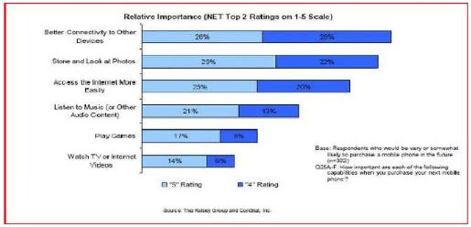
Figure 2.13
They use Google search, GMail, Google Maps, Picasa albums and other popular services on their computers, and this is what they except to have in their mobile devices in the close future.

Mobile Ads
Jaiku – an activity stream and sharing service that works from the Web and mobile phones was bought by Google as important investment into the mobile advertisement. People wondered why Google preferred the micro-blogging service to Twitter, which is much more popular nowadays.
The answer lies in Jaiku’s unique ability to combine mocro-blogging with user’s location. An integral part of the service is a Jaiku client application for Symbain S60 platform mobile phones, which should come to Android platform as well. The client uses location APIs within device to get the handset and the user’s location based on nearby cellular network towers.
Though the location is not very precise, the mobile phone is able to broadcast it automatically. At that point the text can be connected to users’ location and create a list of preferences for each place the user frequently visits.
Using such a technology, it is simple to track down a user via phone’s IP address whenever he comes into McDonald or is sitting in the airport. Google is not a million miles away from being able to push advanced advertising to individuals based on their profile, their location and their availability. They already offer regional and local targeting for ads for desktop users, but this could be much more useful for a mobile phone. And if the ads are truly relevant, interesting and unobtrusive, people might actually start to like them.
Mobile Services
Adding to its fast growing suite of mobile applications and services, Google has applied for a parent for a mobile payments service that would allow users to make payments at retail shops using their mobile phones. The Text Message Payment patent describes a system where Google offers mobile focused payments called GPay. This describes a system where a SMS message would be sent containing a payment amount and other information. That payment amount would then be validated, debited from the user’s account, and communicated from server to server. Payment confirmation that had been received would also simultaneously be sent to the relevant party, as illustrated in the diagram below.
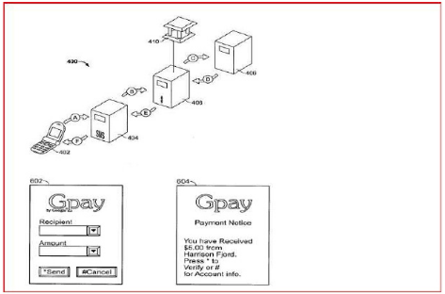
Figure 2.14: Figure describes Google’s mobile focused payments called GPay
Described as “a computer-implemented method of effectuating an electronic on-line payment,” the system mentioned in the patent application is similar to existing mobile payment services.
These services like mobile version of PayPal have been available for some time but have had little success bursting with merchants and with customers. The main difference between existing mobile payment system and GPay is, of course, that GPay is created by Google and will be easily adopted by Android Platform. The more issues regarding Gpay are yet to be released.

What makes Android special?
There are already many mobile platforms on the market today, including Symbian, iPhone, Windows Mobile, BlackBerry, Java Mobile Edition, Linux Mobile (LiMo), and more.
While some of its features have appeared before, Android is the first environment that combines:
- A truly open, free development platform based on Linux and open source. Handset makers like it because they can use and customize the platform without paying a rayalty. Developers like it because they know that the platform “has legs” and is not locked into any one vendor that may go under or be acquired.
- A component-based architecture inspired by Internet mash-ups. Parts of one application can be used in another in ways not originally envisioned by the developer. You can even replace built-in components with your own improved versions. This will unleash a new round of creativity in the mobile space.
- Tons of built-in services out of the box. Location based services use GPS or cell tower triangulation to let you customize the user experience depending on where they are. A full-powered SQL database lets you harness the power of local storage for occasionally connected computing and synchronization. Browser and Map views can be embedded directly in your applications. All these built-in capabilities help to raise the bar on functionality while lowering our development costs.
- Automatic management of the application life cycle. Programs are isolated from each other by multiple layers of security, which will provide a level of system stability not seen before in smart phones. The end user will no longer have to worry about what applications are active, or close some programs so that others can run. Android is optimized for low-power, low-memory devices in a fundamental way that no previous platform has attempted.
- High quality graphics and sound. Smooth, anti-aliased 2D vector graphics and animation inspired by Flash is melded with 3D accelerated OpenGL graphics to enable new common industry standard audio and video formats are built right in, including H.264 (AVC), MP3, and AAC.
- Probability across a wide range of current and future hardware. All your programs are written in Java and executed by Android’s Dalvik Virtual Machine so your code will be portable across ARM,x86, and other architectures. Support for a variety of input methods is included such as keyboard, touch, tilt, camera, voice, and trackball. User interfaces can be customized for any screen resolution and orientation. Android is a fresh take on the way mobile applications interact with users, along with the technical underpinnings to make it possible. But the best part of Android is the software that you are going to write for it.

Android and Java ME
Java Platform, Micro edition or Java ME (previously known as Java 2 Platform, Micro Edition or J2ME) is a specification of a subset of the Java platform aimed at providing a certified collection of Java APIs for the development of software small, resource-constrained devices. Though, do not confuse it with Google Android, even there are similarities:
- Eclipse plug-ins for J2ME and Android look very similar and interface very well with their respective SDKs;
- Both J2ME and Android seem to share the same core Java APIs, such as java.util and java.net. But their APIs for graphics, UIs, etc. are very dissimilar and philosophies for developing applications are very different;
- Android seems to be more tightly integrated (up to even the OS services provided and how they interact with the APIs), while J2ME is far more liberal in its specification for the developer and mobile device manufacturer.
A slower application development and performance – these are the main disadvantages Java’s J2ME have for today. J2ME apps are second-rate citizens in the phones. They do not have an access to most of the low-level features, like call API, external connectivity (USB) and other. There is no way to replace or extend built-in phone apps like contacts, calendar and calls.
For instance, J2ME applications in Nokia devices with S60 work great for standard tasks. But more advanced users find difficulties handling Wi-Fi access points with S60, because APIs simply do not seem to be exposed to J2ME. A user may find difficulties synchronizing Google Calendar with his device – nobody seems to have been able to figure out how to make the J2ME calendar interfaces work correctly on S60. There are lots of problems with Java applications on S60, even though S60 probably has one of the best Java implementations.
Android fills a void in Java Mobile applications by providing API to build richer applications – more useful for Smart Phones which contain the ability to provide these types of functionalities. If J2ME filled every void, Android an API wouldn’t be needed (though Android as an OS could still fill a void).
Google has written its own virtual machine for Android most likely as a way to get licensing issues with Sun. However, Android does not include a complete and complaint Java stack (neither JME nor JSE); only a subset and therefore it is technically not the Java platform, it just looks a lot it.

Openness Of The Platform
The open source school of thought implies that differentiation and competitive advantage come from innovation on top of the underlying platform rather than the platform itself. The robustness and scalability of the platform is secured by the community’s stewardship, and open access to a central repository of updated code. Beyond this, a strong third-party development environment and software development kit (SDK) are critical to attracting innovation.
“Open” is an invariably subjective term. Symbian and Microsoft can claim a degree of openness for their mobile platforms, for example, but ultimate control of API access and source code remains with a single entity. On the country, as Google has pointed out, there’s nothing keeping any of the alliance members from using Android to build a Yahoo! Go phone.
Motorola has had some success delivering high-volume Linux-based devices such as the Ming and RAZR II to market. But mobile Linux initiatives have failed to scale on the basis of attractiveness to third-party developers; it’s been supply-push with the development focus in Java ME or other application framework components.
Importantly, Android includes almost the entirety of the application-related software stack, less key technical pieces such as telephony protocol stacks, which are left to silicon vendors. Android bundles critical components such as a Linux kernel from Wind River, various optimized graphics engines, codecs, notification software, a “clean room” JVM implementation, and the KHTML open source browser. The latter forms the basis of Apple’s Safari and Nokia’s S60 offerings.

Advantages
- Open – Android allows you to access core mobile device functionality through standard API calls.
- All applications are equal – Android does not differentiate between the phone’s basic and third-party applications – even the dialer or home screen can be replaced.
- Breaking down boundaries – Combine information’s from the web with data on the phone – such as contacts or geographic location – to create new user experiences.
- Fast and easy development – The SDK contains what you need to build and run Android applications, including a true device emulator and advanced debugging tools.

Disadvantages
- Security – Making source code available to every one inevitably invites the attention of black hat hackers.
- Open Source – A disadvantage of open-source development is that anyone can scrutinize the source code to find vulnerabilities and write exploits.
- Login – Platform doesn’t run on an encrypted file system and has a vulnerable log-in
- Incompetence – Google’s dependence on hardware and carrier partners puts the final product out of their control.

4.6 INTRODUCTION TO JAVA
JAVA:
Computers connected to the net are from many different manufacturers, running on different operating systems and they differ in architecture, computing power and capacity. By considering this point SUN Microsystems Corporation felt the need for a new programming language suitable for this heterogeneous environment and Java was the solution. This breaks barriers between different computers, chips and operating systems.
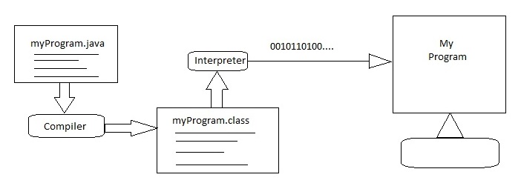
The main properties of the Java, which made Java so popular are as follows:
- Simple
- Secure
- Portable
- Object-Oriented
- Robust
- Multithreaded
- Interpreted
- High performance

The Key Feature Of Java Is Byte Code:
The key that allows Java to solve both the security and the portability problems just described is that the output of a Java compiler is not executable code, rather, it is Byte Code.
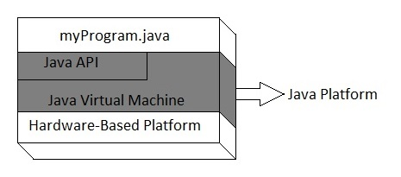
Byte code is a highly optimized set of instructions designed to be executed by the Java runtime systems, which is called the Java Virtual Machine (JVM). That is, in its standard form, the JVM is an interpreter for Byte code. This may come as a bit of surprise.

Java Platform:
One Characteristic of Java is portability, which means that computer programs written in the Java language must run similarly on any supported hardware/operating-system platform. One should be able to write a program once, compile it once, and run it anywhere.

This is achieved by compiling the Java language code, not to machine code but to Java byte code – instructions analogous to machine code but intended to be interpreted by a virtual machine (VM) written specifically for the host hardware. End-users commonly use a Java Runtime Environment (JRE) installed on their own machine for standalone Java applications, or in a web browser for Java applets.

Standardized libraries provide a generic way to access host specific features such as graphics, threading and networking. In some JVM versions, byte code can be compiled to native code, either before or during program execution, resulting in faster execution. A major benefit of using byte code is porting. However, the overhead of interpretation means that interpreted programs almost always run more slowly than programs compiled to native executables would, and Java suffered a reputation for poor performance. This gap has been narrowed by a number of optimizations introduced in the more recent JVM implementations.

One such technique, known as just-in-time (JIT) compilation, translates Java byte code into native code the first time that code is executed, then caches it. This result in a program that starts and executes faster than pure interpreted code can, at the cost of introducing occasional compilation overhead during execution. More sophisticated VMs also use dynamic recompilation, in which the VM analyzes the behavior of the running program and selectively recompiles and optimizes parts of the program. Dynamic recompilation can achieve optimizations on knowledge about the runtime environment and the set of loaded classes, and can identify hot spots – parts of the program, often inner loops, that take up the most execution time. JIT compilation and dynamic recompilation allow Java programs to approach the speed of native code without losing portability.
Android SDK:
Android Development Tools (ADT) is a plug-in for the Eclipse IDE that is designed to give you a powerful, integrated environment in which to build Android applications. ADT extends the capabilities of Eclipse to let you quickly set up new Android projects, create an application UI, add components based on the Android Framework API, debug your applications using the Android SDK tools, and even export signed (or unsigned) APKs in order to distribute your application. Developing in Eclipse with ADT is highly recommended and is the fastest way to get started. With the guided project setup it provides, as well as tools integration, custom XML editors, and debug output pane, ADT gives you an incredible boost in developing Android applications.

5. PROJECT DESIGN

UML
What is UML?
The Unified Modeling Language (UML) is a standard language for specifying, visualizing, constructing and documenting the artifacts of software systems, as well as for business modeling and other non-software systems. The UML represents a collection of best engineering practices that have proven successful in the modeling of large and complex systems. The UML is a very important part of developing objects oriented software and the software development process. The UML uses mostly graphical notations to express the design of software projects. Using the UML helps project teams communicate, explore potential designs, and validate the architectural design of the software.

Goals of UML:
The primary goals in the design of the UML were:
- Provide users with a ready-to-use, expressive visual modeling language so they can develop and exchange meaningful models.
- Provide extensibility and specialization mechanisms to extend the core concepts.
- Be independent of particular programming languages and development processes.
- Provide a formal basis for understanding the modeling language.
- Encourage the growth of the OO tools market.
- Support higher-level development concepts such as collaborations, frameworks, pattern and components.
- Integrate best practices.

Why Use UML?
As the strategic value of software increases for many companies, the industry looks for techniques to automate the production of software and to improve quality and reduce cost and time –to- market. These techniques include component technology, visual programming, patterns and frameworks. Businesses also seek techniques to manage the need to solve recurring architectural problems, such as physical distribution, concurrency, replications security, load balancing, and fault tolerance. Additionally, the development for World Wide Web, while making some things simpler, has exacerbated these architectural problems. The Unified Modeling Language was designed to respond to these needs.

UML Diagrams:
UML diagrams are designed to let developers and customers view a software system from a different perspective and in varying degrees of abstraction. UML diagrams commonly created using visual modeling tools.

5.1 Use case Diagram:
A use case is a set of scenarios that describing an interaction between a user and a system. A use case diagram displays the relationship among actors and use cases. The two main components of a use case diagram are use cases and actors.
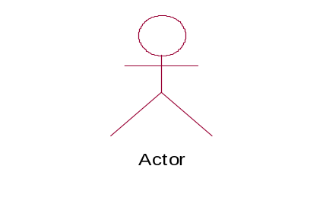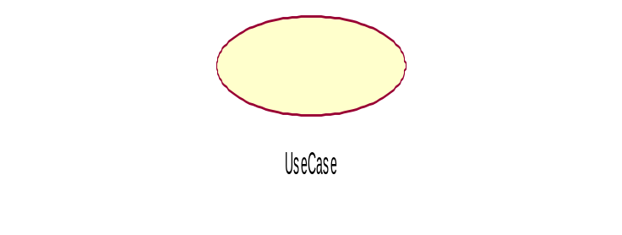
An actor is represents a user or another system that will interact with the system you are modeling. A use case is an external view of the system that represents some action the user might perform in order to complete a task.

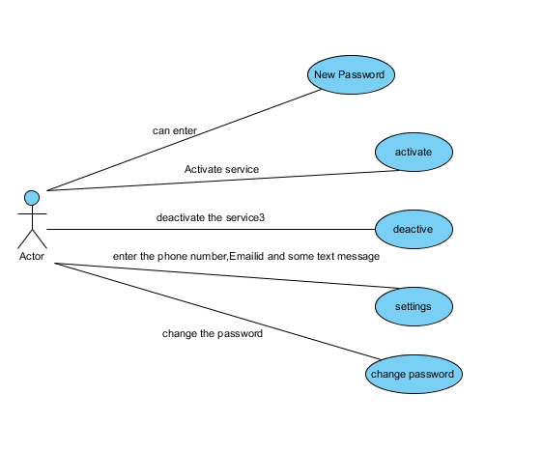

5.2 Class Diagram:
Class diagrams are widely used to describe the types of objects in a system and their relationships. Class diagrams model class structure and contents using design elements such as classes, packages and objects. Class diagrams describe three different perspectives when designing a system, conceptual, specification and implementation. These perspectives become evident as the diagram is created and help solidify the design. This example is only meant as an introduction to the UML and class diagrams.

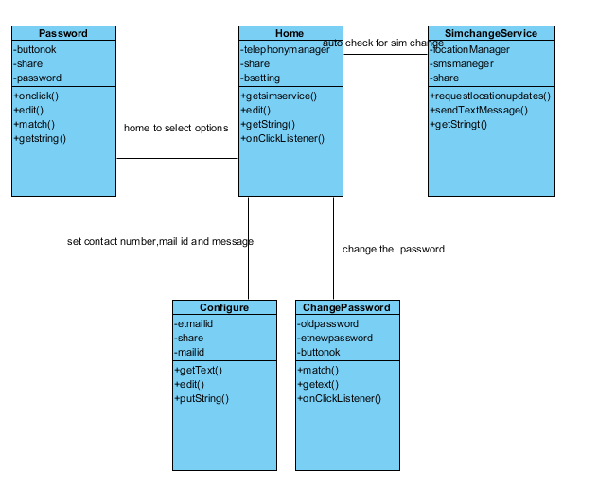

5.3 Sequence Diagram:
Sequence Diagrams demonstrate the behavior of objects in a use case by describing the objects and the messages they pass. The diagrams are read left to right and descending. The example below shows an object of class 1 start the behavior by sending a message to an object of class 2. Messages pass between the different objects until the object of class 1 receives the final message.

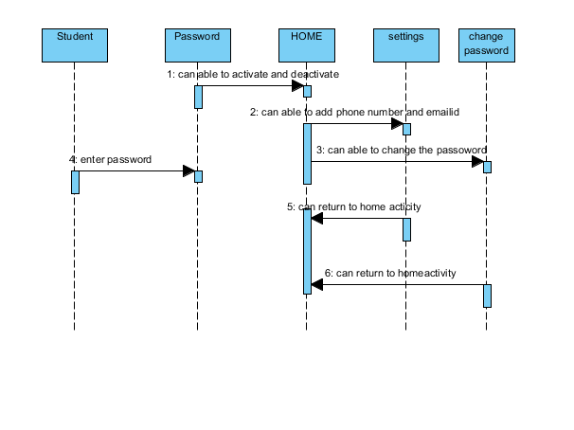

5.4 Activity Diagram:
Activity diagrams describe the workflow behavior of a system. Activity diagrams are similar to state diagrams because activities are the state of doing something. The diagrams describe the state of activities by showing the sequence of activities performed. Activity diagrams can show activities that are conditional or parallel.
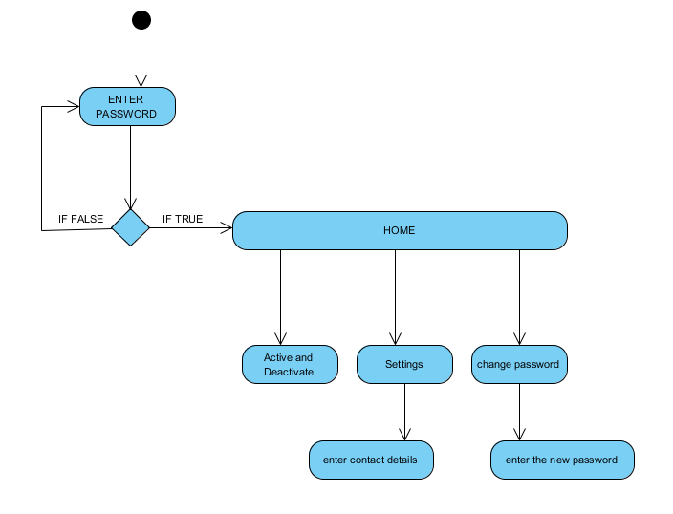

When to use: Activity Diagrams:
Activity diagrams should be used in conjunction with other modeling techniques such as interaction diagrams and state diagrams. The main reason to use activity diagrams is to model the workflow behind the system being designed. Activity Diagrams are also useful for : analyzing a use case by describing what actions need to take place and when they should occur; describing a complicated sequential algorithm; and modeling applications with parallel processes.
However, activity diagrams should not take the place of interaction diagrams and state diagrams. Activity diagrams do not give detail about how objects behave or how objects collaborate.

Deployment Diagram:

Deployment diagrams are a set of nodes and their relationships. These nodes are physical entities where the components are deployed.

Deployment diagrams are used for visualizing deployment view of a system. This is generally used by the deployment team.
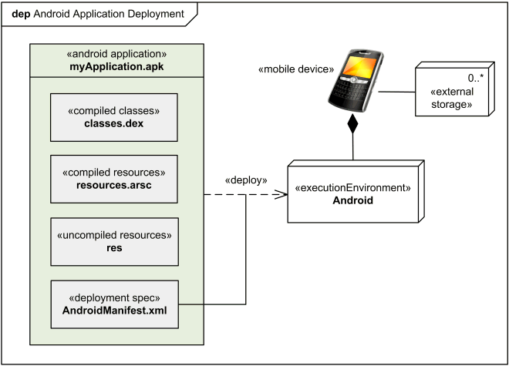
6. SAMPLE CODE
Active.java:

package com.TheftMonitor;

import android.app.Activity;
import android.content.Context;
import android.content.Intent;
import android.content.SharedPreferences;
import android.os.Bundle;
import android.telephony.TelephonyManager;
import android.view.View;
import android.widget.Button;
import android.widget.Toast;
import android.widget.ToggleButton;

public class Active extends Activity {
Button b1, b2;
ToggleButton t;
SharedPreferences share;
SharedPreferences.Editor edit;
TelephonyManager tm;

@Override
protected void onCreate(Bundle savedInstanceState) {
// TODO Auto-generated method stub
super.onCreate(savedInstanceState);
setContentView(R.layout.active);
tm = (TelephonyManager) getSystemService(Context.TELEPHONY_SERVICE);
share = getSharedPreferences("Mobiletheft", 0);
edit = share.edit();

b1 = (Button) findViewById(R.id.button1);
b2 = (Button) findViewById(R.id.button2);
t = (ToggleButton) findViewById(R.id.toggleButton1);

t.setChecked(share.getBoolean("State", false));

}

public void activate(View v) {

if(share.getString("phno", "no").matches("no"))
{
Intent in= new Intent(this,Configure.class);
startActivity(in);
}
else {

if (t.isChecked()) {

String oldss = tm.getSimSerialNumber();

edit.putBoolean("State", true);

edit.putString("oldss", oldss);
edit.commit();
Toast.makeText(this, "oldss" + oldss, Toast.LENGTH_LONG).show();
Toast.makeText(this, "activated", Toast.LENGTH_LONG).show();
Intent i = new Intent(this, SimchangeService.class);
startService(i);

} else {
edit.putBoolean("State", false);
edit.commit();
Intent i = new Intent(this, SimchangeService.class);
stopService(i);
Toast.makeText(this, "deactivated", Toast.LENGTH_LONG).show();
}//else

}//main else

}// on click

public void conf(View v) {
Intent i = new Intent(this, Configure.class);
startActivity(i);

}

public void changepswd(View v) {

Intent i = new Intent(this, ChangePassword.class);
startActivity(i);
}

@Override
protected void onRestart() {
// TODO Auto-generated method stub
super.onRestart();
t.setChecked(share.getBoolean("State", false));
Toast.makeText(this, "App In Active Mode", Toast.LENGTH_LONG).show();
}

}

SimChangeService.java:

package com.TheftMonitor;

import java.io.IOException;
import java.util.List;
import java.util.Locale;

import android.app.Service;
import android.content.Context;
import android.content.Intent;
import android.content.SharedPreferences;
import android.location.Address;
import android.location.Geocoder;
import android.location.Location;
import android.location.LocationListener;
import android.location.LocationManager;
import android.net.Uri;
import android.os.Bundle;
import android.os.IBinder;
import android.telephony.SmsManager;
import android.telephony.TelephonyManager;
import android.widget.Toast;

public class SimchangeService extends Service {
TelephonyManager tm;
SharedPreferences share;
LocationManager locationManager;
SmsManager sms;
String result_address, location_lati_long;

Location currentLocation;
double currentLongitude;
double currentLatitude;

@Override
public IBinder onBind(Intent intent) {
// TODO Auto-generated method stub
return null;
}

@Override
public void onCreate() {
super.onCreate();

share = getSharedPreferences("Mobiletheft", 0);

tm = (TelephonyManager) getSystemService(Context.TELEPHONY_SERVICE);
// getting location information
Toast.makeText(this, "Service Created", Toast.LENGTH_LONG).show();

locationManager = (LocationManager) this
.getSystemService(Context.LOCATION_SERVICE);

}

@Override
public void onDestroy() {
super.onDestroy();

Toast.makeText(this, "Service Destroyed", Toast.LENGTH_LONG).show();

}

@SuppressWarnings("rawtypes")
@Override
public void onStart(Intent intent, int startId) {

super.onStart(intent, startId);
// getting location
LocationListener locationListener = new LocationListener() {
public void onLocationChanged(Location location) {
updateLocation(location);
}

public void onStatusChanged(String provider, int status,
Bundle extras) {
}

public void onProviderEnabled(String provider) {
}

public void onProviderDisabled(String provider) {
}
};

locationManager.requestLocationUpdates(
LocationManager.NETWORK_PROVIDER, 0, 0, locationListener);

if(locationListener!=null){

}

try {
Geocoder gcd = new Geocoder(this, Locale.getDefault());
List addresses = gcd.getFromLocation(currentLatitude,
currentLongitude, 100);

// get latitude and longitude

if (addresses.size() > 0) {
StringBuilder result = new StringBuilder();

Address address = (Address) addresses.get(0);
int maxIndex = address.getMaxAddressLineIndex();
for (int x = 0; x <= maxIndex; x++) {
result.append(address.getAddressLine(x));
result.append(",");
}
result.append(address.getLocality());
result.append(",");
//result.append(address.getPostalCode());
result.append("\n");

// getting total address
result_address=result.toString();

Toast.makeText(this, location_lati_long, Toast.LENGTH_LONG).show();
Toast.makeText(this, result_address, Toast.LENGTH_LONG).show();
}
} catch (IOException ex) {
Toast.makeText(this, location_lati_long, Toast.LENGTH_LONG).show();
Toast.makeText(this, (ex.getMessage().toString())+"no service", Toast.LENGTH_LONG).show();
result_address=ex.getMessage().toString();
}

String ss = tm.getSimSerialNumber();

String oldss = share.getString("oldss", "nonum");
sendingsms();
if (!(ss.matches(oldss))) {
//sendingsms();
// sendMail();
Toast.makeText(this, "sim changed", Toast.LENGTH_LONG).show();

} else {
Toast.makeText(this, oldss + "=" + ss, Toast.LENGTH_LONG).show();
}

Toast.makeText(this, "Service Started", Toast.LENGTH_LONG).show();

}

void sendingsms() {

String s2, s3;

s2 = share.getString("phno", "");
s3 = share.getString("msg", "") + " \n" +location_lati_long+ " \n"+ result_address;

Toast.makeText(this, " " + s2 + " /n" + "location :" + s3,
Toast.LENGTH_LONG).show();
sms = SmsManager.getDefault();
sms.sendTextMessage(s2, null, s3, null, null);

}

void sendMail() {
String s1, s3;
s1 = share.getString("mailid", "");
s3 = share.getString("msg", "") + " \n" + result_address
+ location_lati_long;
Intent mail = new Intent(Intent.ACTION_SEND, Uri.parse("mailto:" + s1));
mail.putExtra(Intent.EXTRA_SUBJECT, s3);
mail.setType("message/rfc822");
startActivity(mail);

}

// location update
void updateLocation(Location location) {
currentLocation = location;
currentLatitude = currentLocation.getLatitude();
currentLongitude = currentLocation.getLongitude();
}

}

7. TESTING

What Is Testing?
A process of executing a program with the explicit intention of finding errors, that is making the program fail. Testing is the process of detecting errors. Testing performs a very crucial role for quality assurance and for ensuring the reliability of software. The results of testing are used later in during maintenance also.

Psychology of Testing:
The aim of testing is often to demonstrate that a program works by showing that it has no errors. The basic purpose of testing phase is to detect the errors that may be present in the program. Hence one should not start testing it the intent of showing that a program works but the intent should be to show that a program does not work .Testing is the process of executing a program with the intent of finding errors.

Testing Objectives:
- The main objective of testing is to uncover a host of errors, systematically and with minimum effort and time. Stating formally, we can say,
- Testing is a process of executing a program with the intent of finding an error.
- A successful test is one that uncovers an as yet discovered error.
- A good test case is one that has a high probability of finding error, if it exists.
- The tests are inadequate to detect possibly present errors.
- The software more or less confirms to the quality and reliable standards.

Software Testing:
It is the process of testing the functionality and correctness of a software by running it. A good test case is the one that has a high probability of finding as an yet undiscovered error. A successful test is one that uncovers an as yet undiscovered error. Software testing is usually performed for one of the two reasons:
- Defect Detection.
- Reliability estimation.

Black Box Testing:
Black Box Testing is not a type of testing; it is instead a testing strategy, which does not need any knowledge of internal design or code etc. As the name “Black Box” suggests, no need of internal logic code structure is required. The types of testing under this strategy are totally based or focused on the testing for requirements and functionality of the work product/software application. Black Box Testing is sometimes also called as “Opaque Testing”, “Functional/Behavioral Testing” and “Closed Box Testing”.

The base of Black Box Testing strategy lies in the selection of appropriate data as per functionality and testing it against the functional specifications in order to check for normal and abnormal behavior of the system. Now a days, it is becoming common to route the testing work to a third party as the developer of the system knows too much of the internal logic and coding of the system ,which makes it unfit to test the application by the developer.
In order to implement Black Box Testing Strategy, the tester is needed to be through with the requirement specifications of the system and as a user, should know how the system should behave in response to the particular action.

White Box Testing:
White Box Testing is a security testing method that can be used to validate whether code implementation follows intended design, to validate implemented security functionality, and to uncover exploitable vulnerabilities. White Box Testing is performed based on the knowledge of how the system is implemented. White Box Testing includes analyzing data, control flow, information flow, coding practices and exception and error handling within the system to test the intended and unintended software behavior. White Box Testing can be performed to validate whether code implementation follows intended design, to validate implemented security functionality, and to uncover exploitable vulnerabilities.

White Box Testing requires access to the source code. Though white box testing can be performed any time in the lifecycle after the code is developed, it is a good practice to perform white box testing during the unit testing phase.

White Box Testing requires knowing what makes software secure or insecure, how to think like an attacker, and how to use different testing tools and techniques. The first step in white box testing is to comprehend and analyze source code, so knowing what makes software secure is a fundamental requirement. Second, to create tests that exploit software , a tester must think like an attacker. Third, to perform testing effectively, testers need to know the different tools and techniques available for white box testing. The three requirements do not work in isolation, but together.

Levels of Testing:
In order to uncover the errors present in different phases we have the concept levels of testing.
The basic levels of testing are:
Client needs Acceptance Testing
Requirements System Testing
Design Integration Testing
Code Unit Testing

Software Testing Strategies:
A Strategy software testing will begin in the following order:
- Unit Testing
- Integration Testing
- Validation Testing
- System Testing

Unit Testing:
It concentrates on each unit of the software as implemented in source code and is a white box oriented. Using the component level design description as a guide, important control paths are tested to uncover errors within the boundary of the module. In the unit testing, the steps can be conducted in parallel for multiple components. In my project I tested all the modules individually related to main function codes and attacks.

Integration Testing:
Here focus is on design and construction of the software architecture. Integration Testing is a systematic technique for constructing the program structure while at the same time conducting tests to uncover errors associating with interfacing. The objective is to take unit tested components and build a program structure that has been dictated by design. The goal here is to see if modules can be integrated properly, the emphasis being on testing interfaces between modules.

This testing activity can be considered as testing the design and hence the emphasis on testing module interactions. In this project the main system is formed by integrating all the modules. When integrating all the modules I have checked whether the integration effects working of any of the services by giving different combinations of inputs with which the two services run perfectly before integration.

Validation Testing:
In this, requirements established as part of software requirement analysis are validated against the software that has been constructed i.e.; validation succeeds when software functions in a manner that can reasonably expected by the customer.

System Testing:
System testing of software or hardware is testing conducted on a complete, integrated system to evaluate the system’s compliance with its specified requirements. System testing falls within the scope of black box testing, and as such, should require no knowledge of the inner design of the code or logic. Here the entire software system is tested. The reference document for this process is the requirements document, and the goal is to see if software meets its requirements.

TEST CASES

A test case in software engineering is a set of conditions or variables under which a tester will determine whether an application or software system meets its specifications. The mechanism for determining whether a software program or system has passed or failed such a test is known as a test oracle. In some settings an oracle could be a requirement or use case. It may take many test cases to determine that a software program or system is functioning correctly. Test cases are often referred to as test scripts, particularly when written. Written test cases are usually collected into test suites.

What are positive and negative test cases?
- A positive test case is when the test is designed to return what is expected according to the requirement.
- Negative test case is when the test is designed to determine the response of the product outside of what is defined.

6. SCREEN SHOTS

Password screen on installation:

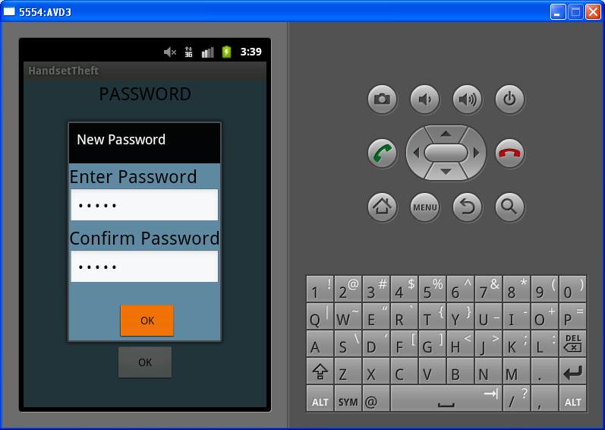

Password Screen:

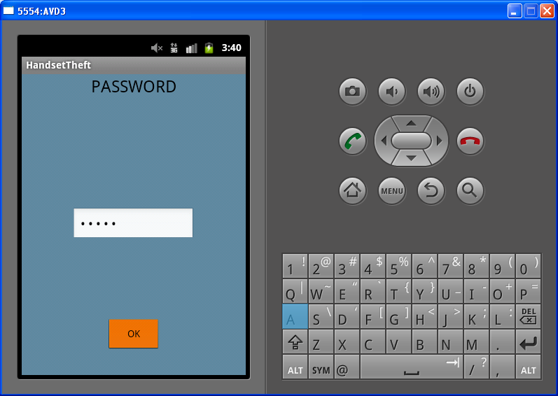

Active Screen:

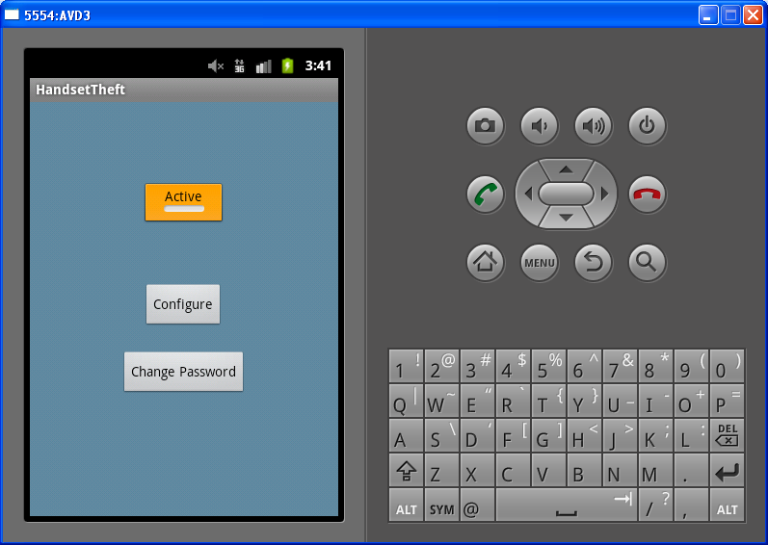

Configure screen:

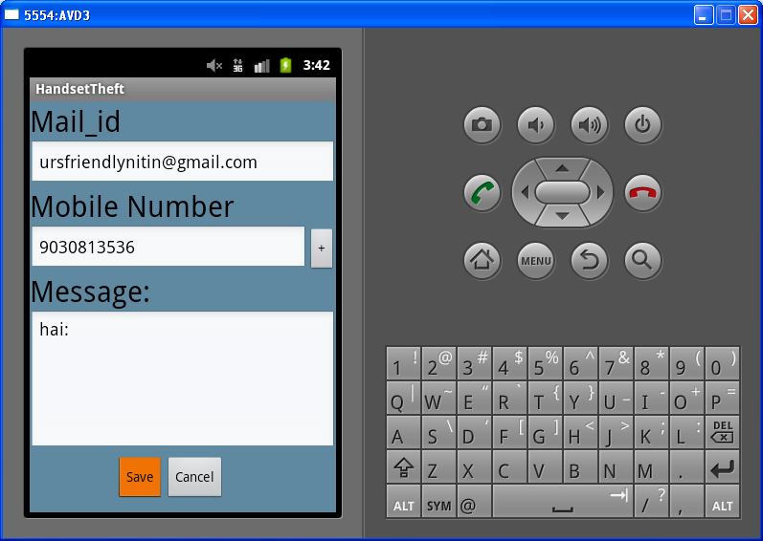

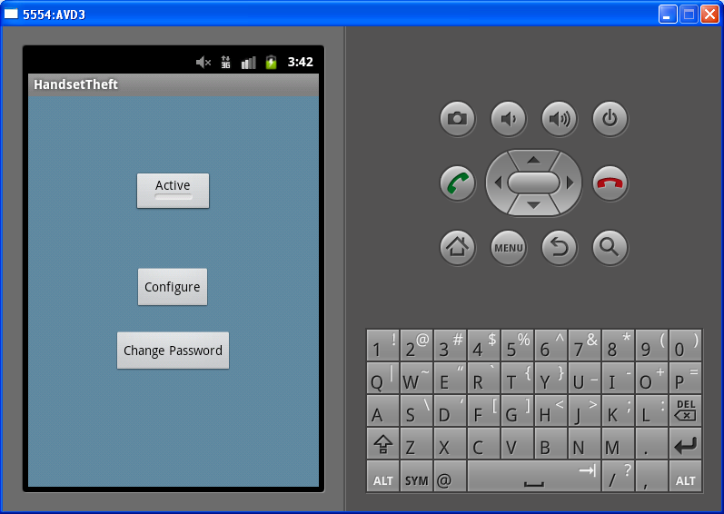

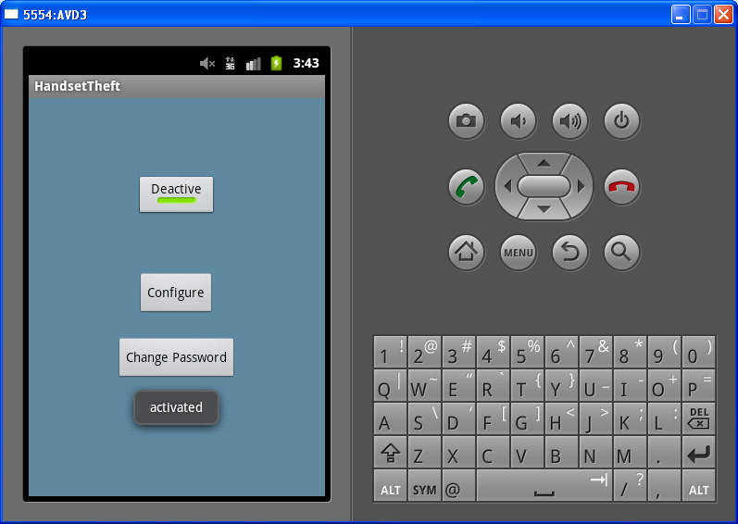

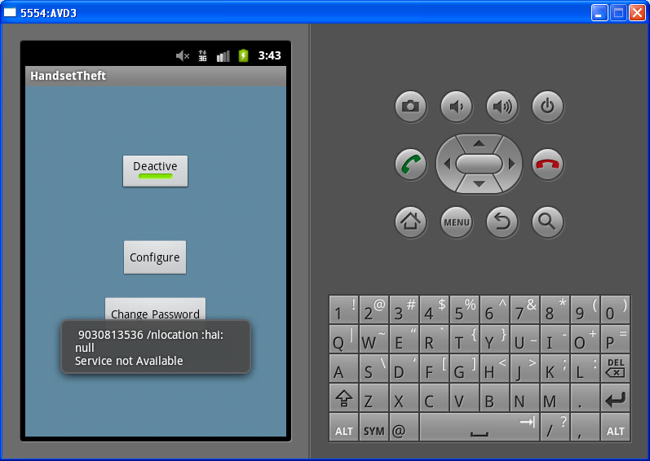

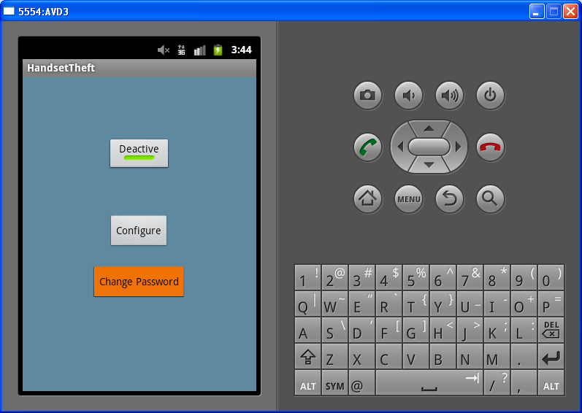

Change password screen:

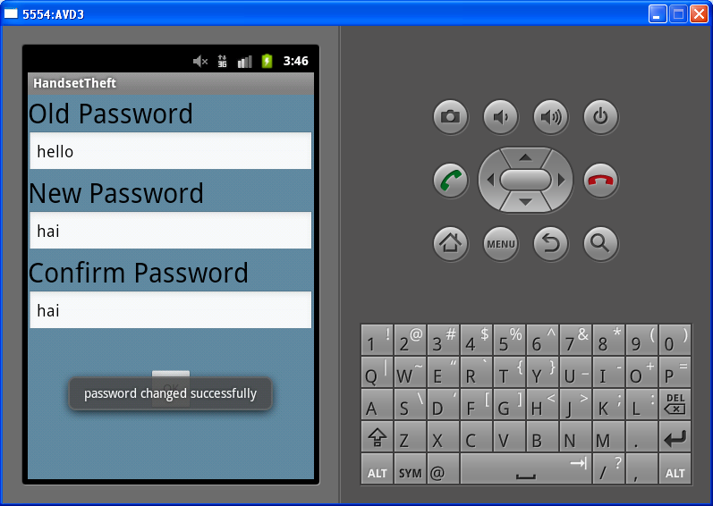

9.FUTURE SCOPE

Through this application we can give the fulfilled information regarding the location of our mobile. There is a chance that the applicant can continuously sends the location through the sms..
So by this we can increase the scope of the application in future…

10.CONCLUSION

Finally we concluded that the “HANDSET THEFT MONITOR” is a application developed on a new mobile platform Android and for the users who used to lost their mobiles frequently. HANDSET THEFT MONITOR is able to make the phone get work even if our sim is not in the mobile. we can also get the details like the numder of new sim inserted and also the GPS location.

11.BIBILIOGRAPHY

http://google.com/
http://android-developers.blogspot.com/
http://androidcommuntiy.com/
http://android.com/

12.APPENDIX

The following terms are used in this document.

.apk extension:
The extension for an Android package file, which typically contains all of the tiles related to a single Android application. The file itself is a compressed collection of an AndroidManifest.xml file, application code (.dex files), resource files, and other files. A project is compiled into a single .apk file.

.dex extension:
Android programs are compiled into .dex (Dalvik Executable) files, which are in turn zipped into a single .apk file on the device. .dex files can be created by automatically translating compiled applications written in the java programming language.

Action:
A description of something that an Intent sender wants done. An action is a string value assigned to intent. Action strings can be defined by Android or by a third-party developer.

Activity:
A single screen in an application, with supporting Java code, derived from the activity class.

Adb:
Android Debug Bridge, a command-line debugging application shipped with the SDK. It provides tools to browse the device, copy tools on the device, and forward ports for debugging.

Application:
A collection of one or more activities, services, listeners, and intent receivers. An application has a single manifest, and is compiled into a single .apk tile on the device.

Content Provider:
A class built on Content Provider that handles content query strings of a specific format to return data in a specific format.

Content URI:
A type of URI. See the URI entry.

Dalvik:
The Dalvik VM is an interpreter-only virtual machine that executes files in the Dalvik Executable (.dex) format, a format that is optimized for efficient storage and memory map able execution. The virtual machine is register-based, and it can run classes compiled by a Java language compiler that have been transformed into its native format using the included “ex” tool. The VM runs on top of posix-complaint operating systems, which it relies on for underlying functionality. The Dalvik core class library is intended to provide a familiar development base for those used to programming with Java Standard Edition, but it is geared specifically to the needs of a small mobile device.

DDMS:
Dalvik Debug Monitor Service, a GUI debugging application application shipped with the SDK. It provides screen capture, log dump, and process examination capabilities.

Drawable:
A compiled visual resource that can be used as a background, title, or other part of the screen. It is compiled into an android.graphics.drawable subclass.

Intent:
A class that contains several fields describing what a caller would like to do. The caller sends this Intent to Android’s intent resolver, which looks through the intent filters of all applications to find the activity most suited to handle this intent. Intent fields include the desired action category, a data string, the MIME type of the data, a handling class, and the restrictions.

Intent Filter:
Activities and intent receivers include one or more filters in their manifest too describe what kind of intents or messages they can handle or want to receive. An intent filter lists a set of requirements, such as data type, action requested, and URI format, that the intent or message must fulfill. For activities ,Android searches for the activity with the most closely matching valid match between the Intent and the activity filter. For messages, Android will forward a message to all receivers with matching intent filters.

Intent Receiver:
An application class that listens for messages broadcast by calling Context.sendBroadcast ().

Layout resource:
An XML file that describes the layout of an Activity screen.

Manifest:
An XML file associated with each Application that describes the various activities, intent filters, services, and other items that it exposes.

URIs:
Android uses URI strings both for requesting data (eg. a list of contacts) and for requesting actions (eg., opening a Web page in a browser). Both are valid URI strings, but have different values. All requests for data must start with the string “content://”. Action strings are valid URIs that can be handled approximately by applications on the device; for example, a URI starting with “http://” will be handled by the browser.

