UML
What is UML?
The Unified Modeling Language (UML) is a standard language for specifying, visualizing, constructing and documenting the artifacts of software systems, as well as for business modeling and other non-software systems. The UML represents a collection of best engineering practices that have proven successful in the modeling of large and complex systems. The UML is a very important part of developing objects oriented software and the software development process. The UML uses mostly graphical notations to express the design of software projects. Using the UML helps project teams communicate, explore potential designs, and validate the architectural design of the software.

Goals of UML:
The primary goals in the design of the UML were:
- Provide users with a ready-to-use, expressive visual modeling language so they can develop and exchange meaningful models.
- Provide extensibility and specialization mechanisms to extend the core concepts.
- Be independent of particular programming languages and development processes.
- Provide a formal basis for understanding the modeling language.
- Encourage the growth of the OO tools market.
- Support higher-level development concepts such as collaborations, frameworks, pattern and components.
- Integrate best practices.

Why Use UML?
As the strategic value of software increases for many companies, the industry looks for techniques to automate the production of software and to improve quality and reduce cost and time –to- market. These techniques include component technology, visual programming, patterns and frameworks. Businesses also seek techniques to manage the need to solve recurring architectural problems, such as physical distribution, concurrency, replications security, load balancing, and fault tolerance. Additionally, the development for World Wide Web, while making some things simpler, has exacerbated these architectural problems. The Unified Modeling Language was designed to respond to these needs.

UML Diagrams:
UML diagrams are designed to let developers and customers view a software system from a different perspective and in varying degrees of abstraction. UML diagrams commonly created using visual modeling tools.

5.1 Use case Diagram:
A use case is a set of scenarios that describing an interaction between a user and a system. A use case diagram displays the relationship among actors and use cases. The two main components of a use case diagram are use cases and actors.
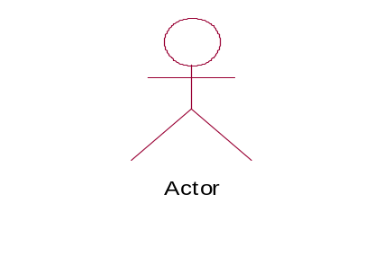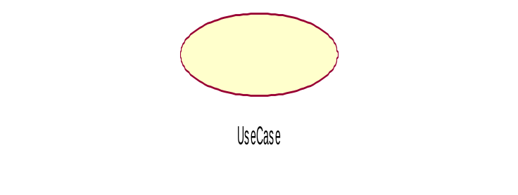
An actor is represents a user or another system that will interact with the system you are modeling. A use case is an external view of the system that represents some action the user might perform in order to complete a task.

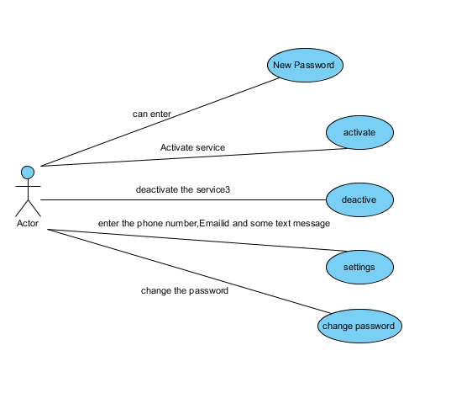

5.2 Class Diagram:
Class diagrams are widely used to describe the types of objects in a system and their relationships. Class diagrams model class structure and contents using design elements such as classes, packages and objects. Class diagrams describe three different perspectives when designing a system, conceptual, specification and implementation. These perspectives become evident as the diagram is created and help solidify the design. This example is only meant as an introduction to the UML and class diagrams.

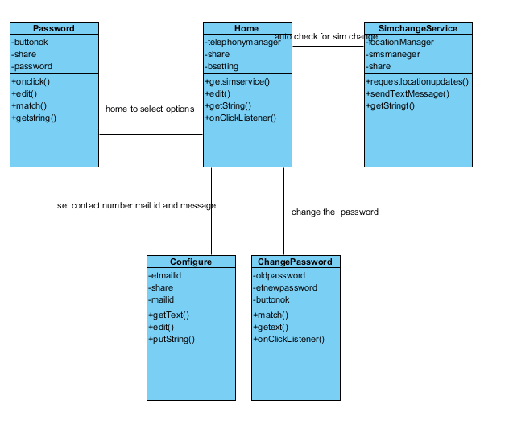

5.3 Sequence Diagram:
Sequence Diagrams demonstrate the behavior of objects in a use case by describing the objects and the messages they pass. The diagrams are read left to right and descending. The example below shows an object of class 1 start the behavior by sending a message to an object of class 2. Messages pass between the different objects until the object of class 1 receives the final message.

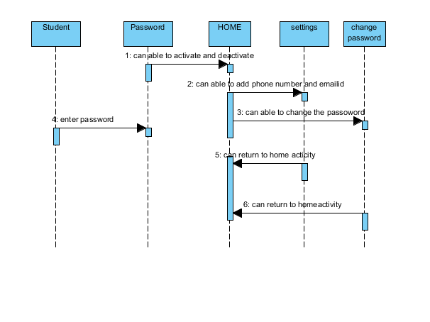

5.4 Activity Diagram:
Activity diagrams describe the workflow behavior of a system. Activity diagrams are similar to state diagrams because activities are the state of doing something. The diagrams describe the state of activities by showing the sequence of activities performed. Activity diagrams can show activities that are conditional or parallel.
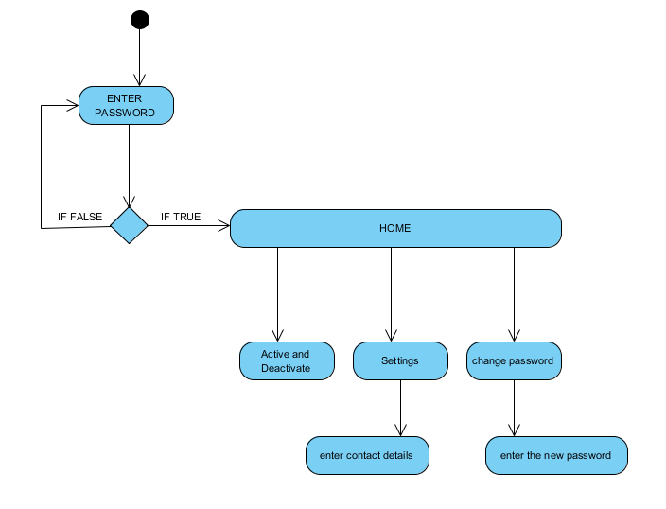

When to use: Activity Diagrams:
Activity diagrams should be used in conjunction with other modeling techniques such as interaction diagrams and state diagrams. The main reason to use activity diagrams is to model the workflow behind the system being designed. Activity Diagrams are also useful for : analyzing a use case by describing what actions need to take place and when they should occur; describing a complicated sequential algorithm; and modeling applications with parallel processes.
However, activity diagrams should not take the place of interaction diagrams and state diagrams. Activity diagrams do not give detail about how objects behave or how objects collaborate.

Deployment Diagram:

Deployment diagrams are a set of nodes and their relationships. These nodes are physical entities where the components are deployed.

Deployment diagrams are used for visualizing deployment view of a system. This is generally used by the deployment team.
