Press releases
This is a collection of example press releases with comments on their language. The releases and the description of their linguistic strategies are meant to help researchers write their own press releases. Still, different contexts, audiences, and personal writing styles will likely require different formulations. While there is no one-size-fits-all solution for writing effective press releases, this collection provides some useful guidelines for science communication.
Examples of press releases with different overall communicative purposes are offered:
- Press release to announce and promote a new publication
- Press release to report on an academic event and promote its results
Press release on a new publication
20.11.2024 15:46
From experts to the public: How science communicators explain complex ideas
Linguist from the University of Zaragoza shows how science communicators take the voices of experts and transform their research into accessible knowledge for the general public.
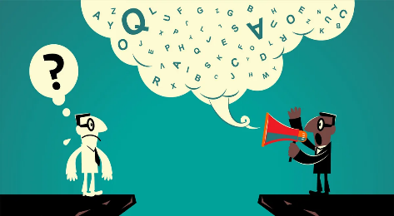
Experts are under increasing pressure to make their research more visible. Many times, the public does not understand what researchers are trying to communicate, and researchers are not trained in explaining their investigation. To find out how experts can solve this problem, Professor Rosa Lorés, a linguist from the University of Zaragoza, has analyzed the language of research digests. Digests are online simplified summaries of new research. The digests from the British Psychological Society that she studied adapt the latest findings in psychology for the general public.
Effective science communication is challenging (Photo: The Fulcrum)
She found science communicators tend to use 10 common strategies. Some of these strategies are used to express the experts’ views, for example, using quotations from the researcher’s original study. In turn, some other strategies are used to simplify complex information for non-expert readers. For instance, by addressing them with “you”, researchers can speak to readers directly. Another case includes giving explanations of technical terms. Professor Lorés quotes a science communicator, explaining that a term researchers define as “hedonistic wellbeing” actually just refers to what we think of as “happiness”.
“Researchers need to think about both language and context when explaining their findings, and this gets complicated when they want to reach both experts and lay users”, says Lorés. In her recent study, she discovered that science communicators most frequently use strategies that mirror the structure and purposes of traditional scientific writing, such as research aims, methods, and findings. What is different is that they put more effort into using everyday terms and they can explain how studies affect us in our daily lives. In short, science communicators reach wide audiences, indicating how the topics and problems they discuss are shared between them and their readers.

Contact:

Prof. Dr. Rosa Lorés. Email: rlores@...

Original Publication:

Lorés, R. (2024). Mediating expert knowledge: The use of pragmatic strategies in digital research digests. Journal of Pragmatics, 232, 26–40. https://doi.org/10.1016/j.pragma.2024.08.007.

Press release on an event
20.11.2024 15:46
“I, Expert” Autumn School: How linguistics can offer guidelines for experts to communicate science with the public
In a world of fake news, how can scientists reach the public in more effective ways?
From 19 to 21 November 2024 a group of linguists from Chemnitz University of Technology (Germany) and University of Zaragoza (Spain) gathered in Zaragoza to share ideas on how to help experts share their scientific findings and knowledge with a wider audience. This Autumn School was part of the project “I, Expert: Media competence for science through linguistics” funded by the DAAD program “Higher Education Dialogue with Southern Europe”.
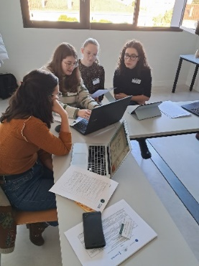
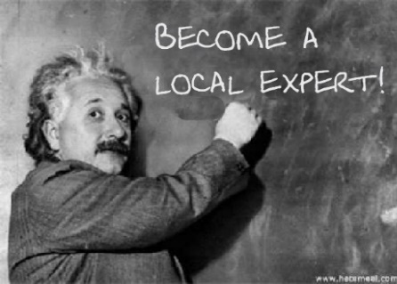
Within the Autumn School, a sequence of workshops brought together international students and junior and senior researchers and teachers working on the language of Twitter/X posts and press releases. Three fruitful days of cooperation resulted in a collection of annotated texts that will be useful for scientists and science communicators. This catalogue will be made available on the project website. Even though Twitter/X posts are very brief, they have diverse aims, communication strategies, and effects. Different types of emoji can also convey different emotions and information: 😀😯🙃 (facial), 🌍💊💰 (pictorial), ↪️✅️❎️ (non-pictorial) or even combinations of these types. Press releases are often the first bridge between experts, journalists, and citizens and offer an opportunity for scientists to exert some control over how their research is conveyed.
Science communication for more visibility of research (Graphic: John Smith (Photo: Pinterest))
Linguistics equips us with a set of instruments for examining the mechanics of science communication. As Daniel Pascual emphasized, “Informative, promotional and interactional pragmatic strategies can be a starting point to appreciate effective choices when writing for the public”. Our project aims to offer a practical toolbox of expressions and specific language features (such as linking words, adjectives, pronouns, expressions) from which scientists can pick and choose to fulfill their communicative needs.
Producing scicom texts during the Autumn School (Photo: John Smith)
The team foresees developing further insights and strengthening institutional links. They will very much welcome feedback from researchers making practical use of the tools developed.

Further information on the Autumn School: https://www.tu-chemnitz.de/phil/english/sections/edling/research/scicom.php#SSc
Contact: Dr Marina Ivanova. Email: mivanova@...
Authors: Patrick McCafferty, Lucía Lasheras, Maja Länder, Pilar Mur Dueñas

