Twitter/X posts
This is a collection of example Twitter/X posts with comments on their language. The posts and the description of their linguistic strategies are meant to help researchers write their own X posts. Still, different contexts, audiences, and personal writing styles will likely require different formulations. While there is no one-size-fits-all solution for writing effective social media posts, this collection provides some useful guidelines for science communication on X.
Examples of X posts with different overall communicative purposes are offered:
- X posts to announce and promote a new publication of a member of a research project
- X posts establishing networks by providing information on a specific academic event
- X posts announcing and describing an event
- X posts in individual accounts announcing research undertaken or published.
X posts on a new publication
X post 1
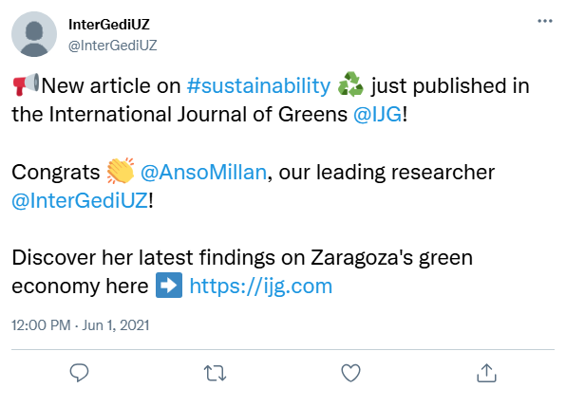
Segment | Strategies | Realisations (verbal, visual)
Loudspeaker emoji 📢 | Interactional: Guiding the audience to perform an action | Visual, pictorial, substituting
New article … just published | Promotional: Promoting accomplishments  Informative: Giving specific details about an event | Promotion through words expressing novelty (new, just)
#Sustainability | Informative: Stating general background / key words | hashtag (#)
Recycling emoji ♻️ | Interactional: Guiding the audience to perform an action | Visual, pictorial, duplicating
In the International Journal of Greens @IJG | Informative: Giving specific details about an event  Interactional: Fostering networks; Offering contacts for information | Journal name; mention (@)
Congrats 👏 | Interactional: Praising and thanking others | Verbal (congratulations); Visual, pictorial, duplicating
@AnsoMillan | Interactional: Praising and thanking others; Fostering networks | Mention (@)
Our leading researcher | Promotional: Accomplishments | Word choice (leading)
@InterGediUZ | Interactional: Fostering networks; Offering contacts for information | Mention (@)
Discover her latest findings on Zaragoza’s green economy here ➡️ | Interactional: Guiding the audience to perform an action | Verbal, directive; Visual, pictorial, duplicating
<link> | Interactional: Fostering networks; Offering contacts for information; Inviting audience to consume project output | Directive (hyperlink)

X post 2
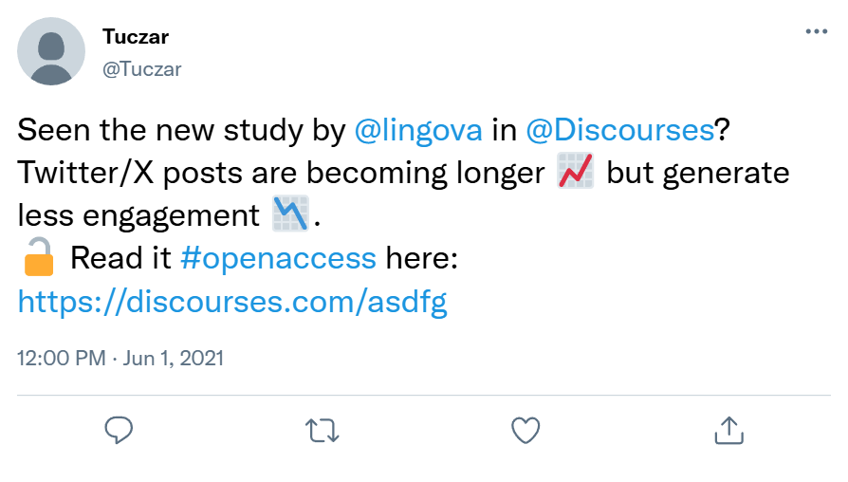
Segment | Strategies | Realisations (verbal, visual)
Seen the new study by @lingova in @Discourses? | Interactional: Inviting audience to consume  project output | Mention of researcher and journal (@); Rhetorical question
Twitter/X posts are becoming longer 📈 but generate less engagement 📉. | Informative: Informing about the result of the research | Clarification (Twitter/X); Emoji (duplicating words, non-facial); but (logical marker)
🔓 Read it #openaccess here: <link> | Interactional: Guiding the audience to perform an action | Emoji (open lock: substituting, non-facial); Hashtag (#); Hyperlink to the paper; Imperative (call to action); here (endophoric marker; interactive metadiscourse)

X post 3

Segment | Strategies | Realisations (verbal, visual)
👀 Check out @someone’s new findings on the language and impact of #scicomm in #Economics just published in the @AdvancedResearch journal! 📰 <link> | Interactional: Guiding the audience to perform an action; Inviting audience to consume project output  Promotional: Accounting for project productivity | Engagement marker (directive: check out); Attitude marker (promotional: new, just); Emojis: Facial duplicating, journal pictorial duplicating
🗣️ Let us know what you think about it ‼️ | Interactional: Guiding the audience to perform  an action | Engagement markers (directive: let us know; reader pronoun: you; exclamation); Non-facial duplicating emoji (opening); Non-pictorial emoji (exclamation marks)

X posts on an event (Autumn school)
X post 1
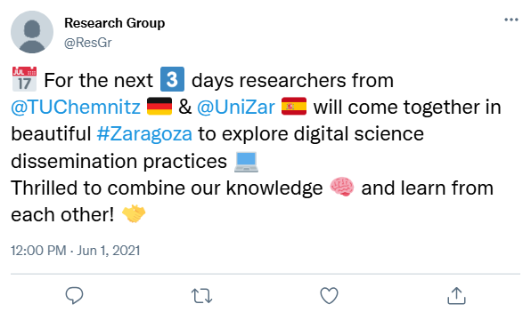
Segment | Strategies | Realisations (verbal, visual)
📆 3 🇩🇪 🇪🇸💻🧠 🤝 | Interactional: Getting the reader’s attention | Visual, pictorial, duplicating emojis
For the next 3 days | Informative: Giving specific details about an event | Duration of event
Researchers from @... and @... | Informative: Giving specific details about an event; Disclosing information about researchers  Interactional: Fostering networks | Mention of the institutions (@)
will come together in beautiful #Zaragoza | Informative: Giving specific details about an event; Hooking the audience | Location specified by hashtag (#)
to explore digital science dissemination practices | Informative: Stating general background of the project | Purpose of the event
Thrilled to combine our knowledge and learn from each other! | Promotional: Promotes collaboration  Interactional: Fostering networks | Adds an emotional aspect

X post 2

Segment | Strategies | Realisations (verbal, visual)
@Tuzcar is organising the 1st international #AutumnSchool 🍂 on digital scientific dissemination in Zaragoza! | Informative: Giving specific details about an event | Self-mention (@); Exclamation (Engagement marker); Hashtag – topicalizer; Emoji (non-facial, duplicating, interactional)
Join us for 3 days of exciting workshops! | Interactional: Engaging audience to participate in the project | Self-mention (Interactional metadiscourse); Directive (Interactional metadiscourse); Exclamation
Find our program and join us via Zoom: <link> | Interactional: Engaging audience to participate in the project | Self-mention: two directives (Interactional metadiscourse); Hyperlink
Follow all updates ⬇️ | Interactional: Engaging audience to participate in the project; Fostering networks | Directive (Interactional metadiscourse); Emoji (non-pictorial, substituting an endophoric marker)

X post 3
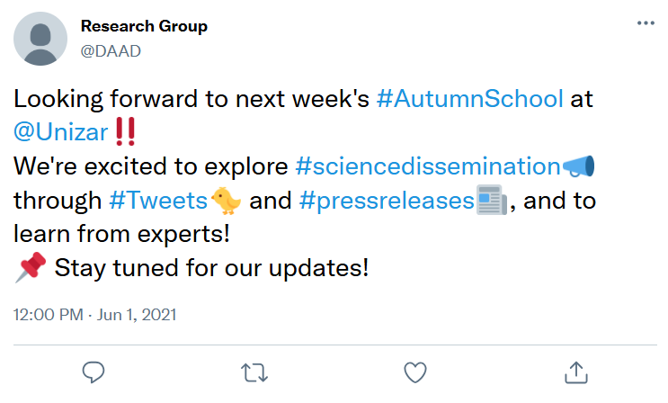
Segment | Strategies | Realisations (verbal, visual)
Looking forward to next week’s #Autumn School in @unizar !! | Promotional: Promoting expected data and accomplishments  Informative: Giving specific details about an event  Interactional: Fostering networks | Hashtag; Mention (university account); Non-pictorial substituting emoji (exclamation marks)
We’re excited to explore #sciencedissemination through #Tweets 🐤 and #pressreleases 📰, and to learn from experts! | Informative: Giving specific details about an event  Promotional: Accounting for project productivity; Promoting expected data and accomplishments | Self-mentions (We); Engagement marker (exclamation); Non-facial emojis, duplicating (loudspeaker, chick, newspaper)
📌 Say tuned for our updates!! | Interactional: Inviting audience to consume project output | Non-facial emoji (pin) as a frame marker; Engagement markers (directive: stay tuned; exclamation); Self-mention (our)

X post on a research project (“I, Expert”)

Segment | Strategies | Realisations (verbal, visual)
Our #DAAD #IExpert project has come to an end! | Promotional: Claiming a project milestone | Exclamation
1. We participated in the #IExpert conference at @TUC where we shared our current research | Promotional: Accounting for project productivity  Informative: Giving specific details about an event  Interactional: Fostering networks | Sequencers: non-pictorial, substituting emoji (number 1); Self-mention (we); Mention of university account (@); Hashtag
2. We participated in the #Autumn School where we explored #scicomm | Promotional: Accounting for project productivity  Informative: Stating general background of the  project | Sequencers: non-pictorial, substituting emoji (number 2); Self-mention (we)
👀 Check out our collection of materials here: <link> | Interactional: Inviting audience to consume project output; Guiding the audience to perform an action | Non-facial, duplicating emoji (eyes); Self-mention (our); Engagement marker (directive: Check out); Attitude marker (new); Endophoric marker (here)

X posts on latest research
X post 1
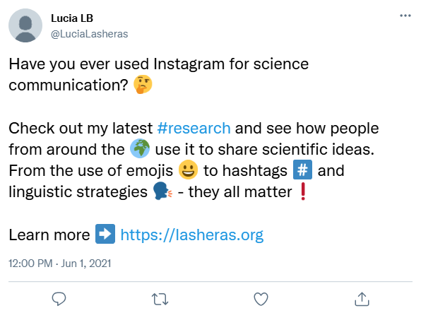
Segment | Strategies | Realisations (verbal, visual)
Have you ever used Instagram for science communication? 🤔 | Interactional: Hooking the audience | Emoji: pictorial and duplicating; Pronouns you, your (engagement marker, interactional metadiscourse); Question (Interactional metadiscourse, Engagement)
Check out my latest #research and see how people from around the 🌎 use it to share scientific ideas. | Interactional: Guiding the audience to perform  an action | Two directives (engagement markers); Logical marker (and); Self-mention (my); Emoji: non-facial, substituting; Hashtag; Imperative (call to action)
From the use of emojis 😀 to hashtags # and linguistic strategies🗣️ - they all matter❗ | Informative: Informing about the result of the  research | Emojis: (smiley) facial and pictorial, duplicating; (hashtag) non-pictorial and duplicating; (talking) non-facial, duplicating; (exclamation mark); Non-pictorial, substituting; Endophoric reference (they)
Learn more ➡️ <link> | Interactional: Guiding the audience to perform an action | Hyperlink, Emoji: arrow: non-pictorial, substituting an endophoric marker; Imperative; Directive
X post 2
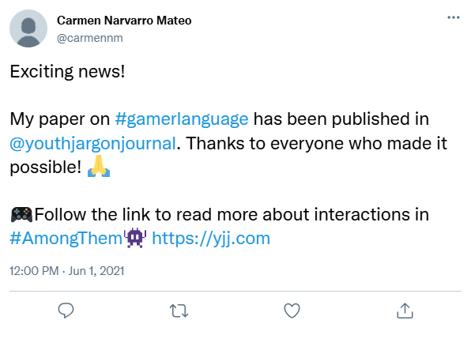
Segment | Strategies | Realisations (verbal, visual)
Exciting news! | Interactional: Hooking the audience  Promotional: expected data and accomplishments | Attitude marker (exciting)
My paper on #gamerlanguage has been published in @youthjargonjournal. | Promotional: Spreading a piece of output; Presenting the content of the outreach  Interactional: Fostering networks | Self-mention (my); Hashtag; Mention (@)
Thanks to everyone who made it possible! 🙏 | Interactional: Praising and thanking others | Engagement marker (Thanks); Emoji: Non-facial, duplicating
🎮 Follow the link to read more about interactions in #AmongThem 👾 <link> | Interactional: Guiding the audience to consume output; Fostering networks | Pictorial emojis used as topicalisers (to open and close the segment); Hashtag, Hyperlink

