Assignment7: Multi Paradigm Problem Solving

Milan Bista

2025 Spring – Advanced Programming Languages (MSCS-632-M51) – Full Term

Instructores: Vanessa Cooper / machica Mcclain

Statistics Calculator: A Paradigm Comparison

Introduction
This report compares the implementation of a basic statistics calculator (mean, median, and mode) across three programming paradigms: procedural (C), functional (OCaml), and object-oriented (Python). The implementations demonstrate the strengths and characteristics of each paradigm while solving the same problem.
GitHub Repository: https://github.com/mbista25742/MSCS-632-M51/tree/main/assignment7

Paradigm Comparison

Procedural Approach (C)
The C implementation demonstrates key characteristics of procedural programming:
- Functions operating on passed data with clear inputs and outputs
- Sequential execution flow with explicit control structures
- Manual memory management (malloc/free for dynamic arrays)
- Direct manipulation of data through array indexing and pointers
Challenges included handling memory allocation for dynamic arrays and implementing the mode calculation efficiently. The procedural nature required careful planning of data flow between functions.

Functional Approach (OCaml)
The OCaml implementation showcases functional programming concepts:
- Immutable data structures with list operations
- Higher-order functions (fold, map, filter)
- Pattern matching for control flow
- Recursion for data processing
- No side effects in core calculation functions
The primary challenge was adapting to the immutable nature of data in OCaml, which required rethinking algorithms traditionally implemented with mutable state. The mode calculation particularly benefited from OCaml's pattern matching capabilities.

Object-Oriented Approach (Python)
The Python implementation demonstrates object-oriented principles:
- Encapsulation of data and methods within a class
- Data abstraction through methods
- Information hiding (private data with getter/setter methods)
- Method organization around the central data
Python's built-in data structures (lists and dictionaries) significantly simplified the implementation. The OOP approach made it easy to maintain state between calculations and provide a clean interface for users.

Conclusion
Each paradigm offered different advantages for implementing the statistics calculator:
- The C implementation provided fine-grained control over memory and execution, ideal for performance-critical applications.
- The OCaml implementation resulted in concise, mathematically elegant code, leveraging higher-order functions to express complex operations clearly.
- The Python implementation offered excellent readability and maintainability, with intuitive organization of related functionality.
The most significant differences were in how each paradigm approached state management and data transformation. While procedural code explicitly managed data flow, functional programming emphasized transformations on immutable data, and object-oriented programming encapsulated both data and operations.
This exercise demonstrates how the same problem can be solved with different programming paradigms, each bringing its own strengths and tradeoffs to the implementation.

Appendix: Screenshots
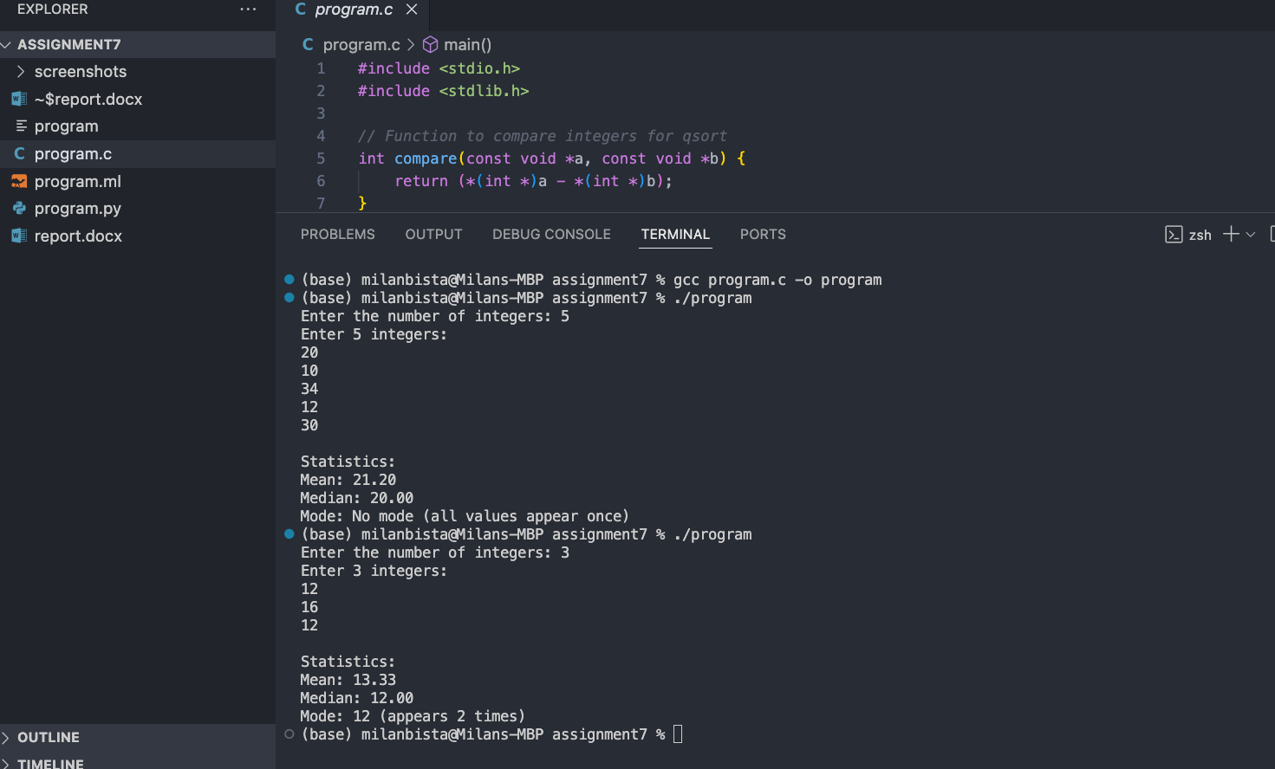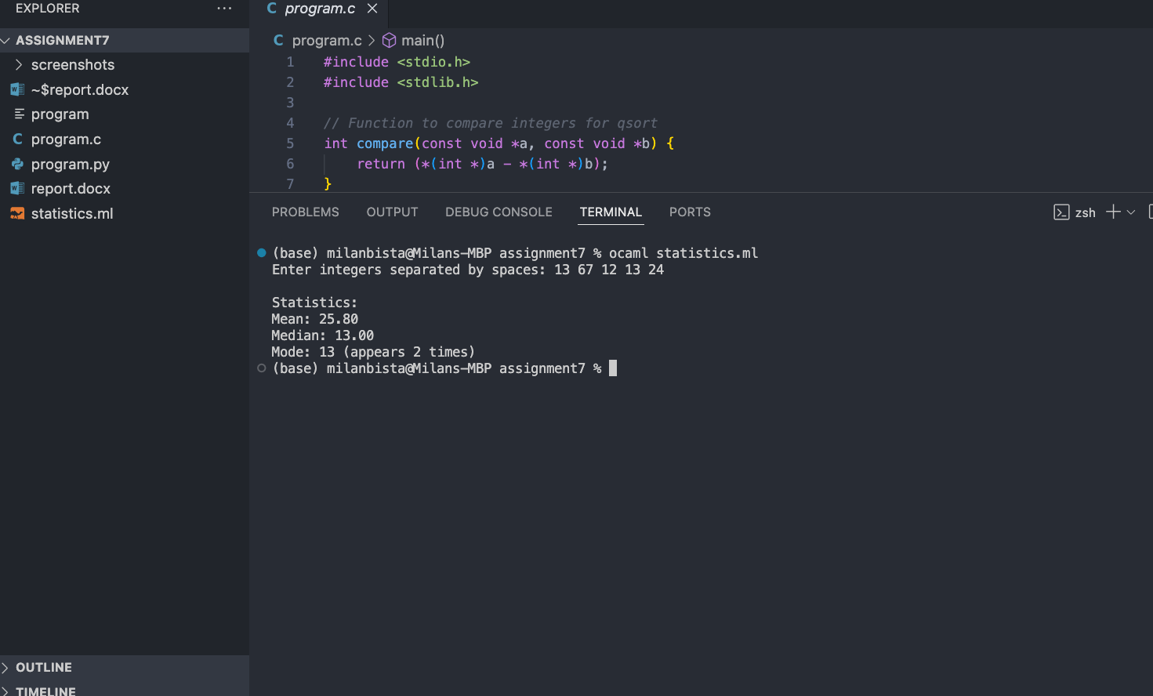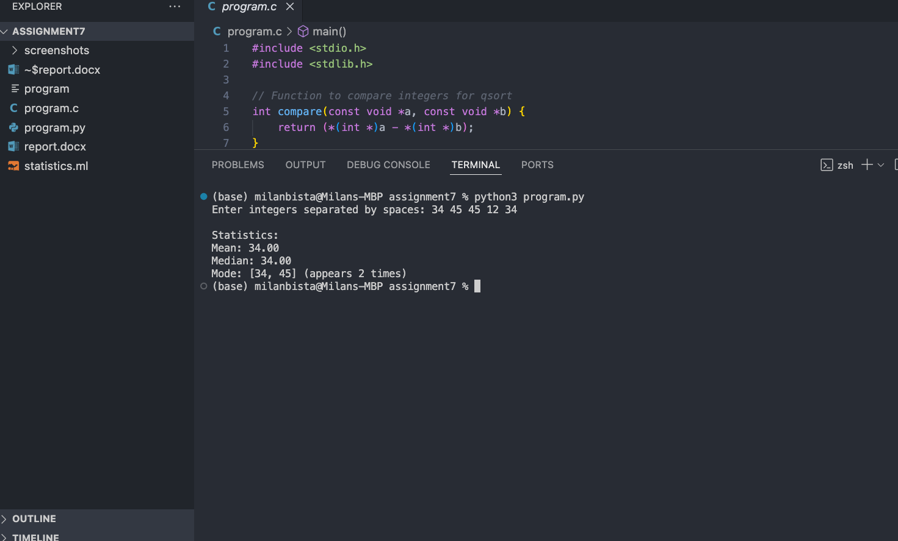

Reference:
Sebesta, R. W. (2018). Concepts of Programming Languages (12th ed.). Pearson Education (US). https://reader2.yuzu.com/books/9780135102251

