**Assignment 2 : QR Code Generator Script Report**

***Milan Bista***

2025 Summer - Advance Artificial Intelligence (MSCS-633-A01) - First Bi-term

*Instructors: Primus Vekuh / Machica Mcclain*

*Github: https://github.com/mbista25742/MSCS-633-A01/tree/main/assignment2*

**1. Introduction**

This document describes a Python 3 script, qr_code_generator.py, which generates QR codes based on a provided URL. If no URL is supplied, the script defaults to generating a QR code for the official BioX Systems website: [https://www.bioxsystems.com](https://www.bioxsystems.com/).

**2. Script Overview**

The script is designed to be simple and efficient, using the qrcode Python package to create QR codes. It supports optional command-line input for URL specification.

**Usage:**

python3 qr_code_generator.py [url]

* If url is provided, the script generates a QR code for that link.
* If no url is specified, it defaults to: https://www.bioxsystems.com/.

**3. Requirements**

To run the script, the following Python package must be installed:

pip install qrcode[pil]

**4. Example Output**

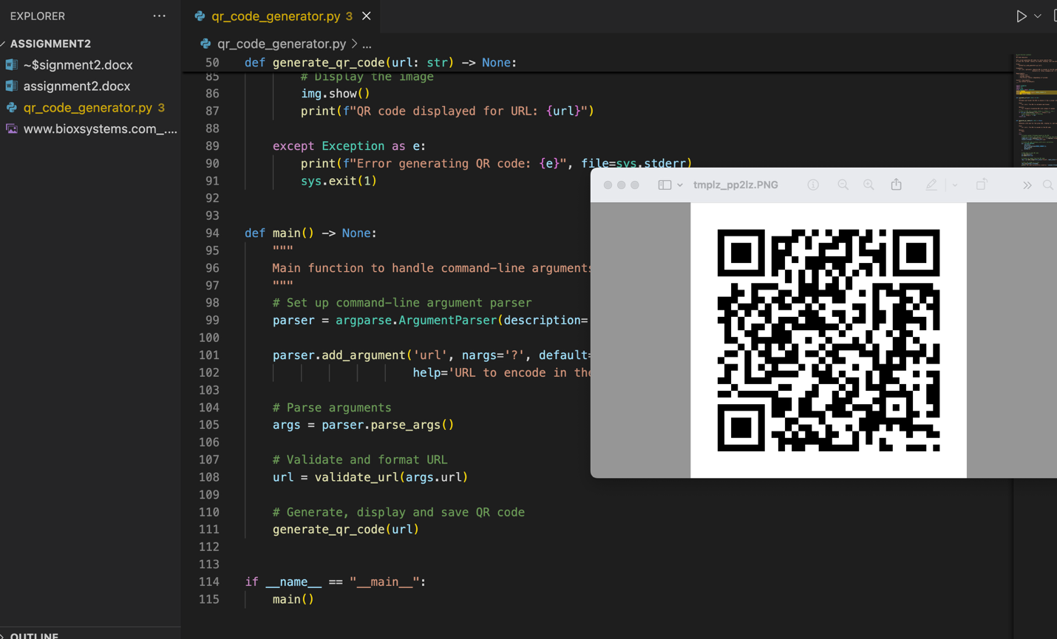

**5. Source Code Repository**

https://github.com/mbista25742/MSCS-633-A01/tree/main/assignment2

**6. Conclusion**

This script provides a lightweight and easy-to-use solution for QR code generation using Python. It is suitable for automation, educational purposes, or integrating into larger projects.

Reference

https://pypi.org/project/qrcode/