WISHBONE SOC VAD

Summary: This document is the verification architecture document for WISHBONE SOC. It is the big picture, 30,000 foot view overall verification strategies document. It describes the overall architecture and implementation for the verification infrastructure (VI) that will surround and verify WISHBONE SOC. The audience for this document is the verification team. They will take this document and create the VI. This document is the mother verification document, and will point to all other verification planning documentation. It will be kept short (under 30 pages) by offloading any areas that grow exponentially (such as coverage, user guide, etc.) or that does not fit with the aim of this document (like detailed requirements which will go into spreadsheet and database).

Revision 0.1
December 14, 2010

Legal Notice and Disclaimer

YOUR COMPANY LEGAL STUFF GOES HERE

Document Location
TBD

Revision History

Rev. | Date | Editor | Description
0.1-0.3 | 14 Dec 2010 | Peet James (mentor) | - Initial Version – Mission, goals, VI block diagram

Table of Contents
1 Introduction 6
1.1 Document Outline 6
1.2 DUT 7
1.3 Mission 7
1.4 Goals 8
2 Strategies 10
2.1 OVM 2.1.1 10
2.2 Documentation generation 11
2.3 Run Management 11
3 Architecture 12
3.1 Verification Infrastructure Architecture Overview 12
3.2 Block Diagram 13
3.3 Layers 14
3.4 Base Components 15
3.5 Work Breakdown : Milestones & Phases 17
4 Implementation 23
4.1 Reuse Methodology and Implementation 23
4.2 Generation Implementation 25
4.3 Checking Implementation 29
4.4 Coverage Implementation 30
5 Requirements 32
5.1 Design Requirements 32
5.2 Verification Requirements 32
5.3 Abstract Design Requirements 32
6 Catch ALL 34
6.1 User Guide 34
6.2 UML Diagrams 34

List of Figures
Figure 1-1: WISHBONE SOC DUT Block Diagram 7
Figure 3-1: WISHBONE SOC Verification Infrastructure Block Diagram 13
Figure 3-2: WISHBONE SOC VI Layering 14
Figure 3-3: Phase Progression 18
Figure 4-1: WISHBONE SOC DITL Top Level 26
Figure 4-2: Usb xyz Format 29
Figure 5-1: Sequence UML Diagram 33

Abbreviations
API | Application program interface
AVM | Advanced Verification Methodology (precursor to OVM)
DDV | Document Driven Verification – Part of VPM that plans & architects a VI, and then records it in a VAD
DITL | “Day in the Life”, use model showing the flow of how the chip is typically setup and used
DR | Design Requirements
DUT | Device under test or Device under verification
HDL | Hardware design language, such as verilog
HVL | Hardware verification language, such as system verilog
IP | Intellectual Property, reusable verification intellectual property
MDV | Metric Driven Verification: gathering useful verification metrics & displaying them in a dashboard
MVC | Mentor Verification Component: VIP for standard interfaces such as WISHBONE, i2c, SPI, etc.
OOP | Object Oriented Programming
OVM | Open Verification Methodology Library
PM | Person Month – One person working one month
RDV | Requirements Driven Verification
RTL | Register Transfer Logic - verilog
SLOC | Source lines of code – how many lines of code is in a particular chunk of code
SS | SuperSequencer – higher level sequencer that controls one or more lower level sequencers
SV | System Verilog
TLM | Transaction Level Modeling
UML | Unified Modeling Language: Software style class or sequence diagrams
VAD | Verification Architecture Document (this document)
VID | Verification Implementation Document -The implementation section of this document expanded into its own separate document if it gets bigger than a few pages.
VIP | Verification Intellectual Property, like Mentor’s WISHBONE MVC
VI | Verification Infrastructure / Verification Environment
VPM | Verification planning & management consulting module given by Mentor consulting at the beginning of the project that god this VAD started.
VR | Verification Requirement

Introduction
This document is the driving verification document for the WISHBONE SOC verification effort. It spearheads a family of verification documents. In fact most other verification documents get there start by initially starting out as a section of this document and then get broken off as they expand in order to keep this document less then 30 pages.
PURPOSE: The purpose of this document is to give the 30,000 to 1,000 foot overall strategy, architecture and implementation approach that will be taken to build the verification infrastructure (VI) that will surround and verify the WISHBONE SOC DUT. It gives the big picture approach and decisions made to facilitate a VI that will accomplish the best and most overall verification in the allotted time. The details are left to the requirements xls/database, but this document chronicles the general methods, layers, phases, components, libraries, scripts, databases, tools, decisions, etc that will be used through out the WISHBONE SOC verification effort.
AUDIENCE: This document is for the verification team. It is a specification to drive the creation and use of the VI. Managers and Designers may also use this document, but it is not written or formatted for them. Other documents will be created for them and their needs. This document describes what the VI will contain and what order we will build it.
OWNERSHIP: This is a living document and it is expected to be updated frequently through out the project.
- D. Heinz

Document Outline
- Chapter 1 states background and defines the project mission, scope and goals.
- Chapter 2 states the overall strategies and methodologies that will be used. 30,000 foot view
- Chapter 3 states the architecture of the Verification Infrastructure (VI) that will be created, block diagram, component list, layers and order of creation (phases) with milestones. 10,000 foot view
- Chapter 4 states further VI implementation details in the area of reuse, generation/stimulus, correctness/checking/scorboarding/assertions, and functional coverage. Details the overall approach, data structures, components micro-architecture, use models, sequences, reference models, etc. 1,000 ft view. These implementation info starts here in the VAD, but will be broken out into 4 separate VID documents later.
- Chapter 5 Is the starting place for requirements. The day-in-the-life (use models) can be put here or in the generation section of chapter 4. Other abstract requirements might go here. This is usually the first chapter that gets broken off into its own document (spreadsheet or database)
- Chapter 6 catchall and link to other documents:
    - Scheduling
    - Users Guide: naming & coding conventions, revision control, file structure, bug tracking, templates, adding a new testcase, environment setup, bug triage, etc.
    - Detailed Requirements xls/database pointer. 1 to 10 ft view
    - Issues Tracking

DUT
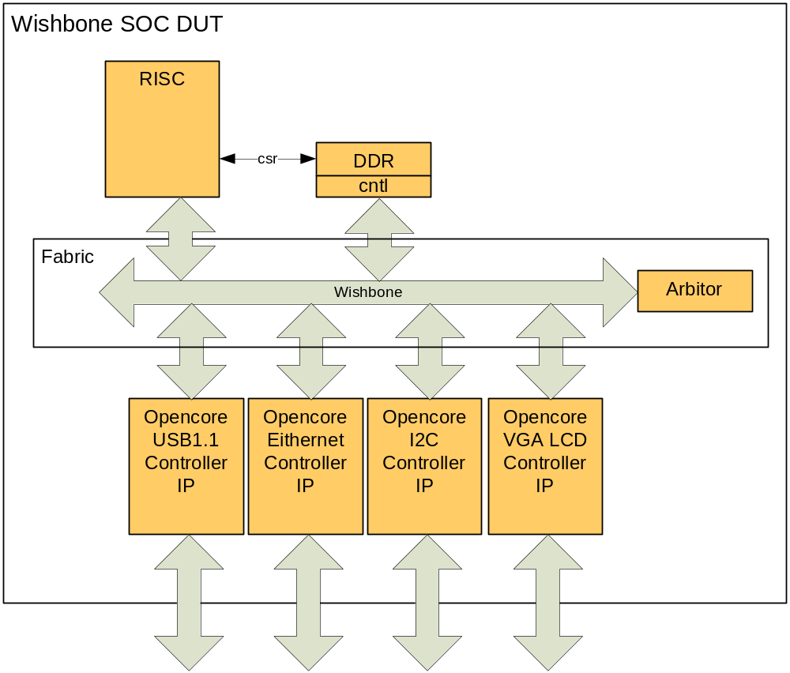
Figure 1-1: WISHBONE SOC DUT Block Diagram

Mission
Background: Previous project’s verification efforts have been done using the verilog HDL language which was not designed specifically for verification. These efforts were done by a segregated verification and design team with the following features:
- Implemented in verilog HDL, with BFMs and some self checking (mostly immediate assertions)
- Verification Plan consisted of a list of directed tests.
- All test were run in regression before release
- Bugs were to be tracked using an internal bug tracking tool. Not other metrics were gathered.

Mission: We will document our verification strategies and processes in a verification architecture document (VAD – this doc) with these characteristics
- Move from a veilog hdl only verification language strategy to a Systemverilog OVM verification language strategy. A layered OOP coding methodology based on the Open Verification Methodology (OVM) library (version 2.0.1) as the base for all code elements, so as to facilitate code reuse and ease of adding to and running the Wishbone SOC VI.
- Use a pseudo-constrained-random generation that aims and models the real use-models of the Wishbone SOC. This generation engine will create aim both typical and interesting real world sequences
- Fully self checking with a collaboration of scoreboards and assertions
- Incorporate a controllable, extensible, set of functional coverage points that collectively can be used as feedback thru analysis to tell the verification team where our random tests went and to guide them where they efforts still need to go until full closure is met.
- All of this will be done with the goal of reusing these verification components from the lower agent, to the subsystem layers and at the chip/system level, as well as future variations of this chip.
Scope: The scope of the project is to first build a library of reusable verification agent for each interface to create a verification infrastructure (VI) to verify each subsystem, and then to reuse and grow the subsystem Vis in various combinations at the WISHBONE SOC level.

Goals
This section divides key verification topics into two categories, goals and a hotlist. Both of these lists came from everyone’s input through an earlier assessment and then a deeper audit done during the Mentor Consulting VPM (verification consulting and planning consulting module). The goals are tied directly to our mission and must be done. They further clarify the verification teams WISHBONE SOC mission. The hotlist is a catch all for everything else. It contains issues that, although important, and most likely necessary to accomplish our mission, are secondary to our Mission. This hotlist is prioritized, and will be implemented according to their priority as time allows. The priority is based on both need and implementation ability. For some items, the necessary money, time or expertise will not be available for this project.

The goals are described in the following list:
- Build a set of reusable basic verification components for each of the WISHBONE SOC interfaces. Each built upon OVM with good OOP strategies, constrainable and random
- Build a reusable testbench architecture that scales from Interface-only verification, full Wishbone SOC verification.
- Build a series of pseudo-random testcase sequences via combination of constraints and OOP extensions to find bugs and regressively functionally verify the functionality of the WISHBONE SOC
- Incorporate a controllable, extensible, set of functional coverage points within a coverage model that will provide useful feedback information to monitor verification progress and to guide further effort.
- Use a layered OOP coding methodology based on the Open Verification Methodology (OVM) library (version 2.1.1) as the base for all code elements, so as to facilitate code reuse and ease of adding to and running the WISHBONE SOC VI.
Table 1-1 summarizes the hotlist with the associated priority and ownership.

Table 1-1: WISHBONE SOC HotList.
Topic | Priority | Ownership | Cost/Benefit
T1. Intellectual Property (IP) Qualification: Need to come up with a process and checklist for IP qualification. To check the IP itself and its accompanying verification code to see what it will and will not do, and if it easily integrates into our FUNCHIP VI. | High | MG Consulting | Static: 0.5PM  Dynamic: 1PM
T2. Code Quality: Linter, Code Coverage, Duplicate code scanner, Good OOP, Doxygen, formal code reviews | Medium | Fred
T3. List of interface assertions based on the all interfaces from their respective compliance documents. | High | Sally
T4. Simulation speed: 1) Performance analysis of simulator: Recoding/Behavioral 2) Linux Frisc expansion 3) Renting more licenses for key push times 4) Running other vendor System Verilog (SV) simulators (interoperability) | Medium | Sam & MG | $125K
T5. Change Management: Stay with SVN, but come up with rules and shame, and enforce them. Have a mustard script for check in, a regression process, a release process (like Peet had in Pilot section). Gather metrics with SVNstat | High | Tom
T6. Scripting: OVM general reporting and self checking married with scripts to run test(s), keep track of seeds and data, and aid in debug. Use new run manager & result analysis in Questa | Medium | MG Consulting
T7. Debug: Bug tracking expanded for what kind of bug and for issues. Gather metrics from Bugzilla. | Medium | MG Consulting
T8. Metric: Verification Dashboard with Functional coverage, code coverage, SVN activity, Bug reporting, etc to gather data for guiding this project and the next. | Low | Sam & Management
T9: User Manual: 1) ROE: Code Template & Conventions 2) Environment Setup 3) SVN rules and how to 4) New testcase creation 5) Running a testcase 6) Running a regression 6 ) Review/Triage a Regression | Medium | Sally

Strategies
This chapter describes the strategic methodologies and technologies that are to be incorporated. Some of these will include information about the why they were selected, and any challenges/risks associated with them.

OVM 2.1.1
The OVM (Open Verification Methodology) is an open source SystemVerilog class library that encapsulates the best practices for developing a verification infrastructure (VI) so that it mwishbonemizes reusability, constrained random generation, functional coverage feedback, and OOP (object oriented programming) capabilities. See www.ovmworld.org

OVM Selection Basis
We favoured OVM over other alternatives as a framework for the following reasons:
- OVM was created and is backed by two vendors and two simulators (Cadence and Mentor).
- OVM is backward compatible with AVM 3.0, mitigating existing AVM testbench integration.
- Future bug fixes and enhancements are expected to be included in OVM.
- OVM includes the infrastructure required to build a dynamically configurable testbench as planned: e.g. the factory and configuration mechanisms
- OVM has many features from the eRM, which will result in easy adoption for our verification lead who has previous Specman/e experience.

OVM Uses
Add OVM subset that we will use here

OVM Risks

Modification over the original OVM library
The OVM have an active development roadmap and new releases will occur during the lifetime of the Wishbone SOC project. It is our plan to use OVM 2.1 for the duration of the WISHBONE SOC project. It is possible that compatibility issues may come up between the new versions and 2.1. We will have to decide which path to take (stick with 2.1 or upgrade) as issues arise.

Interoperability with existing legacy systems
AVM 3.0 (Advanced verification methodology) was used on a pilot SV (SystemVerilog) project. So we have some legacy code we may want to reuse that will introduce some risk on integration efforts.
This risk will be handled as follows:
- OVM use will eliminate the integration efforts with AVM based test benches, as it is fully back compatible with AVM.
- Reuse the expertise from the previous USIF project in integration with legacy systems
- Other cases will be handed on a case-by-case basis and schedule should be adjusted accordingly.

Documentation generation
Having considered both Doxygen and NaturalDocs for documentation of the OVM based environment it was decided to use Doxygen because it is believed that any loss of data in the Doxygen flow was less of a problem that the need to duplicate large amounts of information as comments in the NaturalDocs flow. Doxygen has also been used on previous MENTOR OVM projects.

Run Management
Study Questa Run Management and see if we can interface with our current run management and grow it to be more useful. Add details here later.

Architecture
This section documents the architecting of a VI that will surround the WISHBONE SOC DUT including a block diagram, a list of components, layers, phases of bring up and the milestone for each phase.

Verification Infrastructure Architecture Overview
This VI is architected to deliver on the previous stated Goals. One important goal is to use reusable verification IP when possible. The WISHBONE SOC uses an RISC core, however, the supplied verification environment is Verilog only and does not contain any reusable parts. The use of pre-existent MVC verification components has been considered and is likely to be used at the system level for WISHBONE, and at both system and level for APB. The WISHBONE MVC was of great interest to this project but was not usable because of one of the three deviations from the WISHBONE specification would require a significant change to the MVC. Full details of these changes is recorded in the document (path to be added), a high level summary is –
1. The standard WISHBONE Blah signal has been qualified by an additional signal which allows acknowledge of the data transaction without immediately also acknowledging the address phase. This reduces the need to store addresses when the is busy. It is an optimization used by RISC themselves inside the processor but is not part of the WISHBONE standard. This is the change which would be very difficult to incorporate in the existing MVC models.
2. The RISC processor is allowed to change an address which has been issued but not yet acknowledged, this is a performance enhancement for handling exception jumps, and is not strictly in accordance to the WISHBONE standard.
3. The Wishbone includes optimizations on the I-code interface to allow it perform instruction fetches from sequential addresses without the need to perform a line match on every cycle. To do this, the needs to be aware of when the processor is fetching linear instructions and when it has jumped to a non-sequential location. Some of the internal signals of the RISC are routed to the as WISHBONE sideband signals to communicate various non-linear conditions.

Basic concept
The ultimate aim is to have just one VI that can constrained randomly create all the necessary use cases. This single VI is easily configurable from the top via constraints and extension of code. We achieve this by:
- Using the OVM component structure (Agent: Sequencer, Monitor, Driver: described above and in the OVM documentation).
- Using the layered (hierarchical sequence and sequence) sequence approach of OVM.
- Using the OVM built-in phasing method progression to run tests.

Verification Infrastructure Flow
The reference VI is shown in Figure 3-2. The flow for the test bench execution is as follows:
- User specifies test case to run.
- The IDCPU agent creates (via constraints) a legal configuration of the DUT including:
- As directed from the test case, the top level sequence that starts the appropriate sequences to create stimulus and create interesting scenarios.
- The protocol checkers, the scoreboard(s) will start to issue errors and warnings as needed, the simulator will fill the coverage collection bins, and the pass/fail coverage statistics will be produced automatically.

Block Diagram
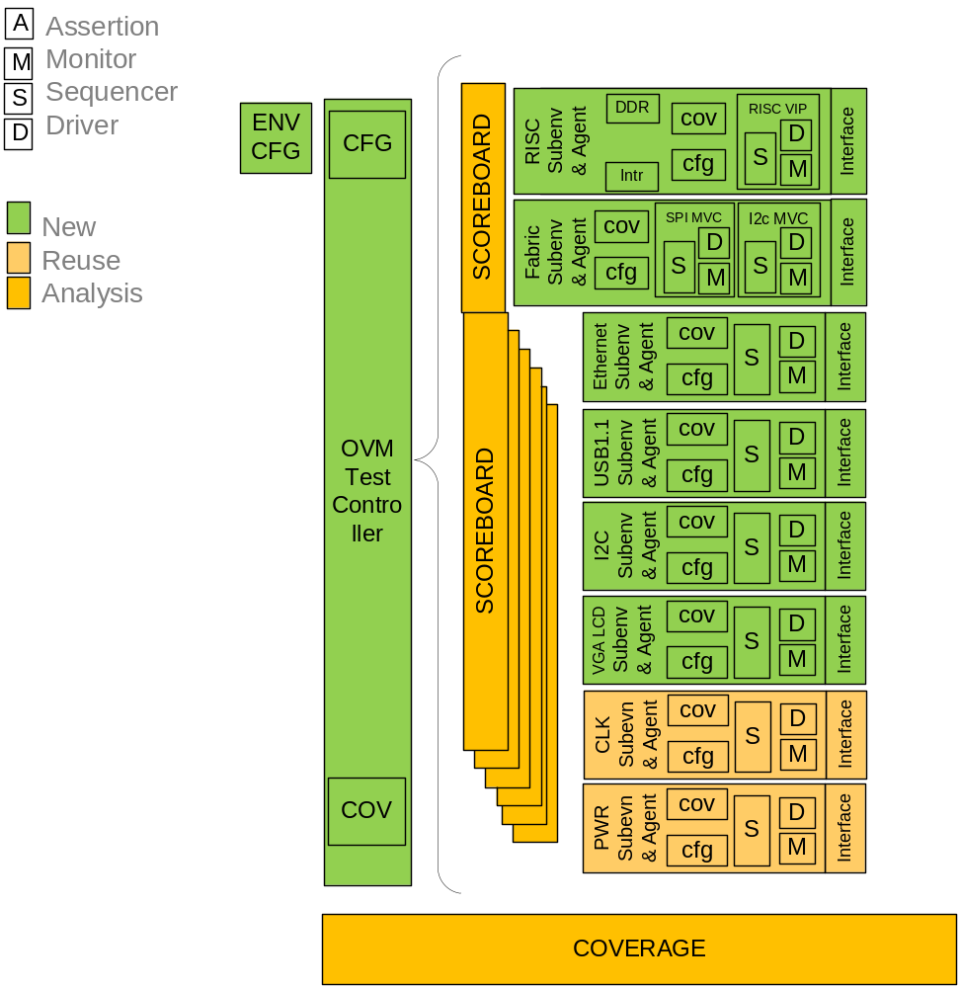
Figure 3-2: WISHBONE SOC Verification Infrastructure Block Diagram

This Architecture Diagram shows the main structure of the OVM testbench, details of how this fits in a phased delivery plan and is reused for other verification tasks is provided later in this document. The small pink hexagons marked “A” indicate areas where assertions will be applied.

Layers
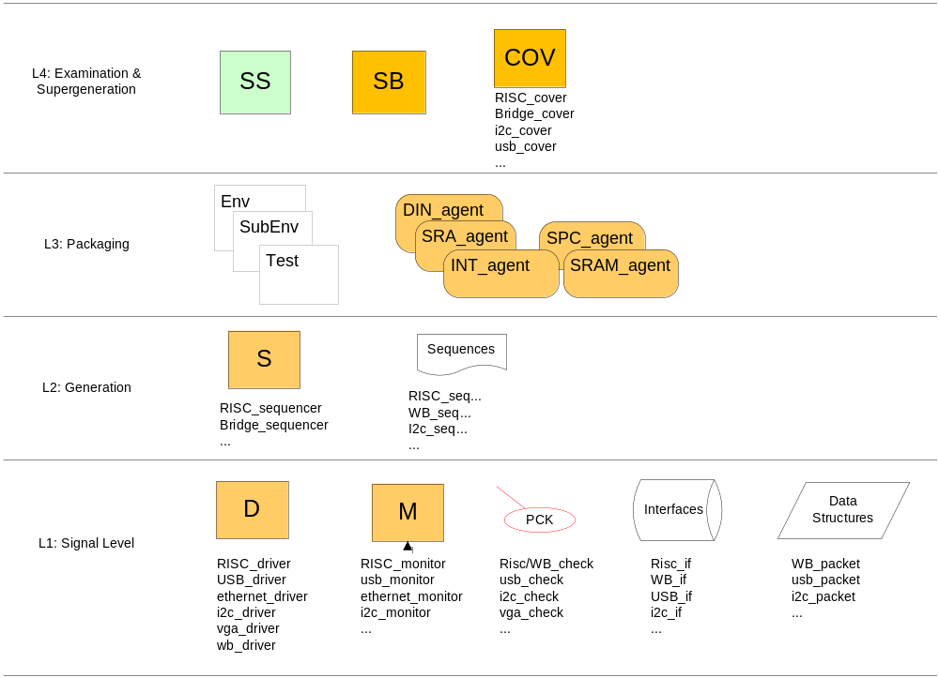
Figure 3-3: WISHBONE SOC VI Layering

Base Components
Table 3-2 summarizes the basic building blocks of the SLE-90 testbench. It includes two kinds:
- Components: A testbench item that will be instantiated at the start of a simulation and remain throughout the entire simulation. Also known as a transactor, something that creates or catches Data Object (transactions). We use the OVM 2.1 meaning of components with its various flavours (agent, driver, monitor, etc.
- Data object: A testbench item that has a life and a death during simulation. Many of these will most likely be created, run their course through the components and the DUT and then die after they are done being used. Also known as transactions, data objects, or data structures, they encapsulate data fields, their constraints, and methods into logical, useable packages.
The details of implementation of these components and data structures will be described in Chapter 4. Here they are listed so that we can see their entirety, assign traceable information to them so as to begin to develop and overall feel, approach and schedule for creation of the SLE-90 VI.
- Name/Sub: Some items are hierarchical and thus have components and sub-components
- Layer: What level of abstraction, as you move away from the DUT, that this code represents
- Phase: The order in which these items will be built in order to achieve various milestones
- Owner: Who will be responsible for architecting, implementing and debugging this code
- SLOC: Estimates of the source lines of code for each chunk of code
Table 3-2: Wishbone SOC Verification Component List
Name | Sub | Type | Desc | Layer | Phase | Owner | SLOC
ID_cpu_agent |  | Component agent |  | L3 | P1
ID_cpu_agent | Instr_driver | Component driver |  | L1 | P1
ID_cpu_agent | Instr_seq | Component  sequencer |  | L2 | P1
ID_cpu_agent | Data_driver | Component driver |  | L1 | P2
ID_cpu_agent | Data_seq | Component  sequencer |  | L2 | P2
ID_cpu_agent | cpu_seq | High level sequencer |  | L4 | P3
ID_cpu_agent | cpu_cov | Component  coverage |  | L4 | P3
ID_cpu_agent | Instr_item | data |  | L1 | P1
ID_cpu_agent | Instr_seq | data  sequence |  | L2 | P1
ID_cpu_agent | Instr_if | interface | Instruction interface description | L1 | P1
ID_cpu_agent | data_item | data |  | L1 | P2
ID_cpu_agent | data_seq | data  sequence |  | L2 | P2
ID_cpu_agent | Instr Monitor (IM) | Component Monitor |  | L1 | P2
ID_cpu_agent | Data Monitor (DM) | Component Monitor |  | L1 | P2
ID_cpu_agent | data_if | interface | Instruction interface description | L1 | P2
debug_agent |  | Component agent |  | L3 | P4
debug_agent | debug_driver | Component driver |  | L1 | P4
debug_agent | debug_sequencer | Component  sequencer |  | L2 | P4
debug_agent | debug_item | data |  | L1 | P4
debug_agent | debug_seq | data  sequence |  | L2 | P4
debug_agent | debug_mon (not shown on diagram) | Component monitor |  | L1 | P4
debug_agent | debug_if | interface | debug interface description | L1 | P4
mem_agent |  | Component agent |  | L3 | P3
mem_agent | MMU_mon | Component monitor |  | L1 | P3
mem_agent | MED_responder | Component responder |  | L1 | P3
mem_agent | mem_item | data |  | L1 | P3
mem_agent | MED_sequencer | Component  sequencer |  | L2 | P3
mem_agent | mem_seq | data  sequence |  | L2 | P3
mem_agent | Skew_cov | Coverage |  | L4 | P4
mem_agent | MMU_if | interface | MMU interface description | L1 | P3
mem_agent | MED_if | interface | MED interface description | L1 | P3
cover | Several groups | coverage | Coverage | L4 | P5
config |  | data | Top level configuration parameters holder SLE-90 | L3 | P5
config | Agent_handshake_config | data | Shared data between CPU and Mem Agents | L3 | P5
bus_sb |  | Component  scoreboard | Scoreboard checking the bus matrix | L4 | P6
_sb |  | Component  scoreboard | Scoreboard for hierarchically divided into instr data mem and cmm with shared data model | L4 | P6
_sb | Instr_sb | Method | Scoreboard code for instr checking | L4 | P6
_sb | Data_sb | Method | Scoreboard code for data bus checking | L4 | P6
_sb | Cmm_sb | Method | Scoreboard code for checking Cmm debug interface | L4 | P6
_sb | Mem_sb | Method | Scoreboard code for checking MEM interface | L4 | P6
_sb | DM | Data model | Shared Reference model of used by above sbs | L4 | P6
env |  | Component  env |  | L3 | P1
Data Monitor (DM) |  | Component Monitor | Monitor on data bus south of bus matrix | L1 | P3
Instruction Monitor (IM) |  | Component Monitor | Monitor on instr bus south of bus matrix | L1 | P3
CMM |  | Component Monitor | Monitor on the debug monitor interface CM | L1 | P3
_test |  | Component test |  | L3 | P1
top_tb |  | module |  | L3 | P1

Work Breakdown : Milestones & Phases
This WISHBONE SOC VI has many components and many layers of code to create the entire environment. To get results more quickly it was decided to break the work up into phases and milestones to strategically bring up the VI in stages to in an orderly fashion. The macro and micro architecture docs will be ready the end of January. The first pass of the RTL will be ready at the end of February (actually delivered ahead of plan on February 12th). Design and early work of the verification environment began in January 2010 and was planned to be initially verified with our own reference model before availability of RTL. However, with early delivery of RTL that phase was no longer required and was dropped, the verification environment being built with the actual RTL DUT.

Milestones
The main milestones identified are as follows:
- M1: one line goal
- M2: one line goal
- a: one line goal
- b: Same as M2, but with the actual
- M4: one line goal
- M5: one line goal
- Expand later to other phases later (I and D sequences, BM SB, etc)

Phases
Each milestone has an associated phase and phases proceed linearly one after the other with the only exception being that P3b might be done before P3a
- P1: Paragraph details
- P2: Paragraph details
- P3a: Paragraph details
- P3b: Paragraph details
- P4: Paragraph details
- P5: Paragraph details
- P6... Future

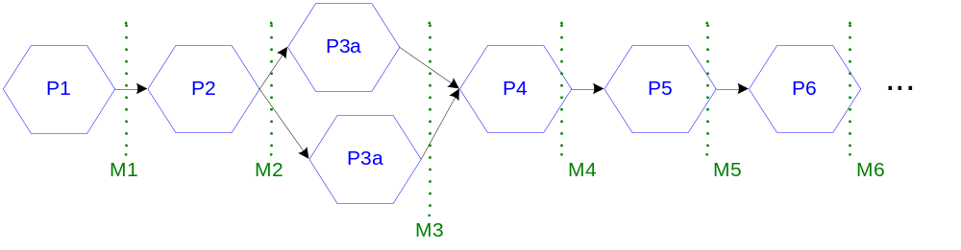
Figure 3-4: Phase Progression

Layer & Phases Matrix
The necessary component work and there layers are described below:
Table 3-2: Layer & Phase Matrix Table
Phases | L1Driver Monitor Responder | L2 Sequencer | L3 Top env Harness Intf | L4 Scoreboard | Assertions | Coverage
Phase1 | Inst _drvr | X | Harness cpu I bus intf | Dut Dummy with I TF | Start thinking assertions as soon as arch spec is done | Start thinking coverage as soon as gen & sb are solid
Phase2 | Mem Responder | X | Harness cpu mem intf | Expand Dut Dummy with mem TF | Decide assertion class schedule | Add coverage info here
Phase3a | X | SI | Harness SI analysis port | X | Add assertions info here
Phase3b  *need BM RTL | DI update? | X | Harness SB I analysis port | Scoreboard Dut Dummy TF migration
Phase4 | DD | X | Harness DD intf | SB AA data structure
Phase5 | X | SD | Harness SD SD to DD anaylisis port | X
Future post RTL Phases Added Here

Phase Diagrams
The following diagrams are provided to show the logical progression of the testbench architecture over time. These diagrams extend beyond the SLE-90 project to ensure that the architecture is designed for reuse in the Core and System level environment.

Phase One
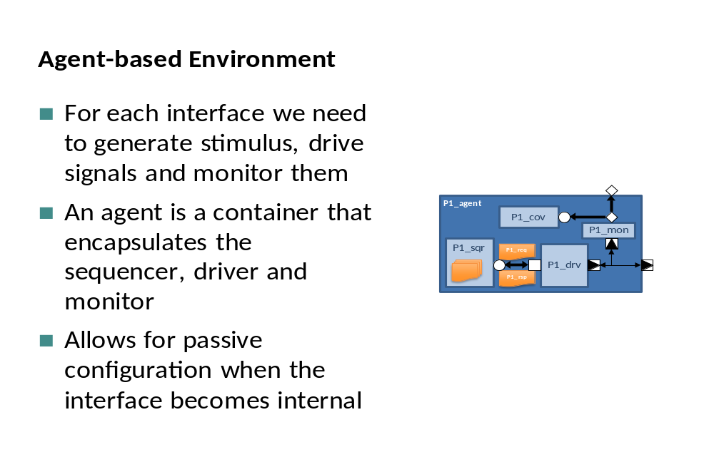
Figure 3-4: Phase 1 – Agent level VI diagram

Simple testbench for learning OVM and investigating if WISHBONE interfaces are simple and can effectively be written by the team, or more complex and should be implemented using the pre-packaged WISHBONE agents (MVC).
Prerequisites
- OVM knowledge from workshop
- Basic WISHBONE understanding
Outcomes/Milestones
- First OVM testbench appropriate to SLE-90 project team
- Understanding and experience of OVM
- Analysis of complexity of WISHBONE interfaces to determine if use of pre-packaged WISHBONE MVC verification IP will be valuable in this project

Phase Two
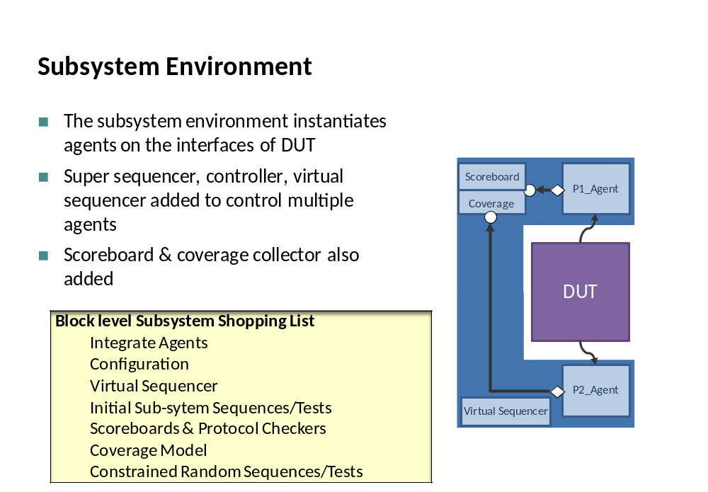
Figure 3-5: Phase 2 – Subenv level VI diagram
Simple testbench for learning OVM and investigating if WISHBONE interfaces are simple and can effectively be written by the team, or more complex and should be implemented using the pre-packaged WISHBONE agents (MVC).
Prerequisites
- OVM knowledge from workshop
- Basic WISHBONE understanding
Outcomes/Milestones
- First OVM testbench appropriate to SLE-90 project team
- Understanding and experience of OVM
- Analysis of complexity of WISHBONE interfaces to determine if use of pre-packaged WISHBONE MVC verification IP will be valuable in this project

Detailed Task List and Schedule
Please refer to the corresponding MS project document. The MS project document refers to the same phases and milestones used in this document

Implementation
The testbench implementation is best described through by following items:
- Reuse Hierarchy & Methodology
  - Agent level
  - Sub env level
  - System level
- Generation / Stimulus: Configuration Sequencing & Traffic Sequencing
  - Flow: DITL, Use Model, UML Diagrams
  - Components: Sequencers, Drivers, Monitors
  - Data Modeling
- Checking: Functional Correctness
  - Scoreboard
  - Assertions
  - Data Modeling
- Functional Coverage:
  - Approach
  - Model

Reuse Methodology and Implementation
The following are the goals of the environment reuse methodology:
- Group and reuse shared agents
- Easy composition from sub-environments
- Make block to chip level reuse easier so that it does not require the development of other environments
- Use the same concept to speed up the development of block level environments
To fulfill the first goal, we identified the shared agents between all the environments and they are:
  - MVC agents
  - Reset agent
  - Clock agent
  - Pin Wiggler Agent
The decision was made to group them in one environment and instantiate it once in the top level environment.
Towards the other goals, a generic base environment that allows composition from sub-environments was developed. This base environment can be extended to implement any hierarchy of environments. Figure depicting the environment is shown below.
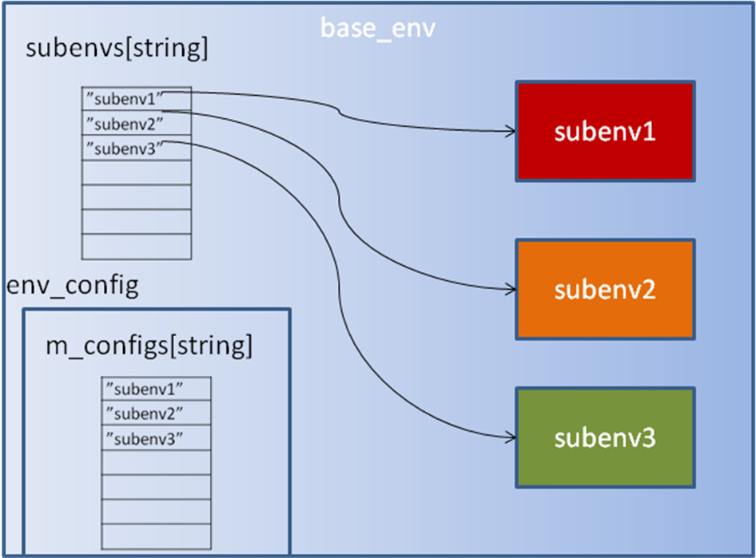
Figure 4-1: Base Environment Diagram Showing Subenvs
The base environment receives a configuration object of type env_config from higher level (typically test). This configuration object has an array of sub-environment configuration objects. Each one of these has a component type associated. This component type determines which environment should be instantiated. The base environment goes over all the configuration objects of the sub-environment, look for the component type and based on it instantiate the corresponding sub-environment and pass it the correct configuration. The UML representation of the base environment and the related configuration object is depicted below.
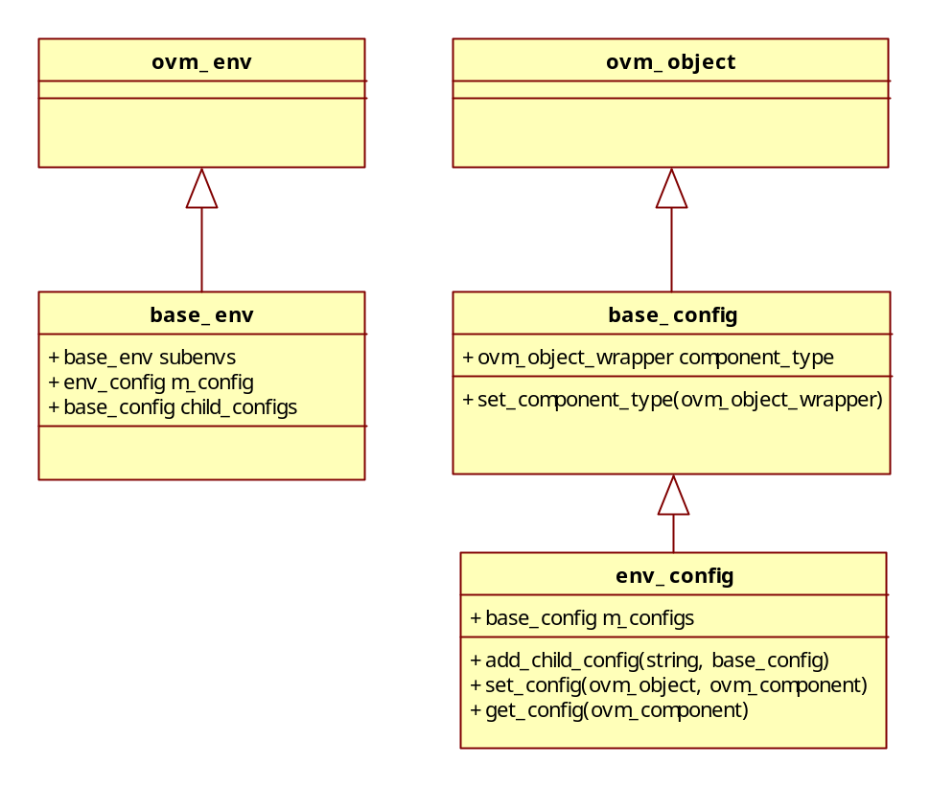
Figure 4-2: UML diagram of base classes

Generation Implementation
Generation for the WISHBONE SOC VI creates a real world users environment that can set up and run the chip in various use models that users might configure the chip. The generation is divided up into three separate lower agents, one for each interface (WISHBONE, Usb & UART), and then a top level FC_seqr to control these lower agents.

DITL / Use Model
The WISHBONE SOC has many use models which are determine upon power up by performing a series of register loads via the WISHBONE interface. Typically, this is done once and the configuration is not changed. This is true for modes A, C, D & E. Modes B and F allow for interrupt driven reconfigurations. Figure 4-1 to the right shows the flows. Table 4-3 below shows configuration A-F. For all modes, once configuration or reconfiguration is complete, the chip enters a traffic mode where corresponding (in line with the configuration) data transfers flow between the various interfaces. Table 4-4 shows the various traffic patterns.
Configuration:
WISHBONE register Loads
Traffic:
Corresponding Data Transfers
Configuration:
WISHBONE register Loads
Traffic:
Corresponding Data Transfers
Interrupt:
WISHBONE interrupt Handling
Modes: A,C,D & E Modes B & F
Configuration:
WISHBONE register Loads
Traffic:
Corresponding Data Transfers
Configuration:
WISHBONE register Loads
Traffic:
Corresponding Data Transfers
Interrupt:
WISHBONE interrupt Handling
Modes: A,C,D & E Modes B & F
Figure 4-5: WISHBONE SOC DITL Top Level

Table 4-3: Configuration Map
Registers |  | Configurations
Registers |  | A | B | C | D | E | F
Master CFG | Value | 16’H5A37
Master CFG | Dependencies
XB CFG | Value
XB CFG | Dependencies
U CFG | Value
U CFG | Dependencies
… |  | … | … | … | … | … | …
RFDG CFG | Value
RFDG CFG | Dependencies

Table 4-4: Traffic Map
Traffic | Configurations
Traffic | A | B | C | D | E | F
Blah1 | x |  | x |  |  | x
Blah2 |  | x |  |  | x | x
Blah3 |  |  | x | x |  | x
… | … | … | … | … | … | …
Blah14 | x |  |  |  | x | x
Component Architecture

Components
The WISHBONE SOC VI has four generation/stimulus engines arranged in two layers. The lower layers include the WISHBONE, Usb & UART agents, each of which go from the pin level to sequence level of abstraction. The FC_seqr is the upper level engine that drives the lower three. Here we will describe the implementation of all four engines from the top down, including their flow (sequence) generation four all four, the driver implementation for the lower 3, and the data models for all four engines.

WISHBONE SOC Sequencer (fc_seqr)
This component, instantiated at the env level, is a virtual sequencer that controls the three lower level sequencers. It implements the WISHBONE SOC DITL use models described above. The fc_seqr will read in a configuration descriptor data model (described below) and then subdivide and transmit this information to the lower three interface sequencers.
- Bulleted details of the fc sequencer go here. Diagrams and tables are used for clarity.

WISHBONE SOC Sequence Library
A fc level sequence here will consist of various legal and illegal configurations.
- Bulleted details of family of sequences and the sequences themselves are described here. Diagrams and tables are used for clarity.

WISHBONE SOC Sequencer Data Models
The fc_seqr has a high level configuration descriptor data model that is built upon a sequence_item class, the hierarchy of which follows the same two level model of the sequencers themselves (top fc level cfg descriptor, 3, WISHBONE, Usb, UART lower level cfg descriptor).
- Bulleted details of the fc configuration descriptor go here. Diagrams and tables are used for clarity. Pseudo code of the data fields (raw, control, informational, physical, etc) and constraints is given. Examples follow:
- The methods or any other useful coding info or style should be included:
function ep_cfg::new(string name);
super.new(name);
// Initialize my_ports to null
my_ports = '{};
// Initialize supported_opcodes to the default opcodes
supported_opcodes = DEFAULT_OPCODES;
endfunction :new
- It bundles all the configuration parameters for all three WISHBONE SOC interfaces, WISHBONE, UART, Usb, and the connections between them.
- It adds an information data field to direct the lower configurations to generate legal or illegal traffic.
- It constructs lower level configuration descriptors for all three lower interfaces, passes them down, and keeps a copy for its own reference.

WISHBONE Agent
This IP is being reused and the details of its sequencer, driver, monitor and data models is outlined in documentation (link here), and will not be repeated here. This WISHBONE IP was chosen because it is an OVC and follows the OVM way of interfacing to a VI. The WISHBONE is configurable and can be used in several different ways. The detailed decisions for its use are outlined here:
- Bulleted details of the WISHBONE OVC IP set up is given here . Diagrams and tables are used for clarity.

Usb Agent
The USB Agent is made up of the Usb sequencer, monitor, driver and data models. All but the monitor (implementation details are explained in the Checking scoreboard section). The Usb agent and all its part are to follow the OVM OVC rules for reuse.

Usb Sequencer
The Usb sequencer is in charge of creating Usb traffic. It may be legal traffic or illegal (error) traffic, based on its own FC_seqr generated usb_cfg.

Usb Sequence Library
A Usb level sequence here will consist of various legal and illegal traffic.
- Bulleted details of family of sequences and the sequences themselves are described here. Diagrams and tables are used for clarity.

Driver (usb_driver.svh)
The Usb driver accepts a transaction from the Usb sequencer, and then pushes the corresponding atomic transaction out onto pins.
- Bulleted details of the driver operations are described here. Diagrams and tables are used for clarity. Examples follow:
- Driver has two local fifos, one for posted transactions and other for non-posted transactions.
- Driver fetches transactions from tlm_fifo and stores the transactions into posted or non-posted fifos based on transaction class.
- It sends posted or non-posted transactions from posted or non-posted fifos based on credits available.
- It also increments or decrements posted and non-posted credits based on posted and non-posted put requests.

Usb Data Models
The usb sequencer and driver each have their own data models.
Usb Sequence Data Model
This data model is responsible for following the FC sequencer derived configuration and to create streams of traffic. These streams of traffic result in a series of atomic transactions being handed down to the driver.
- Bulleted details of the driver operations are described here. Diagrams and tables are used for clarity.
Usb Driver Data Model
This data model is responsible for following the Usb sequencer generated atomic transaction and to creating the corresponding individual data transfer on the actual DUT interface (and pins).
- Bulleted details of the driver operations are described here. Diagrams and tables are used for clarity. Examples follow:
- It contains constraints for all the Usb timing protocol rules.
- It randomly sets to mode blah1 & blah2.
- It randomly selects the amount of data to be read.
- It follows the Usb xyz format shown below

B7 | B6 | B5 | B4 | B3 | B2 | B1 | B0
Destination Addr
Source Addr
Data
Reserved |  |  |  | tag
Figure 4-6: Usb xyz Format

UART AGENT
Blah, Blah, Blah: Similar to the Usb above.

Checking Implementation
Detail here the overall Scoreboard and Assertion strategy, highlighting naming and control to be able to turn various assertion groups, or individual assertion, or the scoreboard, or parts of the scoreboard on or off.

SBC Scoreboard
The WISHBONE SOC scoreboard is divided into two scoreboards based on the direction of the data, Usb to UART and UART to Usb.
- Bulleted details of the scoreboard operations are described here. Diagrams and tables are used for clarity.
This section can be further divided up into transfer function / reference model, data structure, compare, etc.

Monitors
The monitors (WISHBONE, Usb, UART) reside in their respective agent. The WISHBONE monitor is only used to sniff the WISHBONE bus for its built in protocol checker to make sure all WISHBONE operations are legal. The Usb and UART monitors likewise have protocol checkers (see below), but also sniff their respective buses and extract operations and packs them into their respective data models, and then passed to the scoreboards.
- Bulleted details of the monitor operations are described here. Diagrams and tables are used for clarity.

Scoreboard Data Models
The scoreboards will use the same driver data models described in the generation section.

Assertions
Assertion areas preliminary list:
- Interfaces: I, D, MMU, MED
- Two Write Buffers
- 3 FSMs

The assertion implementation section can be divided two ways.
- Have one big table with all assertions entered. One of the columns specifies the category of assertion. This method lends it self into using a requirements database. See Table 4-3 below as an example.
- Divide the assertions into categories, such as protocol, internal, immediate, etc. They can be further sub-divided globally by interface or mode, etc, and/or by further sub-categories such as FSMs, FIFOs, etc.
Number | Section | Name | Description | Category | Link | Type | Priority | Owner | Effort
1 | Usb_abc_1 | Ast1 | sdfasdf | Protocol | Chk_ast_abc_1 | Assertion | I | Fred | 3
2 | UART_def_5 | Ast2 | trwetr | FSM | Chk_ast_def_1 | Assertion | I | Sally | 1
3 | WISHBONE_ghi_6 | Ast3 | gkjkk | Immediate | Chk_ast_ghi_1 | Assertion | III | Ralph | 1.5
4 | Mode_jhk_32 | Ast4 | retwtw | FIFO | Chk_ast_jkl_1 | Assertion | II | Sam | 0.5
Table 4-5: Assertion List

Protocol Checkers
This actor is SBC signal level protocol checker.
- It inserts EOM that lasts for one cycle for each stream of put signals.
- It covers back-to-back posted and non-posted transactions.

Coverage Implementation
This reads all testbench SystemVerilog files, generating the HTML view of the design, including UML diagrams. Next, the Firefox browser is launched and a page displayed allowing you to click into each source file, displaying UML diagrams for inheritance, method descriptions, data descriptions, and other information.

Preliminary coverage areas:
- Fsm coverage
- Generation coverage
- Skew in transaction handler

Requirements

Design Requirements
These are a list of the high level design requirements created with the design team. The design team has signed off on them and agrees to update this table if the design spec or the implementation changes.
Table 5-6: Design Requirements List
Number | Section | Description | Issue | Clarific-ation | Block | Priority | Owner | Effort
DR1 | Usb_abc | Sdfasdf fgsdf ytyr ghjh | sdfsda | asdfa | usb_cntl | I | Fred | 4
DR2_AB | UART_def | Trwetr f asdf dsaf hg | qsvhu |  | uart_fsm | I | Sally | 2
DR3 | WISHBONE_ghi | Gkjkk dsfg dfssdf |  | erwe | wishbone_intf | III | Ralph | 1.5
DR4 | Mode_jhk | Retwtw d dsg sdfg rdff |  |  | jhk_cntl | II | Sam | 7

Verification Requirements
These are a list of the high level requirements created with the design team. The verification team has signed off on them and agrees to update this table if the design spec or the implementation changes.
Table 5-7: Verification Requirements List
Number | Section | Description | issue | Clarific-ation | Link | Type | Priority | Owner | Effort
VR1 | Usb_abc | sdfasdf | tgtnff |  | Gen_ast_abc_1 | CoverPoint | I | Fred | 3
VR2 | UART_def | trwetr |  | vuggfg | Chk_sb_def_1 | CoverGroup | I | Sally | 4
VR3_AB | WISHBONE_ghi | gkjkk |  |  | Chk_ast_ghi_1 | Assertion | III | Ralph | 1.5
VR4 | Mode_jhk | retwtw | sadffd | btgjdsd | Cov_ast_jkl_1 | CoverItem | II | San | 0.5

Abstract Requirements
Abstract design requirements are a layer over conventional design requirements. Abstract requirements reorganize, group, and graphically capture the conventional design requirements in a more understandable way. Examples include: tables, flow graphs, bubble diagrams, y-tree diagrams, sequence diagrams, etc., anything where a picture is more clear than a bunch of words. This helps to elaborate more on the system understanding, and to introduce new interesting verification requirements. An abstract requirement is entered and linked into the standard requirements list as non-abstract requirements, but it has a naming convention (such as the _AB added to the number in the above two tables) that is a flag to the abstract description. What follows is some examples of such diagrams:

Abstract Requirement Example : Sequence UML diagram

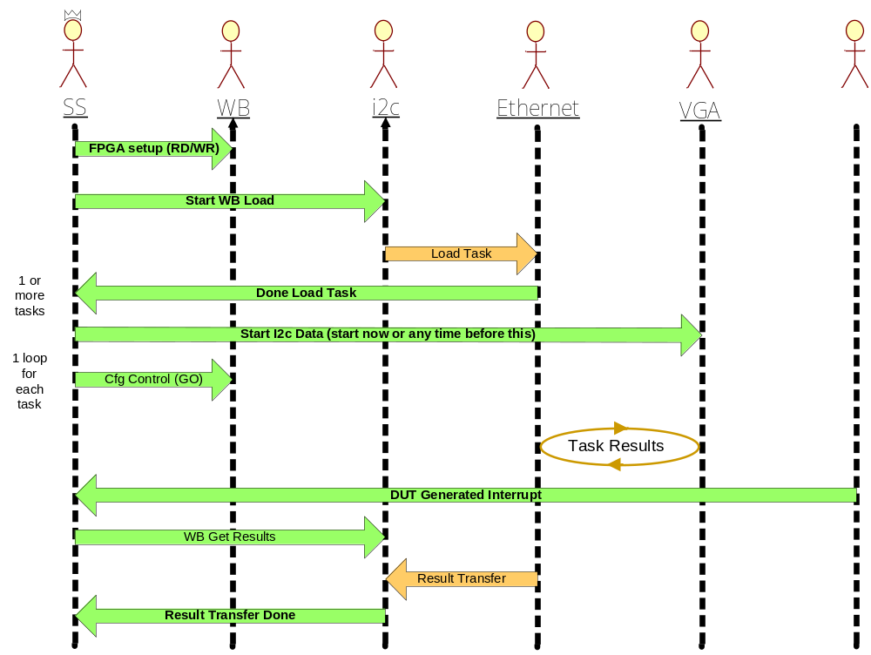

Figure 5-7: Sequence UML Diagram

Catch ALL

User Guide

UML Diagrams

