NOTE: ALL QUERIES ARE STORED IN queryInput.txt

1. Fines owed by each member (Daily fine rate: $0.25 per day)

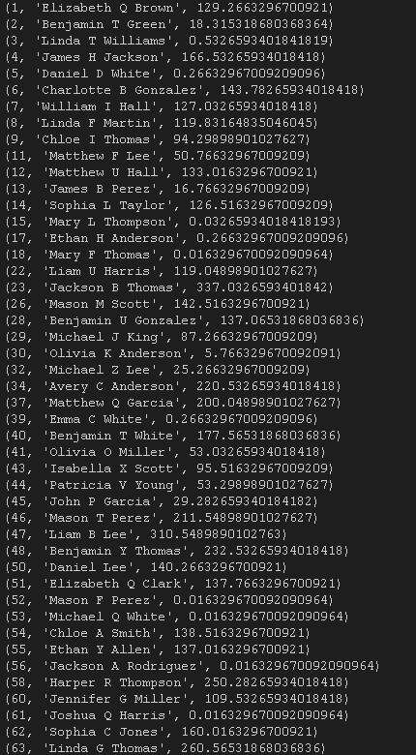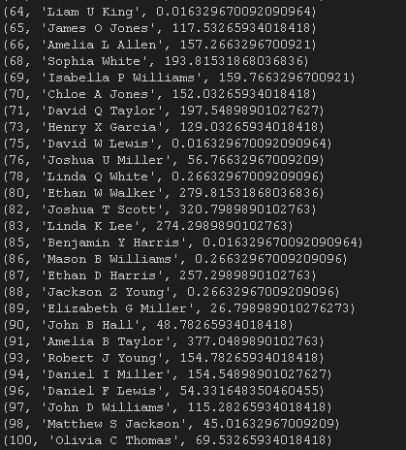

Physical Book, eBook, and Audiobook Availability (Genre: Mystery)

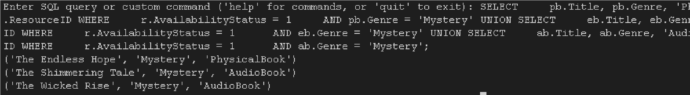

Top 10 Frequent Borrowers of Crime in the last year in Physical Books, eBooks, and Audiobooks combined

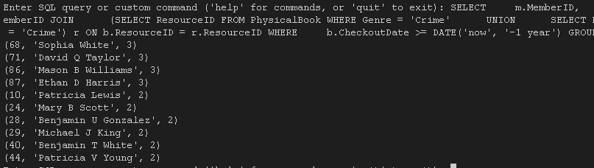

Sort Books Due Soon in a Week

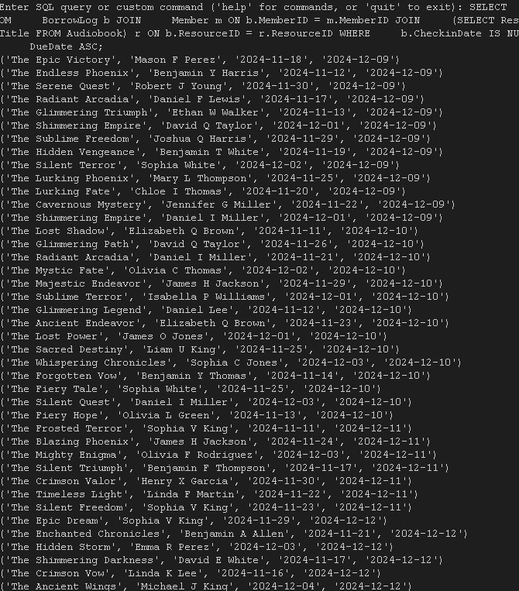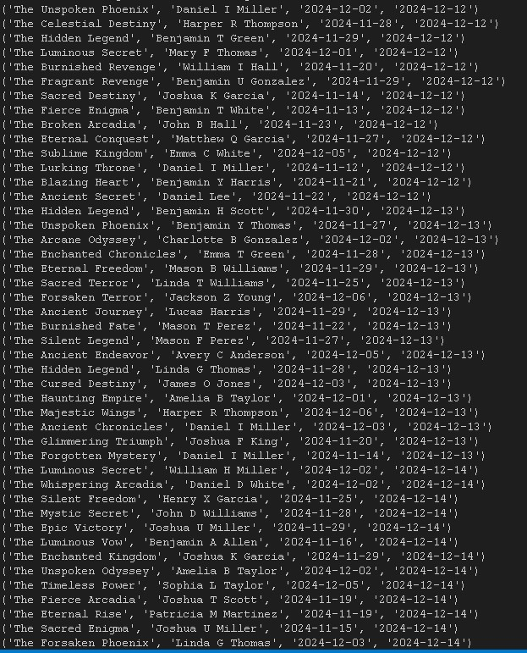

Members with Overdue Books

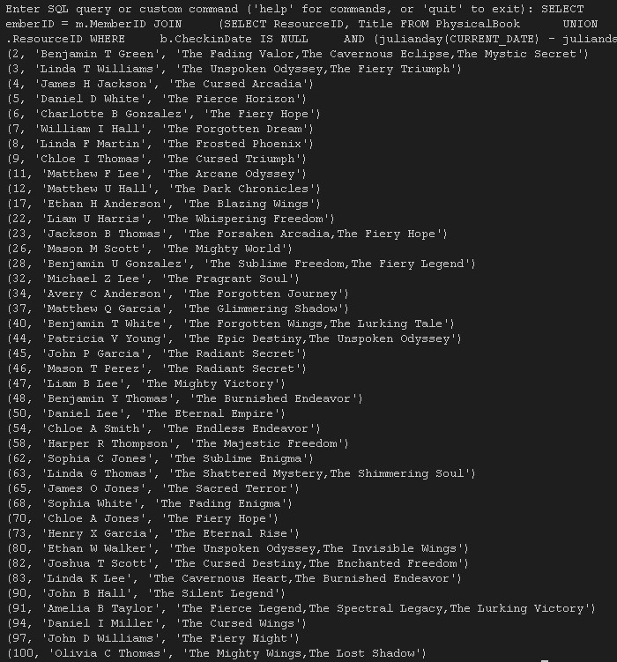

Average Borrow Time for Fantasy eBooks, PhysicalBooks, and AudioBooks

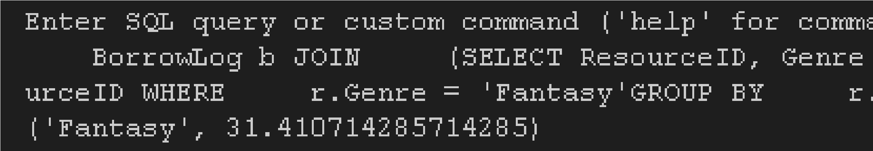

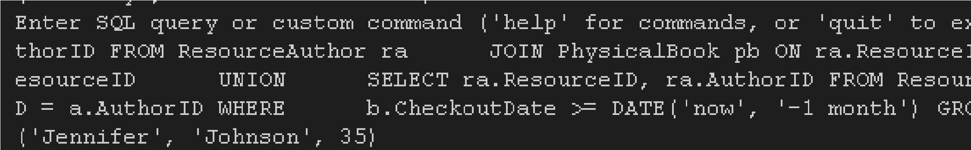Most Popular Author from One Month