**2019下半年高中英语学科教师资格证面试试题（精选）第二批**

2020-01-04 17:27:03

学员回顾

|  |  |  |  |  |
| --- | --- | --- | --- | --- |
| **2020广西教师资格统考相关资讯** | | | | |
| [笔试公告](http://gx.zgjsks.com/html/2019/ksgg_1217/35149.html) | [报考条件](http://gx.zgjsks.com/html/2019/ksgg_1217/35150.html) | [报名入口](http://gx.zgjsks.com/html/2019/bmrk_1217/35146.html) | [缴费入口](http://gx.zgjsks.com/html/2019/bmrk_1217/35147.html) | [时间安排](http://gx.zgjsks.com/html/2019/ksgg_1217/35151.html) |
| [备考讲座](http://gx.zgjsks.com/html/2019/bkhd_1215/35128.html) | [资料领取](http://gx.zgjsks.com/html/2019/bkhd_1227/35299.html) | [笔试课程](http://www.51gouke.com/gxnn/13-37-gk8275.html) | [网校](http://shop.eoffcn.com/jz/19/b6a3924d6ad8460490946b2211ab7d4c/?yearCode=202013) | [汇总](http://gx.zgjsks.com/html/2019/ksgg_1217/35148.html) |
| [**点击加群：广西教师资格1群632334037**](https://jq.qq.com/?_wv=1027&k=5D3oTE8) | | | | |

**本次教资面试试题来源于学员回忆与真实试题存在偏差，仅供参考。**

**高中英语 听力**

一、考题回顾

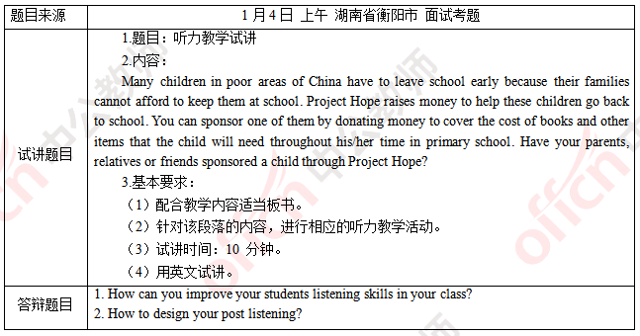

二、考题解析

【教案】

Project Hope

Teaching aims:

Knowledge aims:

Students can know something about Project Hope and other non-profit organizations.

Ability aim:

Students will improve their listening abilities of getting detail information.

Students can develop the skill of prediction.

Emotional aim:

Students can foster the awareness of helping others.

Students will increase their confidence of speaking English.

Key and difficult points:

Key point:

To understand the listening material.

Difficult point:

To cultivate their awareness of helping others.

Teaching procedures:

Step 1: Warming-up

1. Greetings.

2. Show the logo of some famous organizations such as Red Cross, UNESCO, APEC and so on.

Ask students to guess them and lead out the topic of the class.

Step 2: Pre-listening

Show the trailer of Project Hope, and ask them what kind of the project it is? And ask them to predict about what kind of information about the Project Hope may be mentioned in the passage.

Step 3: While-listening

1. Extensive listening

Read the passage for students and ask them to check whether their prediction is right or not. Then invite one student to write the answer on the blackboard.

2. Intensive listening

Play the tape and ask students to fill in the mind map on the blackboard.

Step 4: Post-listening

Ask students to do some pair work to introduce their favorite association to the partner. Then invite some them to share.

Step 5: Summary and Homework

Summary: invite a student to be an assistant teacher and summarize today’s lesson.

Homework: ask students to design the logos of their own association.

Blackboard design:

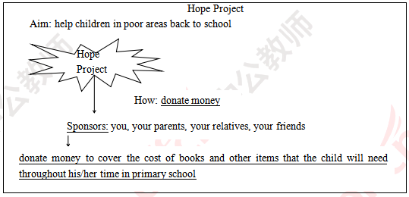

Teaching reflection

【答辩题目解析】

1. How can you improve your students listening skills in your class?

1.怎样在你的课堂上提升学生的听力技能?

【参考答案】

I will teach them some listening strategies and skills in every step during my teaching procedure to improve my students’ listening skills.

In pre-listening, I will play some relative videos or show some relative pictures and ask them to have some predictions, which can improve their skills of prediction. During while-listening, I will play the tape of the listening material twice. At the first time, I will ask them some questions about the main idea of the material to improve their extensive listening ability. At the second time, students should take some notes, and I will ask them to fill the blank or mind map to help them master the detailed information of the material. In this way, students can improve their intensive listening skill.

我会在我教学过程中的每一个环节渗透不同的听力策略与技能，以此来提升学生的听力技能。首先在听前的环节，我会通过播放或者是展示与材料相关的视频或者是图片让学生对文章主题进行预测，以此来锻炼他们的预测与推断的能力。其次我会在听中的环节，让学生听两遍。第一遍通过问学生一些关于文章大意的问题来提高学生泛听的能力。第二遍精听，在精听的时候要同学们学会做笔记，以表格或思维导图的形式来检测学生对文章细节性信息的把握，锻炼学生精听的技能。

2. How to design your post listening?

2.如何设计一个听后环节?

【参考答案】

As pre-listening and while-listening are the steps of input. I will pay more attention to the output during post-listening. I will design a series of communicative activities such as, discussion, survey, role play or debate and ask students communicate with each other by using the target knowledge. I will give them certain time, and divide them into several groups, besides I will give them a certain topic to ensure the activities go on orderly and effectively.

听前和听中的环节主要是一个知识输入的环节，所以在听后的环节我会更加注重学生对所学知识的输出。我会设计一系列交际性活动，比如讨论，调查，角色扮演，辩论等让学生运用所学知识去进行交流。在进行这些活动的时候，我会给出一定的时间，并且让学生进行小组交流，之后会确定一个话题确保活动的有效有序进行

**2019下半年高中英语学科教师资格证面试试题（精选）第二批**

2020-01-04 17:27:03

学员回顾

**2019年下半年教师资格面试-英语学科-考题解析**

**高中英语 听说**

一、考题回顾

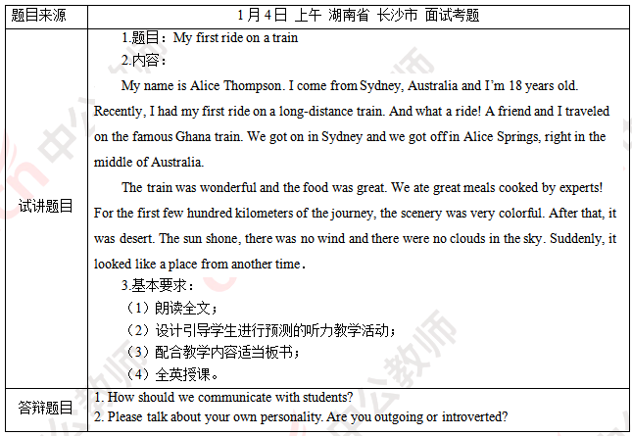

二、考题解析

【教案】

My first ride on a train

Teaching aims:

Knowledge aims:

Students can understand the content of the listening material.

Ability aim:

Students will develop their listening abilities of skimming and scanning.

Emotional aim:

Students can foster the awareness of enjoying their lives.

Key and difficult points:

Key point:

To understand the listening material.

Difficult point:

To foster the awareness of enjoying their lives.

Teaching procedures:

Step 1: Warming-up

1. Greetings.

2. Let students enjoy a song named Five hundred miles and ask them to pay attention to the lyrics and think about one question: How do you feel about when you take the train. The song goes like this:

If you miss the train I’m on

You will know that I am gone

You can hear the whistle blow a hundred miles

A hundred miles A hundred miles

A hundred miles A hundred miles

Ask students to answer the question. Then tell them that taking trains is a pleasant experience and lead in the topic.

Step 2: Pre-listening

Tell students that Alice went on a long trip by train recently, and ask students a question, “Do you want to know how Alice feels?” Then ask students to predict the main idea of the listening material according to the question.

Step 3: While-listening

1. Extensive listening

Read the passage for students and ask them to find the main idea of the listening material.

Then invite one student to write the answer on the blackboard.

2. Intensive listening

Play the tape and ask students to answer two questions:

Q1: How does Alice feel about her trip?

Q2: How was the weather that day, according to the passage?

Then lead students to write the answers on the blackboard.

Step 4: Post-listening

Ask students to talk about their trip experience in groups of four and encourage students to share their ideas. 5 minutes will be given for the discussion. Then invite some groups to share.

Step 5: Summary and Homework

Summary: invite a student to be an assistant teacher and summarize what we’ve learned today. Ask students to enjoy their life moments.

Homework: ask students to write a passage to introduce the places they have ever been to the class.

Blackboard design:

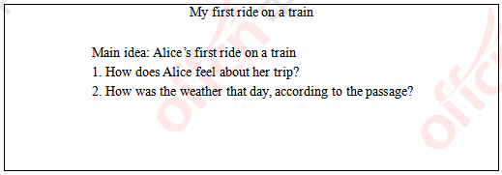

Teaching reflection

【答辩题目解析】

1. How should we communicate with students?

1.我们怎么和学生进行交流?

【参考答案】

On one hand, we must understand students’ learning and living conditions and show sincere concern. If students feel the teacher’s love and trust the teacher, they will certainly be happy to communicate with the teacher. On the other hand, different communication methods should be adopted for different students. For example, naughty students should be talked with frequently and we need to urge him to rectify their shortcomings. For students who are shy and lonely, we can get close to them by using conversations or letters. Meanwhile, good communication requires patient listening and understanding others’ feelings.

一方面，我们必须真诚的关心并了解学生的学习和生活条件。如果学生感受到老师的爱并信任老师，他们肯定会很乐意与老师交流。另一方面,针对不同的学生应该采取不同的沟通方法。例如,老师应多与顽皮的学生进行交谈，敦促他改正自己的缺点。害羞和孤独的学生，我们可以通过交谈或信件走进他们心里。与此同时，良好的沟通也需要耐心倾听，并理解他人的感受。

2. Please talk about your own personality. Are you outgoing or introverted?

2.请说说你自己的个性，是外向还是内向?

【参考答案】

People’s personality can be summarized into two kinds: outgoing and introverted. It depends on the environment and the one they are facing. I am quiet and introverted when I communicate with the elderly. However, when dealing with classmates and friends, I am enthusiastic and active. Besides, I consider myself a fairly humorous person. If I become a teacher, I hope that I will make friends with students, but also keep a distance.

人的性格可以概括为两种：外向和内向。这取决于环境和交流对象。当我和长辈交流时，我很安静，很内向。然而，在与同学和朋友打交道时，我是热情和积极的。此外，我认为自己是一个相当幽默的人。如果我成为一名老师，我希望我会和学生交朋友，但也要保持一定的距离。

**2019下半年高中英语学科教师资格证面试试题（精选）第二批**

2020-01-04 17:27:03

学员回顾

**2019年下半年教师资格面试-英语学科-考题解析**

**高中英语 阅读**

一、考题回顾

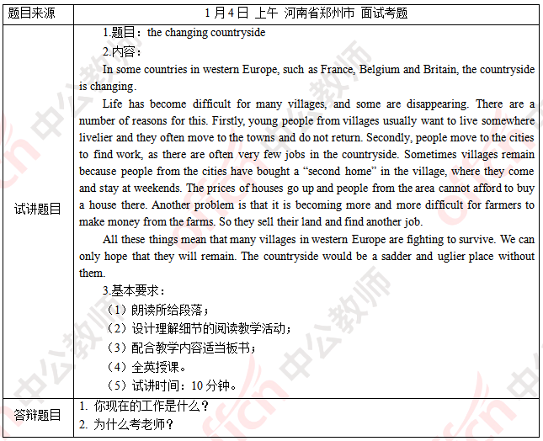

二、考题解析

【教案】

The changing countryside

Teaching aims:

Knowledge aims:

Students can understand several changes in the countryside.

Students can understand some ways to help relieve the struggle.

Ability aims:

Students will find information correctly and quickly after learning the reading skills.

Students can express their concern and ideas about the changing countryside fluently.

Emotional aim:

Students can foster the awareness to cherish and protect the old and precious things around them.

Key and difficult points:

Key point:

To find the reasons of the villages disappearing.

Difficult point:

To foster the awareness of protecting old memories.

Teaching procedures:

Step 1: Warming-up

1. Greetings.

2. Let students enjoy a song named yesterday once more and ask them what the song is about and how they feel. The song goes like this:

When I was young

I'd listen to the radio

Waiting for my favorite songs

When they played I’d sing along

It made me smile

Those were such happy times

And not so long ago

How I wondered where they’d gone

But they’re back again

Just like a long-lost friend

All the songs I loved so well.

Ask students to answer the question. Then tell them this old song tells us things were changed but memories never go thus lead them to think about changes around them.

Step 2: Pre-reading

Invite students to talk about the changes they are familiar with and guess what is going to talk about in the following passage.

Step 3: While-reading

1. Global reading

Read the passage for students and ask them to find the main idea of the material.

2. Detailed reading

Ask students to read again and answer two questions:

Q1: Why some villages are disappearing?

Q2: What is the problem with farmers?

Step 4: Post-reading

Ask students to have a discussion in groups of four to find out ways to help villages survive. 5 minutes will be given for discussion. Then invite some groups to share and explain.

Step 5: Summary and Homework

Summary: summarize with students together. Ask students to cherish and protect the old and precious things.

Homework: ask students to write letter to our government and offer some advice.

Blackboard design:

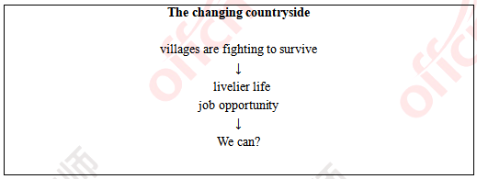

Teaching reflection

【答辩题目解析】

1. What is your present job?

1.你的工作是什么?

【参考答案】

Thank you for your question. At present, I am a salesgirl, mainly responsible for the sale of products and services. In the two years I’ve been working, I’ve learned a lot. For example, how to communicate with people of different ages and identities, and also learn the ability to solve problems and to deal with some urgent situations. Usually I am faced with high pressure and limited time, I know how to efficiently arrange the time reasonably and adjust to relax myself. I think no matter what kind of work we are dealing with, all we need is our sincerity and responsibility that enable us to learn and develop. Thank you for your listening. That will be all.

感谢考官的提问。目前，我的工作是一名销售人员，主要负责产品和服务的销售。在我工作两年以来，我学会了很多。比如如何和年龄身份不同的人进行沟通和交流，也学会了解决问题的能力以及一些紧急事情的处理方式。平时工作压力很大，时间很紧张，我更懂得如何高效合理安排时间和调整心态放松自我。我认为不管是什么样的工作，都需要付出真心，认真负责才能学到东西，得到成长。谢谢考官，我的回答完毕。

2. Why do you want to be a teacher?

2.为什么想要当一名老师?

【参考答案】

Thank you for asking. My previous job was a small experiment in the possibilities of my infinite life. I met a lot of people, but later found myself more eager to communicate with simple children. They are creative, they have potential, and they always take life seriously. Being around them keeps me learning and energetic. That’s one of my reason. Secondly, teacher is the most glorious profession under the sun, to become a teacher can realize my self-worth.

谢谢提问。之前的工作对我来说是我无限人生可能中一次小小的尝试。我接触了很多的人，但是后来发现自己更向往和单纯的孩子交流。他们有创造力，有潜力，他们一直积极认真的对待生活。和他们相处会让我自己一直学习，一直充满活力。这是其一。其二，教师是太阳底下最光辉的职业，成为一名老师能够让我实现自我价值。