**2019下半年高中英语学科教师资格证面试试题（精选）第三批**

2020-01-05 10:56:39

学员回顾

|  |  |  |  |  |
| --- | --- | --- | --- | --- |
| **2020广西教师资格统考相关资讯** | | | | |
| [笔试公告](http://gx.zgjsks.com/html/2019/ksgg_1217/35149.html) | [报考条件](http://gx.zgjsks.com/html/2019/ksgg_1217/35150.html) | [报名入口](http://gx.zgjsks.com/html/2019/bmrk_1217/35146.html) | [缴费入口](http://gx.zgjsks.com/html/2019/bmrk_1217/35147.html) | [时间安排](http://gx.zgjsks.com/html/2019/ksgg_1217/35151.html) |
| [备考讲座](http://gx.zgjsks.com/html/2019/bkhd_1215/35128.html) | [资料领取](http://gx.zgjsks.com/html/2019/bkhd_1227/35299.html) | [笔试课程](http://www.51gouke.com/gxnn/13-37-gk8275.html) | [网校](http://shop.eoffcn.com/jz/19/b6a3924d6ad8460490946b2211ab7d4c/?yearCode=202013) | [汇总](http://gx.zgjsks.com/html/2019/ksgg_1217/35148.html) |
| [**点击加群：广西教师资格1群632334037**](https://jq.qq.com/?_wv=1027&k=5D3oTE8) | | | | |

**本次教资面试试题来源于学员回忆与真实试题存在偏差，仅供参考。**

**高中英语 词汇**

一、考题回顾

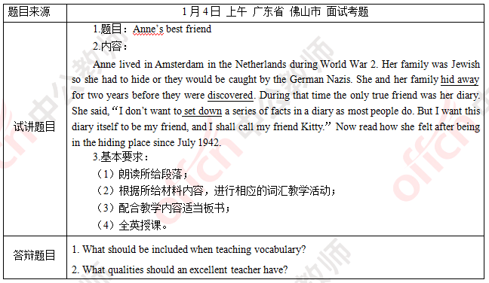

二、考题解析

【教案】

Anne’s best friend

Teaching aims:

Knowledge aims:

Students can understand the content of the passage and the historic background of the second world war.

Ability aim:

Students will learn some new words such as hide away, discover and set down.

Emotional aim:

Students can realize the importance of world peace and cherish our lives.

Key and difficult points:

Key point:

To understand the passage and learn some new words.

Difficult point:

To foster the importance of world peace and cherish our lives.

Teaching procedures:

Step 1: Warming-up

1. Greetings.

2. Let students enjoy a song named You are my sunshine and ask them to pay attention to the lyrics. The song goes like this:

You are my sunshine my only sunshine

You make me happy when skies are gray

You’ll never know dear how much I love you

Please don’t take my sunshine away

Ask students to answer the question “What do you think is your sunshine in your life?” Then tell them that friends are like the sunshine in our lives and lead in the topic.

Step 2: Presentation

1. Read the passage to the students and ask them the main idea of the passage.

2. Ask them to pay attention to some words like hid away, discovered and set down and write them down on the blackboard.

3. Explain to them that the original form of “hid away, discovered” are “hide away, discover” and tell them the meaning of these three phrases.

Step 3: Practice

1. Five minutes will be given to students and ask students to make new sentences with three phrases they have just learned like:

The wanted man hid away in the forest

Columbus discovered America in 1492.

The police set down his phone number.

Step 4: Production

Ask students to discuss the stories they know about the second world war in groups of four and encourage students to share their ideas. 5 minutes will be given for discussion. Then invite some groups to share.

Step 5: Summary and Homework

Summary: invite a student to be a little teacher and summarize today’s lesson. Ask students to cherish our lives.

Homework: ask students to design a poster about promoting Anne’s diary and share it next class.

Blackboard design:

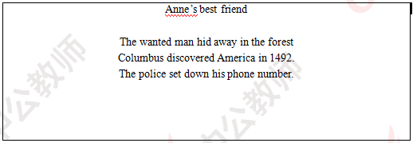

Teaching reflection

【答辩题目解析】

1. What should be included when teaching vocabulary?

1.词汇教学的内容有哪些?

【参考答案】

I think it mainly refers four aspects as follows:

Firstly, meaning. Teaching vocabulary involves two aspects: conceptual meaning and associative meaning.

Secondly, basic information, which involves its part of speech, affixes, spelling and pronunciation. It also includes lexical rules, the syntax structure of words.

Thirdly, usage. It includes collocation, phrases, idioms, and others.

Lastly, learning strategies. It can be divides into controlling strategies, resource strategies, cognitive strategies, memory strategies and strategies for organizing activities.

我觉得主要包括以下四方面的内容：

第一，词义。词义包括概念意义和关联意义;

第二，词汇信息。词汇信息包括词类，词缀，拼写，发音,也包括规则和词法;

第三，用法，包括词汇的搭配、短语、习语等;

最后，词汇学习策略。主要包括控制策略，资源策略，认知策略，记忆策略以及活动组织策略。

2. What qualities should an excellent teacher have?

2.一名优秀的教师应该具备哪些素质?

【参考答案】

I hold that an excellent teacher should have the following qualities:

At first, he should have high professional ethics. All excellent teachers should be dedicated and selfless, and truly concern students and care to help them.

Then, he should possess an abundant knowledge.

Last but not the least, he should own excellent qualities, such as getting along with colleges, or dealing with different situation properly to set a good example for students.

我认为一名优秀的教师应该具备以下几点素质：

首先，他必须具有高尚的职业道德素养。能够做到无私奉献，真正的把学生放在心上，全心全意为学生着想;

其次，她必须具备丰富的知识素养;

最后，她必须拥有良好的个人素养，能够很好地处理人际关系，应对不同情况，给学生树立优秀典范。

**2019下半年高中英语学科教师资格证面试试题（精选）第三批**

2020-01-05 10:56:39

学员回顾

**2019年下半年教师资格面试-英语学科-考题解析**

**高中英语 写作**

一、考题回顾

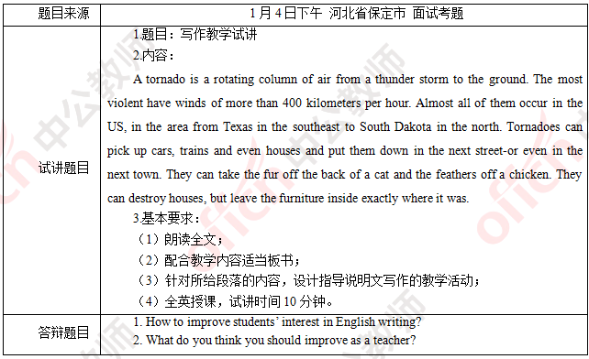

二、考题解析

【教案】

Teaching aims:

Knowledge aims:

Students can understand the content of the passage.

Students can master the structure of exposition writing displayed in this passage.

Ability aim:

Students will be able to write exposition articles to introduce something.

Emotional aim:

Students will foster the ability of critical thinking in English writing.

Key and difficult points:

Key point:

Get the main idea of the passage and understand structure of exposition.

Difficult point:

Students can be able to write their own exposition articles after learning.

Teaching procedures:

Step 1: Warming-up

1. Greetings.

2. Play a radio of a terrible tornado in Yancheng, Jiangsu, 2016. After that, Ask two students to describe this video to conclude the features of tornado, and finally to lead in the topic.

Step 2: Pre-writing

1. Ask students to read this passage to conclude the main idea, and lead in the topic of today’s writing.

2. Guide students to conclude the features of exposition and key points can be covered in writing.

3. Pick out useful expressions in the passage and give additional sentence patterns that can be used in writing.

Step 3: While-writing

Give 10 minutes for students to write down their own articles and walk around to offer them help if necessary.

Step 4: Post-writing

Students can have a peer-editing with their desk mates. 3 minutes later, teacher will invite some students to share their articles and give proper evaluation.

Step 5: Summary and Homework

Summary: invite a student to summarize today’s lesson and teacher gives the final conclusion of this lesson.

Homework: ask students to write an article about their favorite city and share with classmates next week.

Blackboard design:

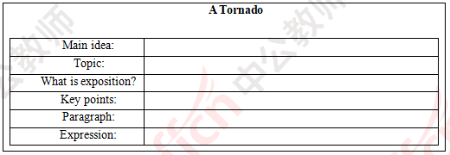

Teaching reflection

【答辩题目解析】

1. How to improve students’ interest in English writing?

1. 怎样提升学生的英语写作兴趣?

【参考答案】

There may be 2 aspects to improve students’ interest of English writing. On one hand, students should be interested in English writing and are willing to practice it. On the other hand, teachers always play an essential role because teachers’ teaching methods can often affect students directly. Therefore, teachers must attach more importance to each English class and gradually foster students’ interest of English writing.

培养学生英语写作的兴趣主要有两个方面。首先，学生必须自己对英语写作感兴趣且乐意实际操练;其次，老师在此问题上扮演者重要的角色。因为，老师的教育方法经常能对学生产生直接的影响。所以，作为英语老师，我们必须重视每一堂英语课，进而培养学生的英语写作兴趣。

2.What do you think you should improve as a teacher?

2.你认为作为英语教师，你需要提高什么?

As a teacher, I think I should improve myself from two aspects. Firstly, I should keep learning. The main task of a teacher is teaching and nowadays it is an age of knowledge explosion. If I want to satisfy students’ thirst for knowledge, teacher should keep learning and keep pace with the times. Secondly, I should gather experience about teaching, which is as important as knowledge and passion. I will read more books about teaching. Meanwhile, I will keep a modest mindset and ask experienced teacher for help.

作为一个老师，我认为我应该从两个方面提升我自己。首先，我需要保持学习。老师的首要任务是教书。在这个知识大爆炸的时期，想要满足学生的求知欲，老师就必须保持学习并且跟上时代的步伐。其次，我需要积累教学经验，它跟知识和热情一样重要。我会看更多的教育书籍，同时我也保持谦虚的心态，向有经验的老师寻求帮助。

**2019年下半年教师资格面试-英语学科-考题解析**

**高中英语 语音**

一、考题回顾

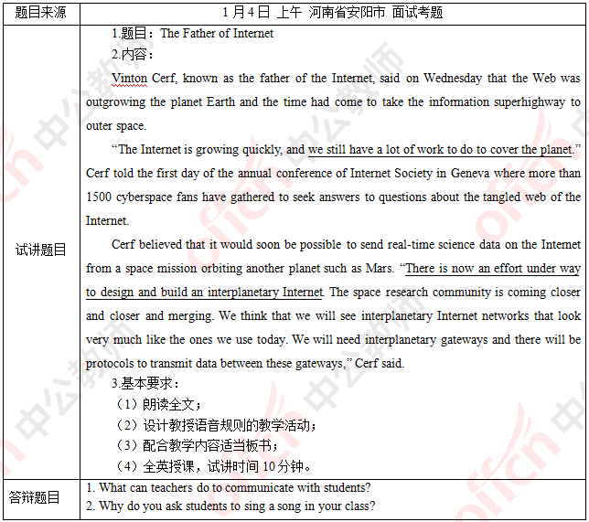

二、考题解析

【教案】

The Father of Internet

Teaching aims:

Knowledge aims:

Students can understand the content of the passage.

Students can master the ruled of liaison mentioned in this passage.

Ability aim:

Students will develop their skills of liaison in their oral English.

Emotional aim:

Students can be more interested in English learning and brave to speak out in English.

Key and difficult points:

Key point:

Get the main idea of the passage and understand the rules of liaison.

Difficult point:

To use liaison in other English passages and read more fluently.

Teaching procedures:

Step 1: Warming-up

1. Greetings.

2. Ask students one question “what are the 4 new inventions in 21th century?” and invite students to answer it. Then, conclude that they are fruits of Internet and lead in today’s topic.

Step 2: Preparation

1. Read the passage for the class and conclude the main idea.

2. Then, invite two students to read the two sentences “we still have a lot of work to do to cover the planet” and “There is now an effort under way to design and build an interplanetary Internet”.

3. Invite students to compare the differences between the two versions.

4. Introduce liaison rules based on the two sentences above and the usage of liaison in English reading: final consonant+ initial vowel.

Step 3: Practice

1. Give five minutes to students to find out more sentences with liaison and read them out in class.

2. Show another passage of Mark Zuckerberg, ask students read the passage sentence by sentence respectively to have a competition.

Step 4: Production

Give 5 minutes to have students firstly read the lyrics of Let It Go with the liaison rules, then teacher will invite students to sing and perform it on the stage.

Step 5: Summary and Homework

Summary: invite a student to be a little teacher and summarize today’s lesson.

Homework: ask students to make a tongue twister with the liaison rules.

Blackboard design:

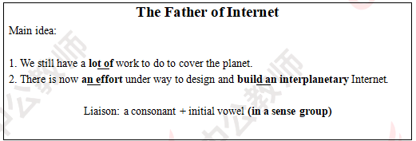

Teaching reflection

【答辩题目解析】

1. What can teachers do to communicate with students?

1. 我们可以怎样和学生进行交流?

【参考答案】

First of all, we must understand the students’ personal conditions. If students are willing to trust the teacher, they will certainly be happy to communicate with the teacher. Second, different communication methods should be adopted for different students. For example, to those students who are poor art study, we should be patient to guide them and do more assistance to their study.

首先，我们必须了解学生各方面的条件。如果学生愿意信任老师，他们势必会乐意与老师交流。其次，针对不同的学生应该采取不同的沟通方法：比如对于后进生，我们需要更有耐心，并且给予他们学习上的支持。

2. Why to ask students sing a song in your class?

2.为什么在课程中设计唱歌环节。

【参考答案】

There are two reasons of this singing part. First of all, we have learned liaison rules in this class and the song Let It Go, which contains plenty of liaison rules. It is useful to have an interesting practice. Secondly, singing a song is an exciting way to attract students and can make the whole class more active to realize the goal of happy English learning.

我设计唱歌环节主要有以下两个原因。第一，我们这节课所学的内容是语音规则中的连读，而且这首歌Let It Go的歌词中包含了许多连读语句，因此有利于进行有趣的练习。其次，在课堂中唱歌有利于活跃课堂氛围，吸引学生注意力，在英语教学中真正实现快乐学习。

**2019下半年高中英语学科教师资格证面试试题（精选）第三批**

2020-01-05 10:56:39

学员回顾

**2019年下半年教师资格面试-英语学科-考题解析**

**高中英语 语音**

一、考题回顾



二、考题解析

【教案】

The Father of Internet

Teaching aims:

Knowledge aims:

Students can understand the content of the passage.

Students can master the ruled of liaison mentioned in this passage.

Ability aim:

Students will develop their skills of liaison in their oral English.

Emotional aim:

Students can be more interested in English learning and brave to speak out in English.

Key and difficult points:

Key point:

Get the main idea of the passage and understand the rules of liaison.

Difficult point:

To use liaison in other English passages and read more fluently.

Teaching procedures:

Step 1: Warming-up

1. Greetings.

2. Ask students one question “what are the 4 new inventions in 21th century?” and invite students to answer it. Then, conclude that they are fruits of Internet and lead in today’s topic.

Step 2: Preparation

1. Read the passage for the class and conclude the main idea.

2. Then, invite two students to read the two sentences “we still have a lot of work to do to cover the planet” and “There is now an effort under way to design and build an interplanetary Internet”.

3. Invite students to compare the differences between the two versions.

4. Introduce liaison rules based on the two sentences above and the usage of liaison in English reading: final consonant+ initial vowel.

Step 3: Practice

1. Give five minutes to students to find out more sentences with liaison and read them out in class.

2. Show another passage of Mark Zuckerberg, ask students read the passage sentence by sentence respectively to have a competition.

Step 4: Production

Give 5 minutes to have students firstly read the lyrics of Let It Go with the liaison rules, then teacher will invite students to sing and perform it on the stage.

Step 5: Summary and Homework

Summary: invite a student to be a little teacher and summarize today’s lesson.

Homework: ask students to make a tongue twister with the liaison rules.

Blackboard design:



Teaching reflection

【答辩题目解析】

1. What can teachers do to communicate with students?

1. 我们可以怎样和学生进行交流?

【参考答案】

First of all, we must understand the students’ personal conditions. If students are willing to trust the teacher, they will certainly be happy to communicate with the teacher. Second, different communication methods should be adopted for different students. For example, to those students who are poor art study, we should be patient to guide them and do more assistance to their study.

首先，我们必须了解学生各方面的条件。如果学生愿意信任老师，他们势必会乐意与老师交流。其次，针对不同的学生应该采取不同的沟通方法：比如对于后进生，我们需要更有耐心，并且给予他们学习上的支持。

2. Why to ask students sing a song in your class?

2.为什么在课程中设计唱歌环节。

【参考答案】

There are two reasons of this singing part. First of all, we have learned liaison rules in this class and the song Let It Go, which contains plenty of liaison rules. It is useful to have an interesting practice. Secondly, singing a song is an exciting way to attract students and can make the whole class more active to realize the goal of happy English learning.

我设计唱歌环节主要有以下两个原因。第一，我们这节课所学的内容是语音规则中的连读，而且这首歌Let It Go的歌词中包含了许多连读语句，因此有利于进行有趣的练习。其次，在课堂中唱歌有利于活跃课堂氛围，吸引学生注意力，在英语教学中真正实现快乐学习。