**2019下半年高中英语学科教师资格证面试试题（精选）第五批**

2020-01-08 19:52:09

[中公广西教师网](http://gx.zgjsks.com/)

|  |  |  |  |  |
| --- | --- | --- | --- | --- |
| **2020广西教师资格统考相关资讯** | | | | |
| [笔试公告](http://gx.zgjsks.com/html/2019/ksgg_1217/35149.html) | [报考条件](http://gx.zgjsks.com/html/2019/ksgg_1217/35150.html) | [报名入口](http://gx.zgjsks.com/html/2019/bmrk_1217/35146.html) | [缴费入口](http://gx.zgjsks.com/html/2019/bmrk_1217/35147.html) | [时间安排](http://gx.zgjsks.com/html/2019/ksgg_1217/35151.html) |
| [课程预约](http://forms.offcn.com/forms/16049.html) | [备考讲座](http://gx.zgjsks.com/html/2019/bkhd_1215/35128.html) | [资料领取](http://gx.zgjsks.com/html/2019/bkhd_1227/35299.html) | [笔试课程](http://www.51gouke.com/gxnn/13-37-gk8275.html) | [网校](http://shop.eoffcn.com/jz/19/b6a3924d6ad8460490946b2211ab7d4c/?yearCode=202013) | [汇总](http://gx.zgjsks.com/html/2019/ksgg_1217/35148.html) |
| [**点击加群：广西教师资格1群632334037**](https://jq.qq.com/?_wv=1027&k=5D3oTE8) | | | | |

**2019年下半年教师资格面试-英语学科-考题解析**

**高中英语 词汇**

一、考题回顾

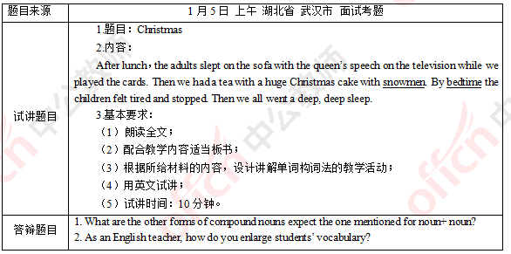

二、考题解析

【教案】

Christmas

Teaching aims:

Knowledge aims:

Students can be familiar with how compound words are constructed with the help of examples such as: snowman and bedtime.

Students can get to know the basics of morphology.

Ability aim:

Students will be able to analyze the way that an English word is constructed.

Emotional aim:

Students can build confidence in enlarging their vocabulary efficiently.

Key and difficult points:

Key point:

How to understand the definition and basic rule of compound words.

Difficult point:

How to analyze the way that an English word is constructed.

Teaching procedures:

Step 1: Warming-up

1. Greetings.

2. Let students enjoy a song named Santa Claus is Coming to Town and ask them what the song is about. The song goes like this:

You better watch out.

You better not cry.

You better not pout.

I’m telling you why.

Santa Claus is coming to town.

He’s making a list.

He’s checking it twice.

He’s gonna find out who’s naughty or nice.

Santa Claus is coming to town.

Ask students to answer the question. Then tell them that the song is about Christmas and Christmas is also the topic for today’s lesson.

Step 2: Presentation

1. Read the short paragraph and ask students to find out the words that are similar to “classroom” in terms of form.

2. Ask students to analyze the similarities of these words: classroom, snowmen, bedtime.

3. Summarize the definition of compounds: a new word that is made up of two or more words and the basic way of constructing a compound noun: noun plus noun.

Step 3: Practice

1. Mechanical drilling

Ask students to write the plural form of these compounds: snowman, bedroom, newspaper, schoolmate, pen-friend.

Then summarize the special rule: the plural form of a compound noun is decided by the core noun.

2. Meaningful drilling

Play the game-Word Master, the game goes like this:

Step 1: divide students into 2 groups;

Step 2: explain the rules: students from both groups are given 2 minutes to write on the blackboard examples of compound nouns as many as possible and repeated words from the same group are not counted, when time’s up, the group that make more examples win the game;

Step 3: teacher acts as the judge to declare the winner of the game.

Step 4: Production

Ask students to work in groups of 4 to make a story using the words on the blackboard. 5 minutes will be given. When time’s up, one group will be invited to share their story then teacher will evaluate their performance.

Step 5: Summary and Homework

Summary: invite one student to summarize today’s lesson.

Homework: ask students to discover more ways of word formation.

Blackboard design:

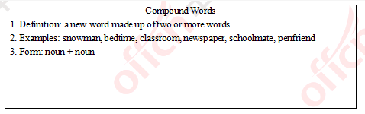

Teaching reflection

【答辩题目解析】

1.What are the other forms of compound nouns expect for noun plus noun?

1.复合名词除了名词加名词这一种构成之外还有哪些构成方法?

【参考答案】

Except for noun plus noun, compound nouns are mostly constructed in the following forms: firstly, verb plus adverb, such as comeback, blowup and runaway. Secondly, noun plus verb, such as snowfall, raindrop and sunrise. Thirdly, adjective plus noun, such as blackboard, gentleman, goodwill and etc.

除了名词加名词外，复合名词还有以下几种形式构成：1.动词加副词，如：comeback, blowup, runaway; 2.名词加动词，如：snowfall, raindrop, sunrise; 3.形容词加名词, 如：blackboard, gentleman, goodwill等。

2. As an English teacher, how do you enlarge students’ vocabulary?

2.作为一名英语老师，你如何提高学生的词汇量?

【参考答案】

English is a relatively regular language that is constructed by many rules, in which word formation plays a significant role. Lacking corresponding knowledge is the main reason why students find it hard to expand their vocabulary and memorize new words. As an English teacher, in class, I will make use of examples to acquaint my students with different means of word formation, which will boost students’ confidence in enlarging their vocabulary as their understanding of morphology is enhanced. After class, I will seek opportunities to organize activities such as vocabulary master to motivate my students.

英语是一门较为规律的语言，构词法就是其中一条重要的规律。学生觉得单词量难以突破，单词难记等往往是由于缺乏相关的构词法知识积累。作为一名英语老师，在课上，我会尽量多通过例子给学生介绍不同的构词法，在掌握相关知识的同时增强学生对扩展词汇量的信心;在课下，我会寻找时机开展词汇比赛等活动，调动学生对词汇学习的积极性。

**2019年下半年教师资格面试-英语学科-考题解析**

**高中英语 词汇**

一、考题回顾

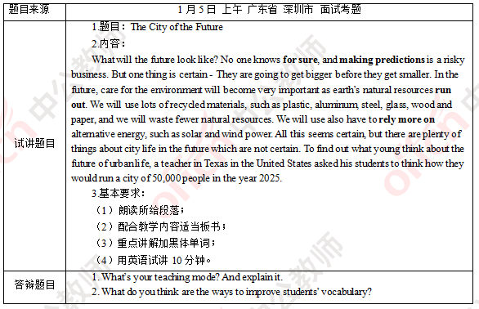

二、考题解析

【教案】

The City of the Future

Teaching aims:

Knowledge aims:

Students can understand the content of the passage.

Students can master the meaning of the new phrases “for sure” “making predictions” “run out” “rely more on.

Ability aim:

Students will develop their reading strategies like guessing the word in their reading process.

Emotional aim:

Students can foster the awareness of protecting environment.

Key and difficult points:

Key point:

To master the usage and meaning of the phrases.

Difficult point:

To foster the awareness of protecting environment.

Teaching procedures:

Step 1: Warming-up

1. Greetings: talk about weather.

2. Show them a video about the past life in city, and ask students “What is your feeling? What is the difference between the past life and today’s life in city?”

Step 2: Presentation

1. Ask students to open the book and read the passage to students and ask students “What is the main idea of this passage.”

2. Ask students to read the passage again and circle the phrases that they can’t understand. Then invite a student write down the phrases on the blackboard.

3. Invite some students to guess the meaning and then explain the new phrases to students.

Step 3: Practice

Ask students to use the new phrases to translate Chinese sentences on the screen into English.

Step 4: Production

Divide students into groups of 4 and give students 10 minutes to have a discussion about “What do you think of the future of urban life.” by using the new phrases as much as possible. After that, invite some groups to share their opinions.

Step 5: Summary and Homework

Summary: invite a student to read the new phrases, explain the meaning and conclude the main idea of the lesson.

Homework: ask students to surf on the internet and find more ways about caring for the environment.

Blackboard design:

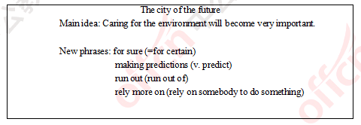

Teaching reflection

【答辩题目解析】

1. What’s your teaching mode? Please explain it.

1.你的教学模式是什么?并解释说明。

【参考答案】

Based on this lesson, I use PPP teaching mode. They are presentation, practice and production. First, presentation, in this part I let my students to read the passage and find out difficult phrases. Then ask them to write the phrase on the blackboard, and explain the meaning. Second, practice, to make my students master the knowledge better, I give them some sentences in Chinese and let them translate them into English with new Phrases. Third, production, I divide them into groups to let them cooperate together to have a discussion about “What do you think the future of urban life?”

这堂课我使用了PPP模式，分别是新知呈现，巩固练习和输出运用。首先在新知呈现环节，我让学生读文章概括大意并找出比较难的短语写在黑板上，接着向学生解释意义和用法。第二步巩固练习环节，为了让他们更好地掌握知识，我给出一些中文句子，让学生用到今天学的新短语将句子翻译为英文。第三步输出运用环节，我将他们分组进行合作并讨论“你们认为未来城市生活会是怎样的。”

2. What do you think of are the ways that can improve students’ vocabulary?

2.你认为有哪些提高学生词汇量的方法?

【参考答案】

1. Master all the basic vocabulary used in the textbook. In case of unfamiliar vocabulary, try to find out whether there is a familiar word root in it, and then combine the context to infer the meaning of the word.

2. Snowballing vocabulary in daily reading. Overcome the problem of only answering questions and not accumulating vocabulary.

3. Watching movies and listening to music can not only help students accumulate vocabulary, but also improve their interest in learning English.

1. 熟练掌握教材中出现过的所有基本词汇。如遇陌生词汇尽力查找是否有熟悉的词根在里面，再结合语境推测词意。

2. 在平时的阅读中滚雪球式地积累词汇。克服只重答题不重词汇积累的毛病。

3. 通过看电影、听音乐等方式，不仅可以帮助学生积累词汇，还能提高他们学习英语的兴趣。

**2019年下半年教师资格面试-英语学科-考题解析**

**高中英语 听说**

一、考题回顾

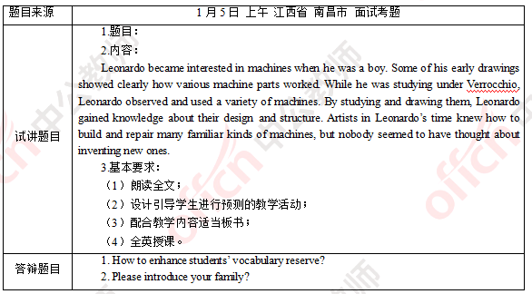

二、考题解析

【教案】

Leonardo and Machines

Teaching aims:

Knowledge aims:

Students can understand the content of the listening material.

Ability aim:

Students will develop their listening abilities of catching key words.

Students can improve their skill of prediction.

Emotional aim:

Students can foster the awareness of innovation.

Key and difficult points:

Key point:

To understand the listening material.

Difficult point:

To foster the awareness of innovation.

Teaching procedures:

Step 1: Warming-up

1. Greetings.

2. Show a clip of a very famous video named Good Will Hunting《心灵捕手》. Tell them Will Hunting, the protagonist of the movie is a mathematical genius, and today we will learn another something from another genius--Leonardo.

Step 2: Pre-listening

Show a picture to students; a man is looking at a machine and thinking. Tell them this picture is from our textbook. Ask them who is the man and then they should have a prediction about what the listening material mainly talk about according to the picture.

Step 3: While-listening

1. Extensive listening

Read the passage for students and ask them “what is Leonardo’s interest?” Meanwhile, let them check their prediction. After that, invite one student to write down the answer on the blackboard.

2. Intensive listening

Play the tape and ask students to answer two questions:

Q1: Who was Leonardo’s teacher at that time?

Q2: What kind of painting did Leonard prefer to drawing?

Q3: How did Leonardo gain knowledge about the machine’s design and structure?

Q4: What did nobody think about to do at Leonardo’s time?

Then lead students to write the answers on the blackboard

Step 4: Post-listening

Ask students to talk about some great persons and their achievements in groups of 4 and encourage students to be creative. 5 minutes will be given for their conversation. Then invite some groups to share.

Step 5: Summary and Homework

Summary: sum up what we have learned today and tell them there should be a sense of innovation at any time.

Homework: search some famous speech of some great persons and try to dubbing them.

Blackboard design:

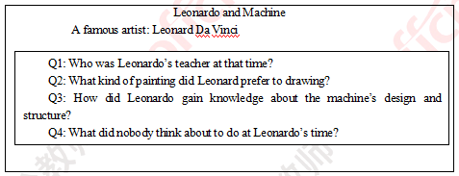

Teaching reflection

【答辩题目解析】

1. How to enhance students’ vocabulary reserve?

1.怎样扩充学生的词汇量?

【参考答案】

It’s very important to enhance students’ vocabulary reserve, because it will be helpful for students to understand passages and learn English more effectively. And here are some suggestions for improving students’ vocabulary reserve

First, using dictionary is a good way to learn English words, and it’s also a kind of learning strategies for students. Dictionary can be an assistant of the teacher to help students study by themselves. It’s includes meaning, pronunciation, example sentences, and so on. Students can use it to have a comprehensive understanding of the word

Second is guessing the meaning of new words according to context. It will be interesting to connect the new words by reading passage. By doing so, students can find a clue of the passage and more phrases and even they can understand some idiomatic usage. So it’s a good methods to improve students comprehensive ability of English, especially the reading skill.

Last one is social contacting strategy. That means students will learn the new words during the communication. It’s includes asking questions, cooperating with others, and so on. They will learn these new words initiatively.

拓展学生的词汇量是非常重要的。因为这对学生理解文章并且高效的学习英语非常有帮助。我会采取以下方法去扩充学生的词汇量。

首先，利用字典，这个方法对于英语学习非常的好，同时他也是一种学习策略。字典是老师让学生自主学习的工具。他上面会包括词汇的意义，发音，例句等方面的知识。学生可以利用字典拓展自己对于一个词汇的理解。

其次，根据上下文猜词。通过阅读文章来猜词义是一种非常有趣的方法。这样做可以让学生熟悉文章的脉络同时也可以掌握一些短语甚至一些习语一方面的用法。这种方法可以拓展学生的英语技能，特别是阅读技能。

最后，社交策略。学生能够在交流中学会一些新单词。这种方式可以是通过简单的提问，或者是与其他同学合作等等来实现。学生能够主动的去学习这些新单词

2. Please introduce your family?

2.请介绍一下你的家庭?

【参考答案】

In my family, there are four members, my farther, my mother, my sister and I. My parents are workers, my father works very hard, and he is always fully occupied, so most of the housework is done by my mother, of course, while I am at home, I would help her. I love my parents and they love me, too. When I make a success, they are more excited than me, and support me to do better. Even though I failed, instead of blaming, they always share sorrow with me, and encourage me not to give up. During my preparation for the teacher recruitment, the support from my family is always my momentum. Parents’ love is unselfish, I am deeply affected, so I will do all what I can to repay them. That is what a teacher also needs, If I had a chance to be a teacher, I would teach and care my students unselfishly.

我家里有四口人，分别是父母，姐姐和我。我的父母都是工人。我爸爸工作非常努力，绝大部分时间他都在工作。所以家里的家务都是妈妈在做。当然当我在家的时候，我也会帮忙。我非常爱我的父母，他们也很爱我。每当我获得一些小成就的时候，他们甚至会比我还激动并且全力支持我。即使我失败了，他们不但不会责怪我还会为我感到难过并且鼓励我不要放弃。在我准备教师资格证考试的时候，家人的支持永远是我前进的动力。父母的爱是无私的，我也被深深的影响了。所以我将会尽我所能去回报他们。这也是作为一名老师所要具备的品质。如果我有幸能成为一名人民教师的话，我也会不求回报的关心爱护我的学生。