**2019下半年高中英语学科教师资格证面试试题（精选）第四批**

2020-01-05 14:00:10

学员回顾

|  |  |  |  |  |
| --- | --- | --- | --- | --- |
| **2020广西教师资格统考相关资讯** | | | | |
| [笔试公告](http://gx.zgjsks.com/html/2019/ksgg_1217/35149.html) | [报考条件](http://gx.zgjsks.com/html/2019/ksgg_1217/35150.html) | [报名入口](http://gx.zgjsks.com/html/2019/bmrk_1217/35146.html) | [缴费入口](http://gx.zgjsks.com/html/2019/bmrk_1217/35147.html) | [时间安排](http://gx.zgjsks.com/html/2019/ksgg_1217/35151.html) |
| [备考讲座](http://gx.zgjsks.com/html/2019/bkhd_1215/35128.html) | [资料领取](http://gx.zgjsks.com/html/2019/bkhd_1227/35299.html) | [笔试课程](http://www.51gouke.com/gxnn/13-37-gk8275.html) | [网校](http://shop.eoffcn.com/jz/19/b6a3924d6ad8460490946b2211ab7d4c/?yearCode=202013) | [汇总](http://gx.zgjsks.com/html/2019/ksgg_1217/35148.html) |
| [**点击加群：广西教师资格1群632334037**](https://jq.qq.com/?_wv=1027&k=5D3oTE8) | | | | |

**本次教资面试试题来源于学员回忆与真实试题存在偏差，仅供参考。**

**高中英语 语音**

一、考题回顾

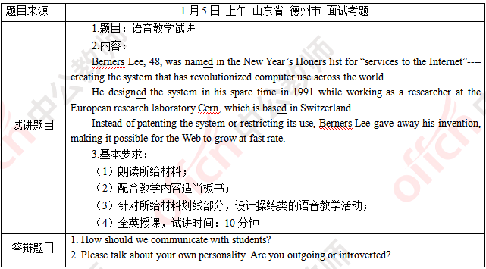

二、考题解析

【教案】

Berners Lee

Teaching aims:

Knowledge aims:

Students will know the rules of the pronunciation of past form “ed”.

Ability aim:

Students can pronounce the past form “ed” and speak in a correct way.

Emotional aim:

Students are able to boost their interest and confidence of speaking English.

Key and difficult points:

Key point:

To know the rules of pronunciation of past form “ed”.

Difficult point:

To foster their cooperative ability by participating activities in class actively.

Teaching procedures:

Step 1: Warming-up

1. Greetings.

2. Show a video of the development of computer. Then tell the students that today we will learn a man who had made a great contribution of the development of computer and lead in the topic.

Step 2: Presentation

1. Read the passage to students. Before my reading, ask students to pay attention to the pronunciation of past form “ed” in each word. After that, ask students to have a discussion and invite some of them to share.

2. Then introduce the rules of the pronunciation of the past form “ed” in different phonetic contexts.

a. ”ed” is pronounced as /t/ when it is after voiceless consonants.

b. ”ed” is pronounced as/d/ when it is after voiced consonants or vowels

c. ”ed” is pronounced as/id/ when it is after two consonants /t/, /d/.

Step 3: Practice

1. Mechanical drilling: ask students to listen and read the passage again and pay attention to the pronunciation of the past form “ed”

2. Meaningful drilling: show some pictures on the screen and ask students to describe them by using past tense.

Step 4: Post-listening

Ask students to introduce their idol’s experience by using past tense in group of 4. 5 minutes will be given for discussion. Then invite some groups to share.

Step 5: Summary and Homework

Summary: invite some students to retell the rules of the pronunciation of the past form “ed”.

Homework: write a story that happened in the past and then share the story with all the students next class.

Blackboard design:

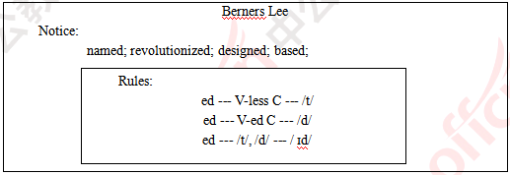

Teaching reflection

【答辩题目解析】

1. How to make students be more interested in learning English?

1. 怎样使学生对英语感兴趣?

【参考答案】

Interest is very important for learning, we can use the following methods.

First of all, we can use diversified teaching aid such as multi-media equipment and pictures. These methods can effectively increase interest and attractiveness of students. Second, we can improve students oral English and ability of communication and cooperation by means of group discussion, survey, role play, dialogue and games. By organizing diversified classroom activities, they can get involved actively and the atmosphere can be aroused. Besides, we can make students enjoy the fun of English by organizing English corner, recommending movies. We need to improve our teaching ability, keep smiling and always be humorous. We can use various scientific and effective teaching methods to increase student’s confidence of learning English.

In this way, we can arouse students’ interest and make them truly love English.

兴趣对于学习是非常重要的，我将会采取以下方式去激发学生的学习兴趣。

首先，我们可以运用不同的教学工具比如多媒体或者是图片。这些工具能够有效的激发学生的学习兴趣并且将学生的注意力吸引到课堂上来。其次，我们可以通过不同形式的小组活动比如讨论，调查，角色扮演和游戏等方式锻炼学生的口语能力，交际能力和合作能力。通过组织不同的课堂活动，学生能够踊跃参加，老师也能够调动课堂气氛。除此之外，我们在课外的时候，还可以组织一些诸如英语角，推荐电影之类的活动增强英语学习的趣味性。我们本身也需要不断的提升自己的教学水平，保持亲和力和幽默感，运用不同的科学高效的教学方法来增强学生的学习兴趣，提升学生学习英语的自信。

通过这些方法，我们可以提高学生学习英语的兴趣并且使他们真正爱上英语。

2. Can you introduce your college life?

2.请介绍一下你的大学生活?

【参考答案】

My life in college was meaningful.

I majored in English. I have had a good command of English after the 4-year study. After finishing all the compulsory courses such as English grammar, reading, writing, pronunciation, literature, cross-cultural communication and so on, I participated in a lot of contests. For example, the English speech contest, and I won the first place in the speech contest of the school. These experiences trained my ability in public speech and made me qualified for being a teacher.

I am now eager to apply my knowledge to practice. I believe that what I’ve got in the college will be of great help to my career life.

我的大学生活对我来说有意义非凡。

我本身是英语专业的，通过四年的学习自己具备了一定的相关方面的知识。在完成了所有的必修课程比如英语语法，精读课，英语写作，英语发音，文学史等之后，通过四年的学习自己具备了一定的相关方面的知识。

同时，我还参加了很多相关方面的比赛，比如英语演讲大赛，并且在学校演讲大赛中获得了第一名。这些公众演讲的经历使我有成为一名老师的资格。

现在，我非常希望将所学知识投身于实践。我相信我在校期间的经历会对我的职业生涯很有帮助。

**2019下半年高中英语学科教师资格证面试试题（精选）第四批**

2020-01-05 14:00:10

学员回顾

**2019年下半年教师资格面试-英语学科-考题解析**

**高中英语 阅读**

一、考题回顾

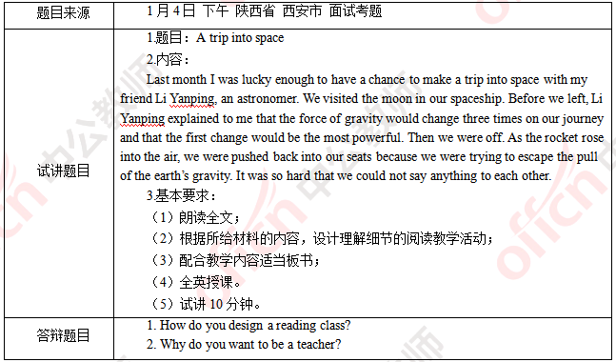

二、考题解析

【教案】

A trip into space

Teaching aims:

Knowledge aims:

Students can learn some new words and phrases about space.

Students can understand the main content of this reading material.

Ability aim:

Students will develop their reading strategy of skimming and scanning.

Emotional aim:

Students can set up a right career view.

Key and difficult points:

Key point:

To master the usage of new words and develop their reading ability.

Difficult point:

To understand the meaning of every job and set up a correct career view.

Teaching procedures:

Step 1: Warming-up

1. Daily greetings.

2. Show a video about Yang Liwei going into space to students. After watching the video, invite some students to share their memory about this event in public. After that, lead in today’s topic.

Step 2: Pre-reading

Before reading, ask students a question: what will happen when people go into space?

Give students 3 minutes to share their ideas with classmates. Then choose some volunteers to share in front of the whole class.

Step 3: While-reading

1. Fast reading

Read the passage for students and ask them to find the main idea of the reading material. Meanwhile, remind them of the new words underlined.

Then invite one student to share his or her answer orally and invite another student to write the new words on the blackboard. Explain these new words for them.

2. Detailed reading

Give students 5 minutes to read this passage again and answer the following questions. While reading, teach students how to get information by skimming — grasp the key words of the question and skim the passage to get relevant information of the key words.

Q1: What will happen in this trip?

Q2: Why will this situation happen?

Then encourage students to answer questions actively and invite some of them show their answers.

Step 4: Post-reading

Divide all of the students into groups of four. 5 minutes will be given to them. Ask them to share their feelings about the astronomer and why, as well as other jobs that they have the same feeling . After discussion, choose some students share their results.

Step 5: Summary and Homework

Summary: invite a student to be an assistant teacher and summarize today’s lesson. Tell students that actually every job has its importance and meaning. As a student, they should study hard and set a goal to pursue.

Homework: ask students to write a short passage about their dream job and their reason.

Blackboard design:

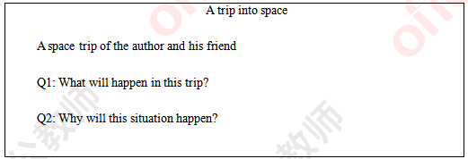

Teaching reflection

【答辩题目解析】

1. How do you design a reading class?

1.你怎样设计一堂阅读课?

【参考答案】

I will design a reading class from three steps mainly. The first step is pre-reading. Before reading, I will set up some activities to help students get prepared for the reading, such as explaining new words, prediction or asking questions. The second step is while-reading. Generally, I will deal with the passage twice. The first time is fast reading, which aims at the main idea or some general information of the passage. The second time is detailed reading, which aims at more detailed information of the passage. Meanwhile, I will teach students some reading strategy. The third step is post-reading. After learning this passage, I will set an activity to let students use English to express themselves.

我将主要从三个步骤来设计一堂阅读课。第一步是读前。在阅读前，我会设计一些活动帮助同学们做好阅读的准备活动，比如解释新词、预测或者设疑。第二步是读中。一般在这个步骤我会处理两遍文章：第一遍是泛读，旨在处理文章大意和一些较简单的细节信息;第二遍是精读，旨在处理更加细节的文章信息，在这个过程中，我也会教给学生一些阅读技巧。最后一步是读后。在阅读后，我会设计一个活动让学生可以用上英语去表达自己。

2. Why do you want to be a teacher?

2.你为什么想要成为一名老师?

【参考答案】

I make up my mind to be a teacher out of three main reasons. The first one is my interest. I like English very much. After graduating from senior high school, I chose English as my major. I hope that I can engage in a career related to English in the future. Furthermore, I like teaching. I enjoy standing in the stage to impart what I know. The third aspect is my ability. In college, I studied many lessons about English and teaching, such as advanced English and pedagogy and got a great grade. What’s more, I’m patient and outgoing. I think those are all my advantages to be a teacher.

我主要从两个方面来考虑我的职业。第一个方面是我的兴趣。我非常喜欢英语，在高中毕业之后，我选择英语作为我的大学专业，我希望将来也可以从事与英语相关的职业;而且我也喜欢教书，我享受站在讲台上传授我所知道的知识的那种感觉。第二个方面是我的能力。在大学我学习了很多与英语和教学相关的课程，比如高级英语和教育学，并且取得了一个好成绩;更重要的是，我非常有耐心并且乐观开朗，我认为这些都是我成为一名老师的优势。

**2019下半年高中英语学科教师资格证面试试题（精选）第四批**

2020-01-05 14:00:10

学员回顾

**2020年上半年教师资格面试-英语学科-考题解析**

**高中英语 口语**

一、考题回顾

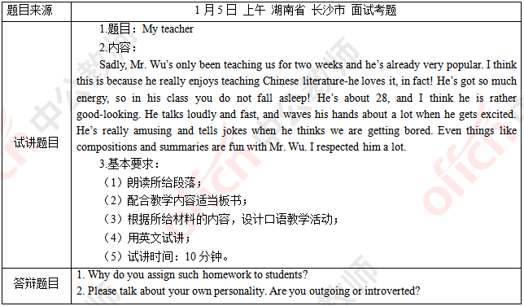

二、考题解析

【教案】

My Teacher

Teaching aims:

Knowledge aims:

Students can understand the content of the given material.

Students can be familiar with the expressions to introduce their teachers.

Ability aim:

Students will be able to describe their teachers logically in English.

Emotional aim:

Students can cultivate the awareness of understanding and respecting their teachers.

Key and difficult points:

Key point:

To learn from the given material about the teacher Mr. Wu.

To talk about their teachers logically.

Difficult point:

To foster the awareness of respecting their teachers.

Teaching procedures:

Step 1: Warming-up

1. Daily greeting.

How is everything going?

2. Let students enjoy a song named You Are My Sunshine. The song goes like this:

You are my sunshine my only sunshine.

You make me happy when skies are grey.

You’ll never know dear how much I love you.

Please don’t take my sunshine away.

3. Ask students who is the sunshine in their life. Then tell them that teachers are to students what sunshine is to seeds and lead in today’s topic.

Step 2: Pre-speaking

1. Read the passage for students and ask them to find the main idea of the given material about the teacher Mr. Wu.

Then introduce the topic of speaking: my favorite teacher.

2. Ask students to discuss with their partners about the aspects that can be included in their description of their teachers. Meanwhile, encourage them to collect necessary information from the given material.

Then invite students to share their ideas.

3. Encourage students to think about how to talk more logically and clearly.

Then conclude the speaking structure together.

4. Ask students to fill in the mind map and brainstorm some words and expression they can use in the following speaking.

Step 3: While-speaking

1. Ask students to talk about their favorite teachers. 10 minutes will be given to them.

2. Provide them with corresponding guidance if they need help during speaking.

Step 4: Post-speaking

1. Invite students to introduce their favorite teachers in front of the class.

2. Give them proper evaluations and suggestions.

Step 5: Summary and Homework

Summary: invite a student to be the assistant teacher and summarize they lesson today. Ask students to understand and respect their teachers.

Homework: ask students to write a letter to their favorite teacher to express their gratitude.

Blackboard design:

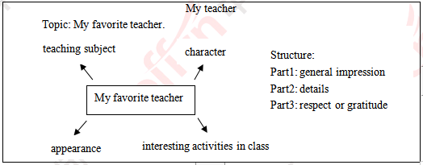

Teaching reflection

【答辩题目解析】

1. Why do you assign such homework to students?

1.你为什么给学生布置这样的作业?

【参考答案】

Homework plays an indispensable role in students’ study. A well-designed homework contributes a lot to the consolidation and application of the knowledge in class.

I assigned such homework for the specific reasons. On one hand, speaking and writing are similar to each other in terms of the output of linguistic knowledge. The combination of them is an efficient way to lay a good foundation for students’ comprehensive ability in English. On the other hand, through writing a letter to their teachers, they will gradually walk into their teachers’ heart and understand teachers’ good intentions, leading to the formation of a harmonious relationship between teachers and students, from which both of them will benefit a lot.

All in all, I hope the assigned homework will promote the all-round development of students.

家庭作业对于学生学习有着举足轻重的作用。好的作业能让学生更好地巩固和运用课堂所学知识。

布置这样的作业主要出于以下原因。一方面，口语和写作在语言知识的输出方面极为相似，而结合两者能有效地为学生的全面英语能力奠定基础。另一方面， 通过写信给老师，学生更加能深刻地理解老师的良苦用心，慢慢建立起良好的师生关系，因此，师生都能受益。

总之，我希望布置这样的作业能促进学生全方位发展。

2. Please talk about the advantages and disadvantages of your lesson.

2. 请谈谈你的课堂的优缺点?

【参考答案】

Firstly, I’d like to talk about the advantages of this class. Most importantly, the teaching procedures are completed within ten minutes. The lead-in is one of the highlights in the lesson. By singing a song called “You Are My Sunshine”, I create a nice atmosphere to draw students’ attention and naturally introduces the lesson with a metaphor. Besides, in the pre-speaking part, I make the students fully prepared step by step from aspects to structure. In this way, students’ divergent thinking ability and information-collecting ability will be trained. Their mind will be enriched so as to be more confident in speaking English.

Then I must admit that there are some shortcomings in the lesson because of limited time and lack of experience. For example, I can’t predict whether students can fully grasp the knowledge in a real class. From now on, I will learn from those experienced teachers and continually reflect on my lesson to accumulate more teaching experience and skills.

首先， 我想谈谈我的优点。最重要的是，我在10分钟内完整地展现了我的课堂。其中导入部分是我这节课的亮点之一。通过唱一首“You Are My Sunshine”，营造了良好的课堂氛围以吸引学生注意并巧用暗喻引入课堂主题。此外，在说前环节，我一步步带领学生做好充分的准备，并且培养了学生的发散性思维与信息收集能力。有了充实的思考，他们才能更自信地说英语。

但我必须指出由于时间有限和经验有限，我的课堂还是存在不足的。例如，我很难知晓学生在真实课堂中是否能完全理解所学内容。从现在开始， 我将向经验丰富的老师们学习并不断反思以积累更多教学经验和技能。