Species & genus plant classification with NEON hyperspectral data

Victoria Scholl1,✉, and Maxwell Joseph1

01 September, 2020

Text of abstract

1 University of Colorado Boulder

✉ Correspondence: [Victoria Scholl <[victoria.scholl@colorado.edu](mailto:victoria.scholl@colorado.edu)>](mailto:victoria.scholl@colorado.edu)

Keywords: keyword 1; keyword 2; keyword 3

Highlights: These are the highlights.

# Introduction

Here is a citation (Marwick, 2017)

# Background

# Methods

# Results

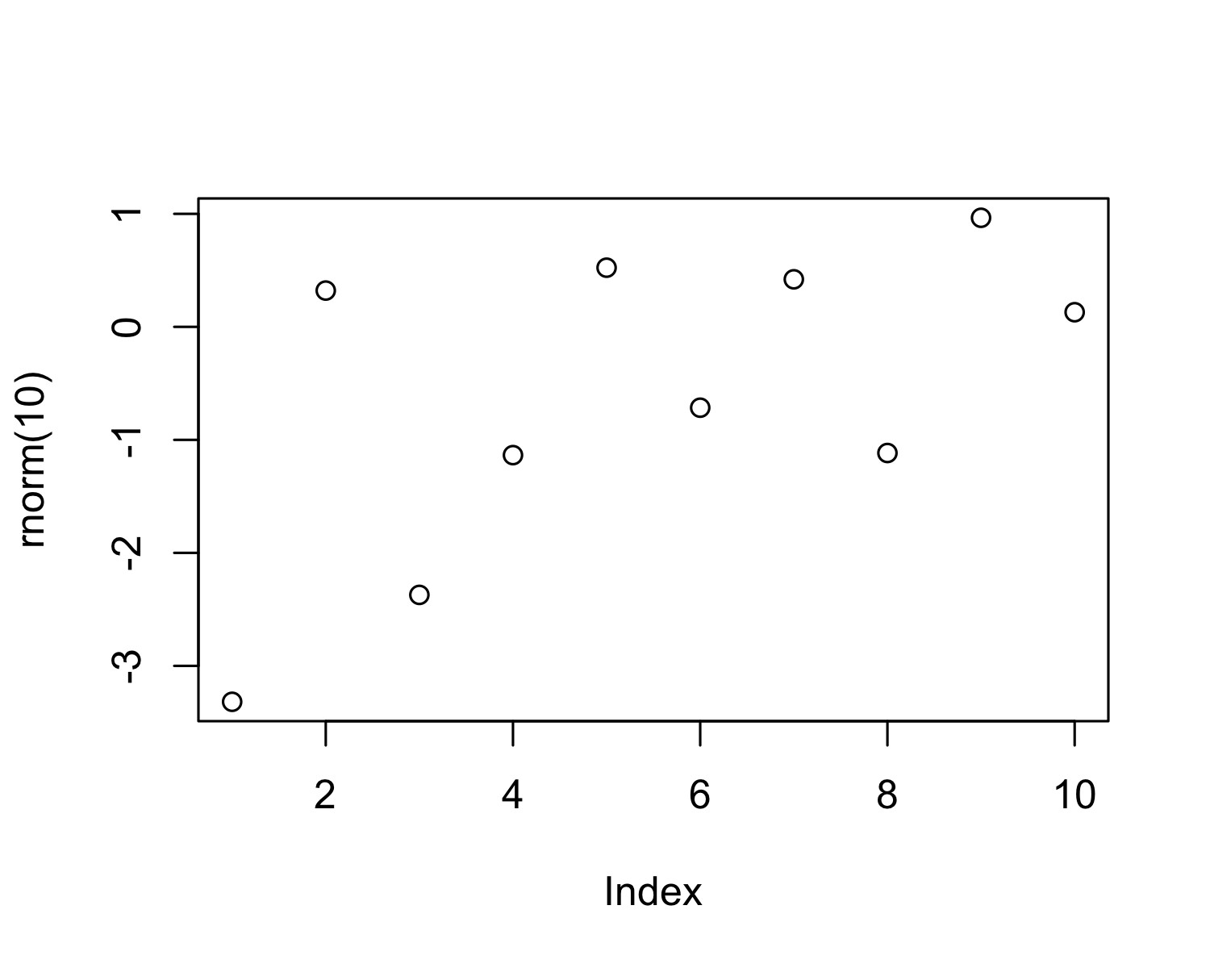

Figure 1: A plot of random numbers

Figure 1 shows how we can have a caption and cross-reference for a plot

Here is an example of inline code 3.14 in the middle of a sentence.

# Discussion

# Conclusion

# Acknowledgements

# References

Marwick, B., 2017. Computational reproducibility in archaeological research: Basic principles and a case study of their implementation. Journal of Archaeological Method and Theory 24, 424–450. <https://doi.org/10.1007/s10816-015-9272-9>

### Colophon

This report was generated on 2020-09-01 10:38:07 using the following computational environment and dependencies:

#> ─ Session info ───────────────────────────────────────────────────────────────  
#> setting value   
#> version R version 4.0.2 (2020-06-22)  
#> os macOS Catalina 10.15.6   
#> system x86_64, darwin17.0   
#> ui X11   
#> language (EN)   
#> collate en_US.UTF-8   
#> ctype en_US.UTF-8   
#> tz America/Denver   
#> date 2020-09-01   
#>   
#> ─ Packages ───────────────────────────────────────────────────────────────────  
#> package * version date lib source   
#> assertthat 0.2.1 2019-03-21 [1] CRAN (R 4.0.2)  
#> backports 1.1.9 2020-08-24 [1] CRAN (R 4.0.2)  
#> bookdown 0.20 2020-06-23 [1] CRAN (R 4.0.2)  
#> callr 3.4.3 2020-03-28 [1] CRAN (R 4.0.2)  
#> cli 2.0.2 2020-02-28 [1] CRAN (R 4.0.2)  
#> crayon 1.3.4 2017-09-16 [1] CRAN (R 4.0.2)  
#> desc 1.2.0 2018-05-01 [1] CRAN (R 4.0.2)  
#> devtools 2.3.1 2020-07-21 [1] CRAN (R 4.0.2)  
#> digest 0.6.25 2020-02-23 [1] CRAN (R 4.0.2)  
#> ellipsis 0.3.1 2020-05-15 [1] CRAN (R 4.0.2)  
#> evaluate 0.14 2019-05-28 [1] CRAN (R 4.0.1)  
#> fansi 0.4.1 2020-01-08 [1] CRAN (R 4.0.2)  
#> fs 1.5.0 2020-07-31 [1] CRAN (R 4.0.2)  
#> glue 1.4.2 2020-08-27 [1] CRAN (R 4.0.2)  
#> highr 0.8 2019-03-20 [1] CRAN (R 4.0.2)  
#> htmltools 0.5.0 2020-06-16 [1] CRAN (R 4.0.2)  
#> knitr 1.29 2020-06-23 [1] CRAN (R 4.0.2)  
#> magrittr 1.5 2014-11-22 [1] CRAN (R 4.0.2)  
#> memoise 1.1.0 2017-04-21 [1] CRAN (R 4.0.2)  
#> pkgbuild 1.1.0 2020-07-13 [1] CRAN (R 4.0.2)  
#> pkgload 1.1.0 2020-05-29 [1] CRAN (R 4.0.2)  
#> prettyunits 1.1.1 2020-01-24 [1] CRAN (R 4.0.2)  
#> processx 3.4.3 2020-07-05 [1] CRAN (R 4.0.2)  
#> ps 1.3.4 2020-08-11 [1] CRAN (R 4.0.2)  
#> R6 2.4.1 2019-11-12 [1] CRAN (R 4.0.2)  
#> remotes 2.2.0 2020-07-21 [1] CRAN (R 4.0.2)  
#> rlang 0.4.7 2020-07-09 [1] CRAN (R 4.0.2)  
#> rmarkdown 2.3 2020-06-18 [1] CRAN (R 4.0.2)  
#> rprojroot 1.3-2 2018-01-03 [1] CRAN (R 4.0.2)  
#> sessioninfo 1.1.1 2018-11-05 [1] CRAN (R 4.0.2)  
#> stringi 1.4.6 2020-02-17 [1] CRAN (R 4.0.2)  
#> stringr 1.4.0 2019-02-10 [1] CRAN (R 4.0.2)  
#> testthat 2.3.2 2020-03-02 [1] CRAN (R 4.0.2)  
#> usethis 1.6.1 2020-04-29 [1] CRAN (R 4.0.2)  
#> withr 2.2.0 2020-04-20 [1] CRAN (R 4.0.2)  
#> xfun 0.16 2020-07-24 [1] CRAN (R 4.0.2)  
#> yaml 2.2.1 2020-02-01 [1] CRAN (R 4.0.2)  
#>   
#> [1] /Library/Frameworks/R.framework/Versions/4.0/Resources/library

The current Git commit details are: