**Lab 4 BCD Adder**

Part 1

Radix of sum is in Ufix

Radix of x is in Hexadecimal

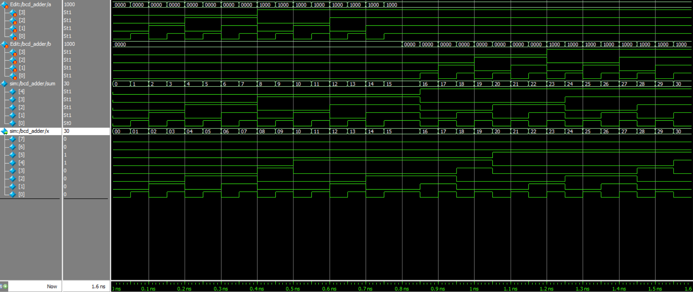

Part 2

