**LAB 6**

*PART 1 : SYNCHRONOUS SHIFT REGISTER*

**ModelSim**

*[shifting in left-to-right; first half w/ sin HI, second half w/ sin LO]*

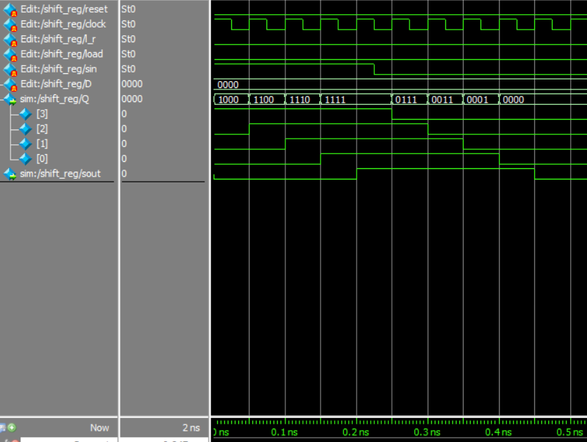

*[shifting in right-to-left; same as above, except l_r is HI]*

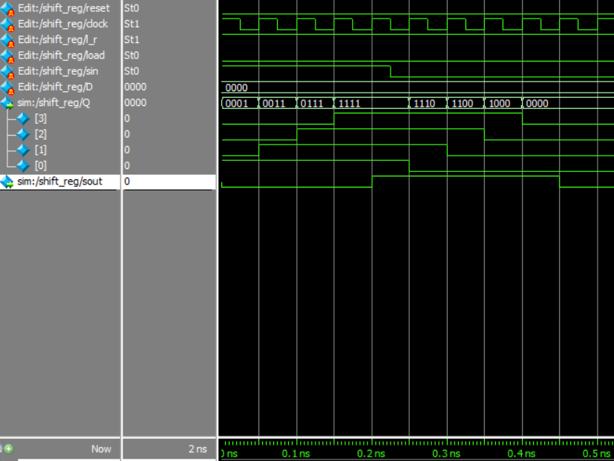

*[loading values from D and then resetting]*

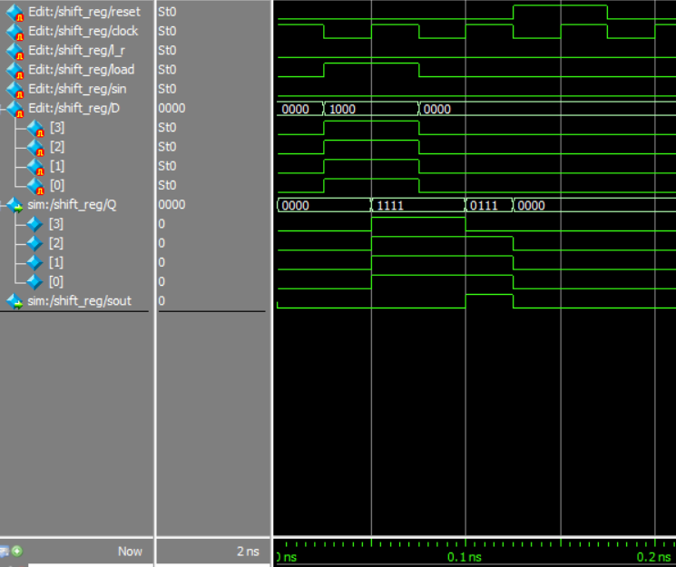

Note: There is one clock cycle between the load and the reset where load=0 and sin=0 is shifted in from the left

**RTL Viewer**

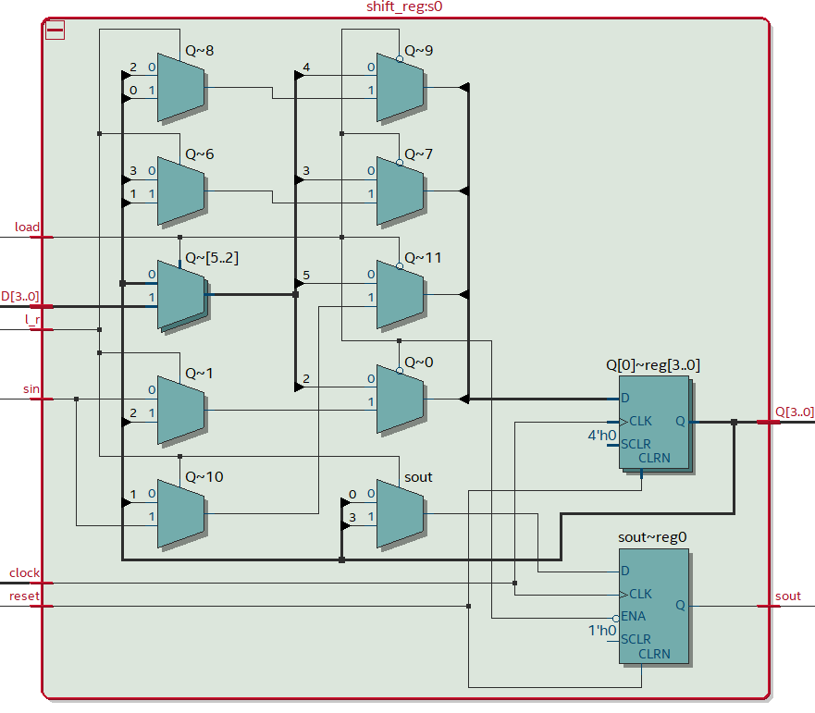

*PART 2 : SYNCHRONOUS BINARY COUNTER*

**ModelSim**

*[counting up from 0 and rolling over at 255]*

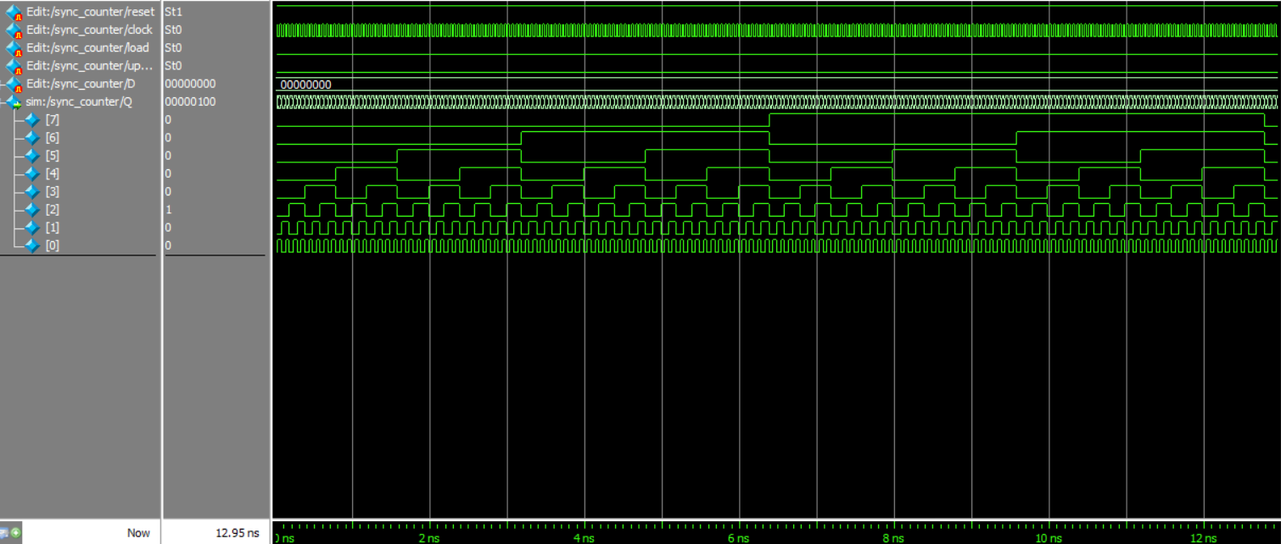

*[above rollover zoomed in]*

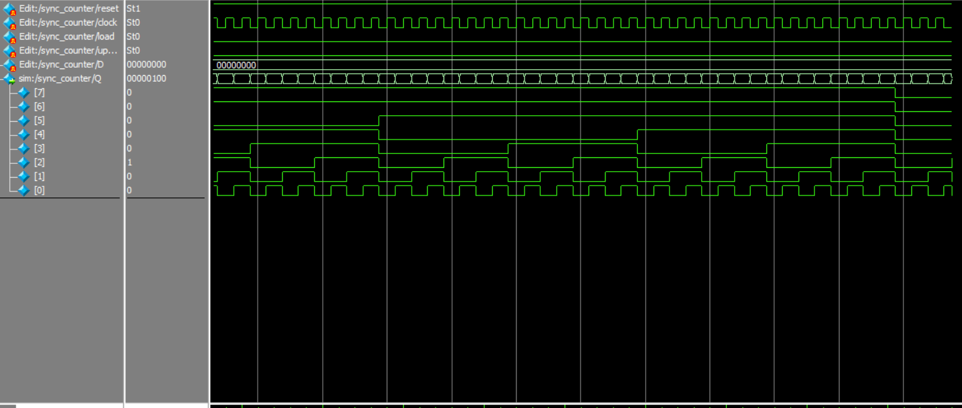

*[counting down from 255 and rolling over at 0 (rolls over twice, once at begin and at end]*

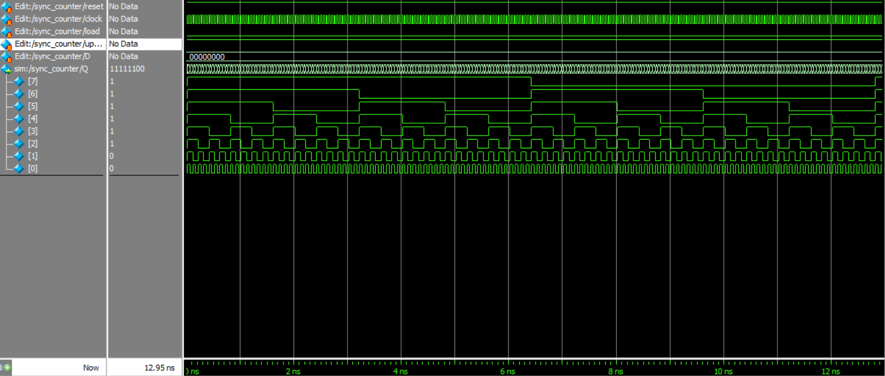

*[loading decimal 255, followed by a reset, followed by normal down-count rollover]*

*\*note: clock is negative edge triggered!*

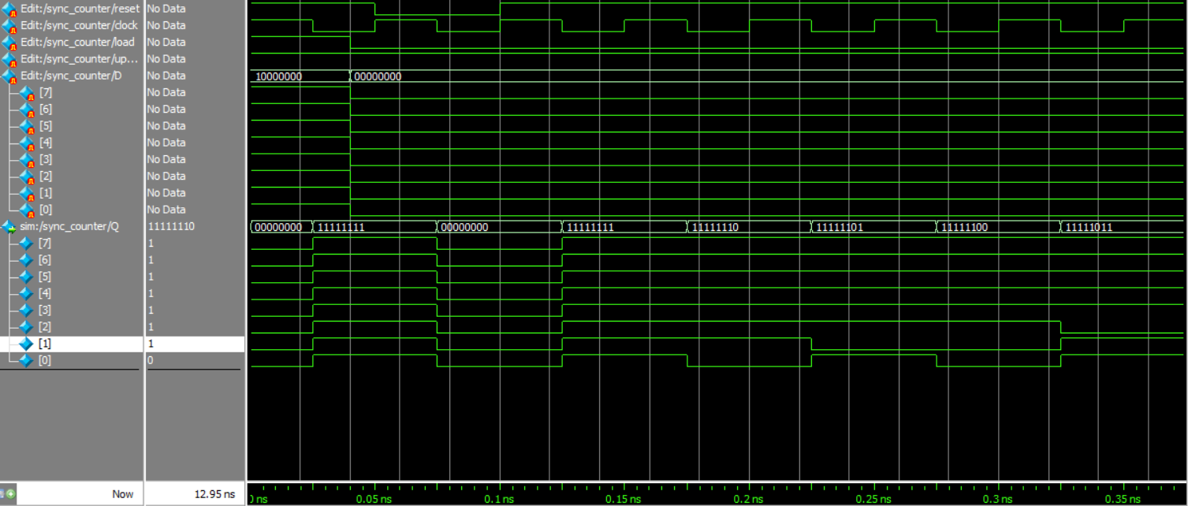

**RTL Viewer**

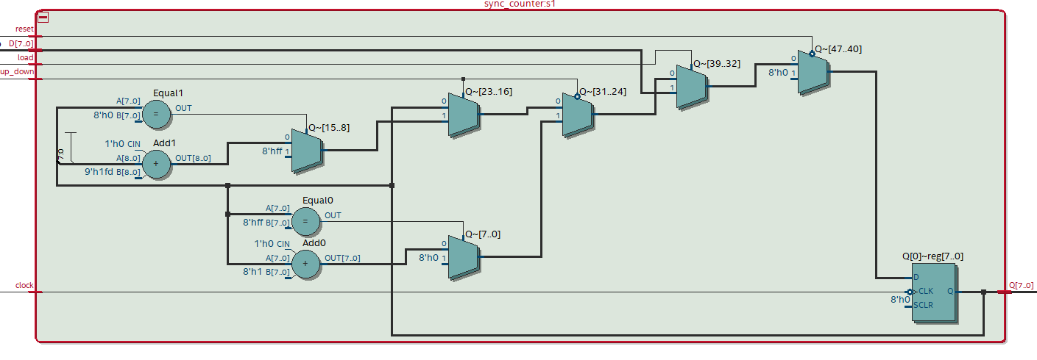

*PART 3 : SYNCHRONOUS BCD COUNTER*

**ModelSim**

*[counting up and rolling over with cen=1 for three clock cycles to hold count]*

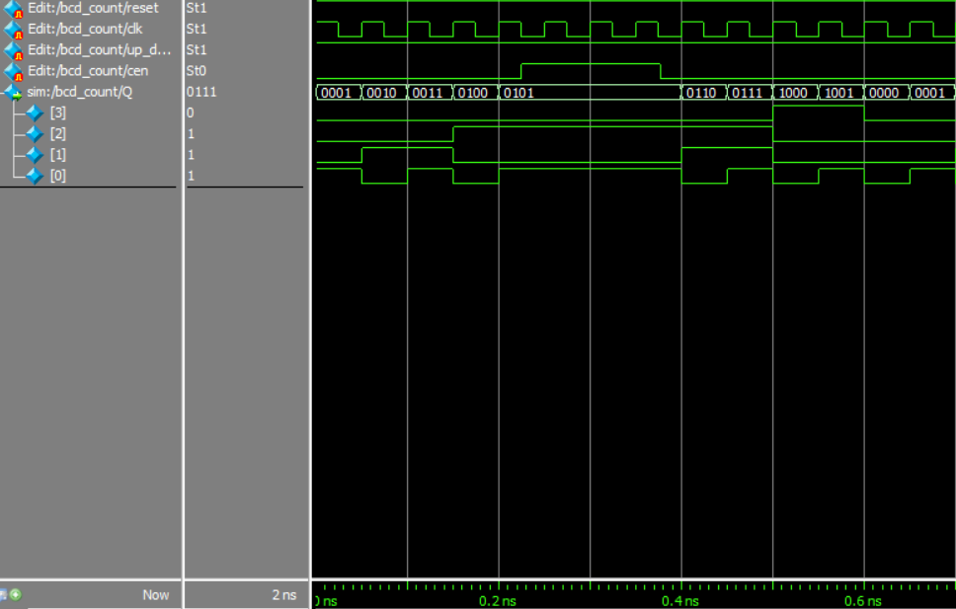

*[counting down and rolling over with cen=1 for three clock cycles to hold count]*

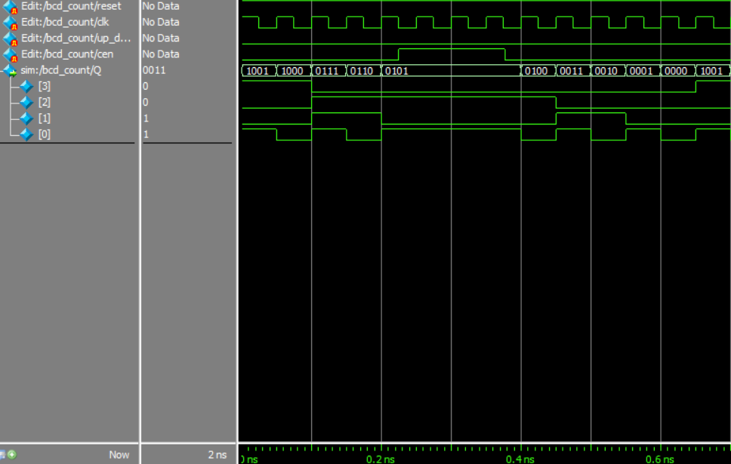

**RTL Viewer**

