**LAB 7**

*TRAFFIC LIGHT CONTROLLER*

**State Transition Diagram**

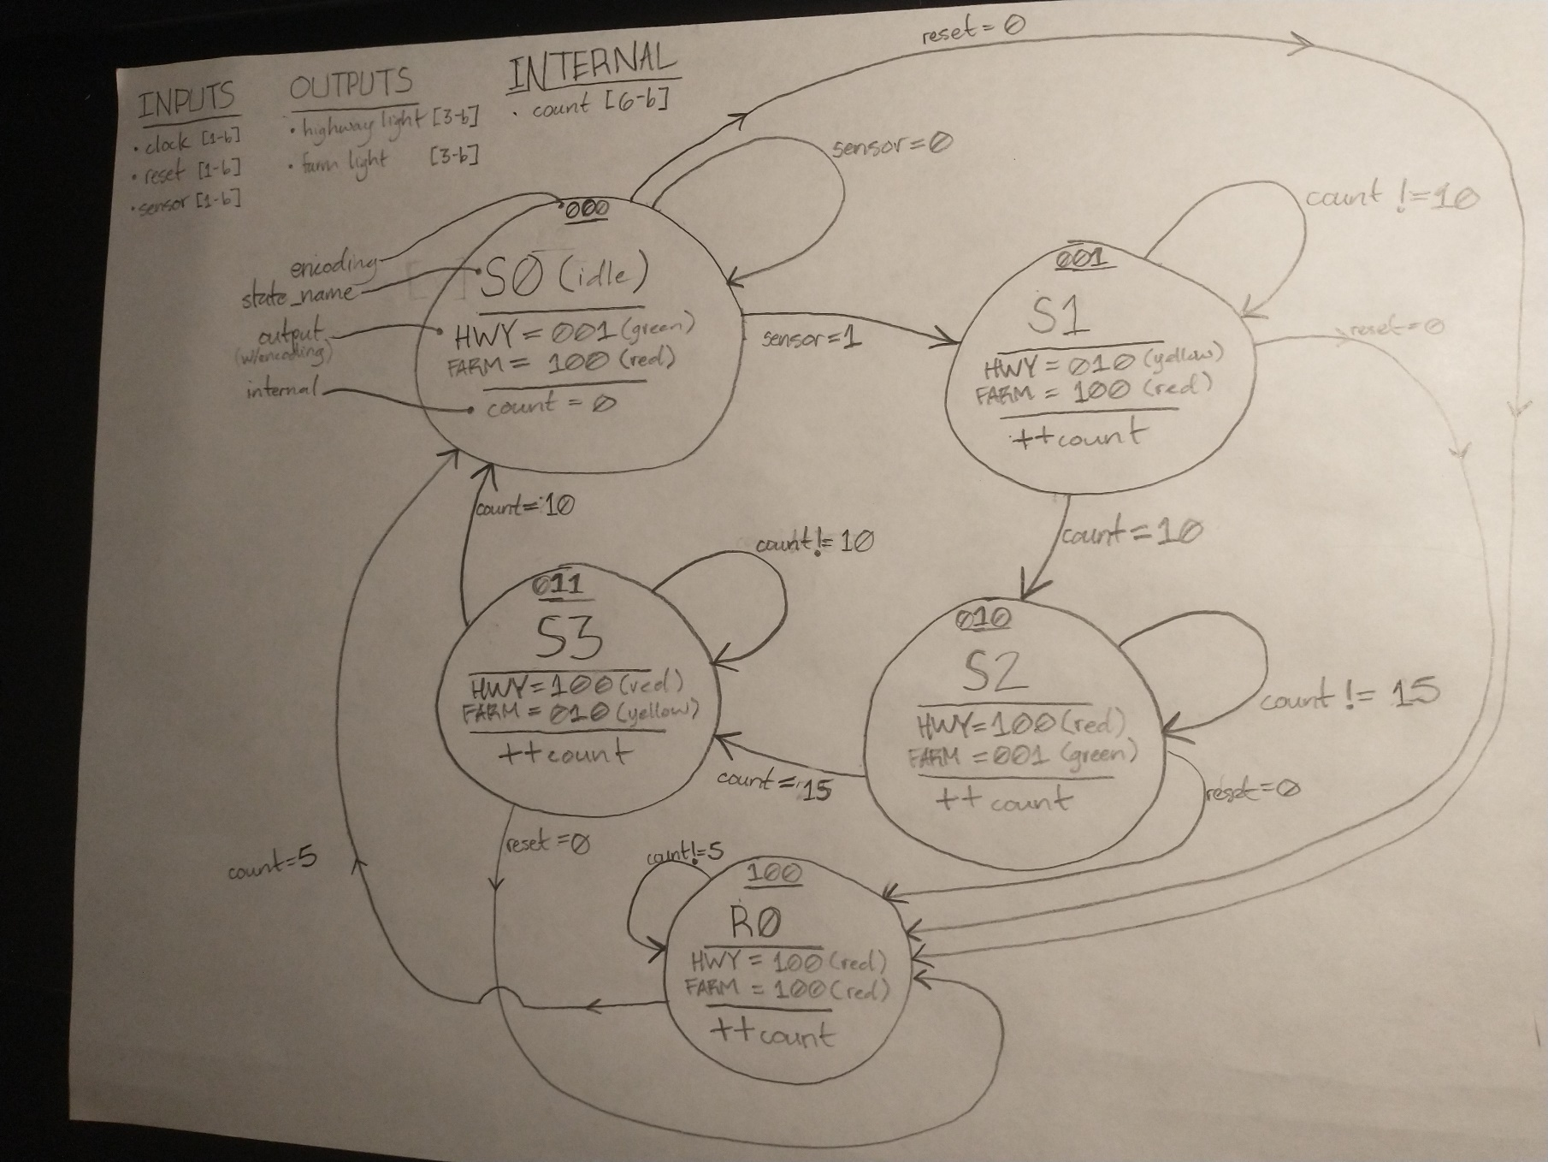

**State Transition Table**

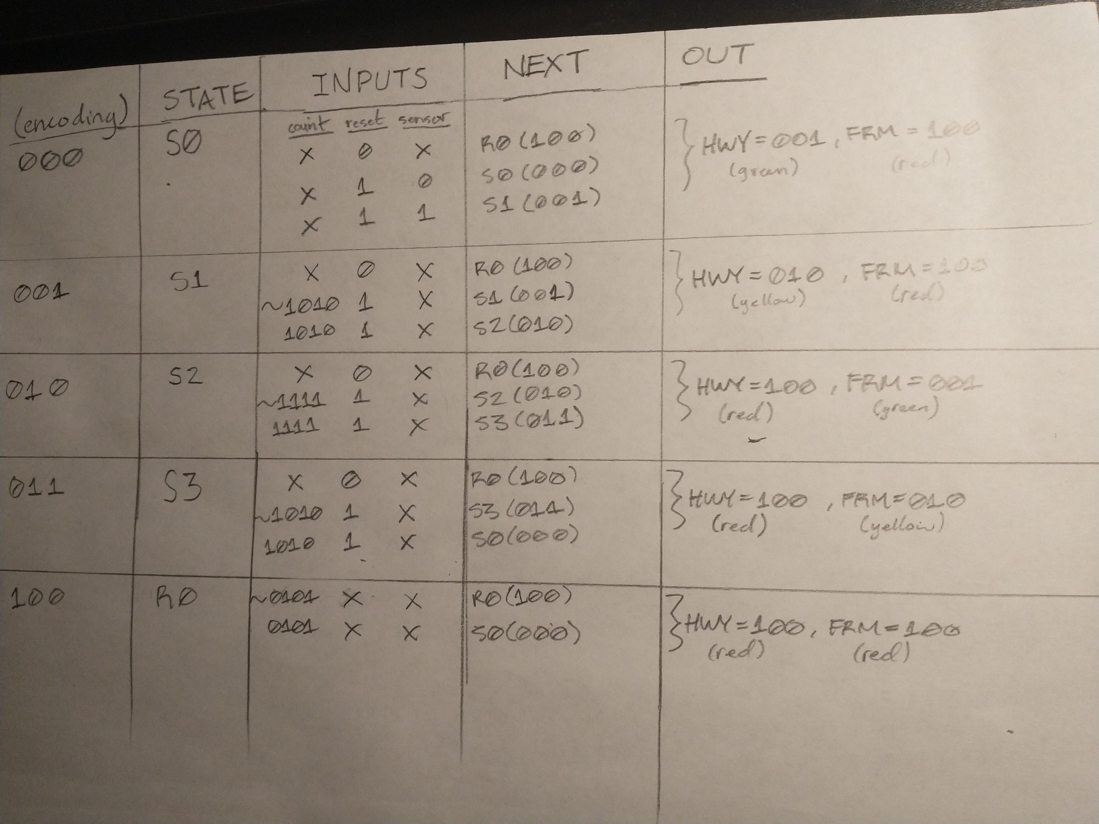

**Next State Equations**

S0 = S0&reset&~sensor + S3&reset&[count==1010]

+ R0&[count==0101]

S1 = S1&reset&[count!=1010] + S0&reset&sensor

S2 = S2&reset&[count!=1111] + S1&reset&[count==1010]

S3 = S3&reset&[count!=1010] + S2&reset&[count==1111]

R0 = S0&~reset + S1&~reset + S2&~reset + S3&~reset

+ R0&[count!=0101]

**Output Equations**

red_farm = S0 + S1 + R0

green_farm = S2

yellow_farm = S3

red_highway = S2 + S3 + R0

green_highway = S0

yellow_highway = S1

**ModelSim**

*[FIRST HALF : 0 ns🡪 1 ns]*

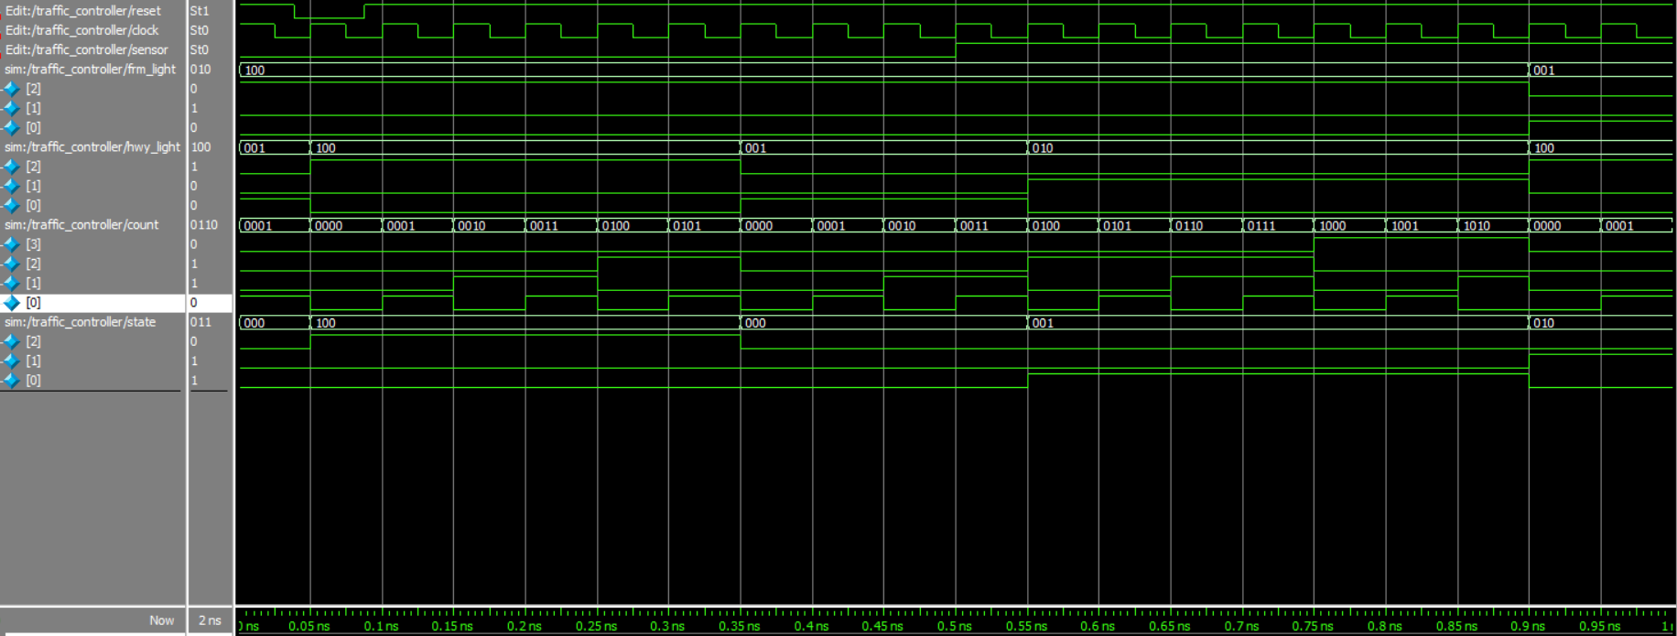

*[SECOND HALF : 1 ns🡪 2 ns]*

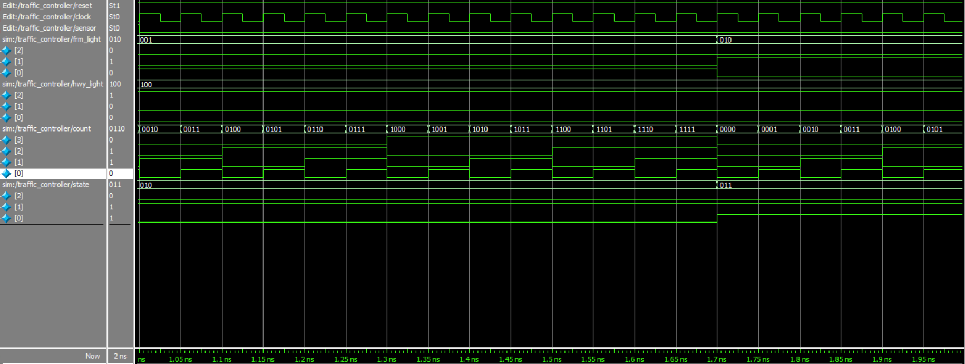

**RTL Viewer**

