*SCREENSHOT #1 -- SCHEMATIC*

*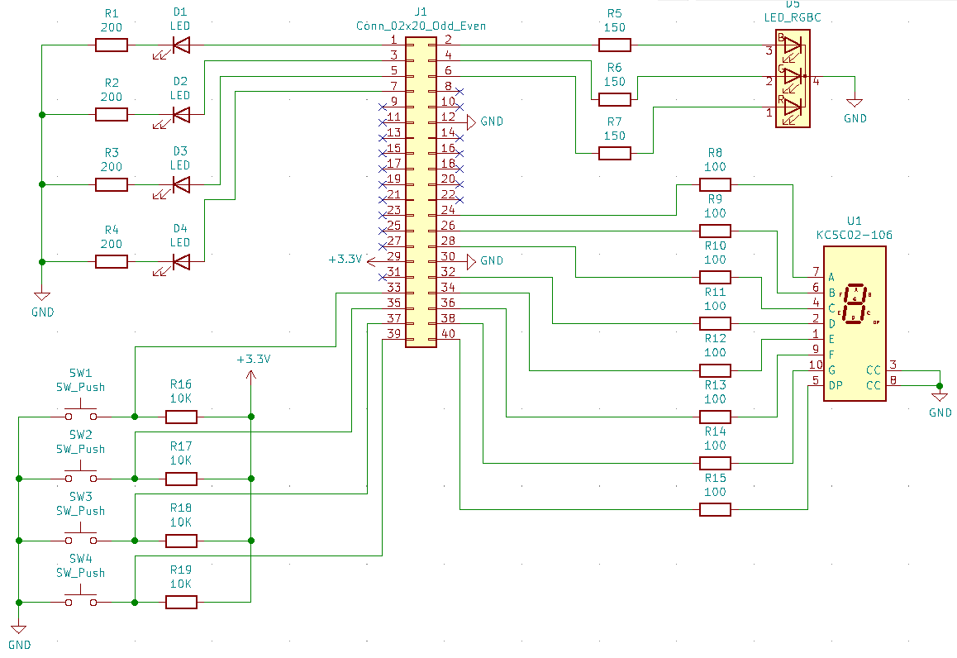*

*SCREENSHOT #2 – LAYOUT*

Text looks horrible I know. Only issues I had were my resistors being too small (the pads overlapped) and the ground copper pour being essentially pointless since all of the ground connections were wired up manually.

