***5-Bit Counter Testbench***

*[BELOW: pulse reset at beginning, begin counting up]*

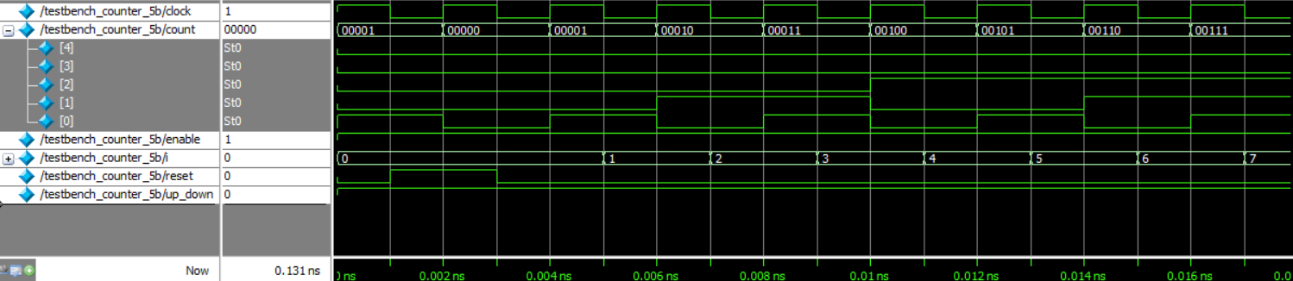

*[BELOW: brief rollover while counting up, then reverse count direction]*

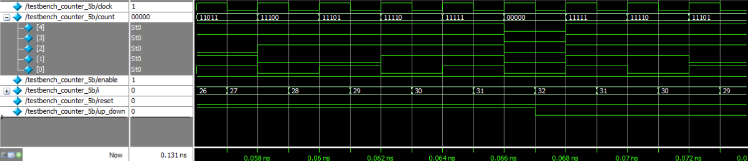

*[BELOW: counting down all the way to zero]*

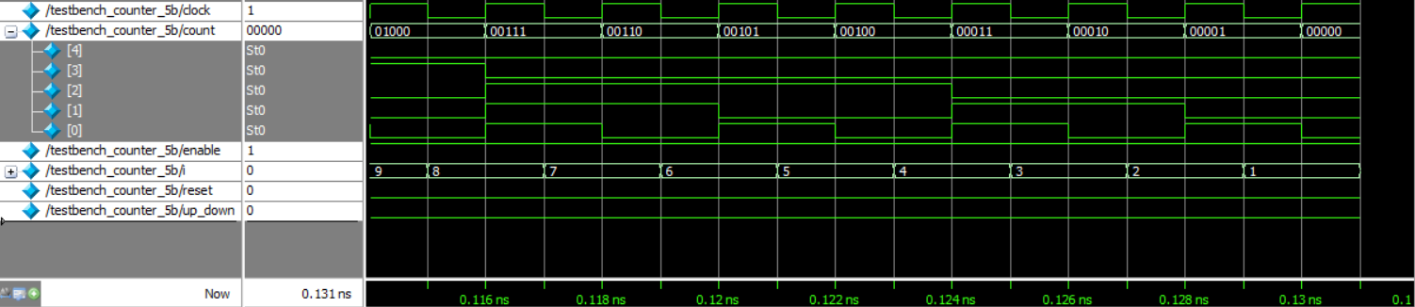

**Answer this question: If we had a 1024 bit counter and limited testing time, what strategies**

**would you use to verify the counter is functional without testing every single value?**

You could set up the test bench to verify the count value after a random number of time units have passed. You could also test edge cases such as whether the counter rolls over as expected when counting up or down near a value boundary.

***AES Decryption Testbench***

