*CLOCK DIVIDER CALCULATIONS*

**9600 Hz baud rate**

**50 MHz / 9600 Hz = 5208 [ratio]**

**5208 / 2 = 2604 [duty cycle :: 50%]**

**2604 == 12'b1010 0010 1100 [12 bit dc reg]**

*TRANSMITTER BLOCK MODEL*

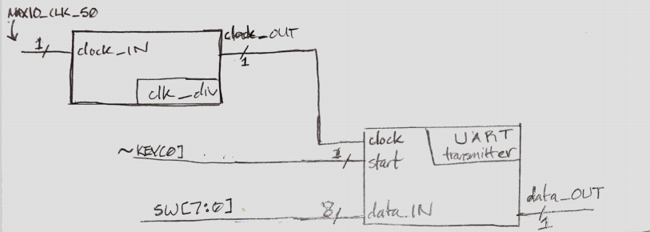

*TRANSMITTER STATE MACHINE*

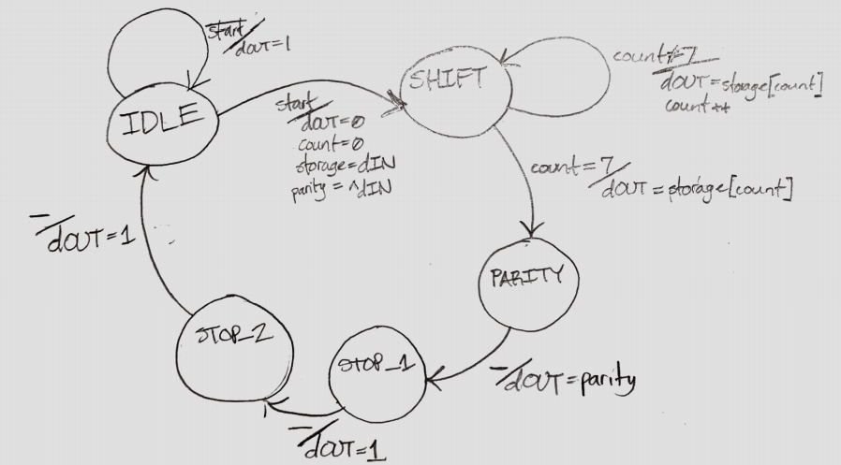

*5-CHARACTER TRANSMITTER STATE MACHINE*

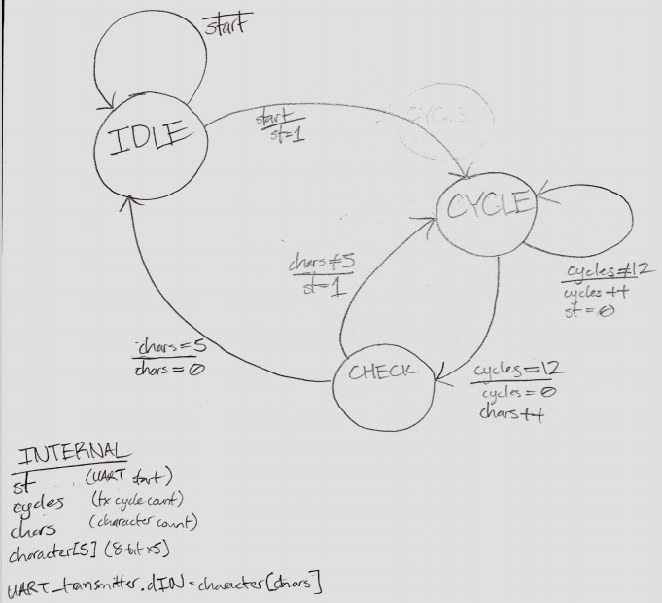

*TRANSMITTER RTL SCHEMATIC*

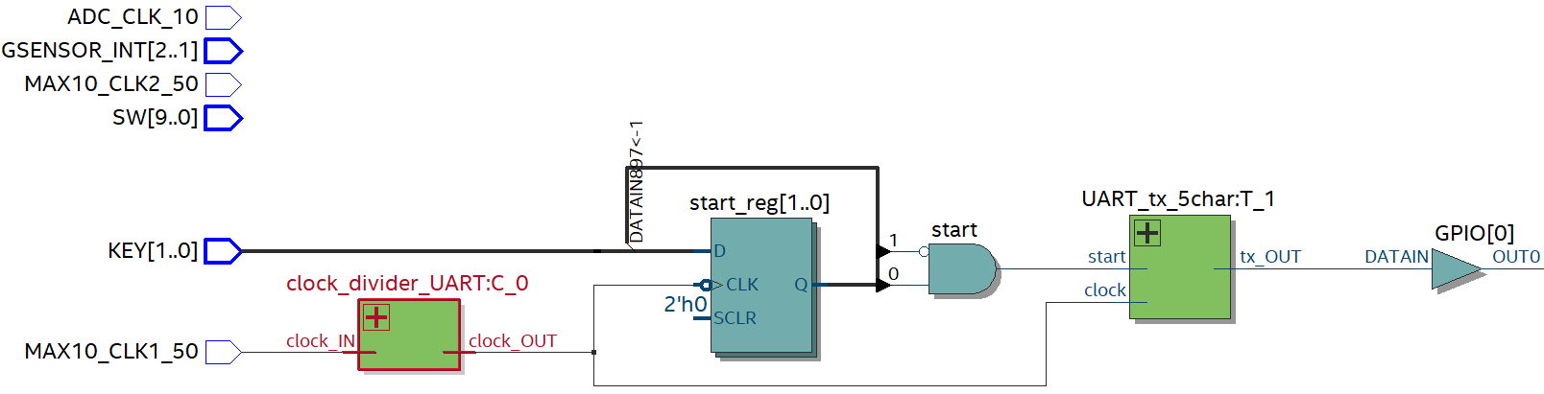

*5-CHARACTER TRANSMITTER RTL SCHEMATIC*

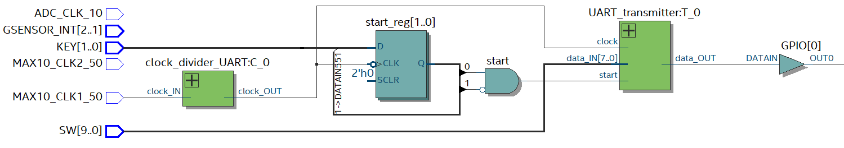

*RESOURCE ALLOCATION (FLOW SUMMARY)*

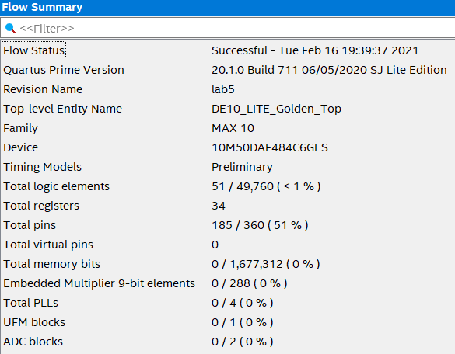

**[***51 logic elements used***]**