**Case Study: Jillian “Loose teeth and bleeding gums”**

Knowledge Level: **Beginner-Intermediate**

**Designed for the *Full* case** (This includes the treatment objectives tab and treatment portion of the case report)

Time allotment for students either in class or out of class: **3-4 hours**

Ideal group size: **5-7 members**

**Objectives:**

* Students will work in groups and evaluate a patient case entirely online.
* Students will analyze and record findings from assessment information provided in the simulation.
* Students will demonstrate evidence-based decision making by searching the literature to explain their differential diagnoses.
* Students will cite literature sources used to develop their differential diagnosis.
* Students will choose treatment options based on patient needs and priorities.
* Students will write a case report including subjective, objective, differential diagnosis and treatment objective sections.

**Problem:** Jillian has presented in your office because of a several loose teeth and bleeding gums. It is your job as a group to evaluate all the assessment information provided to you through the website on Jillian, research the possible diagnoses for Jillian’s condition, and write a case report on your findings including treatment objectives. There are 5-7 members in your group. Each person should select a pre-set role for the assignment.

*Tips:*

* *Take a lot of notes using the software while you are evaluating assessment information. These notes will appear at the end when you write the report and save valuable time not going back to look through the material.*
* *When writing your report, include ALL findings that are not considered normal. You may also want to include normal findings that pertain to Jillian’s case.*

**PART 1**

**Please use the role assignments to separate the workload for writing the case report. These assignments are NOT meant to prevent you from evaluating ALL the assessment information provided in the simulation.**

**Role #1**

1. 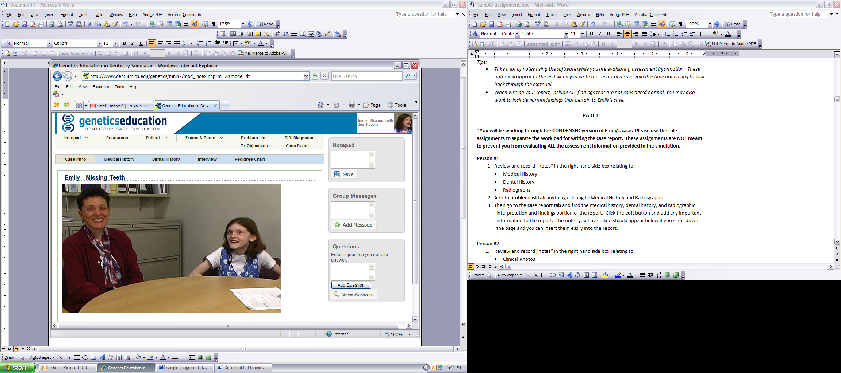Review and record “notes” in the right hand side box relating to:

* Medical History
* Dental History
* Radiographs

1. Add to **problem list tab** anything relating to Medical History, Dental History and Radiographs.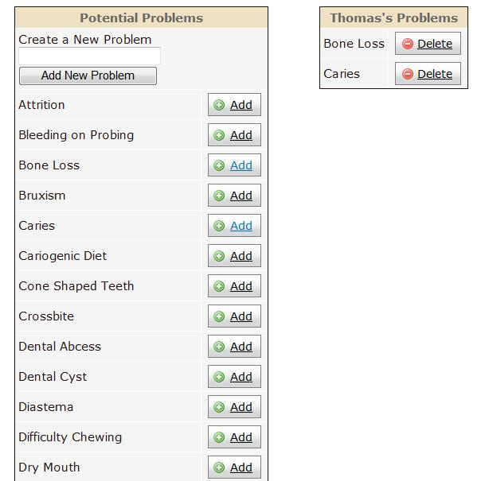

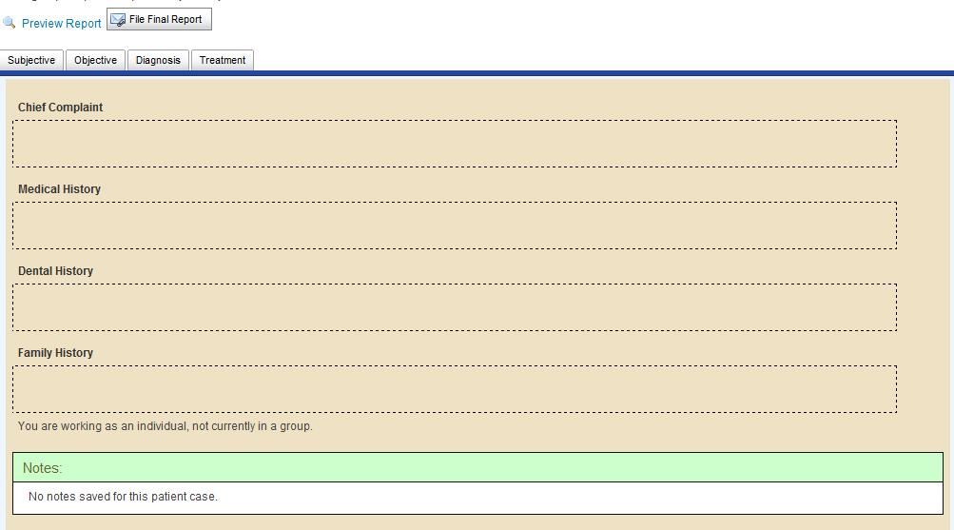

1. Then go to the **case report tab** and find the medical history, dental history, and radiographic interpretation and findings portion of the report. Click theappropriate section of the report and add any important information. The notes you have taken should appear below if you scroll down the page and you can insert them easily into the report.

**Role #2**

1. Review and record “notes” in the right hand side box relating to:

* Clinical Photos
* Dental Chart

1. Add to **problem list tab** anything relating to the Clinical Photos, and the Dental Chart.
2. Then go to the **case report tab** and find the clinical Photos and Dental Exam findings portion of the report. Click theappropriate section of the report and add any important information. The notes you have taken should appear below if you scroll down and you can insert them easily into the report.

**Role #3**

1. Review and record “notes” in the right hand side box relating to:

* Genetic Tests
* Pedigree Chart

1. Add to **problem list tab** anything relating to Genetic Tests and the Pedigree Chart.
2. Then go to the **case report tab** and find the family history and genetic tests portion of the report. Click theappropriate section of the report and add any important information. The notes you have taken should appear below if you scroll down and you can insert them easily into the report.

**Roles #4, #5 and #6**

1. Review and record “notes” in the right hand side box relating to:

* Interview



1. Add to **problem list tab** anything relating to the Interview.



1. Then go to the **case report tab** and find the sections of the report that pertain to the interview. Click theappropriate section of the report and add any important information. The notes you have taken should appear below if you scroll down and you can insert them easily into the report.

**PART 2**

As a group, search for possible diagnoses for Jillian’s condition by clicking the **add** button next to the diagnosis in the **diff. diagnosis tab**.

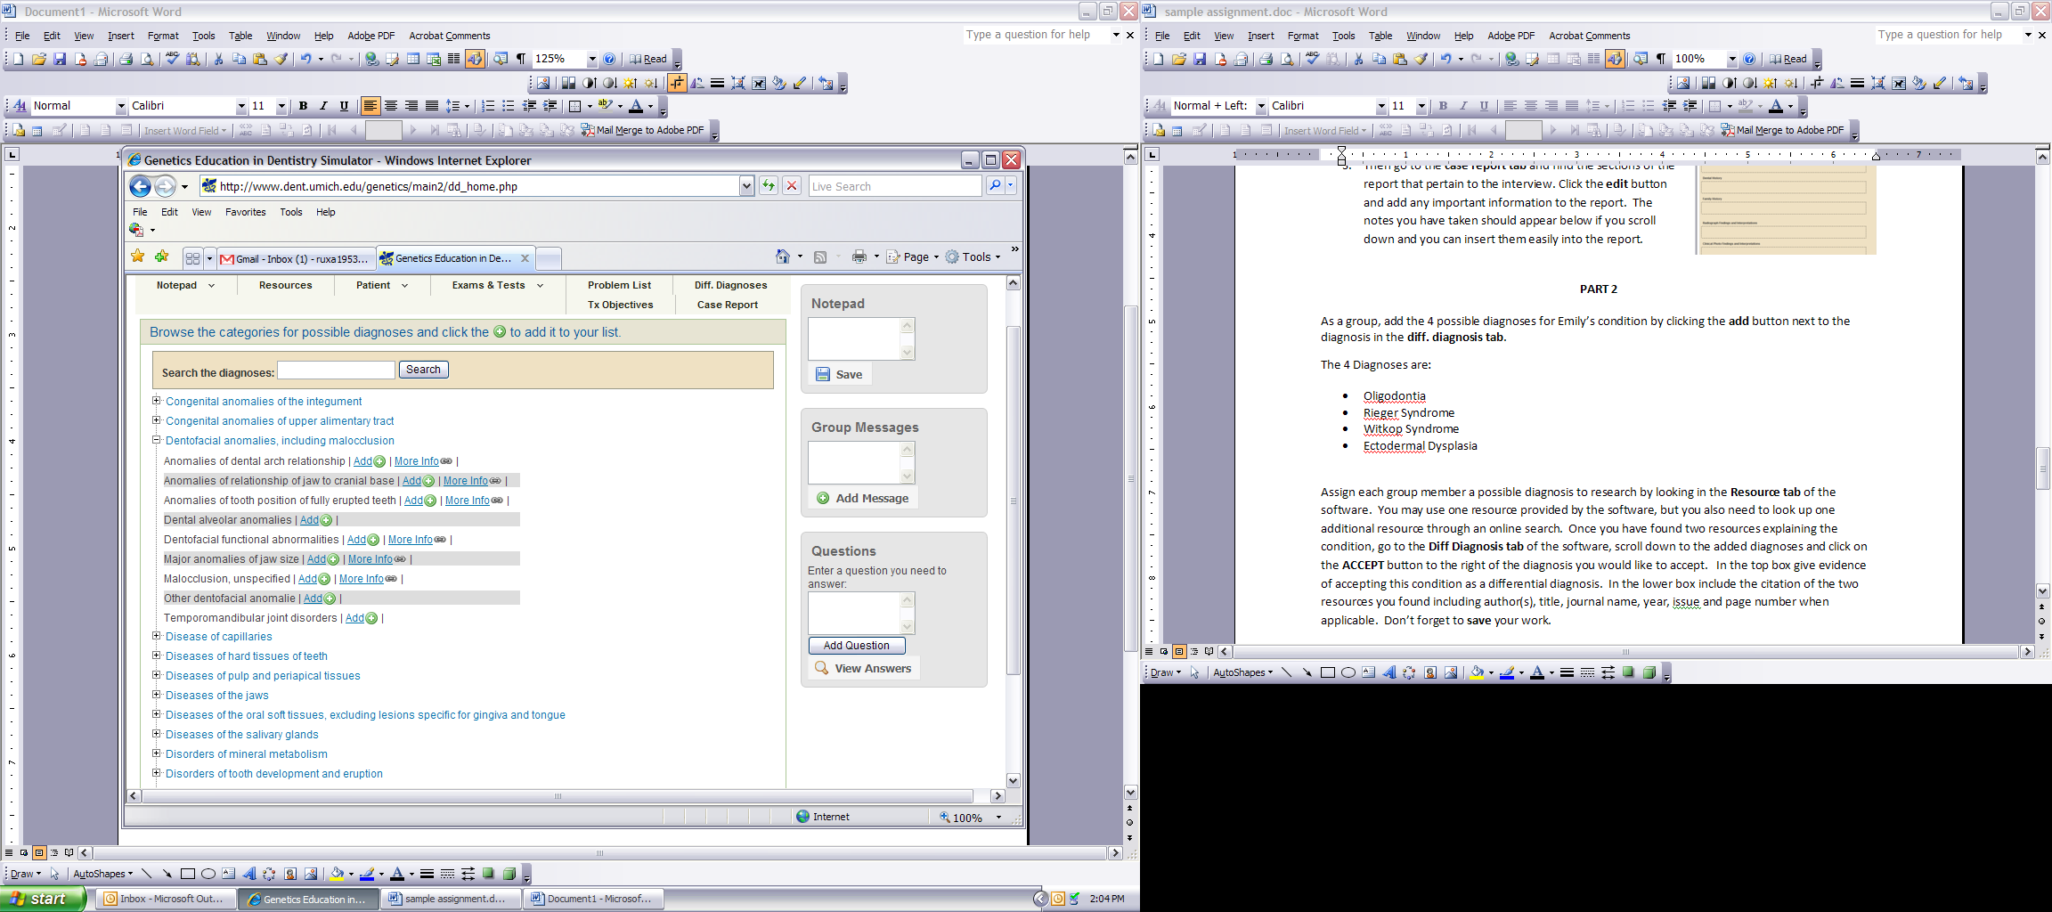

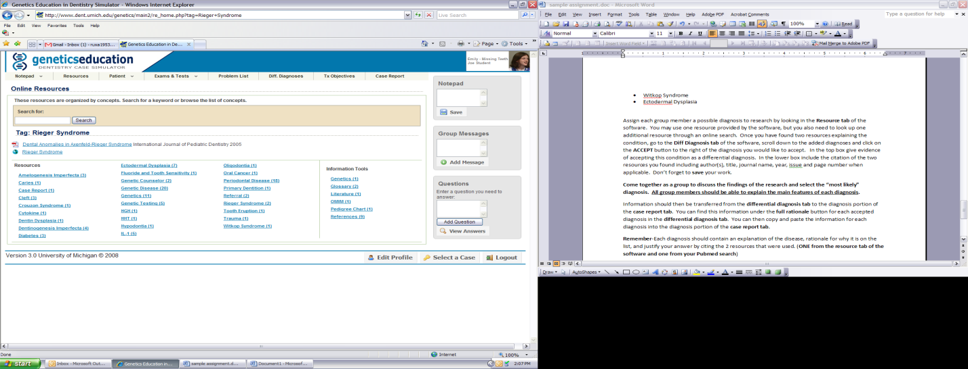

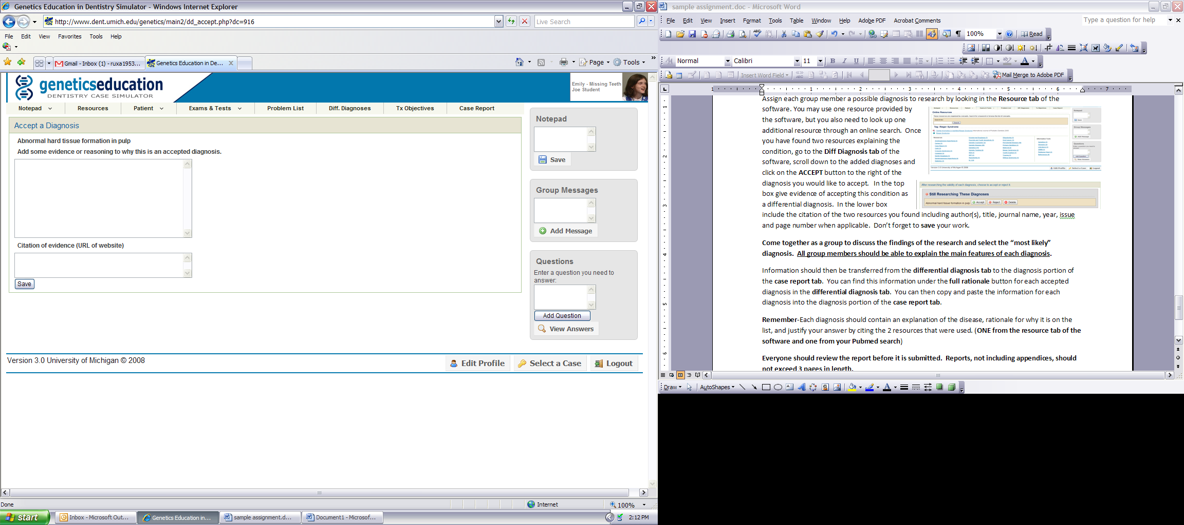Assign each group member a possible diagnosis to research by looking in the **Resource tab** of the software. You may use resources provided by the software, but may also want to search for resources through an online search.

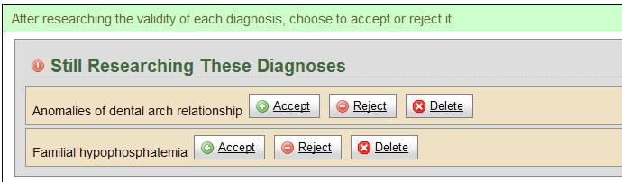

Once you have found resources explaining the condition, go to the **Diff Diagnosis** **tab** of the software, scroll down to the added diagnoses and click on the **ACCEPT** button to the right of the diagnosis you would like to accept. A new box will pop up. In the top box give evidence of accepting this condition as a differential diagnosis. In the lower box include the citation of the two, year, issue and page number when applicable. Don’t forget to **save** your work.

**Come together as a group to discuss the findings of the research and select the “most likely” diagnosis. This should appear at the top of your list in the case report. All group members should be able to explain the main features of each diagnosis.**

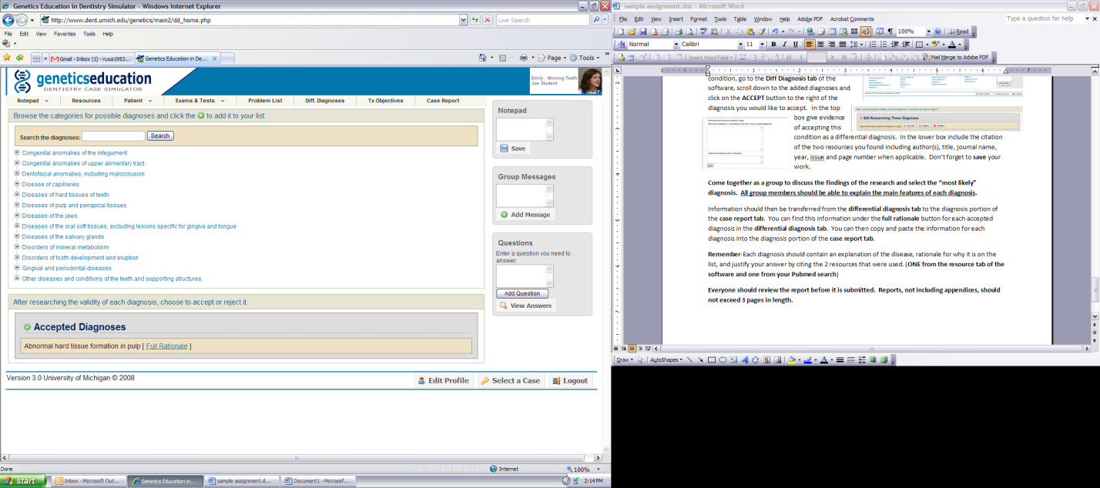You can find this information about each accepted diagnosis under the **full rationale** button in the **differential diagnosis tab**. You should discuss your differential diagnosis in the diagnosis portion of the **case report tab**.

**Remember**-Each diagnosis should contain an explanation of the disease, rationale for why it is on the list, and justify your answer.

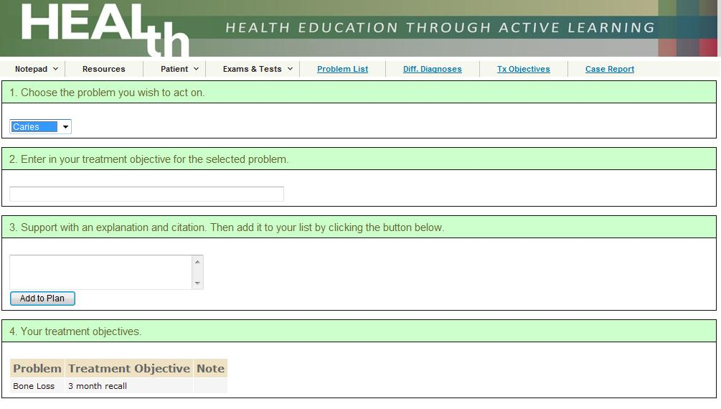You should spend time developing treatment objectives for Jillian. In the **treatment objective** tab of the software you will find all the problems that you added to the list in a dropdown menu. Select each problem individually, enter a treatment objective, support it with an explanation, and add it to the plan. Do this with each of Jillian’s problems. This will form a table at the bottom of the page. This table will also appear the treatment portion of your report. It is here that you should discuss your treatment objectives.

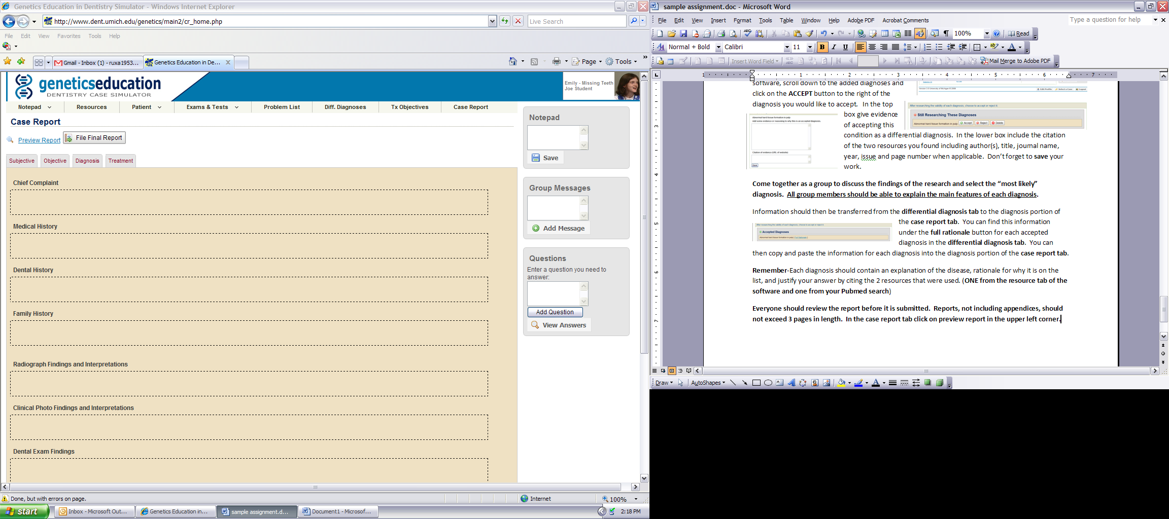Everyone should review the report before it is submitted. Reports, not including appendices, should not exceed 3 pages in length. In the case report tab, click on **preview report** in the upper left corner. Once you are satisfied with the final product you can save a copy of your report. Your instructor will give you directions on how 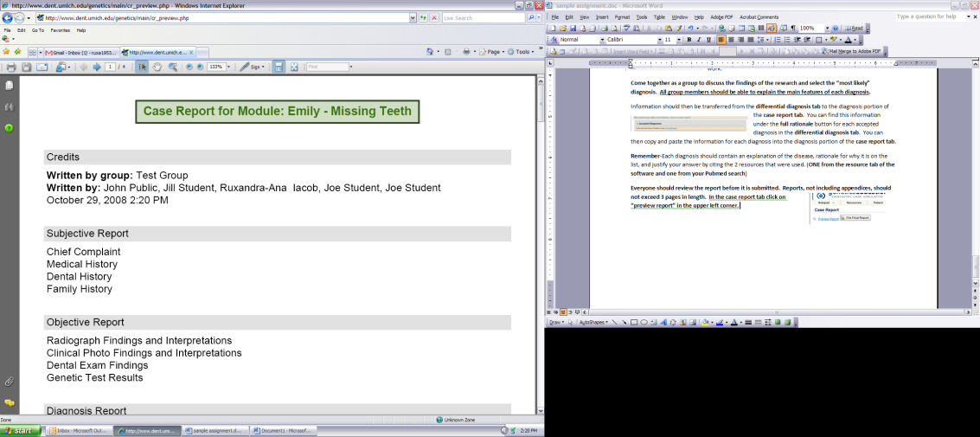they would like to receive the finalized report.