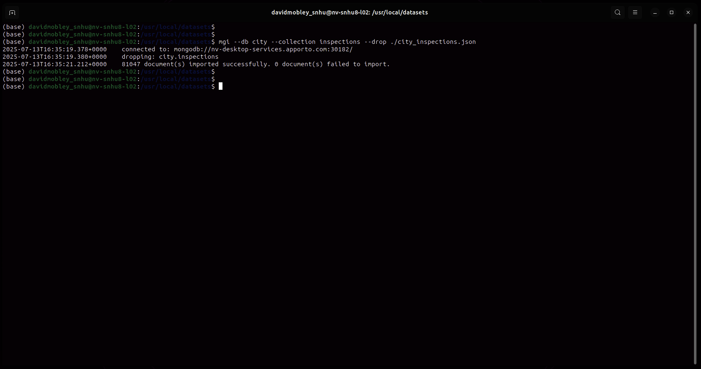
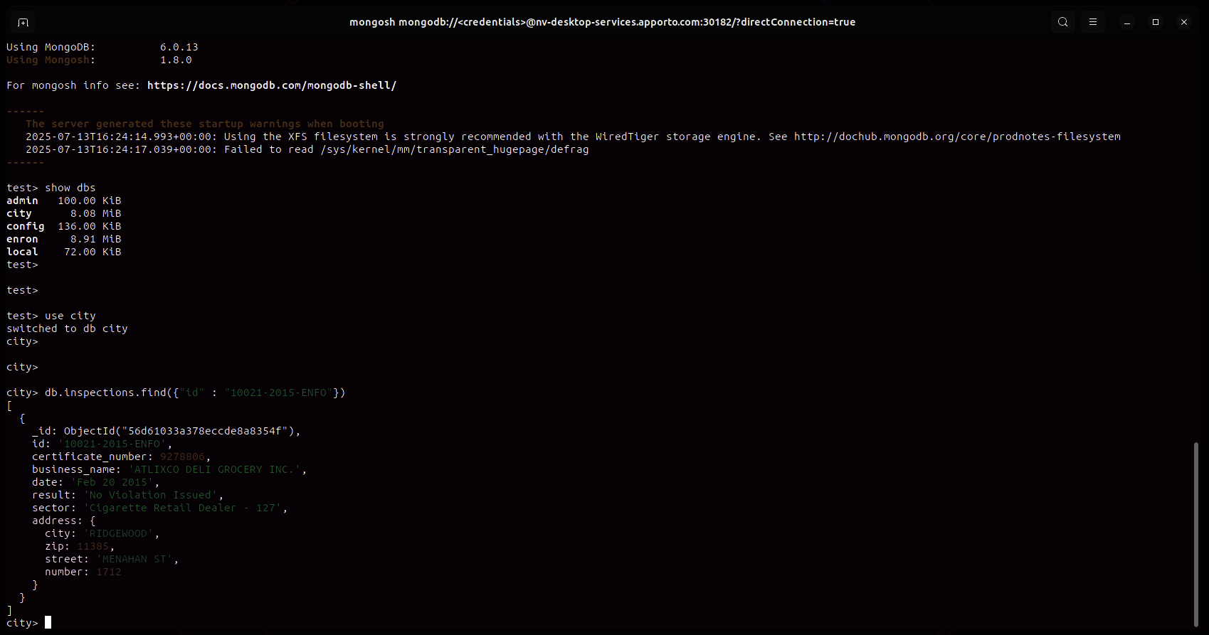
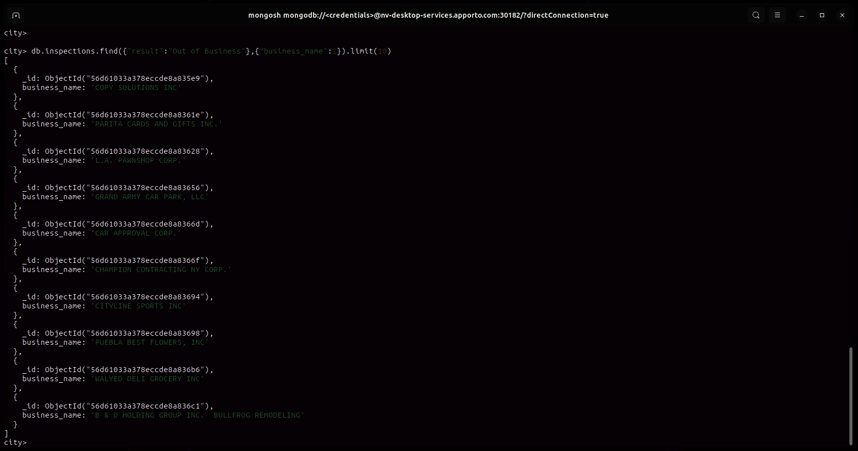
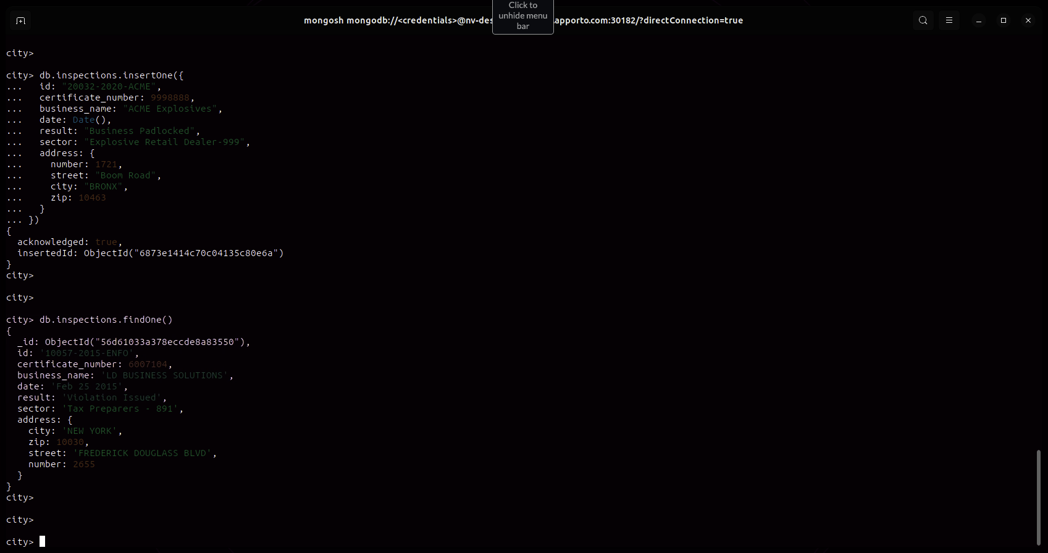
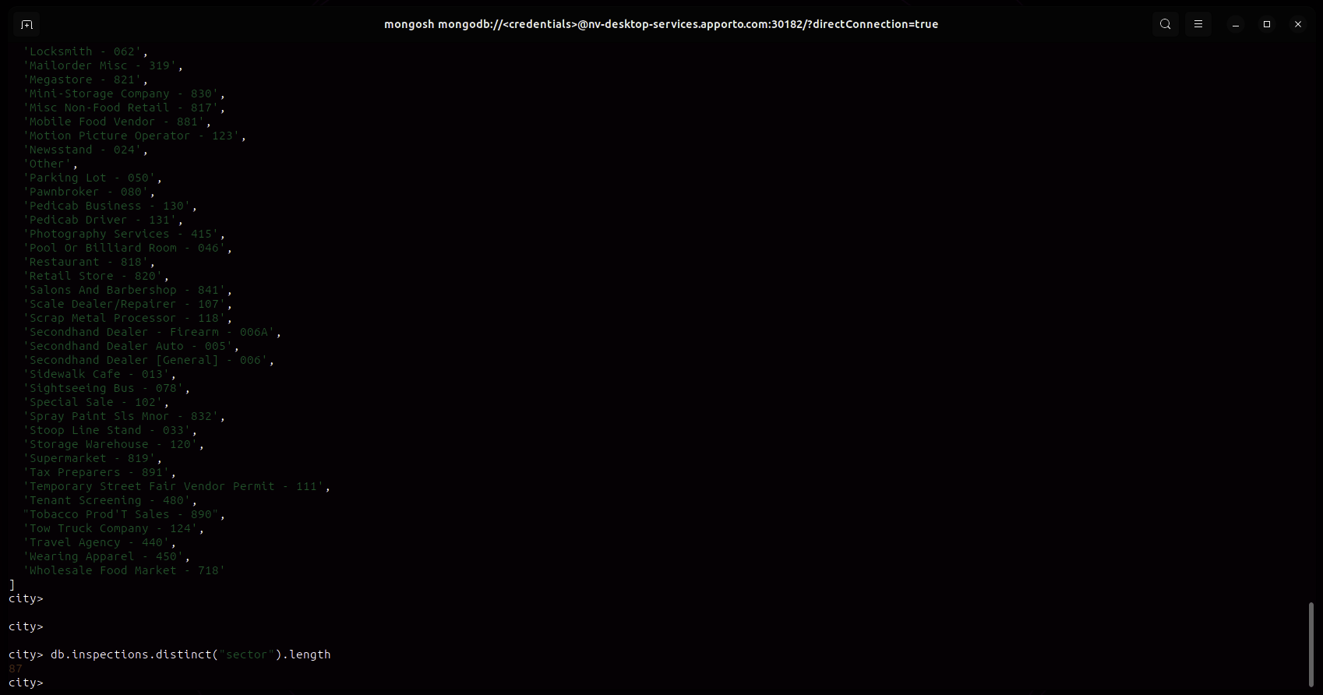

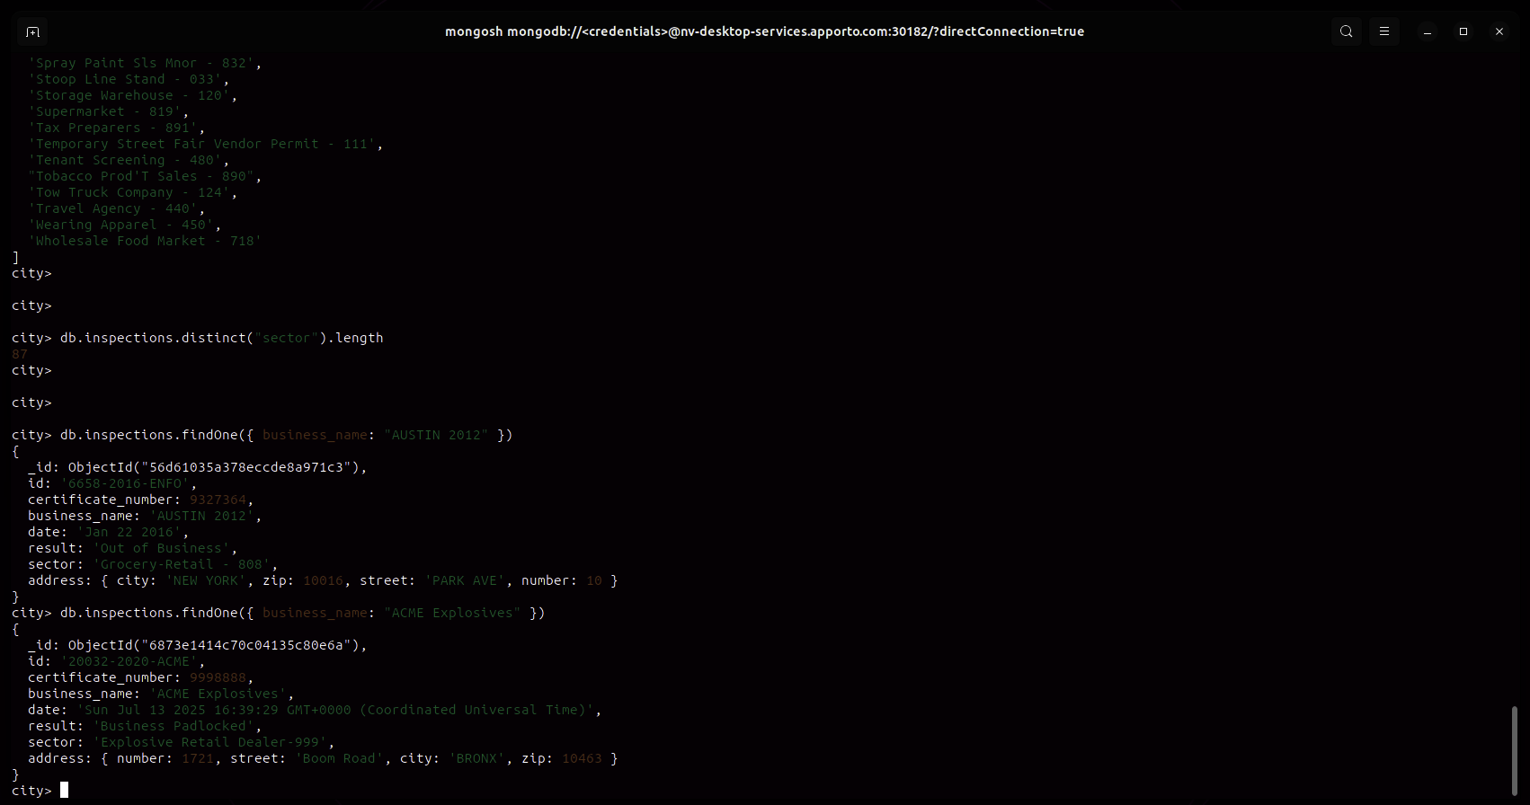

Question:
What is the difference in the date data type for the business named “AUSTIN 2012” versus your business document insertion of “ACME Explosives”?

Answer:
Both the “AUSTIN 2012” and “ACME Explosives” documents store their date fields as strings, not as native date objects. However, the formats differ:
- AUSTIN 2012: The date value is a short, human-friendly string, e.g. 'Jan 22 2016'.
- ACME Explosives: The date value is a verbose JavaScript Date string, e.g. 'Sun Jul 13 2025 16:39:29 GMT+0000 (Coordinated Universal Time)'.
Summary:
Neither field is a true date object; both are strings, just in different formats.
