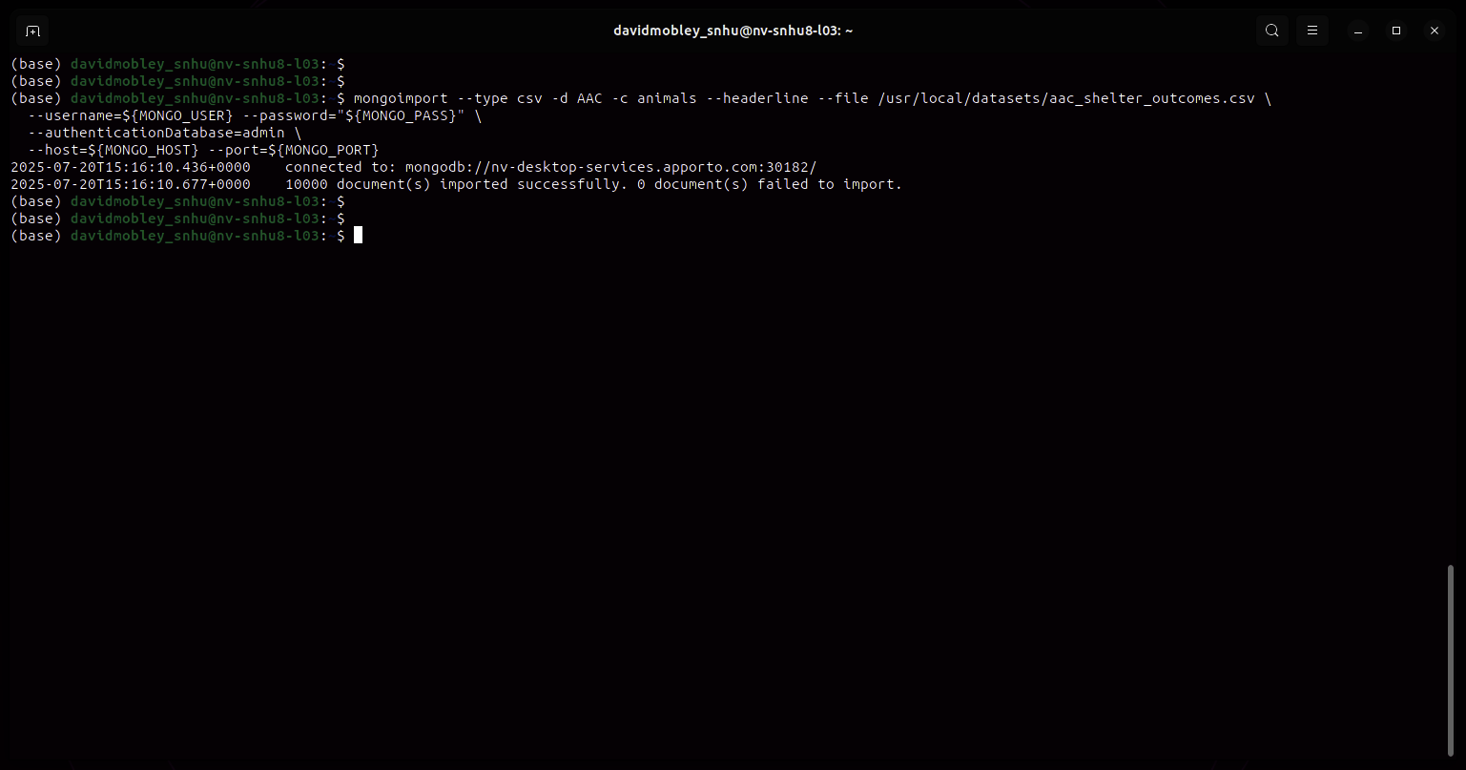
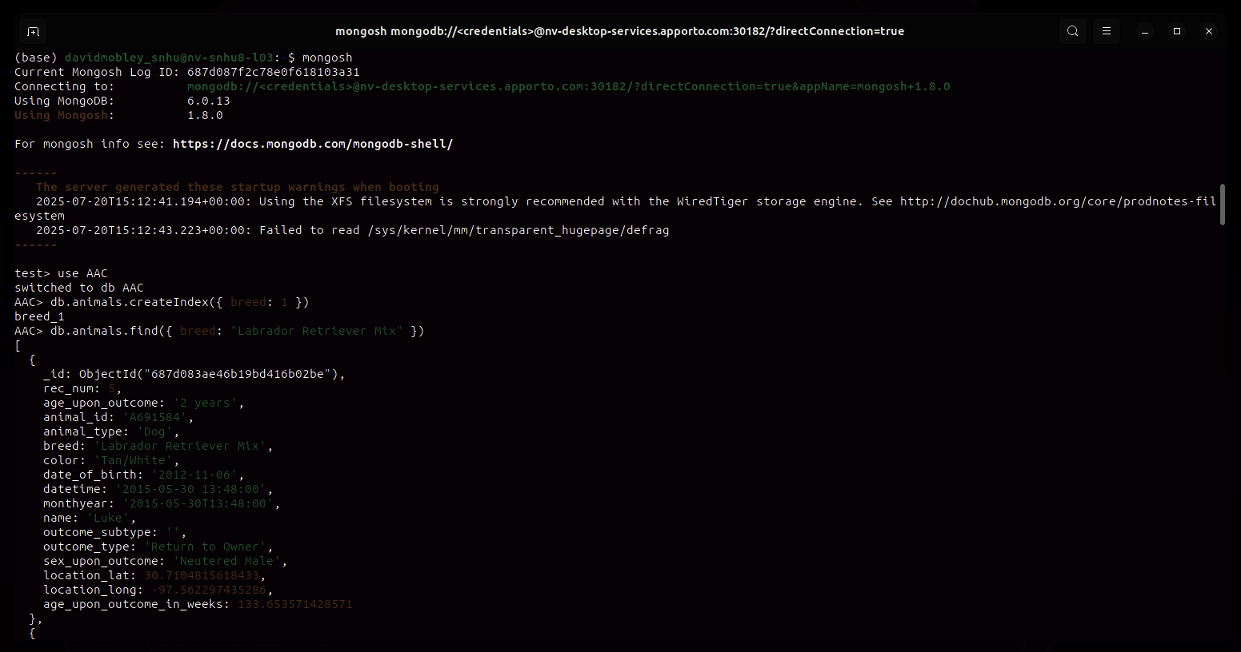
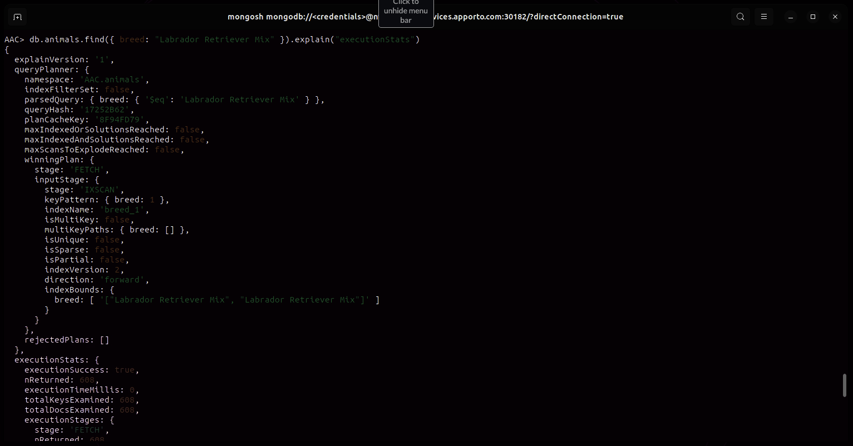
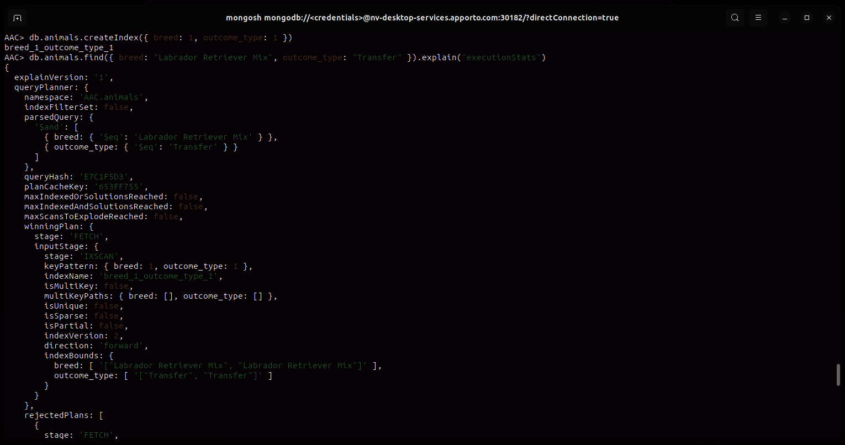

Part 2:
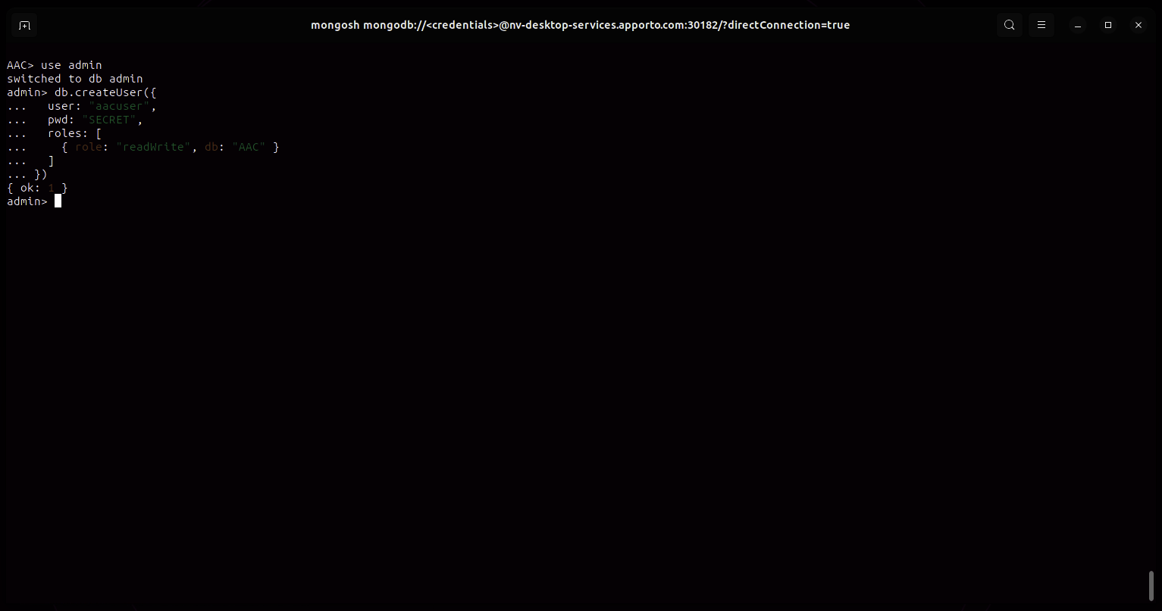

Instead of playing around with the environment variables and needing to change modify things as I need to use them, I created a custom variable file that I will use to track the variables I need:
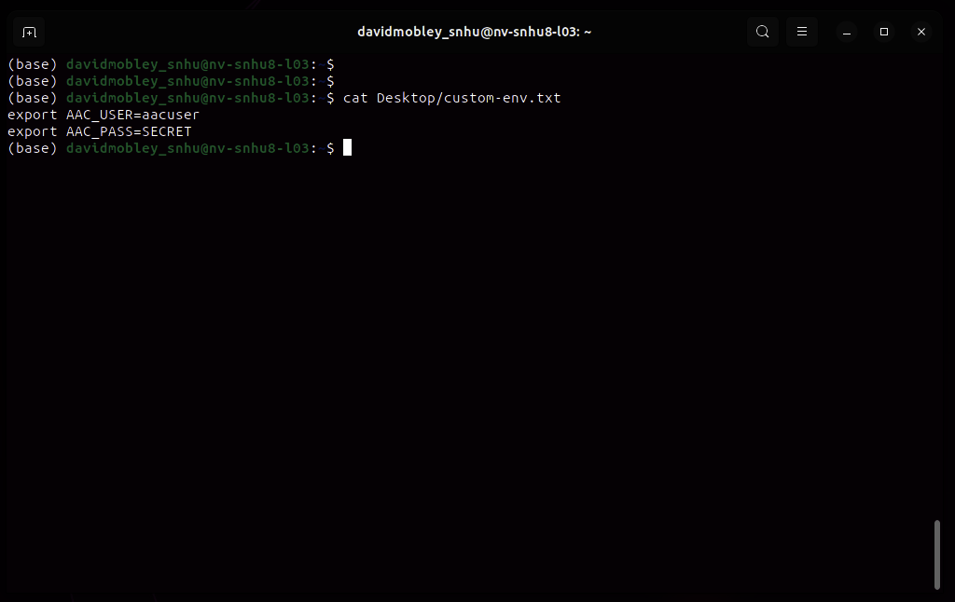

After that, since the `mongosh` command was hijacked and aliased somewhere else, I removed the alias, loaded my environment variables, and created a function that allows me to more easily login:
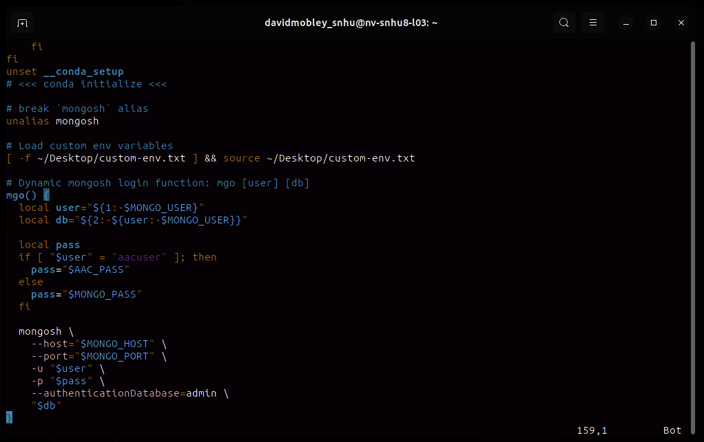

Environment variables loaded:
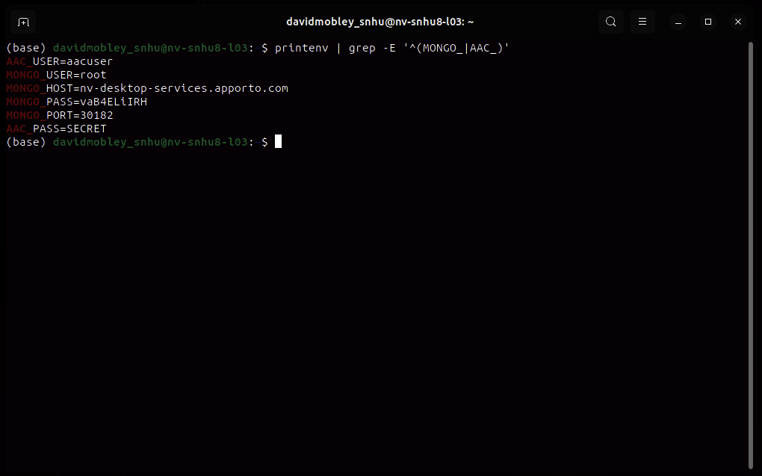

Admin login with custom using `mgo` login function:
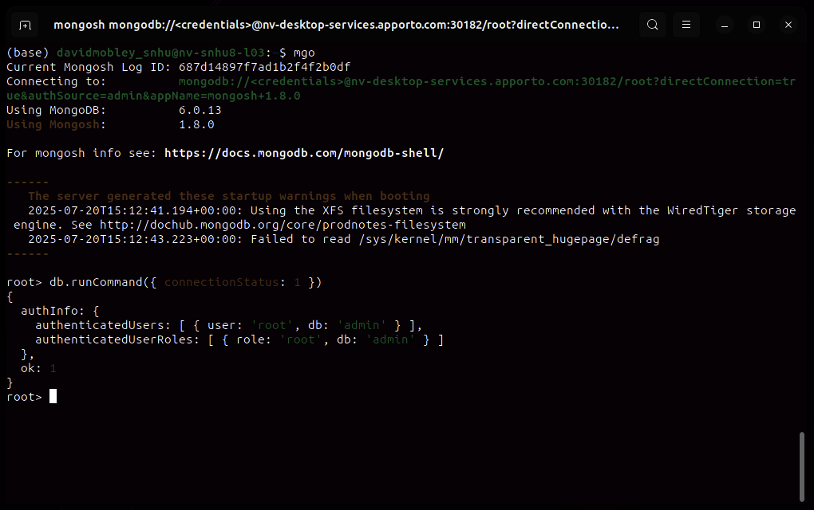

AACUSER login using custom `mgo` login function:
