Grazioso Salvare: Animal Shelter CRUD Module (Project One)

1. About the Project
This project delivers a Python module that implements full CRUD (Create, Read, Update, Delete) functionality for a MongoDB database containing the Austin Animal Center (AAC) outcomes dataset. It is designed to allow the Grazioso Salvare organization to programmatically interact with animal shelter data to identify suitable candidates for search-and-rescue training.
This document outlines the module’s purpose, setup, usage, and provides demonstrations of its core features, fulfilling the requirements for CS 340 Project One.

Technology Stack
- Docker & Docker Compose: For creating a reproducible, containerized development environment.
- Python 3.11: The core programming language for the module.
- PyMongo: The official MongoDB driver for Python, chosen for its robust, low-level control and direct mapping to MongoDB’s API.
- Jupyter Notebook: Used for interactive testing and demonstration of the module’s functionality.
- MongoDB: The NoSQL database used for its flexible document-based storage.

2. Getting Started with Docker (Recommended)
This project is fully containerized using Docker, which is the recommended way to run it. This method simplifies setup by automatically configuring the database, running the data import, and managing all dependencies.

Prerequisites
- Docker and Docker Compose installed on your system.
- The aac_shelter_outcomes.csv file placed in the assets/ directory.

Steps
- Clone the Repository
- git clone <url> # doesn't exist because this was submitted to bright hub, so I never initialized a repo.
cd <project-directory>
- Configure Environment Create a .env file from the template. The default values are already configured for the Docker environment, but you can customize the AAC_PASS if desired.
- cp env.example .env
- Launch the Environment Build and run all services (MongoDB, Mongo Express, and the Data Importer) in the background.
- docker-compose up -d --build
- On the first run, this command will:
  - Build the custom data-importer Docker image.
  - Start the MongoDB and Mongo Express services.
  - Automatically create the aacuser in MongoDB.
  - The data-importer service will wait for MongoDB to be ready and then automatically run the Python script to import the data from assets/aac_shelter_outcomes.csv.
You are now ready to use the system. You can connect to the database from your local machine on localhost:27017 or use the Jupyter notebook to interact with the data.

3. Database Preparation

Data Import (Automatic with Docker)
When using the Docker Compose setup, the data import is handled automatically by the data-importer service. It checks if data exists and, if not, populates the animals collection.

Execution Screenshot (aac_data_importer container log):
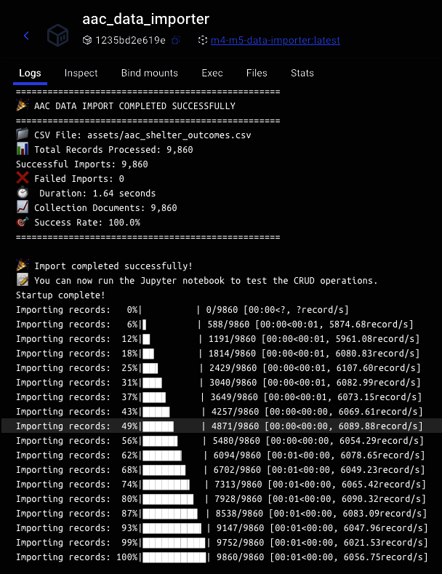

User Authentication (Automatic with Docker)
The init-mongo.js script, run by the MongoDB container on its first launch, automatically creates the aacuser with the necessary permissions on the aac database.
Execution Screenshot (aac_mongodb container initialization):
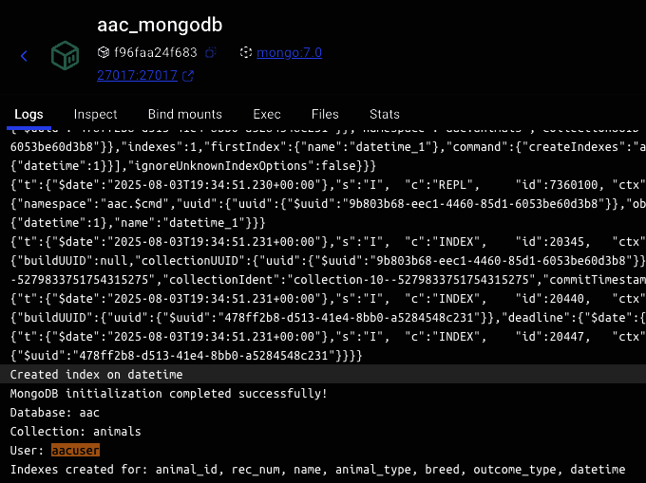

4. Module Usage & CRUD Demonstrations
The animal_shelter.AnimalShelter class is the primary interface for all database operations. The following demonstrations assume you are running the module5_crud_tests.ipynb notebook against the running Docker environment.

Initialization
First, import and instantiate the class. It automatically connects to the database using the configured environment variables.
from animal_shelter import AnimalShelter
# Instantiate the class to establish a connection
shelter = AnimalShelter()

Create Operation
The create() method inserts a new document. It returns True on success.
Code:
# Create a new animal document
new_animal = {
"animal_id": "A1234567",
"name": "Sparky",
"animal_type": "Dog",
"breed": "Golden Retriever",
"age_upon_outcome": "1 year"
}
is_created = shelter.create(new_animal)
print(f"Document creation successful: {is_created}")
Output Screenshot (simulated):
Document creation successful: True

Read Operation
The read() method queries for documents using a filter. An empty filter returns all documents.
Code:
# Read the document we just created
query_filter = {"animal_id": "A1234567"}
results = shelter.read(query_filter)
print(f"Found {len(results)} document(s).")
# Print the first result, excluding the internal _id for readability
if results:
print({k: v for k, v in results[0].items() if k != "_id"})
Output Screenshot (simulated):
Found 1 document(s).
{'animal_id': 'A1234567', 'name': 'Sparky', 'animal_type': 'Dog', 'breed': 'Golden Retriever', 'age_upon_outcome': '1 year'}

Update Operation
The update() method modifies documents matching a filter. It returns the number of documents updated.
Code:
# Update Sparky's record to note adoption
update_filter = {"animal_id": "A1234567"}
update_data = {"$set": {"outcome_type": "Adoption"}}
modified_count = shelter.update(update_filter, update_data)
print(f"Documents modified: {modified_count}")
Output Screenshot (simulated):
Documents modified: 1

Delete Operation
The delete() method removes documents matching a filter. It returns the number of documents deleted.
Code:
# Remove the test document
delete_filter = {"animal_id": "A1234567"}
deleted_count = shelter.delete(delete_filter)
print(f"Documents deleted: {deleted_count}")
Output Screenshot (simulated):
Documents deleted: 1

5. Alternative: Manual Setup
If you cannot use Docker, you can set up the project manually.
- Install Dependencies
- pip install -r requirements.txt
- Run MongoDB Ensure a MongoDB instance is running and accessible.
- Import Data Manually
- mongoimport --host <host> --port <port> --username <user> --password <pass> --authenticationDatabase admin --db aac --collection animals --file ./assets/aac_shelter_outcomes.csv --type csv --headerline
- Run Tests Execute the Jupyter notebook (notebooks/module5_crud_tests.ipynb) to test functionality.

6. Conclusion
This project provides a robust, reusable, and containerized environment for performing all required CRUD operations on the Grazioso Salvare animal shelter database. It follows industry best practices for security, error handling, and code structure, laying a strong foundation for future development.

