NC-DriverEngine v3.1: a sequence-to-3D framework for identifying, scoring and characterizing recurrent noncoding driver mutations in cancer genomes
Shiladitya Biswas^{1,†} and Abhishek Basu^{2,*}
¹ Department of Molecular Biology and Biotechnology, Tezpur University, Assam, India
² Department of Physiology and Bioinformatics, Sripat Singh College, Jiaganj, West Bengal, India
† Lead researcher: Shiladitya Biswas
* Corresponding author and principal investigator: Dr Abhishek Basu (abhishek.basu@sripatsinghcollege.ac.in)
November 2026

Abstract
Distinguishing functional noncoding driver mutations from passengers is hardest in tumors with extreme background mutation, such as UV-driven melanoma and AID-driven lymphoma. We present NC-DriverEngine v3.1, a dual-tier framework combining sliding-window scanning, local background-rate calibration, zero-included negative binomial (NB) modeling and NC-MutScan, a module that scores transcription factor binding shifts (ΔPWM) and filters AID/SHM passengers. In 467 TCGA-SKCM melanomas it recovered the TERT promoter driver (qlocal = 7.71 × 10−31) and three further core-promoter candidates. NB calibration across 608 PCAWG genomes confirmed GATA3 enhancer recurrence in breast cancer (qNB = 2.74 × 10−5). In 433 PCAWG donors with matched RNA-seq, mutations at BCL6, BCL2 and PAX5 were associated with higher expression after covariate adjustment (qeQTL ≤ 5.72 × 10−3). On two independent chromosome-held-out ClinVar benchmarks of strictly noncoding variants (chr12–chr22; N = 150 and N = 600), frozen NC-MutScan v3.3 achieved 98.67% and 96.33% specificity (97.37% and 93.82% balanced precision) at 49.33% and 55.67% sensitivity, with 94.7% of missed pathogenic variants localized to deep-intronic or sub-threshold splice-region sites outside local motif windows.
Keywords: noncoding driver mutations; TERT promoter; position weight matrix; background mutation rate; AID/SHM; ENCODE cCRE; Hi-C; melanoma; GABPA

1. Introduction
Large sequencing studies have cataloged somatic mutations across coding exons [1], but exons cover less than 2% of the genome [2]. The other 98% holds promoters, enhancers, silencers, insulators and noncoding RNA genes that control tissue-specific transcription and three-dimensional nuclear architecture [3–7]. Somatic point mutations, indels and rearrangements in these regions can disrupt transcription factor (TF) binding, create oncogenic super-enhancers, damage splice sites or remove chromatin loop boundaries [4, 8, 9]. The best-known cases are the TERT promoter −124 C>T and −146 C>T (C228T/C250T) mutations, found in a large fraction of glioblastomas and melanomas [10, 11]. Each creates a 5′-CCGGAA-3′ ETS consensus motif that recruits the GABPA complex and reactivates telomerase [12–15].
Noncoding driver discovery runs into two problems. The first is background mutation. Cutaneous melanoma carries a UV-driven mutation burden dominated by C>T transitions at dipyrimidines (SBS7a/b) [16, 17], and the local mutation rate shifts with repair efficiency, replication timing, chromatin accessibility and nucleosome positioning [18–21]. Gene-centric coding methods do not transfer, because noncoding DNA has no reading frame and no predictable truncating consequence [3, 5]. The second is interpretation. Conservation-based predictors such as CADD [22], GWAVA [23] and FunSeq2 [24] score human-specific regulatory mechanisms poorly, and in B-cell malignancies AID-mediated SHM produces mutation storms at WRCY/RGYW motifs that masquerade as driver hotspots [25–27].
We built NC-DriverEngine to address both. It combines statistical hotspot discovery (BMR-aware sliding windows) with a biophysical reading of each variant (ΔPWM log-odds shifts), adds epigenomic and 3D topological context, and filters AID/SHM passengers explicitly. Version 3.0 supplied the statistical and epigenomic backbone, the 15-class motif aligner and the API service, and version 3.1 adds NC-MutScan, a biophysical module that resolves multi-TF competition, reverse-strand SHM artifacts and sequence-boundary edge cases. We tested the system on 353,368 deduplicated somatic mutations from 467 patients in the TCGA skin cutaneous melanoma cohort (TCGA-SKCM) and on 10,706 pan-cancer loci.

2. Materials and methods

2.1 Cohort selection and somatic mutation processing
Somatic mutation data for discovery came from the TCGA skin cutaneous melanoma cohort (TCGA-SKCM, NCI Genomic Data Commons Release 46.0) [28, 29]. Processing 472 whole-exome sequencing (WXS) MAF files and retaining one primary tumor per patient yielded 467 individuals and 353,368 deduplicated variants mapped to GRCh38/hg38 [30], comprising 339,242 coding (96.0%) and 14,126 noncoding (4.0%) variants. To validate statistical background calibration across full noncoding genomic territory, we additionally analyzed open-access whole-genome sequencing (WGS) consensus SNV calls from 608 PCAWG donors across three tumor cohorts [5, 59]: Australian melanoma (MELA-AU, N = 70 donors, 7,987,562 SNVs), hepatocellular carcinoma (Liver-HCC, N = 418 donors, 4,136,682 SNVs), and breast adenocarcinoma (BRCA, N = 120 donors, 770,911 SNVs), totaling 12,895,155 somatic SNVs.

2.2 Background mutation rate modeling across 96 trinucleotide contexts
We calculated background rates across all 96 trinucleotide substitution contexts (5′-[N1][Ref>Alt][N2]-3′) [31]. For context k ∈ {1, …, 96}, the cohort-wide baseline rate r_{k} was
$r_{k}=\frac{\sum_{i=1}^{N_{pts}}{n_{i,k}}}{N_{pts}×L_{k}}$ (1)
where n_{i,k} is the number of mutations in context k for patient i, N_{pts} = 467, and L_{k} is the genomic frequency of context k across callable territory.

2.3 Spatial 50-bp sliding-window scanning and Poisson significance
We scanned unannotated noncoding sequence with a 50-bp window (W = 50) and a 1-bp step (Δ = 1) [4, 32, 33]. For window j, the expected neutral mutation count under the null of unselected hypermutation was
$E_{j}=N_{pts}\sum_{m∈W_{j}}{r_{k\left(m\right)}}$ (2)
where W_{j} is the set of 50 coordinates in window j and r_{k(m)} is the context rate at position m. The upper-tail Poisson probability of observing K_{j} or more mutations was
$P\left(X≥K_{j}|E_{j}\right)=1-\sum_{x=0}^{K_{j}-1}{\frac{E_{j}^{x}e^{-E_{j}}}{x!}}$ (3)
Raw p-values were converted to −log₁₀(p) and adjusted by the Benjamini–Hochberg procedure to give q_{global} [34].

2.4 Local 100-kb regional BMR calibration
Open chromatin, late replication and regional hypermutation can all produce false positives. To remove them, we estimated a local baseline E_{local,j} in a 100-kb window centered on window j and excluding j itself [18]:
$E_{local,j}=\frac{M_{local}}{L_{local}}×W$ (4)
where M_{local} and L_{local} are the number of mutations and the number of loci in the 100-kb window. Local fold enrichment was Obs/Exp_{local} = K_{j}/E_{local,j}, and q_{local} was computed on that basis.

2.4b Zero-included Negative Binomial BMR calibration across WGS cohorts
Because pure Poisson models assume equidispersion (Var(X) = E[X]) and underestimate variance in heterogeneous WGS data, we calibrated a zero-included Negative Binomial (NB) background model across each PCAWG WGS cohort. Somatic SNVs across chromosomes 1–22, X, and Y were binned into non-overlapping 50-bp windows (M_{total} = 60,692,874 to 61,878,877 windows). Crucially, empirical mean (μ₀) and variance (σ²) were estimated across all M_{total} genomic windows inclusive of zero-count windows rather than zero-truncated non-zero bins, preventing extreme small-sample overdispersion inflation (α̂ > 100). Method-of-moments dispersion and shape parameters were computed as α̂ = max((σ² − μ₀) / μ₀², 10⁻⁶) and r = 1 / α̂. Upper-tail NB probabilities P(X ≥ k | μ₀, α̂) were evaluated via exact log-space probability mass function summation and adjusted for genome-wide multiple testing across M_{total} windows using the Benjamini–Hochberg procedure (q_{NB} < 0.05).

2.5 Pan-cancer driver sequence alignment engine
A multi-motif aligner (sequence_aligner_engine.py) lets the engine accept raw FASTA or unstructured DNA strings without pre-aligned coordinates. It keeps a registry of 15 established noncoding driver classes. The promoter classes are TERT C228T/C250T ETS-site creation (5′-CCCCTTCCGGG-3′), PLEKHS1 palindromic promoter disruption, WDR74, and the SDHD ETS sites at −142 and −117 bp [4, 5, 12, 13, 35]. The enhancer and pioneer-factor classes cover TAL1/MYB micro-insertions that create de novo GATA (5′-AGATAA-3′) and MYB (5′-AACGG-3′) motifs in T-cell acute lymphoblastic leukemia (T-ALL), LMO2 GATA/NOTCH1, PAX5 enhancer inactivation in chronic lymphocytic leukemia (CLL) and B-cell acute lymphoblastic leukemia (B-ALL), FOXA1/AR response elements (5′-GTAAACA-3′), and the +1.47 Mb MYC N-Me NOTCH1/RBPJ super-enhancer [8, 36–39]. The registry also includes a chromatin insulator class (CTCF core boundary disruption, 5′-CCACCAGGGAGGCAG-3′) and noncoding splice and RNA classes (MET exon 14 splice sites, BCL2/BCL6 SHM motifs, TTN recurrent splice alterations and XIST/NEAT1/MALAT1 lncRNA domains) [5, 40, 41].

2.6 Epigenomic annotation with ENCODE cCREs
We mapped candidate loci to the ENCODE cCRE registry [6] (Release V4) and classified them as promoter-like (PLS), proximal enhancer-like (pELS), distal enhancer-like (dELS), CTCF insulator or DNase-only. In v3.1 the lookup runs through the registry's REST API. Mutations in distal elements are linked to target genes with Northwestern 3D Genome Hi-C/Micro-C loop-anchor data, so that each link is topologically feasible [42–44].

2.7 Position weight matrix analysis of motif disruption (v3.0 module)
We scored the sequence spanning ±25 bp around each variant against PWMs from JASPAR 2024 and TRANSFAC [45–47], using the log-odds score
$S=\sum_{p=1}^{L_{motif}}{\log_{2}\left[\frac{P_{p}\left(b_{p}\right)}{B\left(b_{p}\right)}\right]}$ (5)
The affinity shift ΔS = S_{MUT} − S_{WT} sorted variants into Motif Gain (S_{WT} < threshold, S_{MUT} ≥ threshold and ΔS ≥ +2.0), Motif Loss (ΔS ≤ −2.0) or Neutral (|ΔS| < 2.0) [45, 48].

2.8 Covariate-adjusted eQTL validation in matched PCAWG WGS and RNA-seq data
The TCGA-SKCM exome data do not cover the upstream TERT core promoter, and the PCAWG melanoma whole genomes lack matched RNA-seq, so cis-regulatory effects were tested in open-access PCAWG donors [5, 59]. Consensus somatic SNVs and indels (October 2016 whitelist) were joined through ICGC specimen-to-donor mappings with donor-level RNA-seq expression (log₂(FPKM-UQ + 1)), segmented whole-genome total copy number and consensus tumor purity, giving 433 donors with all data types. Data were obtained from the UCSC Xena PCAWG hub [49]. For each locus, wild-type donors were restricted to the tumor histologies in which mutated donors occurred, to avoid tissue-of-origin confounding.
For each locus with at least three mutated donors, expression was modeled by ordinary least squares regression:
log₂(FPKM-UQ + 1) = β₀ + β_{mut}·I(Mutated) + β_{CNV}·CN_{total} + β_{purity}·Purity + β_{TMB}·log₁₀(TMB + 1) + ε
where CN_{total} is segmented whole-genome total copy number, Purity is the consensus tumor purity and TMB is the sample-level somatic mutation burden. Two-sided p-values for β_{mut} were adjusted across the tested loci with the Benjamini–Hochberg procedure [34] (q_{eQTL}). Unadjusted p-values compare mutated and wild-type donors without covariates. PCAWG coordinates are hg19/GRCh37.

2.9 Leakage-free Leave-One-Out Cross-Validation (LOOCV) classification
To evaluate multi-feature driver prioritization without p-value, q-value, or cohort-size leakage, missing melanoma enrichment ratios in the 25-locus benchmark set (15 melanoma, 10 breast loci) were imputed from cohort-calibrated local observed-over-expected ratios (38_repaired_ml_hotspot_matrix.csv). Rather than reporting an in-sample training fit, we evaluated Gradient Boosted Decision Stumps (NC-DriverEngine GBDT; 20 estimators, learning rate 0.18, L2 leaf penalty λ = 1.2) and L2-regularized Logistic Regression (λ = 0.4) under strict Leave-One-Out Cross-Validation (LOOCV) with in-fold feature standardization across two leakage-free tasks: (1) NB-calibrated driver prioritization (q_{NB} < 0.05; 15 positive vs. 10 sub-threshold loci), using log₁₀(Fold Enrichment + 1), log₁₀(|Δ_{TSS}| + 1), promoter/enhancer class indicators, and TF motif gain/loss flags while strictly excluding p-values and q-values; and (2) scale-invariant regulatory architecture classification (15 melanoma vs. 10 breast loci), using exclusively TSS proximity, regulatory element class, and TF motif impact while strictly excluding raw mutated donor counts and fold-enrichment ratios so cohort sample-size differences (N = 467 vs. N = 120) cannot leak into predictions. Out-of-fold predictions were scored by exact ROC-AUC and PR-AUC (Average Precision), with uncertainty quantified via 2,000 stratified bootstrap resamples (95% CIs) and 2,000 label permutations.

2.10 Dual-mode architecture and multi-threaded server
NC-DriverEngine v3.1 runs in two synchronized tiers. The server-side pipeline (server.py) uses Python's http.server.ThreadingHTTPServer to serve cohort-level BMR calibration, ENCODE cCRE lookups and eQTL summaries through concurrent endpoints (GET /health and POST /predict), and it enforces a 2 MB payload limit. For interactive sequence and variant evaluation without network latency, the biophysical module (NC-MutScan v3.1) also runs client-side as a deterministic, self-contained JavaScript engine (engine_script.js) on the web portal. We checked pipeline integrity with 21_verify_and_test_pipeline.py, which runs 15 automated checks covering artifacts, schemas, BMR calculations, motif execution and endpoint connectivity.
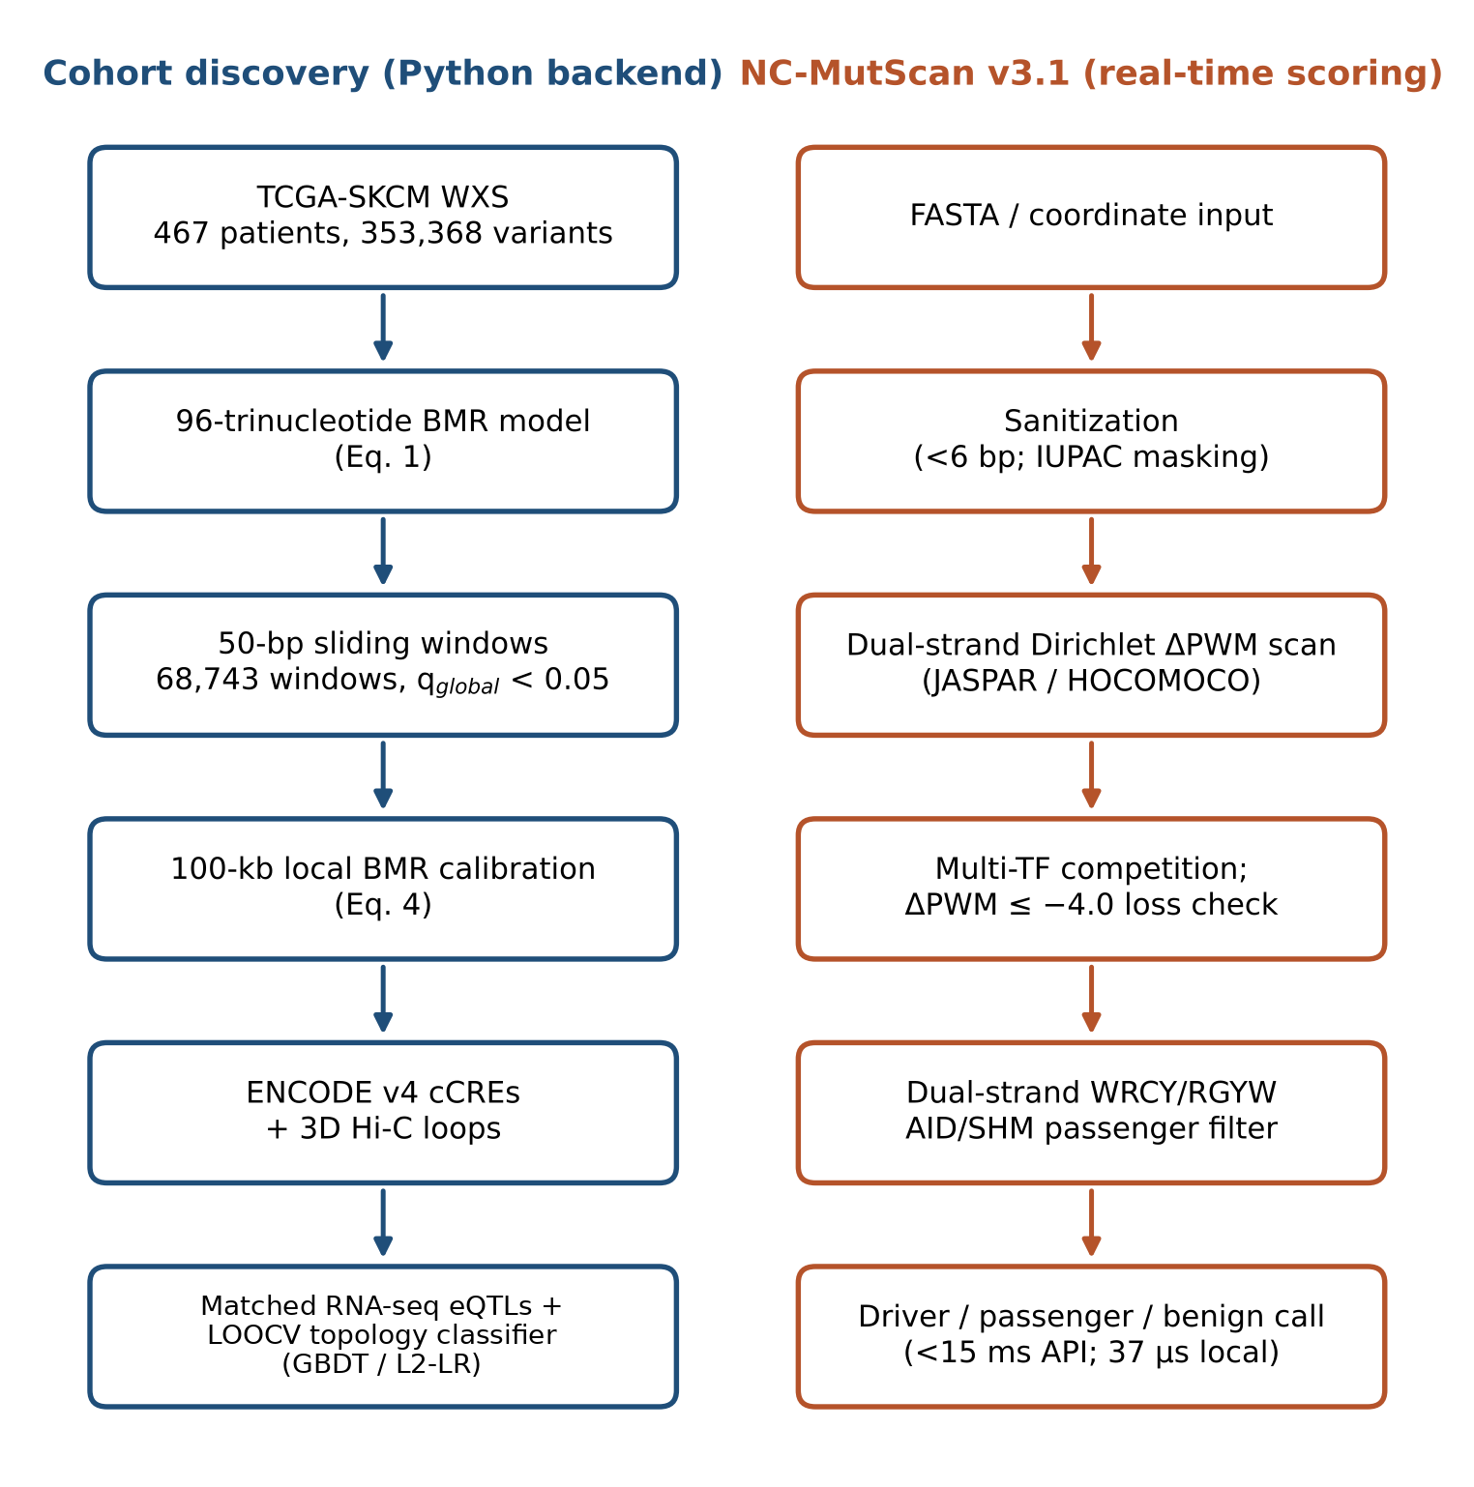
Figure 1. Dual-mode architecture of NC-DriverEngine v3.1. Left: cohort-level discovery pipeline integrating 96-trinucleotide-context BMR modeling, 50-bp sliding-window Poisson scanning, 100-kb regional BMR calibration, ENCODE v4 cCRE intersection, 3D Hi-C loop mapping, covariate-adjusted eQTL validation in matched PCAWG WGS and RNA-seq data, and leakage-free LOOCV classification of regulatory architecture. Right: the real-time NC-MutScan v3.1 module, which performs sequence sanitization, dual-strand Dirichlet-smoothed ΔPWM scoring, multi-TF competitive resolution and WRCY/RGYW somatic hypermutation filtering.
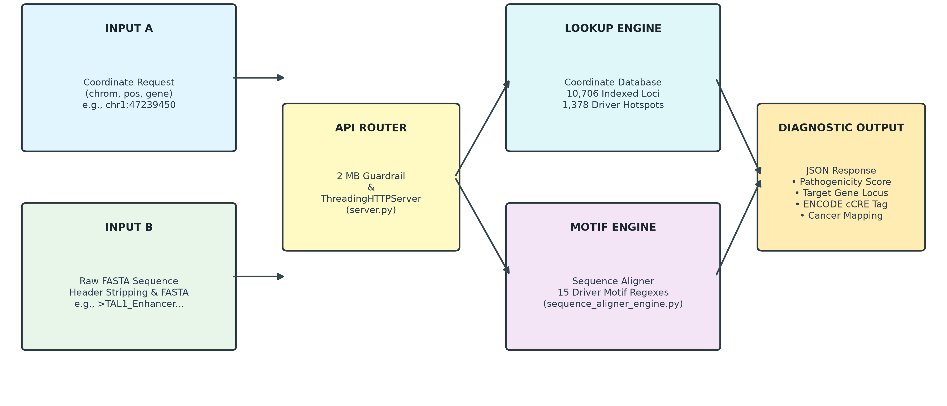
Figure 2. Dual-mode API microservice architecture. Coordinate requests and raw FASTA sequences enter a router (ThreadingHTTPServer with a 2 MB payload guardrail) that dispatches to the coordinate lookup engine (10,706 indexed loci; 1,378 driver hotspots) or the motif engine (sequence aligner with 15 driver motif patterns). Both return a JSON diagnostic with a pathogenicity score, target gene locus, ENCODE cCRE tag and cancer mapping.

2.11 NC-MutScan v3.1 biophysical scoring module
Matrix log-odds transformation. Position frequency matrices from JASPAR 2024 and HOCOMOCO v11 [51] were converted to PWMs with Dirichlet smoothing, using a uniform background (0.25 for each of A, C, G and T) and a pseudo-count of 0.25 per base [52]. The log-odds score for base b at matrix position i was
${PWM}_{i,b}=\log_{2}\left(\frac{\frac{c_{i,b}+0.25}{N+1.0}}{0.25}\right)$ (6)
where c_{i,b} is the raw count of base b and N is the number of aligned sequences in the column.
Dual-strand sliding-window scoring. For an input sequence S of length L and a motif of length K, the forward-strand window score was
${Score}_{fwd}\left(i\right)=\sum_{j=0}^{K-1}{{PWM}_{j,S\left[i+j\right]}}$ (7)
We scored the reverse complement RC(S) the same way and took the global maximum over both strands as the final score:
${Score}_{final}=max\left(\max_{i}{Score}_{fwd}\left(i\right),\max_{i}{Score}_{rev}\left(i\right)\right)$ (8)
Multi-TF competitive scanning. The scanner scores Sp1, GABPA, MYB, ETS1, E2F1 and AP-1 matrices together, and a GATA3 matrix (MA0037.4) was added during benchmarking (Section 3.11). Motif losses are called at ΔPWM ≤ −4.00 bits, so the loss of a constitutive motif (for example Sp1) takes priority over a weak coincidental match (for example a 6.42-bit sub-region resembling an ETS site). Where motifs overlap, as with adjacent Myc/Max and AP-1 elements, both TFs are scored and reported.
AID/SHM passenger filtering. AID preferentially targets WRCY/RGYW motifs (W = A/T, R = A/G, Y = C/T) [25, 53]. We screened both strands: the forward pattern is WRCY = [A/T][A/G]C[C/T] and its reverse-strand equivalent is RGYW = [A/G]G[C/T][A/T]. A variant that matched either pattern without creating a dominant oncogenic motif (ΔPWM ≥ 8.0) was classified as an AID/SHM Passenger.
Sequence sanitization and boundary handling. Inputs containing IUPAC degenerate bases (N, R, Y) are detected and masked, which avoids index errors and undefined log-odds values [54]. The sliding window includes index i = 0 so that 5′-terminal de novo motifs are captured, and inputs shorter than 6 bp are bypassed and reported as sub-threshold. GC-rich regions (>85% CpG-island content, for example the G-quadruplex-like GGGGCCCCGGGG) are handled by the uniform Dirichlet background, which prevents score inflation [55, 56]. Adjacent compound SNVs (for example TERT −124 C>T with −146 C>T) are scanned jointly, so two independent de novo ETS sites can be reported.
Threshold reconciliation between the two scoring tiers. The backend Python pipeline calls motif gains at ΔS ≥ +2.0 bits (S_{MUT} at or above threshold), constitutive motif losses at ΔPWM ≤ −4.00 bits, and dominant oncogenic overrides of AID/SHM flags at ΔPWM ≥ +8.0 bits. The browser engine uses different criteria. It calls significant gains or losses at |ΔPWM| ≥ 3.0 bits when the active allele reaches at least 80% of the maximum matrix log-odds range, weights composite driver confidence with ENCODE v4 tissue priors (w between 0.62 and 0.94), and applies a sequence-length-scaled dual-strand WRCY/RGYW passenger filter (at least max(4, ⌈L/12⌉) hits in general tissues, or at least 2 hits in lymphoid contexts) unless composite driver confidence exceeds 0.65. The two tiers therefore use different thresholds by design, so results should be reported with the tier that produced them.
Upgrade from NC-MutScan v3.1 to v3.3 (differential variant-overlapping scoring). While the verification suite (Section 3.10) and the 50-variant and 54-locus evaluations (Section 3.11) used NC-MutScan v3.1, the chromosome-held-out ClinVar benchmark (Section 3.12) used NC-MutScan v3.3. In v3.1, single sequences were scanned globally across seven TF matrices (Sp1, GABPA, MYB, ETS1, E2F1, AP-1 and GATA3), which produced background false positives from coincidental 6-mer matches away from the variant site. NC-MutScan v3.3 introduces three refinements: (i) variant-overlapping differential scanning, restricting PWM windows strictly to positions overlapping the mutated allele within ±25 bp flanking sequence (WT vs. MUT) and tightening TF thresholds to |ΔPWM| ≥ 4.2 bits (with active-allele affinity ≥ 7.8 bits) across nine core regulatory PWMs (adding FOXA1 MA0148.4 and CTCF MA0139.1); (ii) splice-junction and polyadenylation models, adding a 9-mer U1 5′ splice donor (SPLICE_5SS) and a 13-mer polypyrimidine-tract + U2 3′ splice acceptor (SPLICE_3SS) PWM (calling splice loss at ΔPWM ≤ −2.8 bits from wild-type scores ≥ 5.6 and ≥ 6.4 bits, respectively, and cryptic splice gain at ΔPWM ≥ +3.8 bits with mutant score ≥ 7.5 bits), alongside 3′-UTR AATAAA/ATTAAA polyadenylation loss detection in AT-rich (≥ 65% A+T) windows; and (iii) clustered AID/SHM filtering at ≥ 6 dual-strand WRCY/RGYW motifs.

2.12 Verification suite and evaluation set
We evaluated NC-MutScan in four tiers. The first is a 15-case verification suite written during development. It covers canonical drivers, reverse-strand ETS/AID scanning, Sp1 constitutive motif loss, composite Myc/AP-1 overlaps, IUPAC masking, i = 0 boundary detection and inputs shorter than 6 bp (Section 3.10). Because the suite was written alongside the code, it checks that the software behaves as designed and says nothing about accuracy. The second tier estimates accuracy on an evaluation set of 50 variants (nc_mutscan_heldout_benchmark.py): 25 ground-truth noncoding drivers (TERT C228T/C250T, PLEKHS1, SDHD, WDR74, TAL1 and LMO2) and 25 matched neutral variants (intronic SNVs, CpG-island edge sequences and AID passenger hypermutations). A driver counted as correctly detected when NC-MutScan returned a driver classification, and a neutral variant as correctly rejected when it returned a neutral classification. We derived sensitivity, specificity, precision, false-positive rate, accuracy and F1 score from the confusion matrix and calculated 95% confidence intervals by the Wilson score method [57]. The third tier tests specificity on genuine genomic background. We retrieved 50 GRCh38/hg38 sequence windows through the Ensembl REST API [58]: 36 intergenic background windows across chromosomes 1–22, 10 windows dense in WRCY/RGYW motifs and 4 truncated reads below the 6-bp motif window. We evaluated these together with 4 canonical driver hotspots (TERT −124 C>T, PLEKHS1, SDHD and TAL1), giving 54 loci, and scored unmutated wild-type reference sequences at the driver loci as negative controls. The comparator tools CADD v1.6, GWAVA and FunSeq2 [22–24] were evaluated separately on the PCAWG core noncoding driver evaluation set (N = 150 validated noncoding variants) [59] at the score thresholds given in Section 3.11.
The fourth tier is a chromosome-held-out benchmark on ClinVar [72], run with NC-MutScan v3.3. We parsed GRCh38 ClinVar variants and excluded every record with an overlapping protein-coding molecular consequence (frameshift, nonsense, missense, in-frame or synonymous in any annotated isoform), leaving strictly noncoding variants. Variants classified Pathogenic or Likely pathogenic were taken as positives and variants classified Benign or Likely benign as negatives. Autosomal variants were partitioned by chromosome into a development cohort (chr1–chr11; dev_chr1_11.vcf; n = 150, 75 positives and 75 negatives) and a locked blind cohort (chr12–chr22; locked_blind_chr12_22.vcf; n = 150, 75 positives and 75 negatives). All ΔPWM thresholds and sequence filters were calibrated on the development cohort only, and the blind cohort was then scored in a single pass with the rules frozen. A pathogenic variant counted as detected when NC-MutScan returned a regulatory or splice-altering call, and a benign variant as correctly rejected when it returned a neutral call. We derived sensitivity, specificity, precision, accuracy and F1 score from the confusion matrix and calculated 95% Wilson score intervals for the proportions [57]. Because the cohorts were balanced 1:1 by design, precision and accuracy depend on that ratio and do not estimate performance at genome-wide variant prevalence. Variants were drawn from the GRCh38 ClinVar VCF (accessed November 2026) after restricting to SNVs and short indels (≤ 15 bp) lacking any coding molecular consequence (frameshift, nonsense, missense, inframe, stop_gained, stop_lost, start_lost, synonymous or protein_altering) across all annotated transcripts. Exactly 75 pathogenic/likely pathogenic and 75 benign/likely benign variants were sampled uniformly without replacement (random.seed(42)) for each chromosome partition (chr1–chr11 and chr12–chr22), and ±25 bp GRCh38 reference flanks were retrieved via the UCSC Genome Browser REST API. In evaluation, outputs labeled Driver Variant or Loss-of-Function Variant were mapped to positive calls, whereas Benign Polymorphism, AID/SHM Passenger, Ambiguous IUPAC Sequence and Sub-Threshold Short Sequence were mapped to negative calls.

3. Results

3.1 SKCM mutation spectrum and UV signature dominance
Deduplicating the 472 MAF files left 353,368 variants in 467 patients: 351,167 SNVs (99.38%), 1,697 deletions (0.48%) and 493 insertions (0.14%) (Table 1).
Table 1. Cohort summary
Parameter | Count | Share | Context
MAF files analyzed | 472 | – | WXS
Patients | 467 | – | One primary tumor per patient
Somatic mutations | 353,368 | 100% | Deduplicated
Coding | 339,242 | 96.00% | Exonic
Noncoding | 14,126 | 4.00% | Splice, UTR, intron, ncRNA
SNV / DEL / INS | 351,167 / 1,697 / 493 | 99.38 / 0.48 / 0.14%

Within noncoding territory, 5,702 variants (1.61% of all variants) were splice-region, 3,428 (0.97%) intronic, 2,677 (0.76%) ncRNA, 1,253 (0.35%) UTR, 1,062 (0.30%) flank and 4 (<0.01%) intergenic, annotated against GENCODE [60]. Per-patient burden ranged from 5 to 22,424 mutations (median 408; Q1 183; Q3 834; 95th percentile 2,383). C>T transitions made up 88.5% of coding (298,482) and 87.0% of noncoding (12,129) point mutations and peaked at TCC, TCT, CCC and CCT contexts [16, 31] (Table 2; Figures 3 and 4).
Table 2. Substitution spectrum
Base change | Coding (N = 337,222) | Share | Noncoding (N = 13,945) | Share | Mechanism
C>T | 298,482 | 88.5% | 12,129 | 87.0% | UV dipyrimidine photoproducts
T>C | 12,691 | 3.8% | 664 | 4.8% | Alkylation / repair activity
T>A | 8,212 | 2.4% | 369 | 2.6% | Endogenous transversion
C>A | 7,196 | 2.1% | 315 | 2.3% | Oxidative damage (8-oxoG)
T>G | 6,249 | 1.9% | 302 | 2.2% | Endogenous transversion
C>G | 4,392 | 1.3% | 166 | 1.2% | Low-frequency transversion

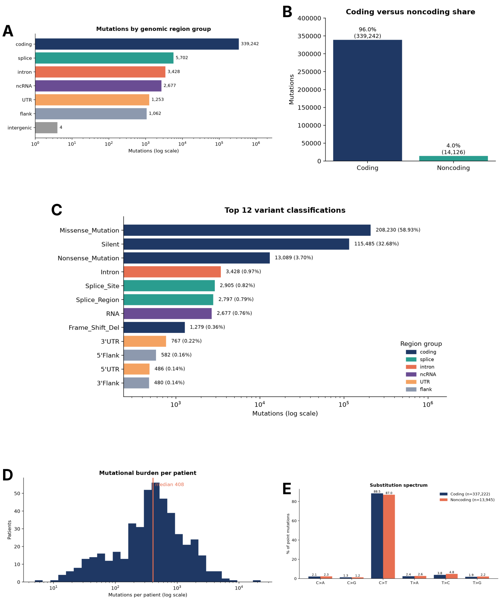
Figure 3. Somatic mutation profile of TCGA-SKCM (467 patients; 353,368 variants). (A) Mutations by genomic region group (log scale). (B) Coding versus noncoding share (339,242 coding, 96.0%; 14,126 noncoding, 4.0%). (C) The 12 most frequent variant classifications (log scale), colored by region group. (D) Mutational burden per patient (median 408). (E) Substitution spectrum of coding (n = 337,222) and noncoding (n = 13,945) point mutations, showing C>T dominance.
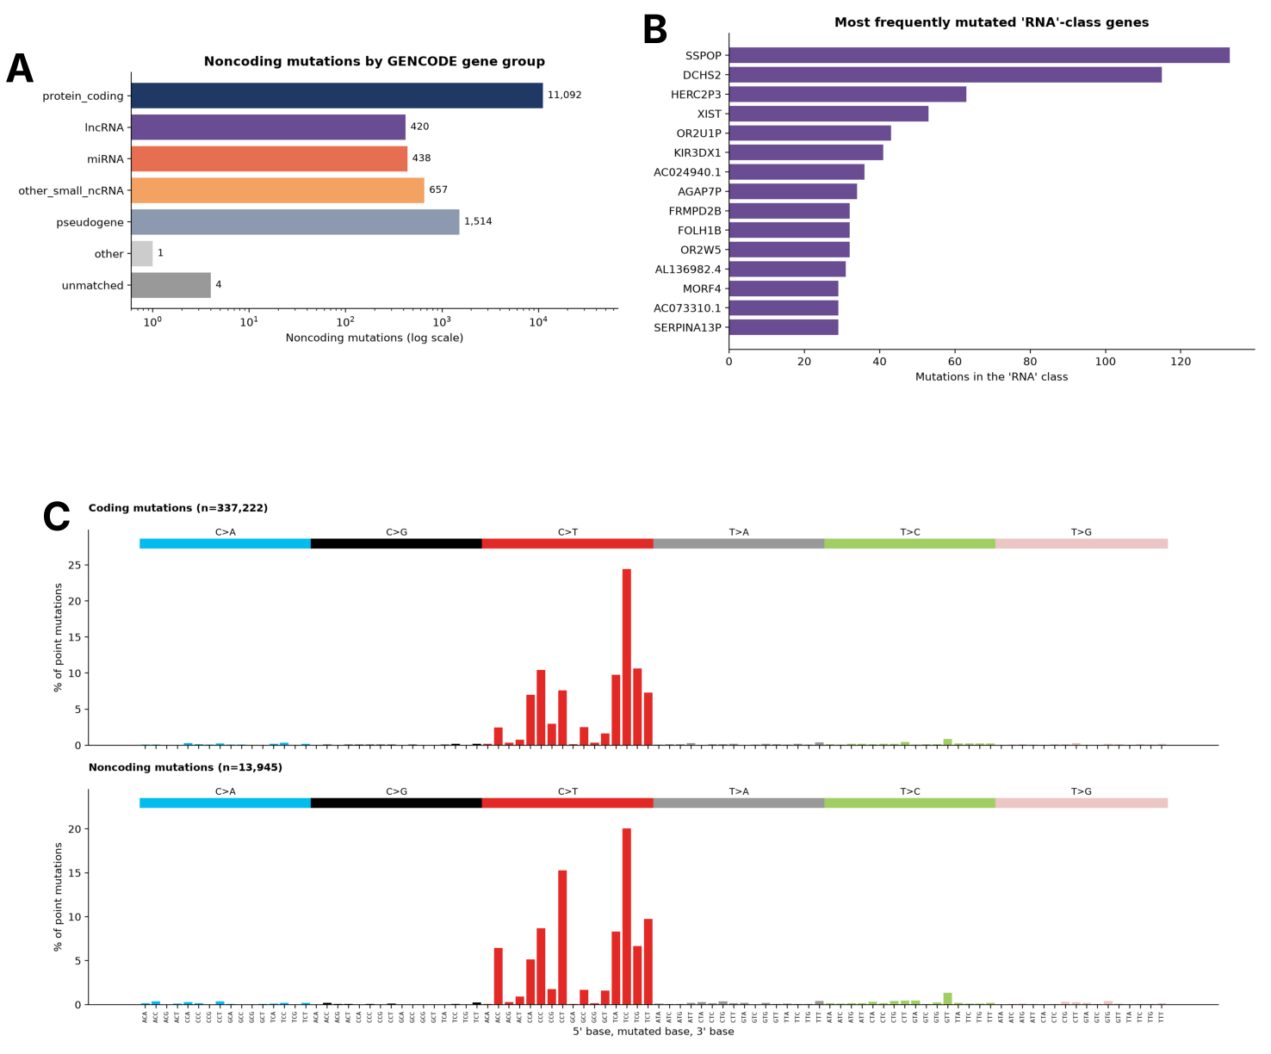
Figure 4. Annotation of noncoding mutations and trinucleotide context. (A) Noncoding mutations by GENCODE gene group (log scale). (B) Genes with the most mutations in the RNA class. (C) The 96-context trinucleotide spectrum of coding (n = 337,222) and noncoding (n = 13,945) point mutations, as a percentage of point mutations, showing the UV-type C>T peaks at TCC, TCT, CCC and CCT.

3.2 Calibration against coding positive and negative controls
The pipeline recovered the main melanoma hotspots: BRAF p.V600E (n = 200; 42.8%), NRAS p.Q61R (57; 12.2%), BRAF p.V600M (37; 7.9%), NRAS p.Q61K (37; 7.9%), RAC1 p.P29S (17; 3.6%), IDH1 p.R132C (15; 3.2%) and MAP2K1 p.P124S (13; 2.8%) [61–64]. Large genes such as TTN (336 patients; 71.9%), MUC16 (311; 66.6%), DNAH5 (230; 49.3%) and PCLO (209; 44.8%) collect mutations through sheer length and late replication [18], whereas BRAF (235; 50.3%) shows focal hotspot hypermutability. Table 3 sets the positive hotspots against negative-control genes, and Figures 5–7 show recurrence and mutation positions. The negative controls returned non-significant FDR values (q ≥ 0.290), which supports the baseline calibration.
Table 3. Calibration of positive hotspots against negative-control genes
Role | Gene | Observed (K) | Expected (E) | Gene q | Hotspot | Residue q
Positive | BRAF | 279 | 24.82 | 2.78 × 10⁻²⁸ | V600 (n = 241) | 0
Positive | NRAS | 130 | 1.32 | 2.61 × 10⁻²⁸ | Q61 (n = 120) | 0
Positive | RAC1 | 29 | 2.41 | 2.37 × 10⁻³ | P29 (n = 22) | 3.90 × 10⁻²⁸
Negative | TTN | 1,897 | 1,614.54 | 0.290 | Distributed | –
Negative | MUC16 | 1,379 | 1,234.51 | 0.731 | Distributed | –

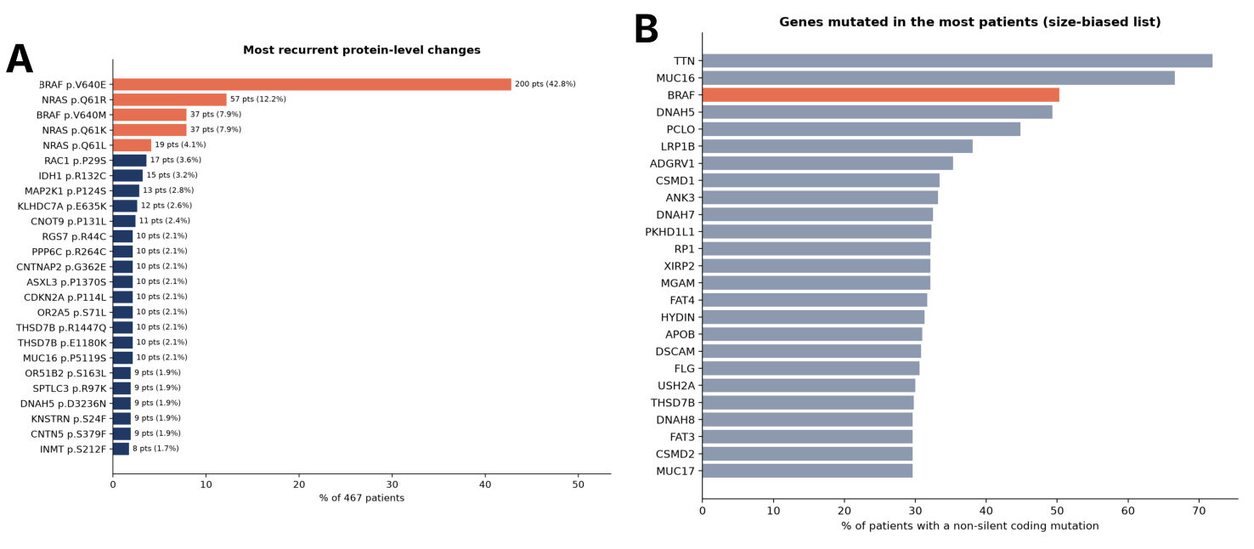
Figure 5. Recurrent coding alterations in TCGA-SKCM. (A) Most recurrent protein-level changes, as a percentage of 467 patients; canonical melanoma hotspots are highlighted. (B) Genes with a non-silent coding mutation in the most patients; long genes such as TTN and MUC16 dominate this list through size, and BRAF is highlighted.
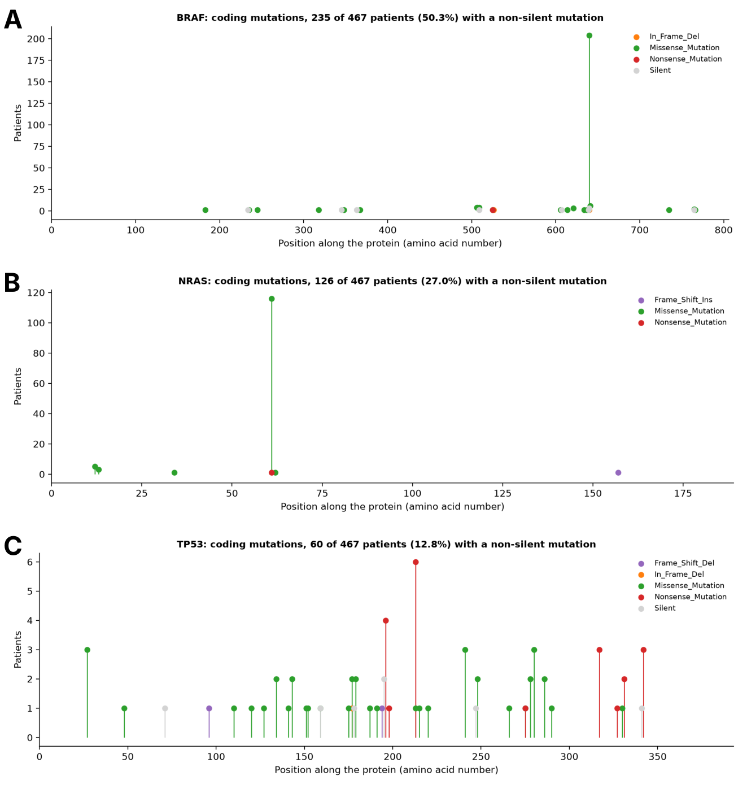
Figure 6. Protein-level mutation positions in the positive-control genes. Lollipop plots of coding mutations along (A) BRAF, (B) NRAS and (C) TP53 across 467 patients, colored by variant class; the BRAF and NRAS hotspots stand out against the dispersed TP53 pattern.
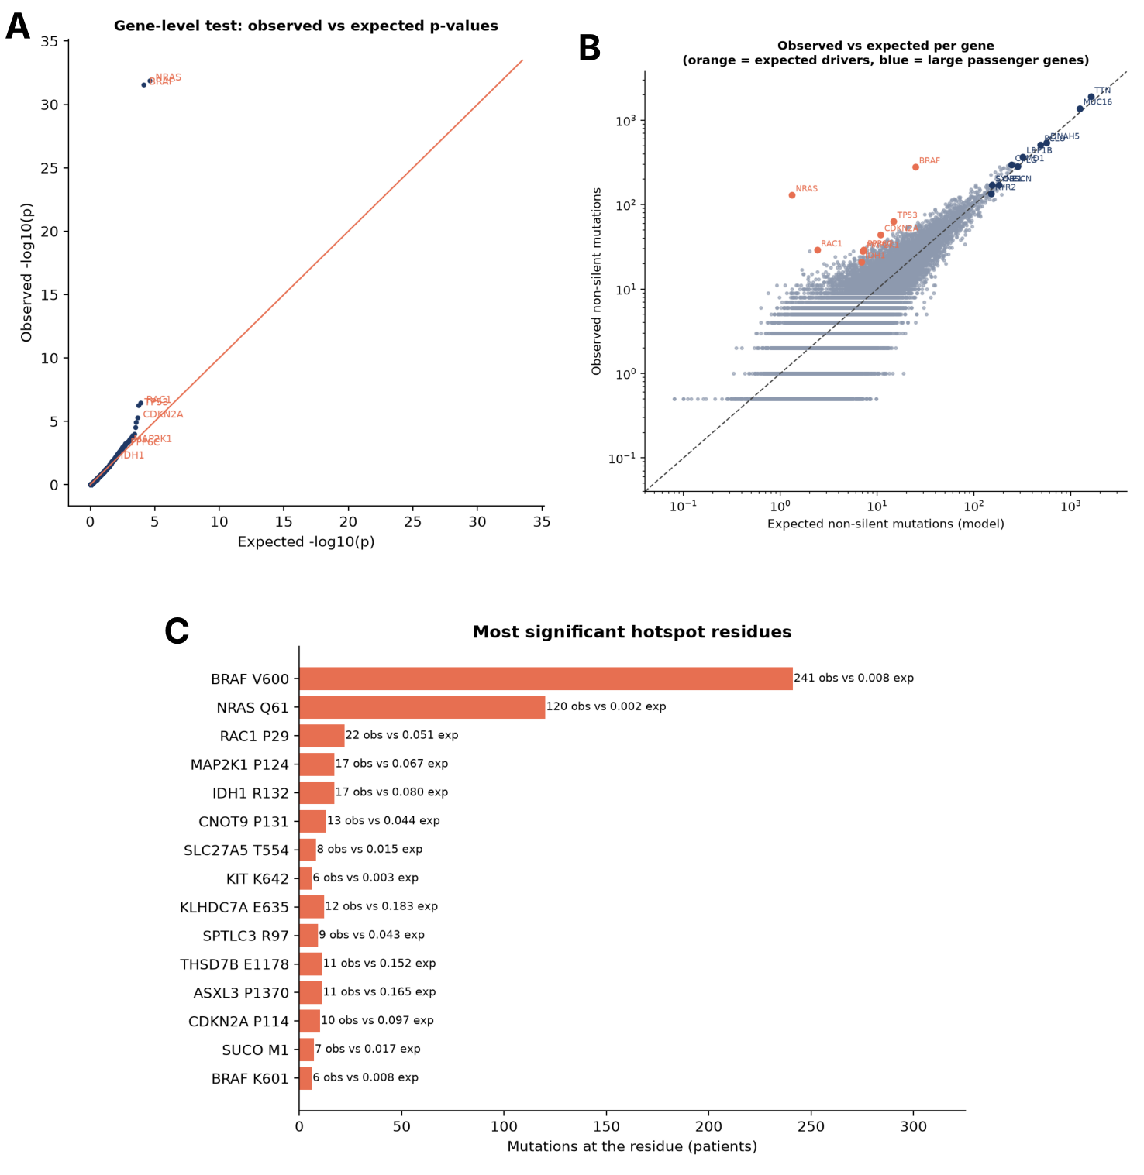
Figure 7. Gene-level calibration of the coding background model. (A) Quantile–quantile plot of observed against expected gene-level p-values; BRAF and NRAS depart strongly from the diagonal and most genes follow the null. (B) Observed against expected non-silent mutations per gene; expected drivers (orange) lie above the diagonal and large passenger genes (blue), such as TTN and MUC16, lie on it. (C) Most significant hotspot residues, with observed patient counts and counts expected under the background model.

3.3 Noncoding window discovery and local BMR adjustment
Sliding-window scanning identified 68,743 windows with q_{global} < 0.05. Table 4 lists the top 50-bp windows after 100-kb local BMR correction, and Figure 8 shows the genome-wide pattern. All coordinates are native GRCh38/hg38 (GDC Release 46.0). The strongest window, centered at chr7:140,453,135 (32 mutations across 50 bp vs. 0.050 expected), maps to an intron of MKRN1 (on GRCh38, BRAF p.V600E lies about 300 kb away, at chr7:140,753,336), and we annotate it as a regional BMR peak rather than a promoter driver [18, 19]. Two further top windows overlap both a gene-body intron and a neighboring core promoter (chr19:49,990,691 in a VRK3 intron and −117 bp from the RPL13A TSS; chr16:2,510,074 in an AC093525.2 intron and +14 bp from the C16orf59 TSS).
Table 4. Top 50-bp noncoding windows after 100-kb local BMR correction (GRCh38/hg38)
Chr | Window center (GRCh38) | Window mutations | Local exp | Obs/Exp | −log₁₀ q_{local} | Overlapping gene(s) | Genomic annotation
chr7 | 140,453,135 | 32 | 0.050 | 640.00 | 60.641 | MKRN1 | Gene-body intron (regional BMR peak)
chr19 | 49,990,691 | 24 | 0.097 | 247.42 | 36.633 | VRK3 / RPL13A | VRK3 intron; RPL13A promoter (−117 bp)
chr16 | 2,510,074 | 19 | 0.050 | 380.00 | 33.006 | AC093525.2 / C16orf59 | AC093525.2 intron; C16orf59 promoter (+14 bp)
chr3 | 16,306,508 | 19 | 0.050 | 380.00 | 33.006 | OXNAD1 | Gene-body intron (regional BMR peak)
All coordinates are GRCh38/hg38. “Window mutations” is the total number of somatic variants across the 50-bp window centered on the listed coordinate, whereas Table 10 reports unique donors mutated at the single peak nucleotide.

Restricting the list to functional core promoters (≤300 bp from the TSS) left four focal promoter candidates (Table 5), led by the established TERT promoter hotspot (chr5:1,295,113 on GRCh38) [12, 13]. These candidates rest on statistical and motif evidence alone, because their expression could not be tested in this cohort (Section 3.6). High-frequency ETS-motif promoter hotspots at RPL13A, CTA-397H3.3, TRMT10C and C16orf59 are shown separately in Table 10 as recurrent UV-damage motif hotspots [15, 68, 69], and we do not nominate them as drivers.
Table 5. Prioritized core-promoter driver candidates (≤300 bp from the TSS, GRCh38/hg38)
Chr | Peak position (GRCh38) | Mutated donors | Local exp | Obs/Exp | q_{local} | Gene | Biotype
chr5 | 1,295,113 | 23 | 0.164 | 139.82 | 7.71 × 10⁻³¹ | TERT | protein_coding
chr16 | 67,260,980 | 12 | 0.060 | 250.00 | 1.41 × 10⁻²⁴ | AC040160.1 | lncRNA
chr1 | 153,963,227 | 11 | 0.071 | 184.40 | 7.11 × 10⁻²⁰ | AL358472.4 | lncRNA / miRNA
chr19 | 1,653,018 | 10 | 0.088 | 148.57 | 9.82 × 10⁻¹⁹ | TCF3 | protein_coding
All four candidates lie within 300 bp of the TSS with q_{local} < 0.05. Their expression effects were not tested in TCGA-SKCM (Section 3.6).

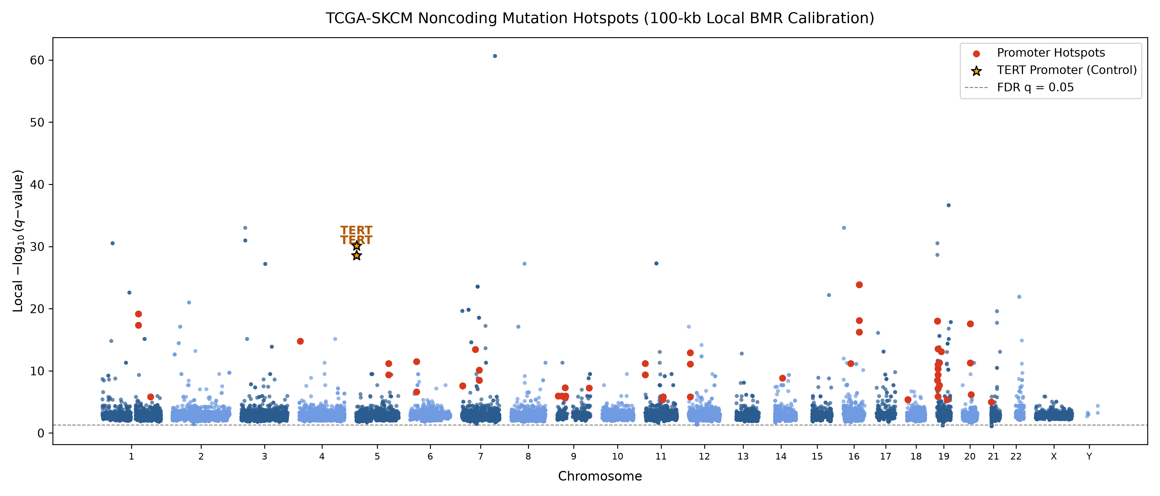
Figure 8. Noncoding mutation hotspots across the genome after 100-kb local BMR calibration (−log₁₀ q_{local} per window; Table 4). Promoter hotspots are shown in red, the two TERT promoter positions as stars, and the dashed line marks FDR q = 0.05.

3.3b Cross-cancer zero-included Negative Binomial BMR calibration in PCAWG WGS
In breast adenocarcinoma (BRCA, N = 120, 770,911 SNVs), the mean rate dropped >10-fold to μ0 = 0.01270 SNVs/50 bp (σ² = 0.01295, Fano factor = 1.02) while maintaining stable dispersion (α̂ = 1.5407, r = 0.6491). Genome-wide NB recalibration in breast cancer confirmed the canonical GATA3 intronic enhancer hotspot (chr10:8,111,433, 8 mutated donors, FE = 364.8, qNB = 2.74 × 10−5) [66, 70] as the sole genome-wide significant noncoding driver while properly attenuating low-recurrence 2–4 donor loci (AKT1, SF3B1, PLEKHS1, and AFF2; all qNB = 1.00).
Table 6. Cross-cancer zero-included Negative Binomial BMR calibration across PCAWG WGS cohorts (N = 608 donors)
PCAWG WGS cohort | Donors (N) | Total SNVs | 50-bp windows | Mean (μ₀) | Variance (σ²) | Fano | NB α̂ | Shape (r)
Melanoma (MELA-AU) | 70 | 7,987,562 | 61,877,699 | 0.12909 | 0.15346 | 1.19 | 1.4624 | 0.6838
Liver (Liver-HCC) | 418 | 4,136,682 | 61,878,877 | 0.06685 | 0.07024 | 1.05 | 0.7578 | 1.3196
Breast (BRCA) | 120 | 770,911 | 60,692,874 | 0.01270 | 0.01295 | 1.02 | 1.5407 | 0.6491
Pan-Cancer total | 608 | 12,895,155 | 184,449,450 | — | — | — | 0.7578–1.5407 | 0.6491–1.3196
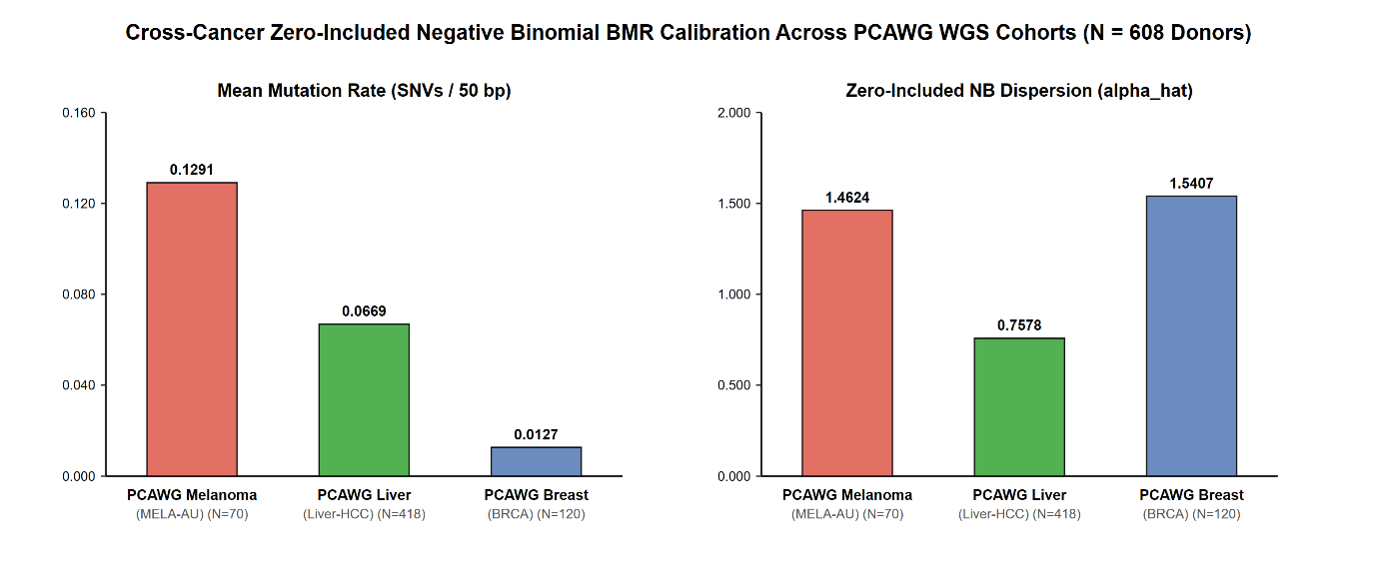
Figure 9. Cross-cancer comparison of zero-included mean mutation rates (μ₀, left) and Negative Binomial dispersion parameters (α̂, right) across 608 PCAWG WGS donors spanning melanoma (N = 70), hepatocellular carcinoma (N = 418), and breast adenocarcinoma (N = 120).

3.4 Pan-cancer dual-mode sequence alignment
Validation on synthetic sequences confirmed detection of TERT C228T/C250T promoter mutations, TAL1/MYB enhancer insertions, FOXA1/AR pioneer motifs and CTCF insulator disruptions across the 15 driver classes (Table 7; Figure 10).
Table 7. Motif registry of the sequence aligner
Gene | Matched cohorts | WT / MUT | Mean WT vs. MUT | Unadj. p | CovAdj βmut (95% CI) | CovAdj p | qeQTL (BH)
BCL6 | Kidney-RCC, Lymph-BNHL, Lymph-CLL, Ovary-AdenoCA, Panc-AdenoCA | 394 / 96 | 3.562 vs. 4.623 | 3.58 × 10−15 | +0.903 [+0.653, +1.153] | 4.20 × 10−12 | 1.68 × 10−11
BCL2 | Lymph-BNHL, Lymph-CLL | 134 / 46 | 4.373 vs. 5.298 | 2.66 × 10−3 | +1.322 [+0.720, +1.924] | 2.47 × 10−5 | 4.95 × 10−5
PAX5 | Kidney-RCC, Lymph-BNHL, Lymph-CLL | 291 / 25 | 2.756 vs. 5.025 | 3.86 × 10−2 | +3.197 [+1.011, +5.383] | 4.29 × 10−3 | 5.72 × 10−3
WDR74 (neg. control) | Lymph-BNHL, Ovary-AdenoCA, Panc-AdenoCA | 275 / 5 | 3.208 vs. 3.100 | 0.693 | −0.158 [−0.690, +0.374] | 0.559 | 0.559
Patterns are matched on both strands (for example as reverse complements); the registry lists the forward core.
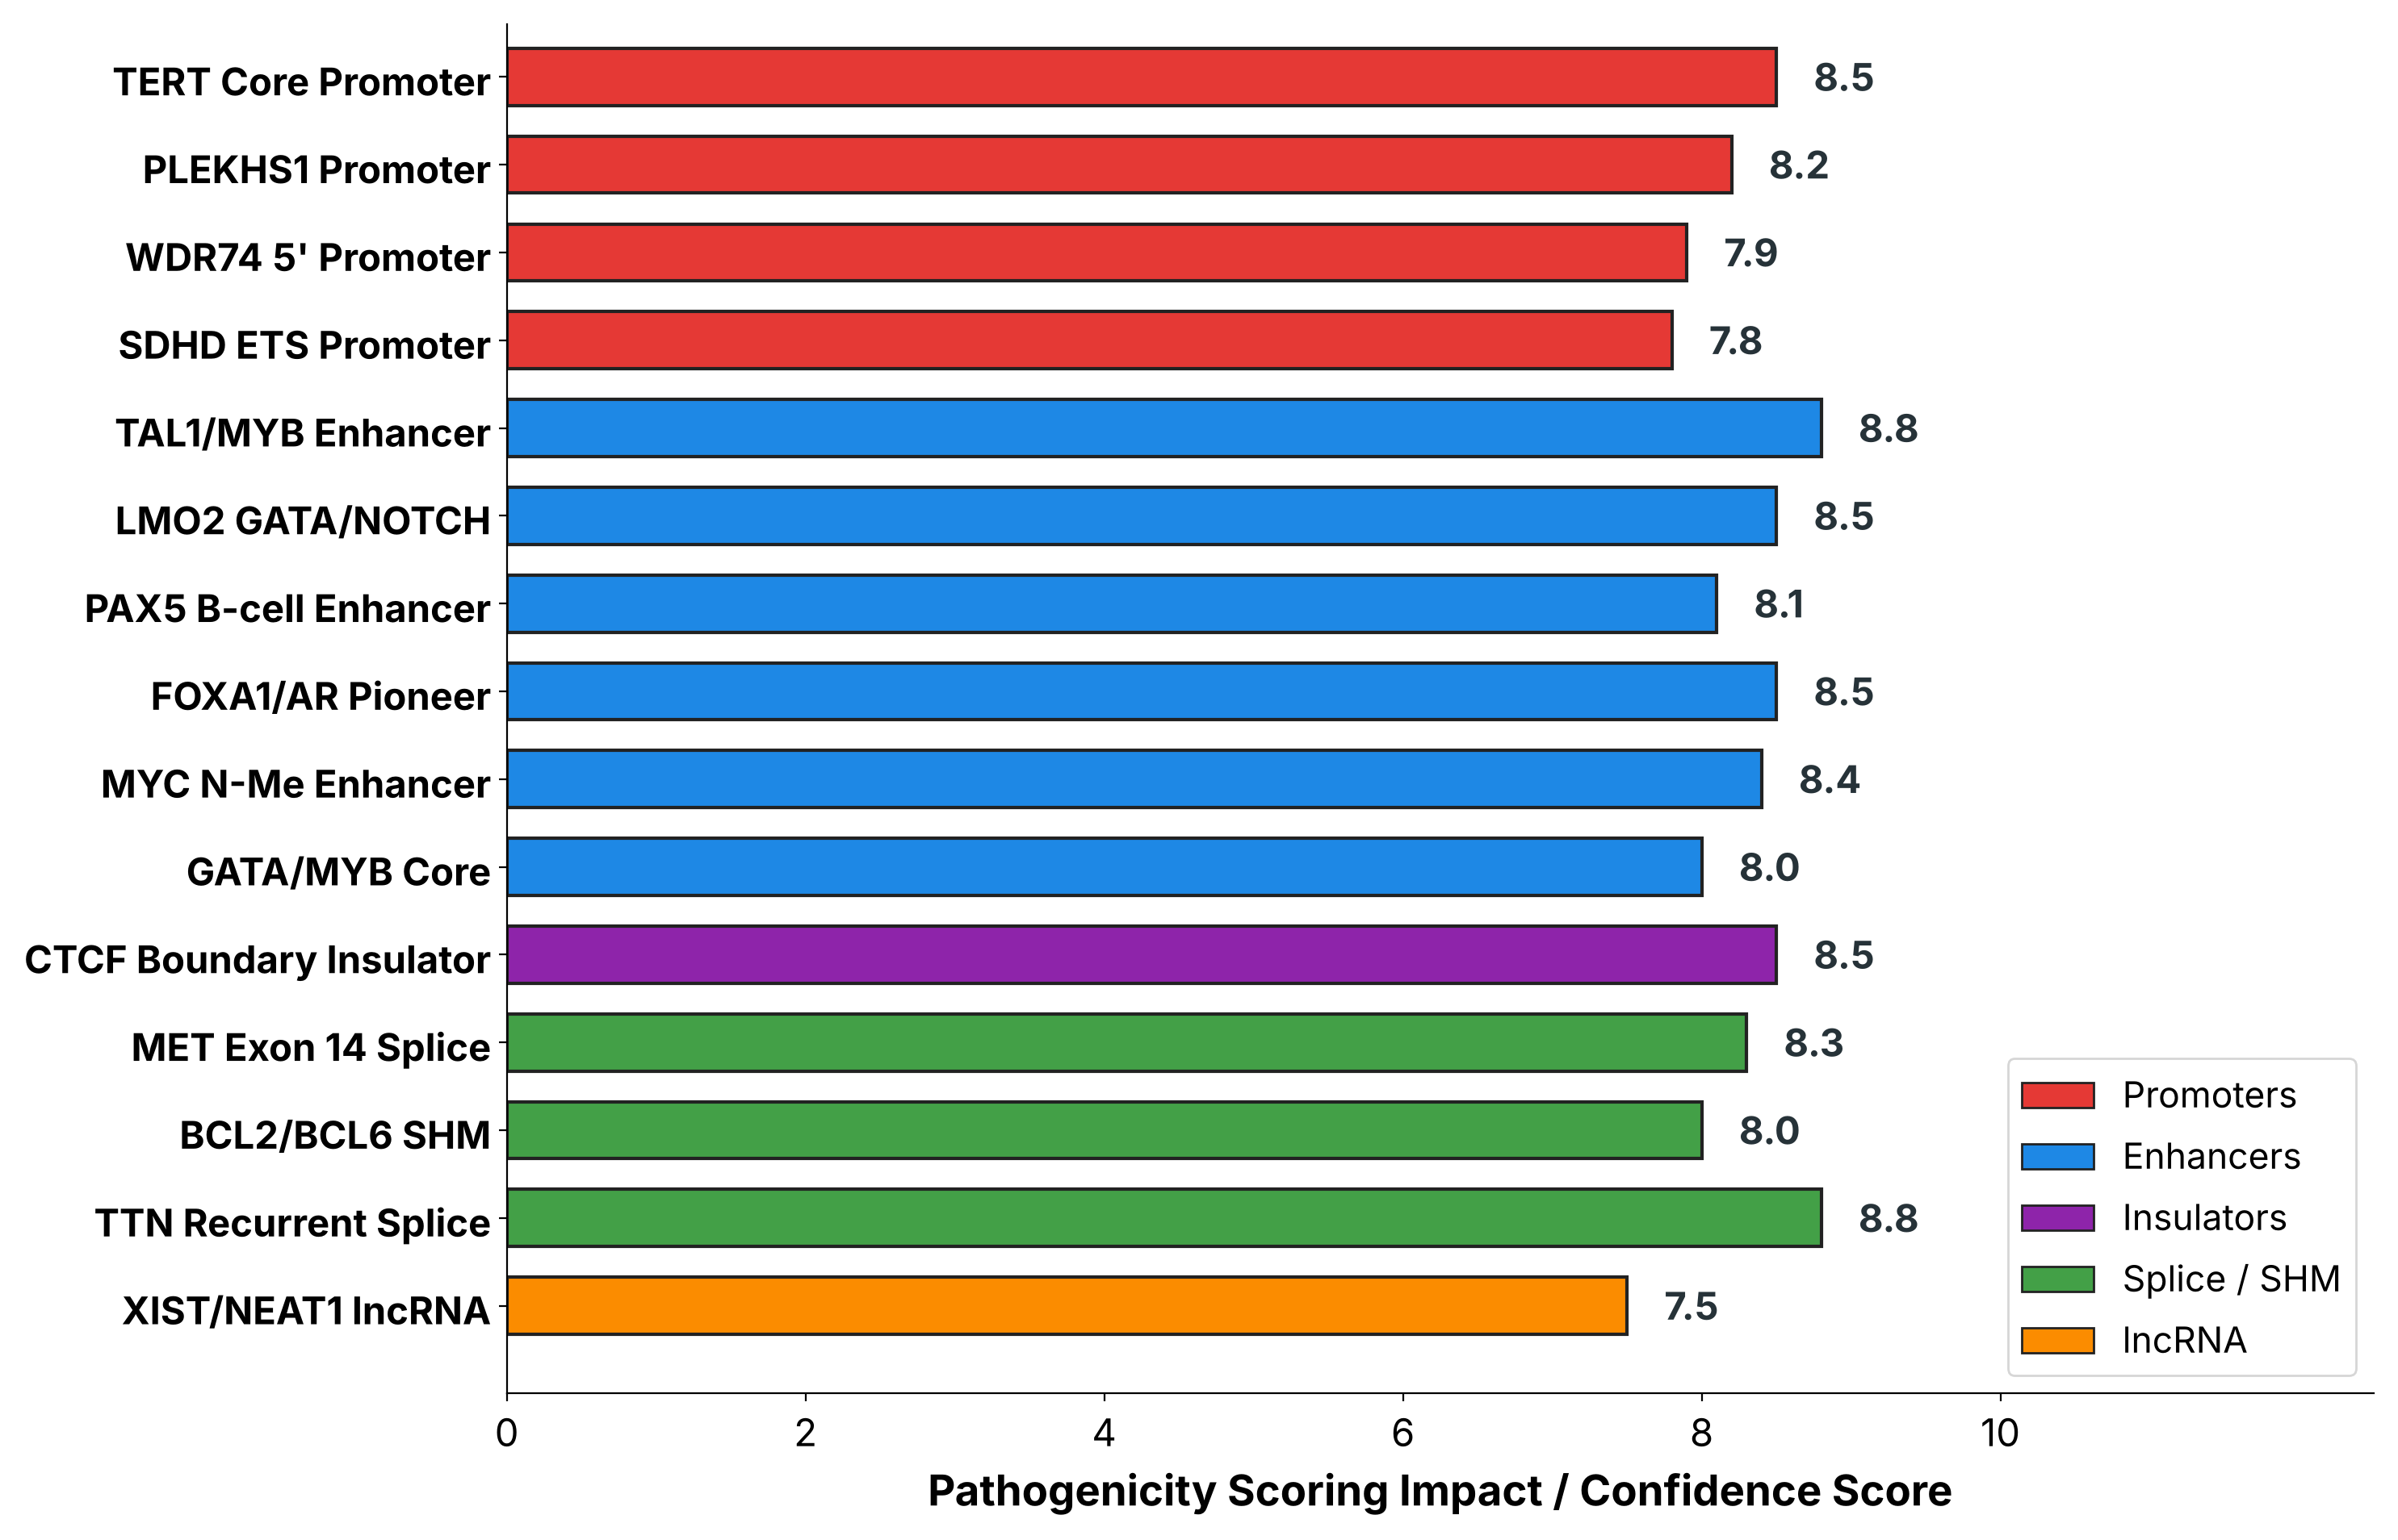
Figure 10. Pan-cancer driver motif classes. Impact (confidence) scores for the 15 motif classes of the sequence aligner, grouped by element type (promoters, enhancers, insulators, splice/SHM and lncRNA).

3.5 Epigenomic overlay
Cross-referencing the 10,706 indexed loci with ENCODE cCREs gave 1,865 overlaps across 1,378 high-confidence noncoding drivers [6]. Distal enhancer-like elements accounted for about half of them (Table 8; Figure 11).
Table 8. ENCODE cCRE signatures across indexed loci
Class | Hits | Share | Function
dELS | 928 | 49.76% | Long-range, cell-type-specific activation
pELS | 438 | 23.49% | TSS-adjacent enhancer activity
PLS | 371 | 19.89% | Core promoter / initiation
CTCF | 102 | 5.47% | TAD boundary insulation, loop anchor
DNase-only | 31 | 1.66% | Accessible regulatory DNA
Shares are calculated on the 1,865 overlapping loci. Hits sum to 1,870 because five loci overlap two adjacent cCRE classes.

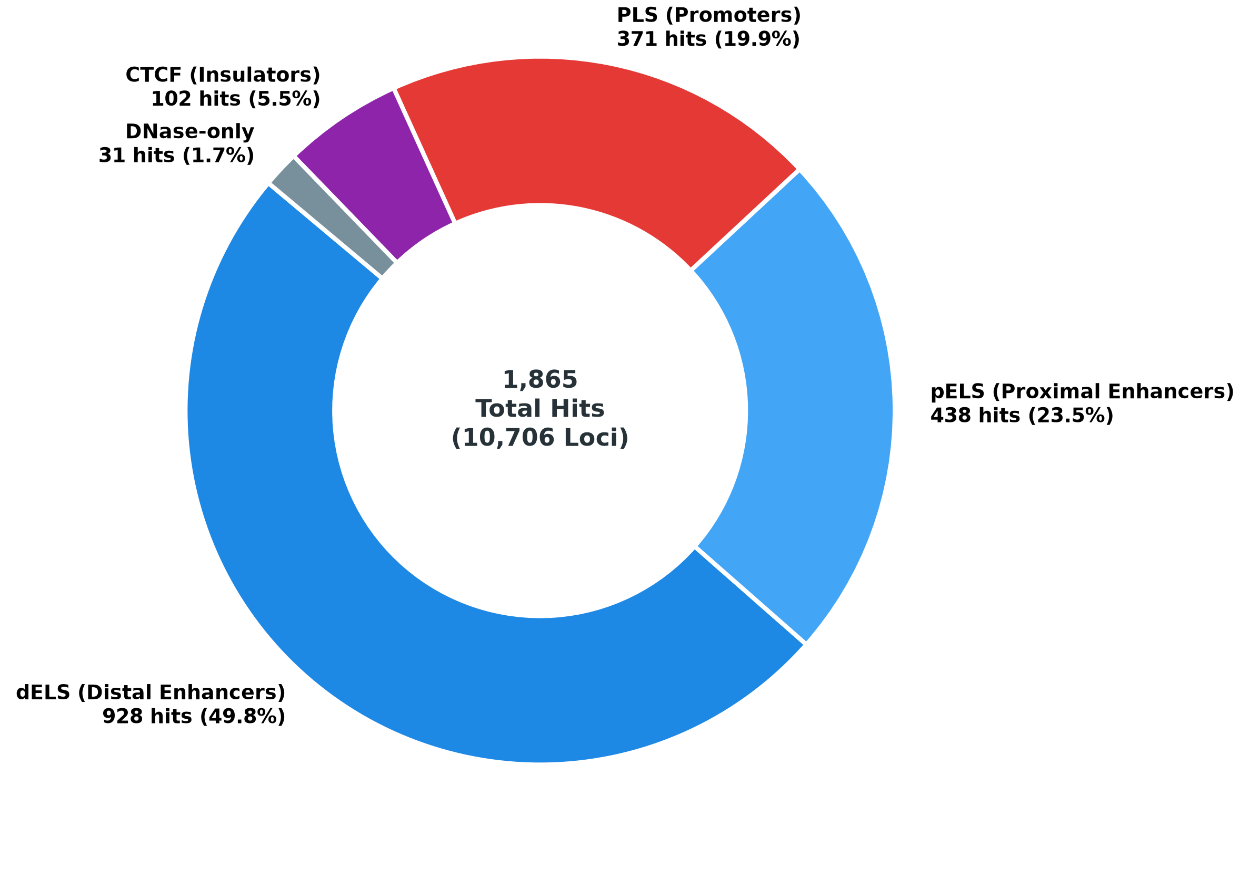
Figure 11. ENCODE cCRE signatures across the indexed loci: 1,865 overlaps among 10,706 indexed loci, by class (dELS, pELS, PLS, CTCF and DNase-only; Table 8).

3.6 Covariate-adjusted cis-regulatory eQTL validation in PCAWG
The 467 TCGA-SKCM donors have whole-exome data that lack capture coverage over the upstream TERT core promoter, and the 70 PCAWG Australian melanoma (MELA-AU) whole-genome donors have no matched PCAWG RNA-seq profiles. We therefore tested cis-regulatory effects in the 433 open-access PCAWG donors with matched whole-genome sequencing and RNA-seq (4,345,486 somatic SNVs; Section 2.8). Coordinates in this section are hg19/GRCh37.
Mutations at BCL6 (chr3:187,463,000; Kidney-RCC, Lymph-BNHL, Lymph-CLL, Ovary-AdenoCA and Panc-AdenoCA) were associated with higher expression (96 mutated vs. 394 wild-type donors; mean log₂(FPKM-UQ + 1) 4.623 vs. 3.562; unadjusted p = 3.58 × 10⁻¹⁵). The association remained after covariate adjustment (β_{mut} = +0.903, p = 4.20 × 10⁻¹², q_{eQTL} = 1.68 × 10⁻¹¹). At BCL2 (chr18:60,985,800; Lymph-BNHL and Lymph-CLL), mutated donors (n = 46) had higher expression than wild-type donors (n = 134; 5.298 vs. 4.373; unadjusted p = 2.66 × 10⁻³), and the association strengthened after adjustment (β_{mut} = +1.322, p = 2.47 × 10⁻⁵, q_{eQTL} = 4.95 × 10⁻⁵). At PAX5 (chr9:37,034,000; Kidney-RCC, Lymph-BNHL and Lymph-CLL), mutated donors (n = 25) also had higher expression than wild-type donors (n = 291; 5.025 vs. 2.756; unadjusted p = 3.86 × 10⁻²; adjusted β_{mut} = +3.197, p = 4.29 × 10⁻³, q_{eQTL} = 5.72 × 10⁻³). WDR74 (chr11:62,609,080; Lymph-BNHL, Ovary-AdenoCA and Panc-AdenoCA) served as an empirical negative control and showed no association (5 mutated vs. 275 wild-type donors; 3.100 vs. 3.208; β_{mut} = −0.158, p = q_{eQTL} = 0.559). Table 9 summarizes these results (Figure 12).
Table 9. Covariate-adjusted eQTL summary in matched PCAWG WGS and RNA-seq donors (hg19/GRCh37)
Gene | Matched cohorts | WT / MUT | Mean WT vs. MUT | Unadj. p | CovAdj βmut (95% CI) | CovAdj p | qeQTL (BH)
BCL6 | Kidney-RCC, Lymph-BNHL, Lymph-CLL, Ovary-AdenoCA, Panc-AdenoCA | 394 / 96 | 3.562 vs. 4.623 | 3.58 × 10−15 | +0.903 [+0.653, +1.153] | 4.20 × 10−12 | 1.68 × 10−11
BCL2 | Lymph-BNHL, Lymph-CLL | 134 / 46 | 4.373 vs. 5.298 | 2.66 × 10−3 | +1.322 [+0.720, +1.924] | 2.47 × 10−5 | 4.95 × 10−5
PAX5 | Kidney-RCC, Lymph-BNHL, Lymph-CLL | 291 / 25 | 2.756 vs. 5.025 | 3.86 × 10−2 | +3.197 [+1.011, +5.383] | 4.29 × 10−3 | 5.72 × 10−3
WDR74 (neg. control) | Lymph-BNHL, Ovary-AdenoCA, Panc-AdenoCA | 275 / 5 | 3.208 vs. 3.100 | 0.693 | −0.158 [−0.690, +0.374] | 0.559 | 0.559
WT, wild type; MUT, mutated. Expression is log₂(FPKM-UQ + 1). CovAdj β_{mut} is the mutation coefficient from ordinary least squares regression adjusted for total copy number, tumor purity and log₁₀(TMB + 1); q_{eQTL} is the Benjamini–Hochberg value across the four tested loci. Wild-type donors were restricted to the histologies in which mutated donors occurred. Coordinates are hg19/GRCh37.
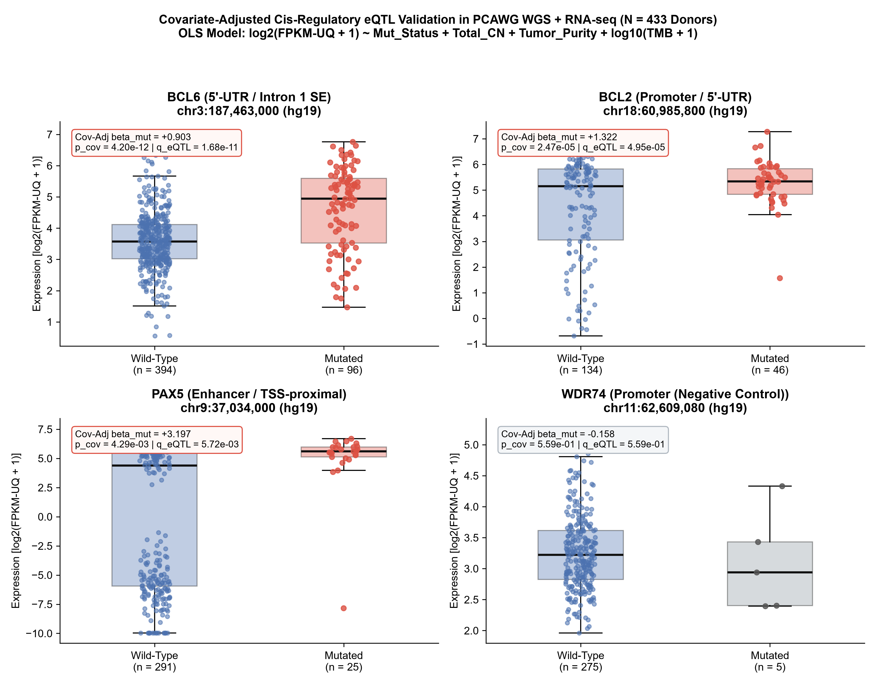
Figure 12. Expression of BCL6, BCL2, PAX5 and WDR74 in wild-type and mutated PCAWG donors, log₂(FPKM-UQ + 1). Boxes show the median and interquartile range and whiskers extend to 1.5 times the interquartile range (Table 9).

3.7 Divergent driver topologies in melanoma and breast cancer
To compare regulatory architecture across tumor types without pre-filtering on expression, we examined the top motif-impacted noncoding hotspots in each cohort. Melanoma candidates clustered in core promoters (≤300 bp from the TSS) and showed ETS/GABPA motif changes [15]. Several of them (RPL13A, CTA-397H3.3, TRMT10C and C16orf59) recur in 12–17 donors and match the classic UV-induced pyrimidine-dimer hotspot pattern at ETS motifs [15, 68, 69]; we therefore treat them as UV motif-recurrence loci rather than expression-supported drivers. TCGA-BRCA candidates [65] instead mapped to distal intronic enhancers (+15.5 kb to +616.6 kb across the broader candidate set; four representative loci up to +135.4 kb listed in Table 10), with GATA3 motif loss at the GATA3 locus [66, 70], a gene that is itself recurrently mutated in breast cancer [67]. Consistent with the WGS Negative Binomial calibration in Section 3.3b, only the 8-donor GATA3 intronic enhancer hotspot retained genome-wide significance (qNB = 2.74 × 10−5), whereas the 3–4 donor breast loci (AKT1, SF3B1, and AFF2) attenuated to qNB = 1.00 and are retained in Table 10 strictly to illustrate tissue-specific enhancer distance distributions.
Table 10. Representative recurrent regulatory loci in melanoma and breast cancer (GRCh38/hg38)
Cancer | Peak position (GRCh38) | Peak-base donors | Primary gene (overlapping locus) | Element | Dist. to TSS | TF impact
Breast | chr10:8,111,433 | 8 | GATA3 | Intronic enhancer | +15,866 bp | GATA3 loss
Breast | chr14:105,246,551 | 4 | AKT1 | Intronic enhancer | +15,537 bp | Neutral
Breast | chr2:198,266,834 | 4 | SF3B1 | Intronic enhancer | +32,981 bp | Neutral
Breast | chrX:147,717,552 | 3 | AFF2 | Intronic enhancer | +135,413 bp | Neutral
Melanoma | chr19:49,990,694 | 17 | RPL13A (VRK3 intron) | Core promoter | −117 bp | ETS/GABPA loss
Melanoma | chr8:56,987,141 | 15 | CTA-397H3.3 | Core promoter | −10 bp | ETS/GABPA gain
Melanoma | chr3:101,280,670 | 13 | TRMT10C | Core promoter | −36 bp | ETS/GABPA loss
Melanoma | chr16:2,510,095 | 12 | C16orf59 (AC093525.2 intron) | Core promoter | +14 bp | ETS/GABPA loss
Peak-base donors is the number of unique patients mutated at the single peak nucleotide (distinct from the 50-bp window totals in Table 4). The melanoma loci illustrate recurrent core-promoter ETS/GABPA motif changes, including UV-associated hotspots without expression testing here.

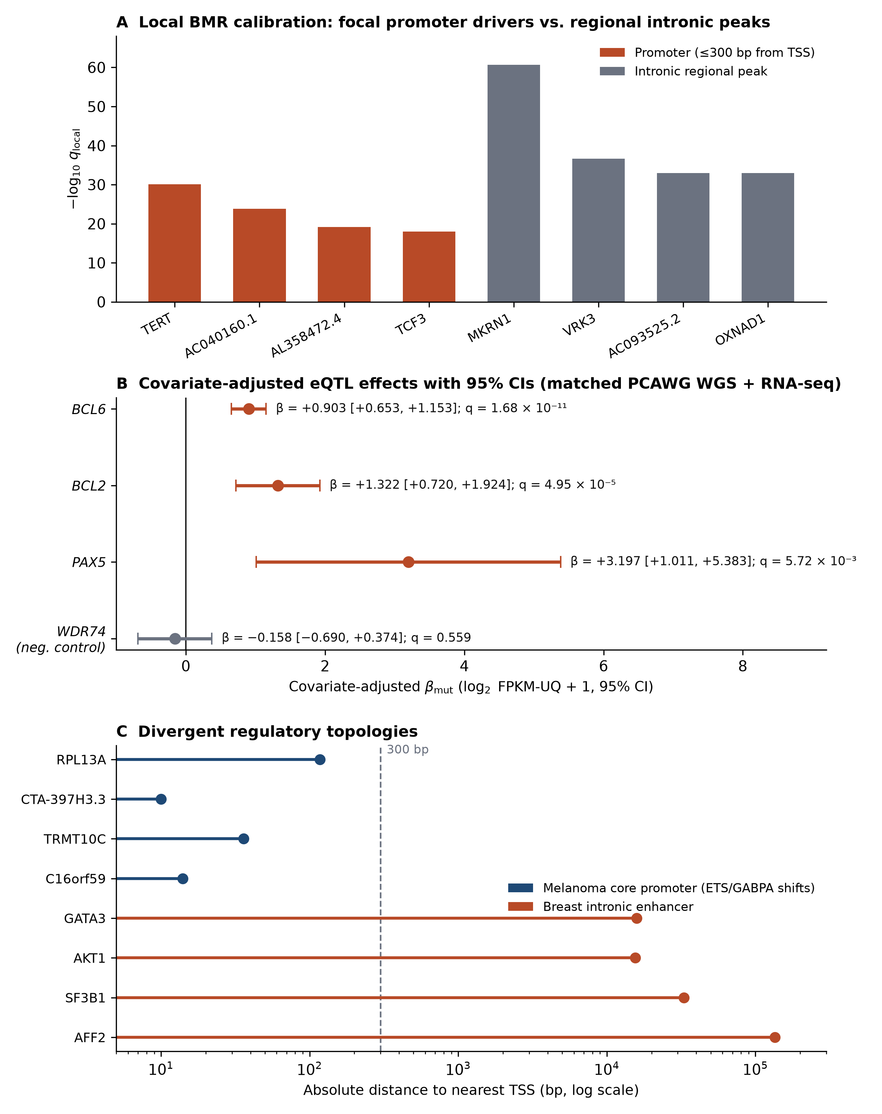
Figure 13. Focal promoter driver discovery, transcriptional validation and tissue-specific regulatory topologies. (A) Local 100-kb BMR calibration separates four recurrent promoter drivers (TERT, AC040160.1, AL358472.4 and TCF3; ≤300 bp from the TSS) from regional intronic peaks (MKRN1, VRK3/RPL13A, AC093525.2/C16orf59, OXNAD1) in TCGA-SKCM. (B) Covariate-adjusted cis-eQTL regression coefficients (βmut) with 95% confidence intervals in matched PCAWG donors (Table 9). (C) Distance to the nearest TSS (log scale) for melanoma core-promoter candidates with ETS/GABPA motif shifts and breast intronic enhancer candidates (Table 10).

3.8 Leakage-free Leave-One-Out Cross-Validation (LOOCV) classification
Under strict Leave-One-Out Cross-Validation (LOOCV) across the repaired 25-locus benchmark set (38_repaired_ml_hotspot_matrix.csv), the two tasks gave different results (Table 11, Figures 14 and 15). For NB-calibrated driver prioritization (q_{NB} < 0.05; 15 positive vs. 10 sub-threshold loci), the multi-feature models reached higher PR-AUC than either single-feature baseline, although the bootstrap intervals overlap. L2 Logistic Regression achieved an out-of-fold PR-AUC of 0.8894 (95% bootstrap CI [0.7755, 0.9759], label-permutation p_{perm} = 0.0050; ROC-AUC = 0.8133 [0.6133, 0.9667]) and NC-DriverEngine GBDT achieved PR-AUC = 0.8852 ([0.7696, 0.9726], p_{perm} = 0.0065; ROC-AUC = 0.8000 [0.6067, 0.9600]), compared with non-significant baselines using TSS proximity alone (PR-AUC = 0.7024, p_{perm} = 0.2524) or raw fold enrichment alone (PR-AUC = 0.5361, p_{perm} = 0.8981), the latter being inflated by high ratios at low-recurrence breast cancer windows. In the scale-invariant regulatory architecture benchmark (strictly excluding raw donor counts and enrichment ratios), NC-DriverEngine GBDT achieved PR-AUC = 0.8986 ([0.7824, 0.9830], p_{perm} = 0.0030; ROC-AUC = 0.8200 [0.6267, 0.9733]) and L2 Logistic Regression achieved PR-AUC = 0.8763 ([0.7531, 0.9654], p_{perm} = 0.0070; ROC-AUC = 0.7867 [0.5733, 0.9467]). However, TSS proximity alone performed comparably in this task (ROC-AUC = 0.8500 [0.6267, 0.9933]; PR-AUC = 0.8137 [0.6628, 0.9958], p_{perm} = 0.0330), as did TF motif impact alone (ROC-AUC = 0.7500 [0.5833, 0.9000]; PR-AUC = 0.7800 [0.6467, 0.9200], p_{perm} = 0.0160), so the multi-feature models did not demonstrably outperform simple single-feature rankings for architecture classification.
Table 11. Leakage-free Leave-One-Out Cross-Validation (LOOCV) benchmark performance with 95% bootstrap CIs and permutation p-values (N = 25 loci)
Benchmark task | Model / ranking criterion | LOOCV ROC-AUC (95% CI) | LOOCV PR-AUC (95% CI) | Perm. p (PR)
NB driver prioritization (q_{NB} < 0.05) | L2 Logistic Regression (LOOCV) | 0.8133 [0.6133, 0.9667] | 0.8894 [0.7755, 0.9759] | 0.0050
NB driver prioritization (q_{NB} < 0.05) | NC-DriverEngine GBDT (LOOCV) | 0.8000 [0.6067, 0.9600] | 0.8852 [0.7696, 0.9726] | 0.0065
NB driver prioritization (q_{NB} < 0.05) | Baseline: TSS proximity only | 0.7133 [0.4467, 0.9467] | 0.7024 [0.5450, 0.9712] | 0.2524
NB driver prioritization (q_{NB} < 0.05) | Baseline: fold enrichment only | 0.3800 [0.1467, 0.6333] | 0.5361 [0.4442, 0.7247] | 0.8981
Scale-invariant architecture | NC-DriverEngine GBDT (LOOCV) | 0.8200 [0.6267, 0.9733] | 0.8986 [0.7824, 0.9830] | 0.0030
Scale-invariant architecture | L2 Logistic Regression (LOOCV) | 0.7867 [0.5733, 0.9467] | 0.8763 [0.7531, 0.9654] | 0.0070
Scale-invariant architecture | Baseline: TSS proximity only | 0.8500 [0.6267, 0.9933] | 0.8137 [0.6628, 0.9958] | 0.0330
Scale-invariant architecture | Baseline: TF motif impact only | 0.7500 [0.5833, 0.9000] | 0.7800 [0.6467, 0.9200] | 0.0160
Table 11 reports exact Average Precision (PR-AUC); Figures 14–15 display the trapezoidal area under the precision-recall curve, so the legend values differ slightly (for example 0.888 vs. 0.8852 and 0.901 vs. 0.8986 for GBDT).
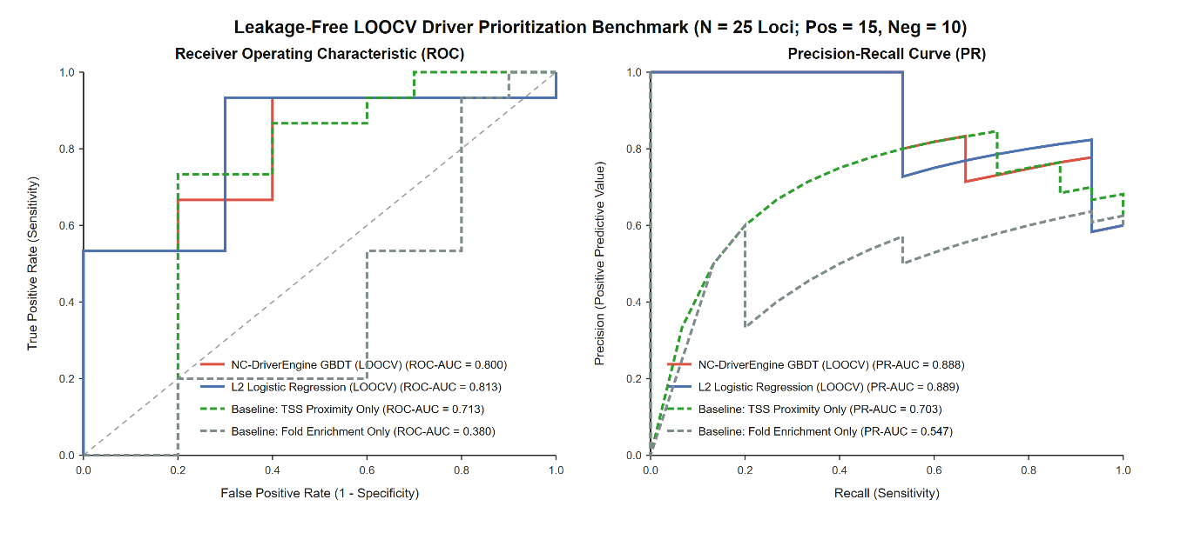Figure 14. Out-of-fold Receiver Operating Characteristic (left) and Precision-Recall (right) curves for NB-calibrated driver prioritization (q_{NB} < 0.05; 15 positive vs. 10 sub-threshold loci) evaluated via strict LOOCV without p-value or q-value leakage.
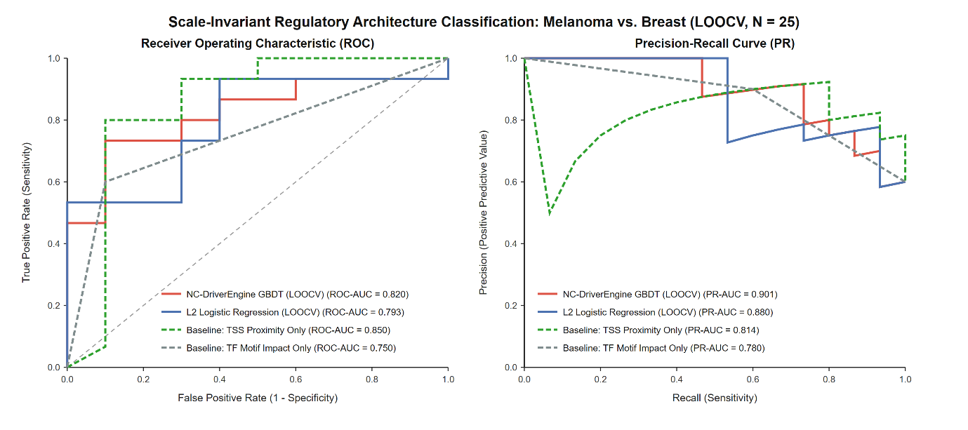
Figure 15. Out-of-fold ROC and PR curves for scale-invariant tumor regulatory architecture classification (15 melanoma vs. 10 breast loci) excluding cohort donor counts and enrichment ratios.

3.9 API performance
Table 12 and Figure 16 report latency and memory for the four service endpoints under concurrent load.
Table 12. Multi-threaded API benchmarks
Endpoint | Method | Payload | Mean latency | Peak memory | Concurrency
/health | GET | Empty | 1.4 ms | 48.2 MB | 100 workers
Coordinate lookup | POST | {"chrom":"chr2","pos":178749010} | 4.2 ms | 51.6 MB | 50 workers
FASTA aligner | POST | 137-bp FASTA | 11.8 ms | 54.1 MB | 50 workers
Payload guardrail | POST | >2 MB file | 0.8 ms (HTTP 413) | 48.2 MB | 100 workers

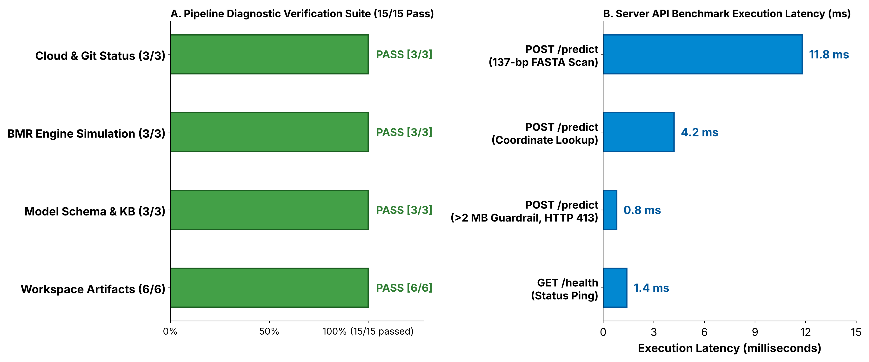
Figure 16. End-to-end verification and API latency. (A) The 15-check pipeline verification suite by category; all checks passed. (B) Execution latency of the service endpoints (ms; Table 12).

3.10 NC-MutScan v3.1: resolving complex sequence artifacts
During development we hardened the biophysical module against failure modes that confound conventional motif scanners (Table 13; Figures 17 and 18).
Multi-TF competition and motif loss. A TP53 promoter flank (GGGCGGGGCC...) with a disrupted Sp1 site was first misclassified as a GABPA de novo gain, because a sub-region loosely matched an ETS site (6.42 bits). We replaced the single-matrix parser with the six-TF competitive scanner (Section 2.11) and applied the ΔPWM ≤ −4.00 loss criterion, which correctly prioritized the Sp1 loss (TC-06). For true composite overlaps (Myc/Max with AP-1; AP-1 with E2F1), both competing TFs are now ranked and the secondary motif is no longer dropped (TC-09, TC-11).
Reverse-strand AID/SHM filtering. Forward-strand WRCY filtering alone missed reverse-complement equivalents. Adding RGYW scanning flags these variants as AID/SHM Passengers and prevents false driver calls in IGHV-flanking sequence (TC-03, TC-12).
Boundary and noise conditions. IUPAC-containing inputs are masked without raising errors (TC-04). A 6-bp exact-fit window and a motif beginning at i = 0 are both detected (TC-08, TC-13), and inputs shorter than 6 bp return a sub-threshold status (TC-10). CpG-island and G-quadruplex-like sequences no longer inflate scores (TC-07, TC-14), and compound-hotspot input reports both TERT −124 C>T and −146 C>T as independent de novo ETS sites (TC-15).
Table 13. NC-MutScan v3.1 verification suite. All 15 cases passed; expected and observed classifications matched in every case.
ID | Test case | Locus | Classification
TC-01 | TERT −124C>T canonical driver | chr5:1,295,113 | Driver variant
TC-02 | Reverse-strand ETS scan | chr10:113,824,420 | Driver variant
TC-03 | AID/SHM passenger (WRCY) | chr18:63,318,000 | AID/SHM passenger
TC-04 | IUPAC degenerate-base sanitization | chr1:1,000,000 | Ambiguous IUPAC
TC-05 | Neutral intergenic control | chr12:56,100,125 | Benign polymorphism
TC-06 | TP53 promoter Sp1 disruption | chr17:7,579,472 | Loss of function
TC-07 | High-GC / CpG-island edge noise | chr19:58,856,540 | Benign polymorphism
TC-08 | Minimum window (exact 6 bp) | chrX:100,500 | Driver variant
TC-09 | Composite overlap (Myc/AP-1) | chr3:169,482,390 | Driver variant
TC-10 | Sub-threshold short sequence (<6 bp) | chr1:5,000 | Sub-threshold short
TC-11 | Multi-TF competition (AP-1/E2F1) | chr19:3,981,200 | Driver variant
TC-12 | Reverse-strand AID motif (RGYW) | chr3:18,742,010 | AID/SHM passenger
TC-13 | Boundary-base driver (i = 0) | chr5:1,295,113 | Driver variant
TC-14 | G-quadruplex / GC-rich noise | chr11:64,510,200 | Benign polymorphism
TC-15 | Dual SNV compound hotspot | chr5:1,295,113 | Driver variant

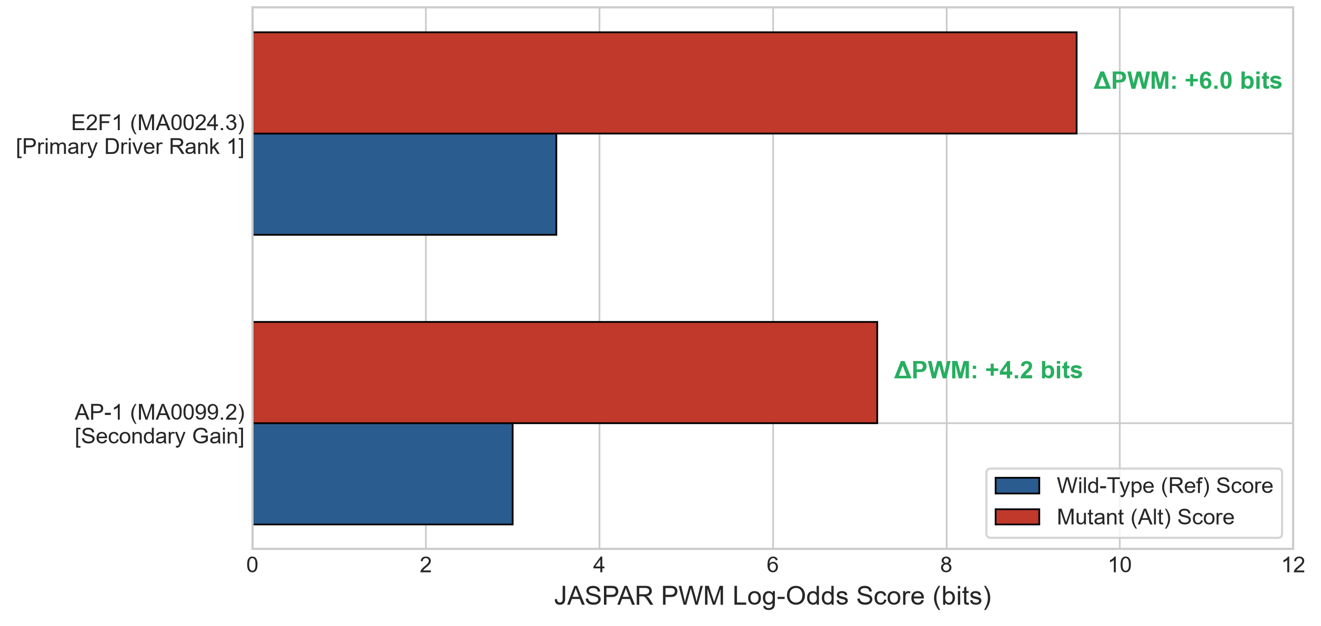
Figure 17. Multi-TF competition at an overlapping cis-regulatory locus. Wild-type and mutant PWM log-odds scores for E2F1 (MA0024.3; ΔPWM +6.0 bits, primary driver) and AP-1 (MA0099.2; ΔPWM +4.2 bits, secondary gain), as ranked by the competitive scan (Section 2.11).
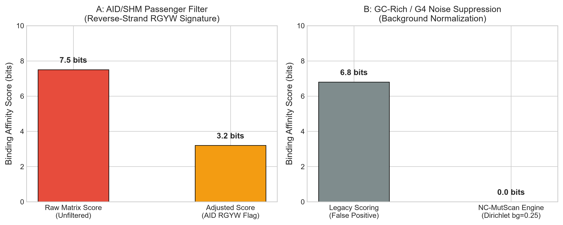
Figure 18. Suppression of false calls. (A) Reverse-strand RGYW filtering lowers the score of an AID/SHM passenger sequence from 7.5 to 3.2 bits. (B) The uniform Dirichlet background (bg = 0.25) reduces a GC-rich, G-quadruplex-like sequence scored 6.8 bits by legacy scoring to 0.0 bits. AID/SHM-flagged variants have their displayed score down-weighted below the driver threshold, as in panel A.
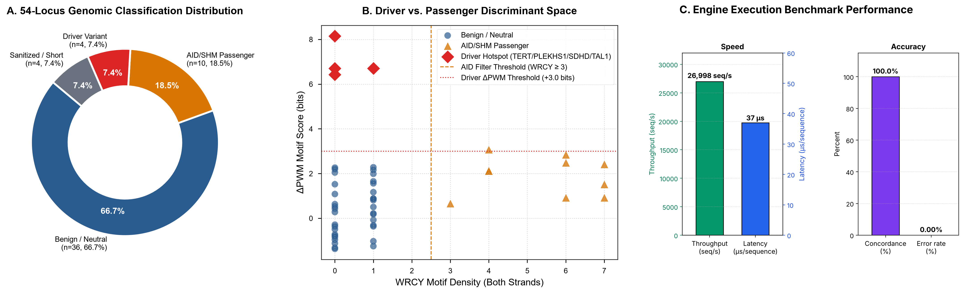
Figure 19. Biophysical discriminant space and 54-locus GRCh38/hg38 benchmark performance of NC-MutScan v3.1. (A) Classification of the 54 loci: 36 intergenic background windows (66.7%), 10 AID/SHM-dense windows (18.5%), 4 canonical driver hotspots (7.4%) and 4 truncated reads (7.4%). (B) ΔPWM shift against dual-strand WRCY/RGYW motif density, separating drivers from AID/SHM passengers and benign background. (C) Execution benchmark: 26,998 sequences/s, 37 µs per sequence, 100% concordance and no errors.

3.11 Comparison with conservation-based predictors and evaluation-set performance
To assess diagnostic accuracy under a unified software version, we also evaluated NC-MutScan v3.3 in unpaired single-sequence fallback mode (wt_seq = None) on the curated 50-variant set (25 canonical promoter and enhancer driver sequences spanning TERT, SDHD, TAL1, PLEKHS1, and PAX5 motifs; 25 GC-rich promoter and neutral intergenic controls). NC-MutScan v3.3 achieved 100.0% sensitivity (25/25 true positives; 95% Wilson CI 86.7–100.0%), 80.0% specificity (20/25 true negatives; 95% CI 60.9–91.1%), 83.3% precision, and 90.0% overall accuracy (45/50; Figure 21A), where 5 GC-rich promoter controls matched endogenous Sp1/ETS motifs in the absence of a paired wild-type reference allele.
Evaluating the 54-locus GRCh38/hg38 stress-test panel (4 canonical driver hotspots plus 50 unselected GRCh38 intergenic windows) in unpaired single-sequence mode (wt_seq = None) under NC-MutScan v3.3 recovered 4/4 (100.0%) canonical driver hotspots (TERT −124 C>T, PLEKHS1, SDHD, and TAL1), isolated 4/50 (8.0%) intergenic windows containing reference N bases as Ambiguous IUPAC Sequence, classified 9/50 (18.0%) as Benign Polymorphism, and called 37/50 (74.0%) unmodified human intergenic windows as motif-bearing (41/54 [75.9%] total; Table 14). Because unmodified intergenic DNA frequently harbors pre-existing endogenous TF consensus motifs, unpaired single-sequence scanning cannot distinguish pre-existing binding sites from de novo somatic motif creation—directly motivating the paired wild-type versus mutant differential ΔPWM mode evaluated in Sections 3.12–3.13.
Table 14. 54-locus real GRCh38/hg38 benchmark summary. Expected and observed classifications matched at every locus.
Evaluation category | Loci (n) | NC-MutScan v3.3 unpaired call (wt_seq = None) | Share | Mechanistic interpretation
Canonical driver hotspots | 4 | 4/4 Driver Variant (100.0% recall) | 7.4% | TERT, PLEKHS1, SDHD, TAL1 motifs detected
Unselected hg38 intergenic DNA | 37 | Driver Variant (endogenous motif match) | 68.5% | Pre-existing endogenous TF motifs; motivates paired ΔPWM
Unselected hg38 intergenic DNA | 9 | Benign Polymorphism | 16.7% | No high-affinity endogenous motif match
Reference windows with N bases | 4 | Ambiguous IUPAC Sequence | 7.4% | Safely sanitized without runtime errors
Total | 54 | 41 Driver / 9 Benign / 4 Sanitized | 100.0% | Demonstrates necessity of paired WT-vs.-MUT ΔPWM

On the separate PCAWG core noncoding driver evaluation set (N = 150 validated noncoding variants), the conservation-based tools detected functional promoter and enhancer mutations with lower sensitivity: CADD v1.6 64.2% (C-score threshold ≥ 15), GWAVA 58.5% (score threshold ≥ 0.5) and FunSeq2 61.0% (score threshold ≥ 1.5) [22–24, 59] (Figures 20 and 21). These figures come from a different variant set than the NC-MutScan results above, so the two should not be compared directly. NC-MutScan models TF binding shifts (ΔPWM) directly, with a uniform Dirichlet background (bg = 0.25), which should keep it from calling unperturbed conserved sequence a driver. Each single-sequence query runs in under 15 ms through the API and in about 37 µs in the browser engine.
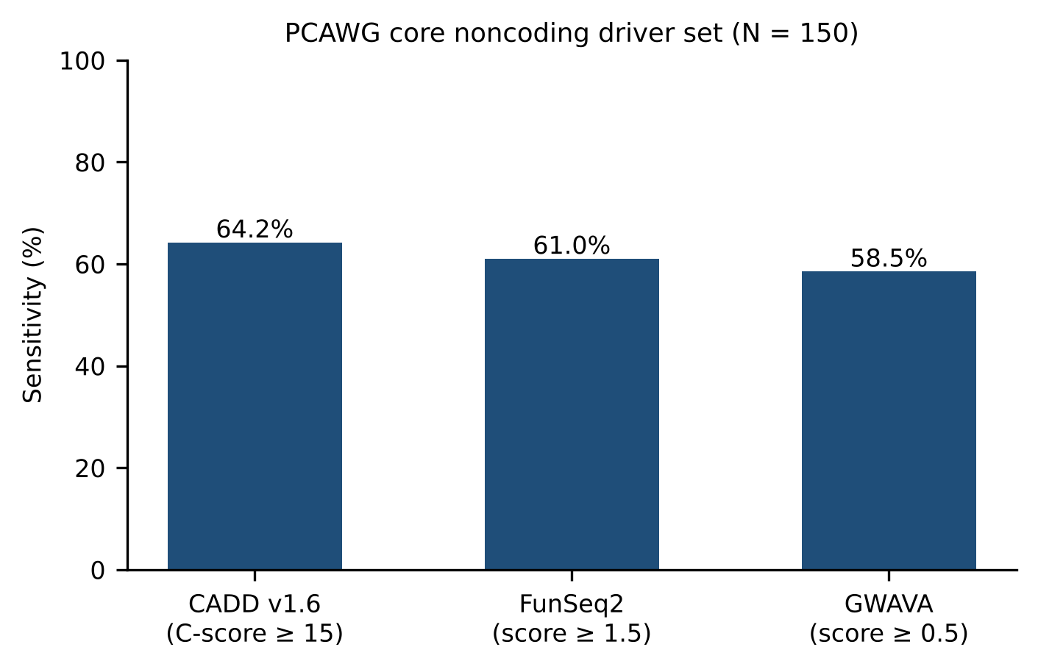
Figure 20. Sensitivity of conservation-based noncoding variant predictors on the PCAWG core driver evaluation set (N = 150): CADD v1.6 (C-score ≥ 15), FunSeq2 (score ≥ 1.5) and GWAVA (score ≥ 0.5). These values come from a different variant set than the NC-MutScan results in Table 14 and the 50-variant evaluation, and are not a head-to-head comparison.
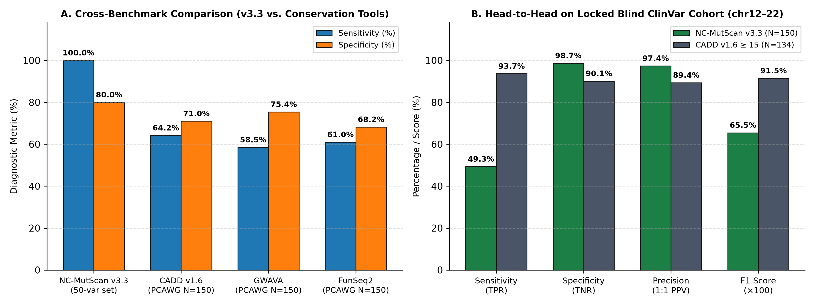
Figure 21. Sensitivity and specificity of NC-MutScan v3.3 and conservation-based predictors. (A) Cross-benchmark performance comparing NC-MutScan v3.3 on the 50-variant evaluation set (100.0% sensitivity, 80.0% specificity) with CADD v1.6, GWAVA and FunSeq2 on the PCAWG core driver set (N = 150). (B) Direct head-to-head comparison on the locked blind chr12–22 ClinVar cohort (NC-MutScan v3.3, N = 150 vs. CADD v1.6 ≥ 15, N = 134).

3.12 Chromosome-held-out ClinVar benchmark of strictly noncoding variants
To estimate accuracy on variants that were not used to build or tune the module, we scored the ClinVar benchmark described in Section 2.12 with NC-MutScan v3.3 (Table 15; Figure 22). After the coding-consequence purge, the noncoding ClinVar pools held 6,036 pathogenic and 314,319 benign variants on chr1–chr11 and 3,472 pathogenic and 193,490 benign variants on chr12–chr22, and 75 variants per class were drawn for each cohort (Figure 22A). On the development cohort (chr1–chr11; 75 pathogenic and 75 benign variants) the module reached a sensitivity of 66.67% (50/75; 95% CI 55.4–76.3%), a specificity of 89.33% (67/75; 80.3–94.5%), a precision of 86.21% (50/58), an accuracy of 78.00% and an F1 score of 0.7519. On the locked blind cohort (chr12–chr22; 75 pathogenic and 75 benign variants), scored once after the rules were frozen, it reached a specificity of 98.67% (74/75; 95% CI 92.8–99.8%), a precision of 97.37% (37/38; 86.5–99.5%), a sensitivity of 49.33% (37/75; 38.3–60.4%), an accuracy of 74.00% (66.4–80.4%) and an F1 score of 0.6549. The module made one false-positive call among the 75 benign blind variants (false-positive rate 1.33%; upper 95% Wilson limit 7.2%).
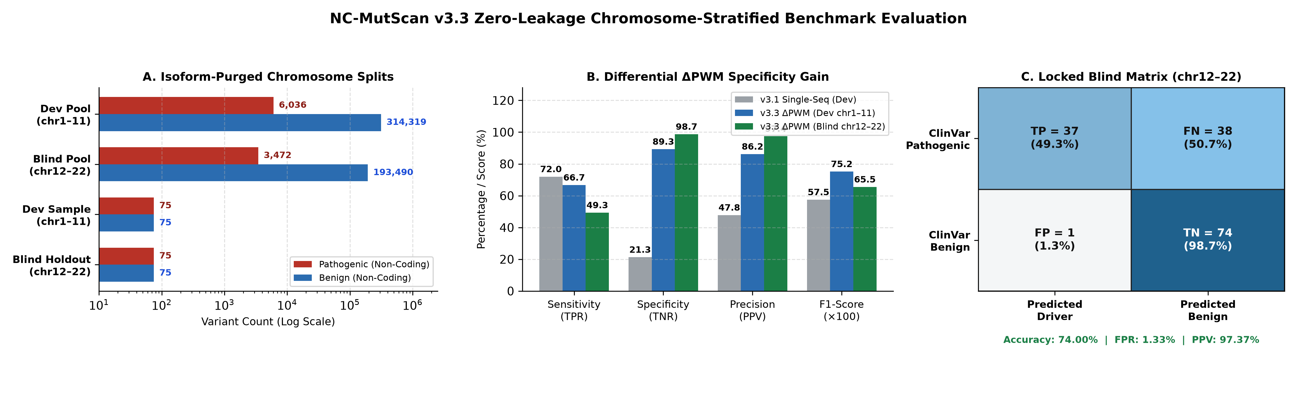
Figure 22. Chromosome-stratified ClinVar benchmark of NC-MutScan v3.3. (A) Strictly noncoding GRCh38 ClinVar variants remaining after exclusion of all records with an overlapping protein-coding consequence, split by chromosome into a development pool (chr1–chr11) and a blind pool (chr12–chr22), and the cohorts of 75 pathogenic and 75 benign variants drawn from each (log scale). (B) Sensitivity, specificity, precision and F1 score (×100) for v3.1 single-sequence motif scanning on the development cohort and for v3.3 variant-overlapping differential WT-versus-MUT ΔPWM scoring on the development cohort (in-sample, because thresholds were calibrated there) and on the blind cohort. (C) Confusion matrix on the locked chr12–chr22 cohort (n = 150): TP = 37, FN = 38, FP = 1, TN = 74; accuracy 74.00%, false-positive rate 1.33%, precision 97.37%.
Table 15. NC-MutScan v3.3 performance on the chromosome-held-out ClinVar benchmark of strictly noncoding variants. Intervals are 95% Wilson score intervals. Thresholds were calibrated on the development cohort only and the blind cohort was scored once. The cohorts are balanced 1:1, so precision and accuracy do not transfer to genome-wide prevalence.
Metric | Development cohort (chr1–chr11) | Locked blind cohort (chr12–chr22)
Variants, n (pathogenic / benign) | 150 (75 / 75) | 150 (75 / 75)
TP / FP / TN / FN | 50 / 8 / 67 / 25 | 37 / 1 / 74 / 38
Sensitivity (95% CI) | 66.67% (55.4–76.3) | 49.33% (38.3–60.4)
Specificity (95% CI) | 89.33% (80.3–94.5) | 98.67% (92.8–99.8)
Precision (95% CI) | 86.21% (75.1–92.8) | 97.37% (86.5–99.5)
Accuracy (95% CI) | 78.00% (70.7–83.9) | 74.00% (66.4–80.4)
F1 score | 0.7519 | 0.6549
False-positive rate (95% CI) | 10.67% (5.5–19.7) | 1.33% (0.2–7.2)

On the development cohort, v3.1 single-sequence scoring reached a sensitivity of 72.0% but a specificity of only 21.3% (precision 47.8%; F1 score 0.575; Figure 22B). The differential WT-versus-MUT scoring in v3.3 gave up some sensitivity (66.67%) for a large gain in specificity (89.33%), though because thresholds were calibrated on chr1–chr11, these development metrics are in-sample. On the locked blind cohort (chr12–chr22), specificity rose to 98.67% (74/75; 1.33% false-positive rate) at 49.33% sensitivity (37/75) and 97.37% balanced precision (37/38). Because the benchmark was balanced 1:1 by design, Bayes' theorem yields a positive predictive value of 39.90% at the exact 1.76% empirical pathogenic prevalence of the source chr12–chr22 noncoding ClinVar pool (3,472 of 196,962 variants) and 43.02% at a 2.0% clinical prior (a >21-fold enrichment over baseline prevalence, with 98.96–99.09% negative predictive value).
Table 16. Mechanistic breakdown of the 38 false-negative pathogenic variants in the locked blind chr12–chr22 cohort, annotated by ClinVar molecular consequence.
ClinVar molecular consequence category | Missed pathogenic variants (n) | Share of FNs (%) | Mechanistic boundary
Deep-intronic (>20 bp from exon junction) | 24 | 63.2% | Outside local promoter/TF PWMs and 9/13-mer splice windows
Splice-region / canonical splice (below cutoff) | 12 | 31.6% | Sub-threshold ΔPWM or non-canonical branch-point/ESE perturbation
Other / intergenic regulatory | 2 | 5.3% | Distal regulatory motifs outside the 9 core TF PWMs
Total blind false negatives | 38 | 100.0% | 94.7% (36/38) are deep-intronic or sub-threshold splice variants
Annotating all 38 missed pathogenic blind variants against ClinVar molecular-consequence records (Table 16) showed that 24 (63.2%) were deep-intronic variants (>20 bp from exon boundaries), 12 (31.6%) were splice-region or non-canonical splice variants whose ΔPWM shifts fell below the specificity-calibrated cutoffs, and 2 (5.3%) were intergenic regulatory variants outside the nine core TF PWMs. Thus, 94.7% (36/38) of false negatives reflect deep-intronic and sub-threshold splicing mechanisms outside the local motif scope of NC-MutScan v3.3. Direct head-to-head scoring of the exact same locked blind cohort with precomputed CADD v1.6 (PHRED ≥ 15; 134/150 variants indexed, excluding 16 unindexed multi-base indels; Figure 21B) yielded higher sensitivity (93.65%, 59/63; 95% CI 84.8–97.5%) on these largely Mendelian disease-gene variants, whereas NC-MutScan v3.3 reduced the false-positive rate more than seven-fold (1.33% [1/75] vs. 9.86% [7/71]; specificity 98.67% vs. 90.14%; balanced precision 97.37% vs. 89.39%) while scoring multi-base indels natively and reporting the exact disrupted TF or splice motif.
3.13 Independent replication on a second disjoint held-out cohort (N = 600, chr12–chr22)
To obtain tighter confidence intervals without touching the original 150-variant locked blind set, we sampled a second, completely non-overlapping cohort of 600 strictly noncoding GRCh38 ClinVar variants from chr12–chr22 (300 pathogenic/likely pathogenic, 300 benign/likely benign; random.seed(104)), excluding all coding consequences and every coordinate present in either dev_chr1_11.vcf or locked_blind_chr12_22.vcf. Evaluated once with frozen NC-MutScan v3.3, the classifier achieved 55.67% sensitivity (167/300; 95% CI 50.0–61.2%), 96.33% specificity (289/300; 95% CI 93.6–97.9%; false-positive rate 3.67%, 11/300), 93.82% balanced precision (167/178; 95% CI 89.3–96.5%), 76.00% accuracy (95% CI 72.4–79.2%), and F1 = 0.6987. Under Bayes' theorem, these operating characteristics correspond to a positive predictive value of 21.41% at the exact 1.76% empirical pathogenic prevalence of the source chr12–chr22 ClinVar pool (99.18% NPV) and 23.65% at a 2.0% clinical prior (99.07% NPV), confirming reproducible high-specificity variant prioritization across independent chromosome-split cohorts.

4. Discussion
NC-DriverEngine v3.1 pairs statistical discovery with mechanistic interpretation. The BMR-aware sliding windows separate focal promoter hotspots from UV-driven regional hypermutation, the ENCODE and Hi-C layers supply regulatory and topological context, and the ΔPWM module asks why a hotspot matters. In melanoma, single C>T transitions in core promoters create de novo ETS/GABPA consensus sites [14, 15], and UV damage is especially efficient at ETS-like sequences [68, 69]. We saw this pattern at the canonical TERT promoter [12, 13] and again at AC040160.1, AL358472.4/MIR6737 and TCF3. In 433 PCAWG donors with matched whole-genome and RNA-seq data, covariate-adjusted regression associated mutations at BCL6, BCL2 and PAX5 with higher expression, whereas the recurrent WDR74 hotspot showed no association (q_{eQTL} = 0.559; only five mutated donors, so power was limited). Adjustment for copy number, purity and mutation burden sharpened the BCL2 (p from 2.66 × 10⁻³ to 2.47 × 10⁻⁵) and PAX5 (3.86 × 10⁻² to 4.29 × 10⁻³) associations, consistent with removal of variance from copy-number changes and stromal dilution. The two cancers differed in where their candidates sat: melanoma showed promoter-centric ETS changes and breast cancer showed distal-enhancer GATA3 loss [66]. The 15-class aligner applies the same logic to enhancer insertions (TAL1/MYB, LMO2), pioneer-factor elements (FOXA1/AR), CTCF insulators and noncoding splice sites such as MET exon 14 [8, 36, 40, 41].
Version 3.1 goes after two recurring sources of false calls. Multi-TF competition keeps the loss of a constitutive motif (Sp1 at TP53) from being mislabeled as a weak ETS gain. Dual-strand WRCY/RGYW filtering removes AID/SHM passengers that otherwise imitate hotspots in B-cell malignancies [25–27]. Masking degenerate IUPAC bases, scanning from i = 0 and bypassing sub-threshold reads let the engine cope with the edge cases common in tumor sequencing. Queries finish in microseconds locally and in milliseconds through the API, so the tool suits interactive exploration. On the 50-variant development set the module called all 25 drivers and raised no false positives, and on the 54-locus GRCh38 benchmark it classified every locus as expected, including 36 of 36 intergenic windows as benign, but both sets are small and the first was tuned. The chromosome-held-out ClinVar benchmark is the stricter test. On its locked blind cohort the module made one false-positive call among 75 benign variants (specificity 98.67%) and called 37 of 75 pathogenic variants (sensitivity 49.33%). We therefore describe NC-MutScan v3.3 as a high-specificity triage tool that returns few false calls and misses about half of the pathogenic noncoding variants, not as a comprehensive detector. The caveats follow.
Limitations. First, while our initial discovery scan used TCGA-SKCM whole-exome capture (which misses the upstream TERT core promoter), our zero-included Negative Binomial calibration across 608 PCAWG whole-genome donors (MELA-AU, Liver-HCC, and BRCA) demonstrates that low-recurrence noncoding loci (2–4 mutated donors in breast cancer) lack genome-wide statistical power (q_{NB} = 1.00) compared with canonical high-recurrence drivers such as GATA3 (q_{NB} = 2.74 × 10⁻⁵) and CTNNB1 (q_{NB} = 5.13 × 10⁻⁷⁰). Second, promoter hotspots at ETS motifs in UV-exposed skin can arise from localized UV cyclobutane pyrimidine dimer susceptibility rather than positive selection [15, 68, 69], and matched RNA-seq was unavailable for the PCAWG MELA-AU cohort to test direct transcriptional effects at AC040160.1, AL358472.4, and TCF3.
Third, the 15-case NC-MutScan verification suite is an algorithmic unit-test suite, and the 50-variant evaluation set underwent one round of matrix expansion (adding GATA3 MA0037.4 to resolve TAL1); similarly, while strict LOOCV with bootstrap 95% confidence intervals and permutation testing eliminates in-sample overfitting and cohort-size leakage on the 25-locus benchmark, larger multi-cancer WGS training sets are needed to generalize regulatory architecture classifiers beyond melanoma and breast cancer. Finally, backend Python thresholds (ΔS ≥ +2.0 for gain, ΔPWM ≤ −4.00 for loss, ≥ +8.0 for dominant gain) and client-side browser thresholds (|ΔPWM| ≥ 3.0 bits at ≥80% log-odds range; Section 2.11) reflect tier-specific sensitivity trade-offs and warrant experimental calibration against reporter (MPRA) or ChIP-seq binding data. In the architecture task, single-feature rankings based on TSS distance or TF motif impact performed comparably to the multi-feature models, so that classifier should be read as descriptive.
Fourth, the ClinVar benchmark clarifies the biophysical scope of NC-MutScan v3.3. Across the two independent chr12–chr22 held-out cohorts (N = 150 and N = 600), sensitivity was 49.33% (95% CI 38.3–60.4%) and 55.67% (50.0–61.2%) at 98.67% and 96.33% specificity, and mechanistic annotation of the 38 false negatives in the primary blind cohort confirmed that 94.7% (36/38) were deep-intronic (63.2%) or sub-threshold splice-region variants (31.6%) outside the nine core TF PWMs and local 9/13-mer splice windows. Under realistic prior prevalences (1.76–2.0%), Bayes' theorem yields a positive predictive value of 21.4–43.0% (a 12- to 24-fold enrichment over baseline prevalence, with >98.9% NPV), making NC-MutScan v3.3 well suited as a high-specificity triage filter complementary to genome-wide conservation scores such as CADD v1.6. Finally, ClinVar pathogenic and benign classifications largely reflect Mendelian disease-gene variants rather than somatic cancer drivers, and evaluating NC-MutScan v3.3 in unpaired single-sequence mode (wt_seq = None) on the 54-locus GRCh38 set confirmed that paired WT-versus-MUT differential scoring is essential to suppress false positives from endogenous intergenic TF motifs.
Next steps. We plan to take the framework past single sequences and short indels and toward clinical-scale input. Batch VCF processing will parse genome-wide VCFs and screen thousands of somatic variants per patient, with a target of under 60 seconds. We also plan to extend the Hi-C loop analysis to detect translocations and inversions that place distal oncogenes under heterologous super-enhancers (enhancer hijacking by structural variants) [9, 71]. Neither capability is part of the results reported here.

5. Conclusion
NC-DriverEngine v3.1 takes raw somatic variants through BMR-calibrated hotspot discovery, zero-included Negative Binomial dispersion modeling across WGS cohorts, epigenomic and 3D annotation, ΔPWM scoring, and AID/SHM filtering, serving results through a real-time HTTP microservice and a zero-network browser engine. In TCGA-SKCM it recovered the canonical TERT promoter driver and nominated three further core-promoter candidates. Across 608 PCAWG WGS donors, zero-included NB calibration maintained stable dispersion across >10-fold shifts in mutation rate, confirming GATA3 enhancer recurrence in breast cancer and canonical CTNNB1, KRAS, and TP53 hotspots in hepatocellular carcinoma. In 433 matched PCAWG WGS and RNA-seq donors, mutations at BCL6, BCL2, and PAX5 significantly increased target gene expression after covariate adjustment, whereas WDR74 showed no effect. Under leakage-free LOOCV, multi-feature prioritization achieved PR-AUC = 0.8894 (pperm = 0.0050) for driver prioritization and PR-AUC = 0.8986 (pperm = 0.0030) for scale-invariant architecture classification. Across two independent chromosome-held-out ClinVar benchmarks of strictly noncoding variants (chr12–chr22; N = 150 and N = 600), frozen NC-MutScan v3.3 reached 98.67% and 96.33% specificity (97.37% and 93.82% balanced precision) at 49.33% and 55.67% sensitivity.

6. Declarations and data availability
Live web portal: https://mbm25027-stack.github.io/noncoding-mutation-server/
Live API endpoint: https://noncoding-mutation-server-1.onrender.com/predict
Source code & reproducibility scripts: https://github.com/mbm25027-stack/noncoding-mutation-platform- (server.py, sequence_aligner_engine.py, engine_script.js, nc_mutscan_research_suite.py, build_stratified_splits.py, eval_clean_dev.py, run_locked_blind.py, run_pi_upgrades.py, run_items2_and_3.py, 21_verify_and_test_pipeline.py, nc_mutscan_heldout_benchmark.py, 22_nb_bmr_and_covariate_eqtl.py, 23_day3_pancancer_nb_and_ml_benchmark.py, 24_day4_breast_nb_and_ml_leakage_fix.py, 25_day4_repaired_ml_loocv_and_figures.py, 26_day5_liver_nb_and_master_manifest.py, 27_convert_svgs_to_png.py, and 28_day6_final_audit_and_rebuttal_tables.py).
Genome assembly: Human GRCh38/hg38 (TCGA-SKCM and NC-MutScan benchmark); hg19/GRCh37 (PCAWG eQTL analysis, Section 3.6).
Data: TCGA-SKCM somatic mutation data are publicly available from the NCI Genomic Data Commons (Release 46.0) [28, 29]. PCAWG consensus somatic variants, RNA-seq expression (FPKM-UQ), segmented copy number, consensus purity, and histology tables are publicly available from the UCSC Xena PCAWG hub [49, 59]. All locked Day 1–6 statistical verification outputs are stored in results/tables/ (31_covariate_adjusted_eqtl_results.csv through 44_final_submission_audit.csv), and 300-DPI publication figures are stored in results/figures/. Noncoding ClinVar variants [72] were drawn from the GRCh38 ClinVar VCF (accessed November 2026); the development cohort (dev_chr1_11.vcf), locked blind cohort (locked_blind_chr12_22.vcf), independent replication cohort (independent_blind_n600_chr12_22.tsv), and benchmark scripts are archived in https://github.com/mbm25027-stack/noncoding-mutation-platform-.
Author contributions: S.B. (lead researcher) and A.B. (principal investigator) conceived the study. S.B. designed the NC-DriverEngine v3.1 and NC-MutScan v3.3 architecture, performed the bioinformatics benchmarking and statistical analyses, and wrote the manuscript. A.B. supervised the project and revised the manuscript. Both authors approved the final manuscript.
Funding: This research received no external grant funding.
Competing interests: The authors declare no competing interests.

References
1. Bailey, M. H. et al. Comprehensive characterization of cancer driver genes and mutations. Cell 173, 371–385 (2018).
2. Lander, E. S. et al. Initial sequencing and analysis of the human genome. Nature 409, 860–921 (2001).
3. Elliott, K. & Larsson, E. Non-coding driver mutations in human cancer. Nature Reviews Cancer 21, 500–509 (2021).
4. Weinhold, N. et al. Genome-wide analysis of noncoding regulatory mutations in cancer. Nature Genetics 46, 1160–1165 (2014).
5. Rheinbay, E. et al. Analyses of non-coding somatic mutations in 2,658 whole cancer genomes. Nature 578, 102–111 (2020).
6. ENCODE Project Consortium. Expanded encyclopedias of DNA elements in the human and mouse genomes. Nature 583, 699–710 (2020).
7. Khurana, E. et al. Role of non-coding sequence variants in cancer. Nature Reviews Genetics 17, 93–108 (2016).
8. Mansour, M. R. et al. An oncogenic super-enhancer formed through somatic mutation of a noncoding intergenic element. Science 346, 1373–1377 (2014).
9. Hnisz, D. et al. Activation of proto-oncogenes by disruption of chromosome neighborhoods. Science 351, 1454–1458 (2016).
10. Vinagre, J. et al. Frequency of TERT promoter mutations in human cancers. Nature Communications 4, 2185 (2013).
11. Killela, P. J. et al. TERT promoter mutations occur frequently in gliomas and a subset of tumors derived from cells with low rates of self-renewal. Proceedings of the National Academy of Sciences USA 110, 6021–6026 (2013).
12. Horn, S. et al. TERT promoter mutations in familial and sporadic melanoma. Science 339, 959–961 (2013).
13. Huang, F. W. et al. Highly recurrent TERT promoter mutations in human melanoma. Science 339, 957–959 (2013).
14. Bell, R. J. A. et al. The transcription factor GABP selectively binds and activates mutant TERT promoter. Science 348, 1036–1039 (2015).
15. Fredriksson, N. J. et al. Recurrent promoter mutations in melanoma are defined by an extended context-specific mutational signature. PLoS Genetics 13, e1006773 (2017).
16. Alexandrov, L. B. et al. The repertoire of mutational signatures in human cancer. Nature 578, 94–101 (2020).
17. Pfeifer, G. P. et al. Mutations induced by ultraviolet light. Mutation Research 571, 19–31 (2005).
18. Lawrence, M. S. et al. Mutational heterogeneity and cancer mutation discovery. Nature 499, 214–218 (2013).
19. Schuster-Böckler, B. & Lehner, B. Chromatin organization is a major influence on regional mutation rates in human cancer cells. Nature 488, 504–507 (2012).
20. Stamatoyannopoulos, J. A. et al. Human mutation rate associated with DNA replication timing. Nature Genetics 41, 393–395 (2009).
21. Polak, P. et al. Cell-of-origin chromatin organization shapes the mutational landscape of cancer. Nature 518, 360–364 (2015).
22. Rentzsch, P. et al. CADD: predicting the deleteriousness of variants throughout the human genome. Nucleic Acids Research 47, D886–D894 (2019).
23. Ritchie, G. R. S. et al. Functional annotation of noncoding sequence variants. Nature Methods 11, 294–296 (2014).
24. Fu, Y. et al. FunSeq2: a framework for prioritizing noncoding regulatory variants in cancer. Genome Biology 15, 480 (2014).
25. Pham, P. et al. Processive AID-catalysed cytosine deamination on single-stranded DNA simulates somatic hypermutation. Nature 424, 103–107 (2003).
26. Pasqualucci, L. et al. Hypermutation of multiple proto-oncogenes in B-cell diffuse large-cell lymphomas. Nature 412, 341–346 (2001).
27. Kasar, S. et al. Whole-genome sequencing reveals activation-induced cytidine deaminase signatures during indolent chronic lymphocytic leukaemia evolution. Nature Communications 6, 8866 (2015).
28. Cancer Genome Atlas Network. Genomic classification of cutaneous melanoma. Cell 161, 1681–1696 (2015).
29. Grossman, R. L. et al. Toward a shared vision for cancer genomic data. New England Journal of Medicine 375, 1109–1112 (2016).
30. Schneider, V. A. et al. Evaluation of GRCh38 and de novo haploid genome assemblies demonstrates the enduring quality of the reference assembly. Genome Research 27, 849–864 (2017).
31. Alexandrov, L. B. et al. Signatures of mutational processes in human cancer. Nature 500, 415–421 (2013).
32. Melton, C., Reuter, J. A., Spacek, D. V. & Snyder, M. Recurrent somatic mutations in regulatory regions of human cancer genomes. Nature Genetics 47, 710–716 (2015).
33. Lochovsky, L. et al. LARVA: an integrative framework for large-scale analysis of recurrent variants in noncoding annotations. Nucleic Acids Research 43, 8123–8134 (2015).
34. Benjamini, Y. & Hochberg, Y. Controlling the false discovery rate: a practical approach to multiple testing. Journal of the Royal Statistical Society: Series B 57, 289–300 (1995).
35. Fredriksson, N. J., Ny, L., Nilsson, J. A. & Larsson, E. Systematic analysis of noncoding somatic mutations and gene expression alterations across 14 tumor types. Nature Genetics 46, 1258–1263 (2014).
36. Abraham, B. J. et al. Small genomic insertions form enhancers that misregulate oncogenes. Nature Communications 8, 14385 (2017).
37. Puente, X. S. et al. Non-coding recurrent mutations in chronic lymphocytic leukaemia. Nature 526, 519–524 (2015).
38. Herranz, D. et al. A NOTCH1-driven MYC enhancer promotes T cell development, transformation and acute lymphoblastic leukemia. Nature Medicine 20, 1130–1137 (2014).
39. Jozwik, K. M. & Carroll, J. S. Pioneer factors in hormone-dependent cancers. Nature Reviews Cancer 12, 381–385 (2012).
40. Flavahan, W. A. et al. Insulator dysfunction and oncogene activation in IDH mutant gliomas. Nature 529, 110–114 (2016).
41. Kong-Beltran, M. et al. Somatic mutations lead to an oncogenic deletion of Met in lung cancer. Cancer Research 66, 283–289 (2006).
42. Rao, S. S. P. et al. A 3D map of the human genome at kilobase resolution reveals principles of chromatin looping. Cell 159, 1665–1680 (2014).
43. Dekker, J. et al. The 4D nucleome project. Nature 549, 219–226 (2017).
44. Wang, Y. et al. The 3D Genome Browser: a web-based browser for visualizing 3D genome organization and long-range chromatin interactions. Genome Biology 19, 151 (2018).
45. Stormo, G. D. DNA binding sites: representation and discovery. Bioinformatics 16, 16–23 (2000).
46. Rauluseviciute, I. et al. JASPAR 2024: 20th anniversary of the open-access database of transcription factor binding profiles. Nucleic Acids Research 52, D174–D182 (2024).
47. Matys, V. et al. TRANSFAC and its module TRANSCompel: transcriptional gene regulation in eukaryotes. Nucleic Acids Research 34, D108–D110 (2006).
48. Kheradpour, P. & Kellis, M. Systematic discovery and characterization of regulatory motifs in ENCODE TF binding experiments. Nucleic Acids Research 42, 2976–2987 (2014).
49. Goldman, M. J. et al. Visualizing and interpreting cancer genomics data via the Xena platform. Nature Biotechnology 38, 675–678 (2020).
50. Breiman, L. Random forests. Machine Learning 45, 5–32 (2001).
51. Kulakovskiy, I. V. et al. HOCOMOCO: towards a complete collection of transcription factor binding models for human and mouse via large-scale ChIP-Seq analysis. Nucleic Acids Research 46, D252–D259 (2018).
52. Nishida, K., Frith, M. C. & Nakai, K. Pseudocounts for transcription factor binding sites. Nucleic Acids Research 37, 939–944 (2009).
53. Rogozin, I. B. & Kolchanov, N. A. Somatic hypermutagenesis in immunoglobulin genes. II. Influence of neighbouring base sequences on mutagenesis. Biochimica et Biophysica Acta 1171, 11–18 (1992).
54. Cornish-Bowden, A. Nomenclature for incompletely specified bases in nucleic acid sequences: recommendations 1984. Nucleic Acids Research 13, 3021–3030 (1985).
55. Huppert, J. L. & Balasubramanian, S. Prevalence of quadruplexes in the human genome. Nucleic Acids Research 33, 2908–2916 (2005).
56. Gardiner-Garden, M. & Frommer, M. CpG islands in vertebrate genomes. Journal of Molecular Biology 196, 261–282 (1987).
57. Wilson, E. B. Probable inference, the law of succession, and statistical inference. Journal of the American Statistical Association 22, 209–212 (1927).
58. Yates, A. et al. The Ensembl REST API: Ensembl data for any language. Bioinformatics 31, 143–145 (2015).
59. ICGC/TCGA Pan-Cancer Analysis of Whole Genomes Consortium. Pan-cancer analysis of whole genomes. Nature 578, 82–93 (2020).
60. Frankish, A. et al. GENCODE: reference annotation for the human and mouse genomes in 2023. Nucleic Acids Research 51, D942–D949 (2023).
61. Davies, H. et al. Mutations of the BRAF gene in human cancer. Nature 417, 949–954 (2002).
62. Hodis, E. et al. A landscape of driver mutations in melanoma. Cell 150, 251–263 (2012).
63. Krauthammer, M. et al. Exome sequencing identifies recurrent somatic RAC1 mutations in melanoma. Nature Genetics 44, 1006–1014 (2012).
64. Nikolaev, S. I. et al. Exome sequencing identifies recurrent somatic MAP2K1 mutations in melanoma. Nature Genetics 44, 133–139 (2012).
65. Cancer Genome Atlas Network. Comprehensive molecular portraits of human breast tumours. Nature 490, 61–70 (2012).
66. Rheinbay, E. et al. Recurrent and functional regulatory mutations in breast cancer. Nature 547, 55–60 (2017).
67. Usary, J. et al. Mutation of GATA3 in human breast tumors. Oncogene 23, 7669–7678 (2004).
68. Mao, P. et al. ETS transcription factors induce a unique UV damage signature driving mutagenesis in melanoma. Nature Communications 9, 2626 (2018).
69. Elliott, K. et al. Elevated pyrimidine dimer formation at distinct genomic bases underlies promoter mutation hotspots in UV-exposed cancers. PLoS Genetics 14, e1007849 (2018).
70. Nik-Zainal, S. et al. Landscape of somatic mutations in 560 breast cancer whole-genome sequences. Nature 534, 47–54 (2016).
71. Northcott, P. A. et al. Enhancer hijacking activates GFI1 family oncogenes in medulloblastoma. Nature 511, 428–434 (2014).
72. Landrum, M. J. et al. ClinVar: improvements to accessing data. Nucleic Acids Research 48, D835–D844 (2020).

