**الجمباز**

[](http://www.google.com.om/imgres?q=%D8%B5%D9%88%D8%B1+%D9%85%D8%AA%D9%86%D9%88%D8%B9%D8%A9+%D9%84%D9%84%D8%AC%D9%85%D8%A8%D8%A7%D8%B2&hl=ar&sa=X&rlz=1R2RNRN_enOM441&biw=1280&bih=603&tbm=isch&prmd=ivns&tbnid=aX1-uLmHK4WExM:&imgrefurl=http://ar.beijing2008.cn/news/sportsnews/headlines/artisticgymnastics/n214508962.shtml&docid=eneon9bXCz4OAM&w=500&h=322&ei=n1A1Tr7FO4HirAfPwon1Dg&zoom=1)

[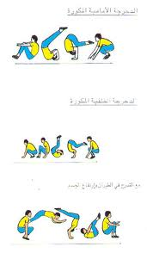](http://www.google.com.om/imgres?q=%D8%B5%D9%88%D8%B1+%D9%85%D8%AA%D9%86%D9%88%D8%B9%D8%A9+%D9%84%D9%84%D8%AC%D9%85%D8%A8%D8%A7%D8%B2&hl=ar&sa=X&rlz=1R2RNRN_enOM441&biw=1280&bih=603&tbm=isch&prmd=ivns&tbnid=dqWoa35MOD-ZvM:&imgrefurl=http://photos.7be.com/photo-7983.html&docid=2b5NtI62actydM&w=473&h=811&ei=n1A1Tr7FO4HirAfPwon1Dg&zoom=1)[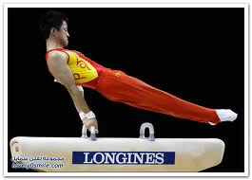](http://www.google.com.om/imgres?q=%D8%B5%D9%88%D8%B1+%D9%85%D8%AA%D9%86%D9%88%D8%B9%D8%A9+%D9%84%D9%84%D8%AC%D9%85%D8%A8%D8%A7%D8%B2&hl=ar&sa=X&rlz=1R2RNRN_enOM441&biw=1280&bih=603&tbm=isch&prmd=ivns&tbnid=rBrpLcQKOxq7JM:&imgrefurl=http://lovely0smile.com/Msg-3587.html&docid=scasLOq-ACj2fM&w=692&h=498&ei=n1A1Tr7FO4HirAfPwon1Dg&zoom=1)

[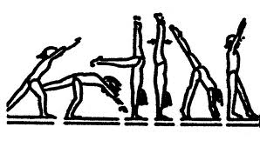](http://www.google.com.om/imgres?q=%D8%B5%D9%88%D8%B1+%D9%85%D8%AA%D9%86%D9%88%D8%B9%D8%A9+%D9%84%D9%84%D8%AC%D9%85%D8%A8%D8%A7%D8%B2&hl=ar&sa=X&rlz=1R2RNRN_enOM441&biw=1280&bih=603&tbm=isch&prmd=ivns&tbnid=zrXPegfSyb_OoM:&imgrefurl=http://www.saspea.com/vb/showthread.php%253F441-%2525D5%2525E6%2525D1-%2525E1%2525C8%2525DA%2525D6-%2525C7%2525E1%2525CD%2525D1%2525DF%2525C7%2525CA-%2525C7%2525E1%2525C7%2525D1%2525D6%2525ED%2525E5&docid=En-P4n2DKUnIVM&w=930&h=528&ei=n1A1Tr7FO4HirAfPwon1Dg&zoom=1)

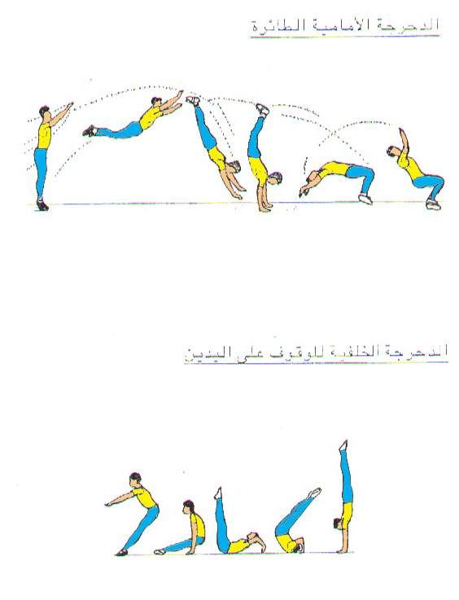

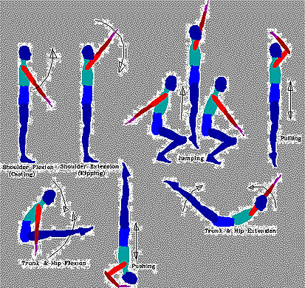

[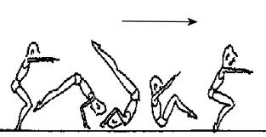](http://www.google.com.om/imgres?q=%D8%B5%D9%88%D8%B1+%D9%85%D8%AA%D9%86%D9%88%D8%B9%D8%A9+%D9%84%D9%84%D8%AC%D9%85%D8%A8%D8%A7%D8%B2&hl=ar&sa=X&rlz=1R2RNRN_enOM441&biw=1280&bih=603&tbm=isch&tbnid=42Wy6an-Dhj3aM:&imgrefurl=http://www.4ig.info/vb/showthread.php%253Fp%253D78307&docid=dxCPMiAjxIcdhM&w=396&h=204&ei=zVE1Ts6VBIfqrAeOoczACw&zoom=1)

[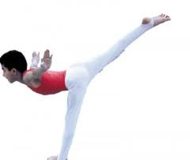](http://www.google.com.om/imgres?q=%D8%B5%D9%88%D8%B1+%D9%85%D8%AA%D9%86%D9%88%D8%B9%D8%A9+%D9%84%D9%84%D8%AC%D9%85%D8%A8%D8%A7%D8%B2&hl=ar&sa=X&rlz=1R2RNRN_enOM441&biw=1280&bih=603&tbm=isch&tbnid=V2xAIgMxPzEqTM:&imgrefurl=http://www.soharuni.net/vb/t32482.html&docid=XaV6xD1tpiS9KM&w=300&h=254&ei=zVE1Ts6VBIfqrAeOoczACw&zoom=1)

[](http://www.google.com.om/imgres?q=%D8%B5%D9%88%D8%B1+%D9%85%D8%AA%D9%86%D9%88%D8%B9%D8%A9+%D9%84%D9%84%D8%AC%D9%85%D8%A8%D8%A7%D8%B2&hl=ar&sa=X&rlz=1R2RNRN_enOM441&biw=1280&bih=603&tbm=isch&tbnid=sqFc0N6pq3maoM:&imgrefurl=http://ar.beijing2008.cn/news/sportsnews/headlines/artisticgymnastics/n214563269.shtml&docid=m6ckFVvnEuv3vM&w=335&h=500&ei=zVE1Ts6VBIfqrAeOoczACw&zoom=1)

[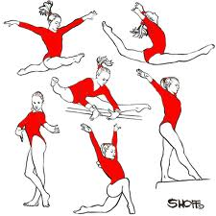](http://www.google.com.om/imgres?q=%D8%B5%D9%88%D8%B1+%D9%85%D8%AA%D9%86%D9%88%D8%B9%D8%A9+%D9%84%D9%84%D8%AC%D9%85%D8%A8%D8%A7%D8%B2&hl=ar&sa=X&rlz=1R2RNRN_enOM441&biw=1280&bih=603&tbm=isch&tbnid=126OxHXHwD3tUM:&imgrefurl=http://www.ibtesama.com/vb/showthread-t_216636.html&docid=3zcZo1PLSRPdTM&w=500&h=500&ei=GVI1TsiSDovyrQfFlb3VCw&zoom=1)

[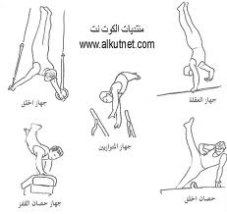](http://www.google.com.om/imgres?q=%D8%B5%D9%88%D8%B1+%D9%85%D8%AA%D9%86%D9%88%D8%B9%D8%A9+%D9%84%D9%84%D8%AC%D9%85%D8%A8%D8%A7%D8%B2&hl=ar&sa=X&rlz=1R2RNRN_enOM441&biw=1280&bih=603&tbm=isch&tbnid=ig-r6wQrQOFkLM:&imgrefurl=http://www.alkutnet.com/vb/showthread.php%253F85892-%2525CF%2525D1%2525E6%2525D3-%2525DD%2525ED-%2525C7%2525E1%2525CC%2525E3%2525C8%2525C7%2525D2-%2525E6%2525C8%2525DA%2525D6-%2525CD%2525D1%2525DF%2525C7%2525CA%2525E5-%2525C8%2525C7%2525E1%2525D5%2525E6%2525D1&docid=NoarIuFXyXS0hM&w=896&h=848&ei=GVI1TsiSDovyrQfFlb3VCw&zoom=1)

[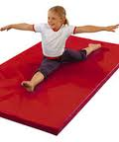](http://www.google.com.om/imgres?q=%D8%B5%D9%88%D8%B1+%D9%85%D8%AA%D9%86%D9%88%D8%B9%D8%A9+%D9%84%D9%84%D8%AC%D9%85%D8%A8%D8%A7%D8%B2&hl=ar&sa=X&rlz=1R2RNRN_enOM441&biw=1280&bih=603&tbm=isch&tbnid=WvEWWABdn3fSgM:&imgrefurl=http://www.gihane.com/vb/showthread.php%253Ft%253D24384&docid=iFpUk86h3QTObM&w=150&h=180&ei=S1I1TsLSEovJrQfBornLCw&zoom=1)

[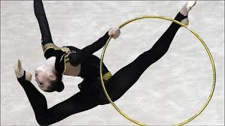](http://www.google.com.om/imgres?q=%D8%B5%D9%88%D8%B1+%D9%85%D8%AA%D9%86%D9%88%D8%B9%D8%A9+%D9%84%D9%84%D8%AC%D9%85%D8%A8%D8%A7%D8%B2&hl=ar&sa=X&rlz=1R2RNRN_enOM441&biw=1280&bih=603&tbm=isch&tbnid=bfF0i2a35sGYDM:&imgrefurl=http://www.sawa24.com/forum/t26451.html&docid=iycSF3SdEBH8vM&w=585&h=329&ei=S1I1TsLSEovJrQfBornLCw&zoom=1)

[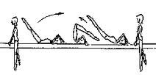](http://www.google.com.om/imgres?q=%D8%B5%D9%88%D8%B1+%D9%85%D8%AA%D9%86%D9%88%D8%B9%D8%A9+%D9%84%D9%84%D8%AC%D9%85%D8%A8%D8%A7%D8%B2&hl=ar&sa=X&rlz=1R2RNRN_enOM441&biw=1280&bih=603&tbm=isch&tbnid=_UeCFKR4KMvy4M:&imgrefurl=http://www.dhnuae.com/forums/showthread.php%253Ft%253D457&docid=wmhGA9aQuJzrZM&w=265&h=128&ei=S1I1TsLSEovJrQfBornLCw&zoom=1)

[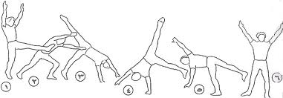](http://www.google.com.om/imgres?q=%D8%B5%D9%88%D8%B1+%D9%85%D8%AA%D9%86%D9%88%D8%B9%D8%A9+%D9%84%D9%84%D8%AC%D9%85%D8%A8%D8%A7%D8%B2&hl=ar&sa=X&rlz=1R2RNRN_enOM441&biw=1280&bih=603&tbm=isch&tbnid=Au8qxA2-5yTDsM:&imgrefurl=http://www.dorar-aliraq.net/threads/10069-%2525D8%2525AF%2525D8%2525B1%2525D9%252588%2525D8%2525B3-%2525D9%252581%2525D9%25258A-%2525D8%2525A7%2525D9%252584%2525D8%2525AC%2525D9%252585%2525D8%2525A8%2525D8%2525A7%2525D8%2525B2-%2525D9%252588%2525D8%2525A8%2525D8%2525B9%2525D8%2525B6-%2525D8%2525AD%2525D8%2525B1%2525D9%252583%2525D8%2525A7%2525D8%2525AA%2525D9%252587-%2525D8%2525A8%2525D8%2525A7%2525D9%252584%2525D8%2525B5%2525D9%252588%2525D8%2525B1&docid=DzXbzCS8VvqnvM&w=905&h=314&ei=S1I1TsLSEovJrQfBornLCw&zoom=1)

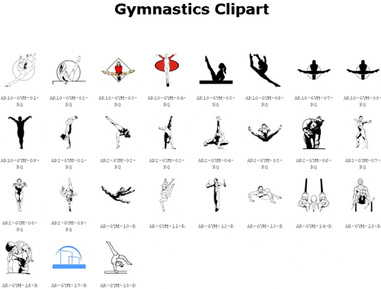

[](http://www.google.com.om/imgres?q=%D8%B5%D9%88%D8%B1+%D9%85%D8%AA%D9%86%D9%88%D8%B9%D8%A9+%D9%84%D9%84%D8%AC%D9%85%D8%A8%D8%A7%D8%B2&hl=ar&sa=X&rlz=1R2RNRN_enOM441&biw=1280&bih=603&tbm=isch&tbnid=MTlFUuF0OQmtFM:&imgrefurl=http://alrahman.iowoi.com/t288-topic&docid=zbX-fiKQA_MTqM&w=554&h=400&ei=vVI1To-nBYbKrAfjusnLCw&zoom=1)

[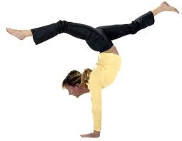](http://www.google.com.om/imgres?q=%D8%B5%D9%88%D8%B1+%D9%85%D8%AA%D9%86%D9%88%D8%B9%D8%A9+%D9%84%D9%84%D8%AC%D9%85%D8%A8%D8%A7%D8%B2&hl=ar&sa=X&rlz=1R2RNRN_enOM441&biw=1280&bih=603&tbm=isch&tbnid=WOn8WmO6VRqTEM:&imgrefurl=http://www.sweka.info/vb/showthread.php%253Ft%253D5917&docid=CyZPJuguSXnkVM&w=640&h=496&ei=2VI1TrnJBYTIrQf-_Jm4Cw&zoom=1)

[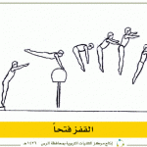](http://alfaris.net/up/68/alfaris_net_1305381994.gif)  
  
  
[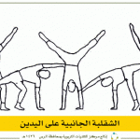](http://alfaris.net/up/68/alfaris_net_1305382033.gif)  
  
  
[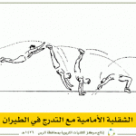](http://alfaris.net/up/68/alfaris_net_1305382062.gif)  
  
  
[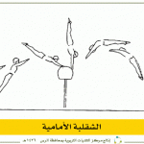](http://alfaris.net/up/68/alfaris_net_1305382097.gif)  
  
  
  
  
  
[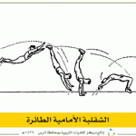](http://alfaris.net/up/68/alfaris_net_1305382281.gif)

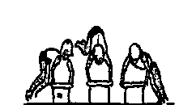

[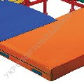](http://www.ua.all.biz/ar/g427187/)

[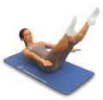](http://www.ar.all.biz/ar/g31914/)

[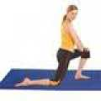](http://www.tr.all.biz/ar/g11946/)

[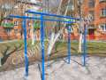](http://www.ru.all.biz/ar/g338855/)

[](http://www.kz.all.biz/ar/g60719/)

[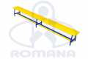](http://www.kz.all.biz/ar/g60720/)

[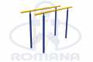](http://www.kz.all.biz/ar/g60718/)

[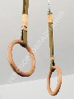](http://www.ua.all.biz/ar/g426455/)

[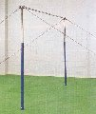](http://www.ua.all.biz/ar/g451625/)

[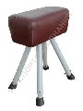](http://www.ua.all.biz/ar/g424994/)

[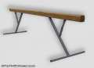](http://www.ua.all.biz/ar/g568769/)

[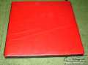](http://www.ua.all.biz/ar/g568774/)

[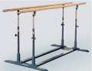](http://www.ua.all.biz/ar/g533824/)

[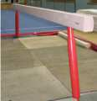](http://www.ua.all.biz/ar/g1013603/)

[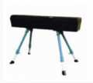](http://www.ua.all.biz/ar/g1013591/)