Of Mice and Manimals Outline

For generations stories of a medical facility of the Ancient Ones have run through your village. Unfortunately, the stockpile of medical tech has been under the control of The Experimented, a tribe of biomedically enhanced manimals. Scouts have reported the possibility of an internal conflict arising amongst The Experimented! The bionically-evolved Enhanced have revolted against the hyper-intelligent White Mice. Now may be the perfect opportunity to join with your 2nd-level compatriots to infiltrate and loot the Domain of the Experimented.

The Enhanced represent some of the more successful

Why did they splinter?

* Oppression? Change of heart?
* Infiltration by The Chosen Zuu.
  + Radical branch? ZLF – Zuu Liberation Front
* See the actions of the White Mice as an affront

Location

* Abandoned Military/Medical Facility??
* Multiple Buildings
* How do they get there?
* What kind of security is set up?

Surrounding area?

* Typical Hothouse jungle?
* Jungle has overtaken the civilization.
* Inspiration images





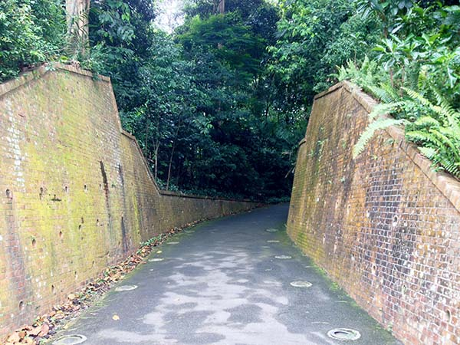



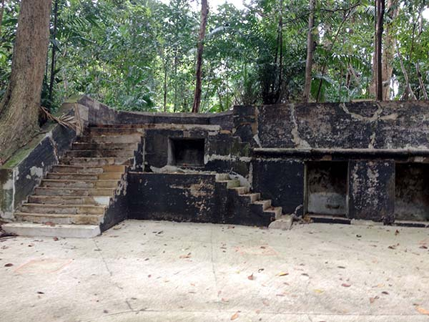

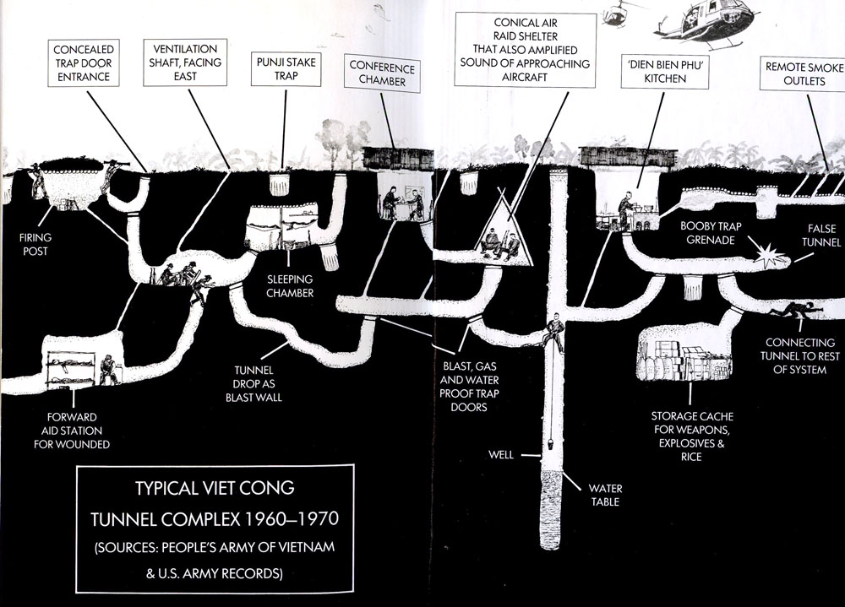

Two Factions:

* White Mice - medical facility
  + The Brain -- Enlarged skull - Mental Mutations
  + Pinky
    - Init +2; Atk Slam +5 melee (1d6+6); AC 16; HD 4d8+4; HP 25; MV 20’; Act 1d20; SP bear hugs; SV Fort: +4, Ref: +2; Will +1
    - Pinky is a giant white rat with a predilection for yelling “Snarf” prior to engaging in combat. He is completely loyal to his brother, the Brain. Although he typically prefers to beat foes into submission with his giant fists, he is capable of using a bear hug against a foe that was successfully slammed. On their initiative, foe can make an opposed strength roll against Pinky’s 20 str (+5). Strength/height may be adjusted via amplimorph mutation.
    - Physical Mutations d20+4:
      * Amplimorph
      * Taller (20 – 10’ Tall, +5 Str)
  + The “Band”
    - Phlegmy Killmicester, Euronymouse, Moustradamus, Verminator X, Anonymouse.
    - Upright walking mouse/rat manimals in bloody lab coats and a bunch of implants bolted into their heads (wired, knobs, bolts, etc)
    - Cybernectic Brain Implants - Sonic Attacks!
      * Same as Sonic Generation physical mutation; Immune to their own attacks.
    - Other mutations??
  + Others?? Other mutant rodents?
* The Enhanced - Overgrown bunker
  + Doctor Human
    - Human android body - Octopus sealed in tank
  + We3 Team
    - Bandit - Dog; Tinker - Cat; Pirate – Rabbit
    - All have brain implants, allowing speech.
    - Power Armor - Simplified versions of scout, attack, and assault
  + Dar - Beast Master - Manimal - Bionic War Ape (DCC Jungle Ape Man?)
    - Team of hyper-intelligent creature.
      * Eagle
      * Two Ferrets
      * Black Tiger
  + Other Manimals
    - Cyber Raccoon Scouts
    - Cyber Large Cat
    - Frogmen
    - Cybernetic Attack Dog
  + Baxter Stockman-like Cat Man
    - Building an army of Android Mousers
    - Needs more resources

Rumor Table:

1. Hidden entrance to??
2. Connections between facilities?
3. Other threats in the jungle?
4. Types of artifacts available?
5. Possible allies?
6. Wants/needs of the factions?
7. Specific leaders?