Prevalence and Environmental Factors Associated with Diarrhea in Kigali, Rwanda
1. Project Overview
Diarrheal diseases remain a major public health concern globally, particularly in rapidly growing urban areas where environmental sanitation, safe drinking water, and waste management infrastructure may be limited (World Health Organization, 2023). Urban populations in developing regions often experience increased exposure to environmental health risks due to overcrowding, poor drainage systems, inadequate sanitation facilities, and limited access to clean water (UNICEF, 2022).
This project analyzes the prevalence of diarrhea and associated environmental and behavioral risk factors in Kigali, Rwanda. Rwanda has made significant progress in improving water, sanitation, and hygiene (WASH) services, but disparities in urban informal settlements still contribute to disease risk (Ministry of Health Rwanda, 2022). Using environmental data science methods, the study evaluates how sanitation conditions, water access, hygiene practices, and environmental exposures influence diarrheal disease risk.
The purpose of this capstone project is to apply data analysis techniques to a real-world environmental health problem and communicate insights that could inform public health interventions and environmental policy (World Bank, 2021).
2. Research Questions
The project investigates the following research questions:
- What is the prevalence of diarrhea among individuals surveyed in Kigali?
- Which environmental and behavioral factors are associated with increased diarrhea risk?
- How do sanitation, water access, and living conditions influence disease occurrence?

3. Methodology
3.1 Study Design and Dataset
This study employed a cross-sectional analytical design to investigate the prevalence of diarrhea and its associated environmental risk factors in Kigali, Rwanda. The dataset consisted of a sample of 1,000 individuals residing in Kigali. The data captured both health outcomes and environmental, behavioral, and socio-economic factors potentially linked to diarrheal disease.
The main outcome variable was diarrhea occurrence (Yes/No), while explanatory variables included environmental exposure, hygiene practices, and household conditions such as water quality, sanitation, and waste management.
3.2 Variables Used in the Study
The key variables analyzed in this study are summarized below:
Variable | Description
diarrhea | Whether the individual experienced diarrhea (Yes/No)
unsafe_water | Use of untreated or unsafe drinking water
poor_sanitation | Lack of improved sanitation facilities
handwashing | Hygiene behavior related to handwashing practices
malnutrition | Nutritional status of individuals
overcrowding | Household population density
healthcare_access | Access to healthcare services
flooding | Exposure to flooding or stagnant water
waste_disposal | Household waste management practices
temperature | Environmental heat or seasonal temperature
The dataset was processed and analyzed using R programming language and the tidyverse framework, which provides tools for data manipulation, visualization, and statistical modeling.
3.3 Data Cleaning and Preparation
Prior to analysis, the dataset underwent a structured cleaning and preprocessing process to ensure quality and reliability of results. The steps included:
- Importing the dataset into R for analysis
- Examining data structure and generating summary statistics
- Converting categorical variables into appropriate factor formats
- Identifying and handling missing values
- Ensuring consistency in variable coding and data types
These procedures ensured that the dataset was clean, consistent, and suitable for statistical analysis and visualization.
3.4 Data Analysis Methods
Several environmental data science techniques were applied to achieve the study objectives:
3.4.1 Descriptive Analysis
Descriptive statistics were used to summarize the dataset and estimate the prevalence of diarrhea among the study population. This provided an overall understanding of the distribution of both outcome and explanatory variables.
3.4.2 Data Visualization
Exploratory visualizations were developed to identify patterns and relationships within the data. These included:
- Composition plots illustrating diarrhea prevalence across the population
- Distribution plots showing characteristics of participants
- Relationship plots exploring associations between diarrhea and environmental or behavioral factors
3.4.3 Logistic Regression Analysis
A logistic regression model was used to examine the association between diarrhea occurrence and selected risk factors. This statistical approach is appropriate for binary outcomes and enables estimation of odds ratios, which measure the strength and direction of association between predictors (e.g., unsafe water, sanitation, hygiene) and the likelihood of diarrhea.

6. Finding
Diarrhea Prevalence
The analysis found that 76.9% of participants reported experiencing diarrhea, while 23.1% reported no history of diarrhea. These findings indicate a substantial burden of diarrheal disease within the surveyed population in Kigali. The high prevalence suggests that diarrheal illness remains a significant public health concern and may be strongly influenced by environmental and behavioral risk factors in the study area.
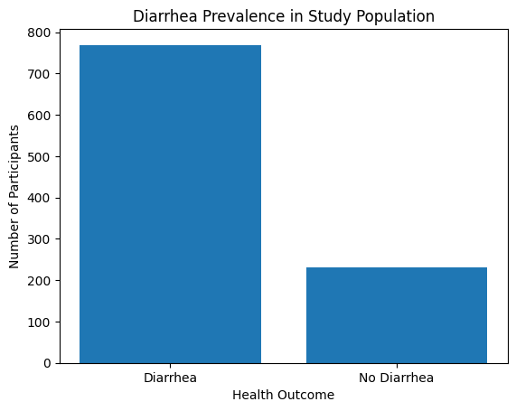
Associated Risk Factors
