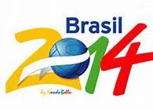 | Instructions for completing the predictions spread sheet

Step 1 – Download the spreadsheet

Go to http://bel-markb/wc/index.html

Download the “predictions - template.xlsx” spreadsheet

Open the spreadsheet

Step 2 - Username and Goal Scorer

Make sure you have the "Group A,B,C,D" Tab selected

Fill in a unique username, e.g MarkB,

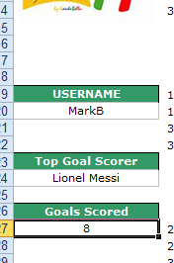

Fill in who you think the top scorer in the competition will be. Get some advice here

http://www.oddschecker.com/football/world-cup/top-goalscorer

Fill in how many goals you believe your top goal scorer will score

Step 3 – The Qualifying Rounds

The qualifying stages are on tabs "Group A,B,C,D" and "Group E,F,G,H"

Fill in your predictions for each of the games. Just enter a score for each match as below

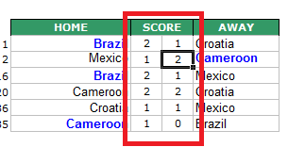

You can chose who qualifies in each of the 8 groups by adjusting the scores for each game...don't try and edit the group league tables as these are completed automatically by the results of the games in each group.

Step 4- The KnockOut Stages

When you have completed the qualifying stages the Knockout stages will have been fill in automatically based on the scores you entered for the qualifying games.

Fill in the scores for each of the stages in the Knock Out competition. Complete them in this order.

- Last Sixteen
- Quarter Finals
- Semi Finals
- 3rd Place Playoff
- Final

Each stage will automatically fill in the teams for the next stage.

Adjust the scores to make sure your preferred teams’ progress through to the next stage

Step 5 - Save the spreadsheet

Save the spread Sheet.

You can use anything you like just as long as the name starts with “predictions“ e.g.

predictions – markB
predictionsED
predictions DavidMC
predictionsGraemeR

Email the completed spreadsheet back to mark.boomer@microfocus.com

